# Assignment 9: DHCP

Name Hrishikesh Ravindra Karande

Part1

Q1] Is this DHCP Discover message sent out using UDP or TCP as the underlying transport protocol?

A] DHCP Message is sent on UDP.

Q2. What is the source IP address used in the IP datagram containing the Discover message? Is there anything special about this address? Explain.

A] Source Address = 0.0.0.0. This address is non-routable (indicates that this address **cannot be used for routing data packets** across a network). It is a special address that serves a specific purpose beyond regular communication. This signifies that the actual source address is **unknown** or **not yet assigned**.

3. What is the destination IP address used in the datagram containing the Discover message? Is there anything special about this address?

A] Destination IP 255.255.255.255

The **IP address 255.255.255.255** serves a unique purpose in networking, especially during the **DHCP (Dynamic Host Configuration Protocol)** process.

* + **255.255.255.255** is the **broadcast address** for an IPv4 network.  
    When a **DHCP client** (such as a computer or device seeking an IP address) sends a **DHCPDISCOVER** message, it uses **255.255.255.255** as the **destination address**.
  + This address signifies a **broadcast to all devices** on the local network segment.
  + Supports Network configuration for clients without assigned IP.

4. What is the value in the transaction ID field of this DHCP Discover message? 5. Now inspect the options field in the DHCP Discover message. What are five pieces of information (beyond an IP address) that the client is suggesting or requesting to receive from the DHCP server as part of this DHCP transaction?

A] Transaction ID :0x04186130

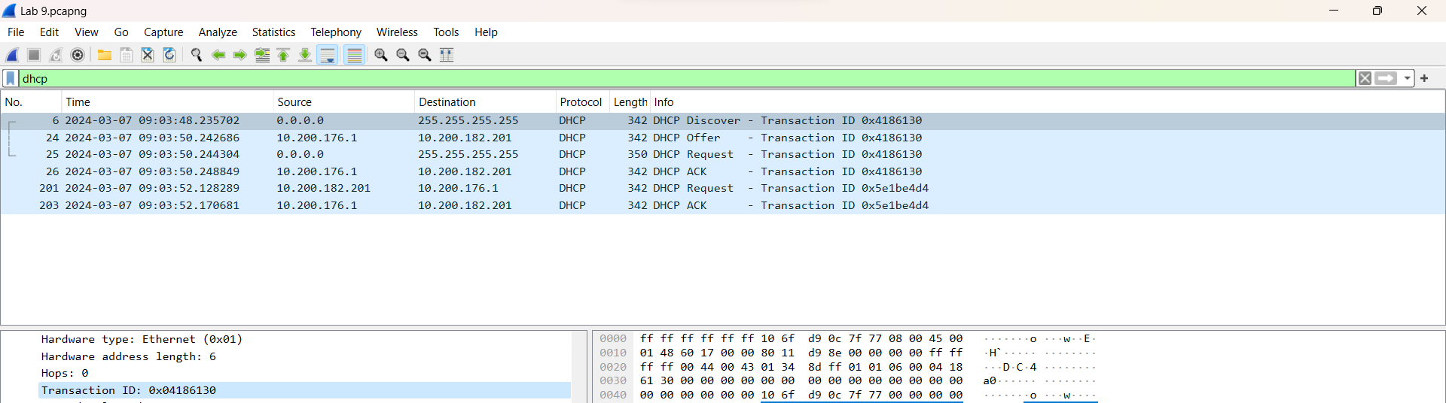

Q5] Now inspect the options field in the DHCP Discover message. What are five pieces of information (beyond an IP address) that the client is suggesting or requesting to receive from the DHCP server as part of this DHCP transaction?

A]

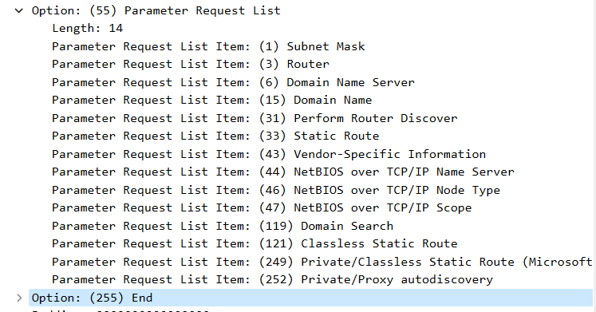

Q6] . How do you know that this Offer message is being sent in response to the DHCP Discover message you studied in questions 1-5 above?

A] The message type is set as offer and has same Transaction ID as in the Discover message sent above.

Q7] . What is the source IP address used in the IP datagram containing the Offer message? Is there anything special about this address? Explain

A] The source IP address = 10.200.176.1  
This is the DHCP server IP address.

Q8] What is the destination IP address used in the datagram containing the Offer message? Is there anything special about this address? Explain.

A] Destination IP address: 10.200.182.201  
This is my systems IPv4 address.

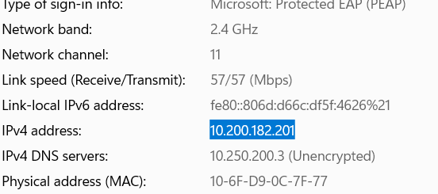 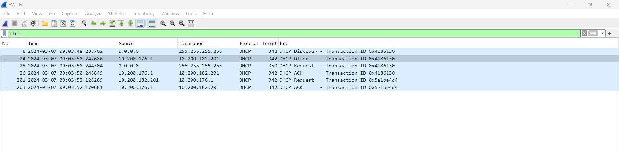

Q9] Now inspect the options field in the DHCP Offer message. What are five pieces of information that the DHCP server is providing to the DHCP client in the DHCP Offer message?

A] 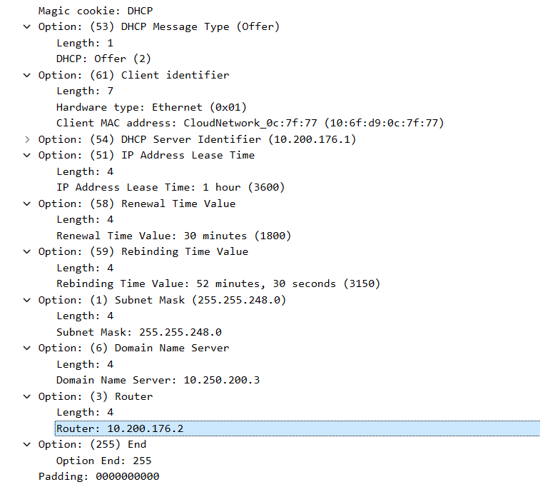

Q10] What is the UDP source port number in the IP datagram containing the first DHCP Request message in your trace? What is the UDP destination port number being used?

A] User Datagram Protocol, Src Port: 68, Dst Port: 67



Q11] What is the source IP address in the IP datagram containing this Request message? Is there anything special about this address? Explain.

A] Internet Protocol Version 4, Src: 0.0.0.0

Q12] . What is the destination IP address used in the datagram containing this Request message. Is there anything special about this address? Explain

A] Dst: 255.255.255.255. The use of 255.255.255.255 as the destination address in the DHCP request packet allows the client to broadcast its request effectively and efficiently, ensuring that it reaches all potential DHCP servers within the broadcast domain.

Q13] What is the value in the transaction ID field of this DHCP Request message? Does it match the transaction IDs of the earlier Discover and Offer messages?

A] Trasaction ID = 0x04186130  
Yes it matches the transaction ID from the earlier Discover and Offer Message

Q14] What differences do you see between the entries in the ‘parameter request list’ option in this Request message and the same list option in the earlier Discover message?

A] There is no difference in the Parametre Lists.

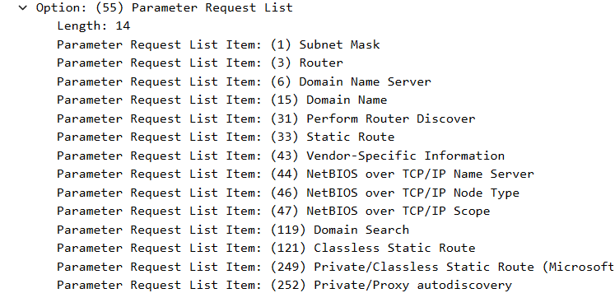

Q15] What is the source IP address in the IP datagram containing this ACK message? Is there anything special about this address? Explain.

A] Internet Protocol Version 4, Src: 10.200.176.1. This is the IP of the DHCP server that has responded by providing the acknowledegement to the client

Q16]What is the destination IP address used in the datagram containing this ACK message. Is there anything special about this address? Explain

A] Destination IP: 10.200.182.201  
This is the IP of my system, or the client to which the acknowledgement is being sent.

Q17] What is the name of the field in the DHCP ACK message (as indicated in the Wireshark window) that contains the assigned client IP address?

A] Your client’s IP Address field contains the IP of my system 10.200.182.201.

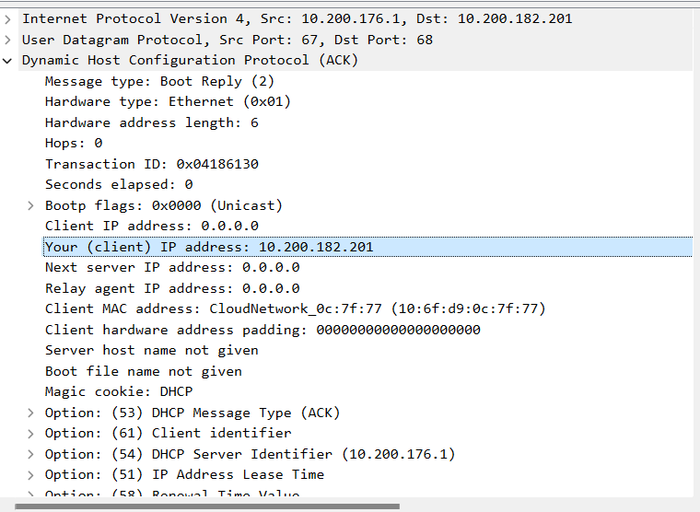

Q18] For how long a time (the so-called “lease time”) has the DHCP server assigned this IP address to the client?

A] Lease Time = 1hour = 3600 s



Q19] What is the IP address (returned by the DHCP server to the DHCP client in this DHCP ACK message) of the first-hop router on the default path from the client to the rest of the Internet?

A] IP Address of Next Hop is 10.200.176.2