#include<stdio.h>

#include<conio.h>

#include<dos.h>

void main()

{

int ch;

char fname[25]="C://a.txt";

char fname1[25]="C://abcd";

union REGS regs;

clrscr();

do

{

printf("\n enter your choice:\n1:delete exisiting file\n2:create directory");

scanf("%d",&ch);

switch(ch)

{

case 1:

regs.h.ah=0x41;

regs.x.dx=&fname;

int86(0x21,&regs,&regs);

if((regs.x.cflag&0x01)==0)

printf("\nfile is deleted");

else

printf("\nerror");

break;

case 2:

regs.h.ah=0x39;

regs.x.dx=&fname1;

int86(0x21,&regs,&regs);

if((regs.x.cflag&0x01)==0)

printf("\ndirectory is created");

else

printf("\nerror");

break;

default:

printf("\n invalid choice");

}

}while(ch!=3);

getch();

}

OUTPUT:-

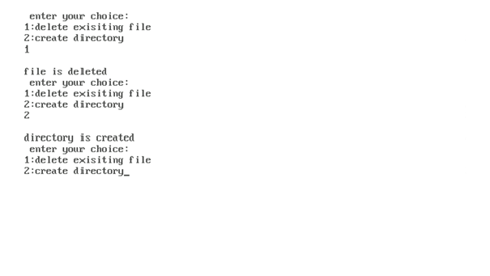

.model small

.data

m1 db 10,13,"error occured$"

m2 db 10,13,"error in reading file$"

m3 db 10,13,"error in writing file$"

m4 db 10,13,"copied successful$"

m5 db 10,13,"reading file name successful"

hd1 dw ?

hd2 dw ?

buf1 db 15 dup("$")

file1 label byte

max1 db 20h

act1 db 00h

buff db 20 dup("$")

file2 label byte

max2 db 20h

act2 db 00h

bufff db 20 dup("$")

.code

mov ax,@data ;to link cs with ds

mov ds,ax

mov si,82h ;to link with psp

lea di,file1 ;reading name of 1st file

cmp bl,es:[si]

cmp bl," "

je next

read1:

mov [di],bl

inc di

inc si

jmp read1

next:

inc si

lea di,file2 ;reading name of 2nd file

read2:

mov bl,es:[si] ;whether user has typed enter key or not

cmp bl,0dh

je loop1

mov [di],bl

inc di

inc si

jmp read2

loop1:

lea dx,m1

mov ah,09h

int 21h

;open file

mov ah,3dh

mov al,00h

lea dx,file1

int 21h

jnc b1

lea dx,m1 ;print error msg

mov ah,09h

int 21h

jmp quit

b1:mov hd1,ax

;create 2nd file

mov ah,3ch

mov cx,00h

lea dx,file2

int 21h

jnc b2

lea dx,m1

mov ah,09h

int 21h

b2:mov hd2,ax

;read content of 1st file

a5:

mov ah,3fh

mov bx,hd1

mov dx,offset buf1

mov cx,15

int 21h

jc a4

cmp ax,00h

je a2

;write in destination

mov cx,ax

mov ah,40h

mov bx,hd2

int 21h

jc a3

jmp a5

lea dx,m1

mov ah,09h

int 21h

a4:

lea dx,m2

mov ah,09h

int 21h

jmp a1

a3:

lea dx,m3

mov ah,09h

int 21h

a2:

lea dx,m4

mov ah,09h

int 21h

;close files

a1:mov ah,3eh

mov bx,hd1

int 21h

mov bx,hd2

int 21h

quit:

mov ah,4ch

int 21h

end

output:-

