Requirements doc and policy rules

IT equipment requests
Internal employees ask for equipment in plain language. The system looks up the employee, applies that role's policy, and returns one of three outcomes: approve, deny, or escalate to a human reviewer. It does not guess when the record or the request is ambiguous.

Request fields
A request has four fields. Role is never taken from the message; it is looked up from the employee id.
Field | Source | Notes
Employee id | The request text (E001, E002, ...) | Required. Unknown ids are escalated.
Role | get_employee_info | intern, engineer, or manager.
Item | The request text, normalized to the catalog | laptop, monitor, headset, keyboard, docking_station. Anything else is escalated.
Reason | The request text | Used to detect accommodation or exception language.

Policy limits
Counts are the maximum number of that item on file. Refresh is how old the oldest matching item must be before a replacement is approved. Ages are in years.
Interns are not eligible for permanent equipment. A loaner already on file does not create an entitlement. A catalog purchase for an intern is a clear deny, unless the reason is an accommodation.
Role | Item | Max on file | Refresh
engineer | laptop | 1 | 4 years
engineer | monitor | 1 | 3 years
engineer | headset | 1 | 2 years
engineer | keyboard | 1 | 2 years
engineer | docking_station | not eligible | —
manager | laptop | 1 | 2 years
manager | monitor | 2 | 3 years
manager | headset | 1 | 2 years
manager | keyboard | 1 | 2 years
manager | docking_station | 1 | 4 years
Synonyms map onto the catalog before the check: display/screen to monitor, notebook to laptop, dock/docking station to docking_station.

Decisions
check_request_eligibility returns approve, deny, or escalate.
Approve when the employee is under the count limit, or already at the limit and the oldest matching item is at least as old as the refresh interval. At the limit, an approval is a replacement of that oldest item, not an extra unit.
Deny when the outcome is clear and outside policy:
- the employee is an intern asking for a permanent catalog item
- the role is not eligible for that item (an engineer asking for a docking station)
- they are at the limit and the oldest matching item is more than 6 months short of the refresh date
Escalate instead of approving or denying when the case is ambiguous:
- the employee id is not on file
- the item is not in the catalog
- a matching item is missing an issue age, so refresh cannot be checked
- the reason mentions an accommodation or exception (injury, medical, disability, ADA, physician, doctor, accommodation)
- they are at the limit and the oldest matching item falls inside the 6 months before the refresh date
Accommodation language overrides an otherwise clear approve or deny. Those requests go to a human reviewer.
flag_for_human_review records an escalation. It does not approve or deny the request. The queue is a JSON file (REVIEW_QUEUE_PATH, default data/review_queue.json).

Mock employees
Id | Name | Role | Tenure | Equipment
E001 | Priya Shah | engineer | 4.2 years | laptop 2.0 years, monitor 1.0 year
E002 | Luis Ortega | engineer | 1.1 years | laptop 1.1 years, no monitor
E003 | Dana Okonkwo | manager | 5.0 years | laptop 1.6 years, monitors at 1.0 and 2.5 years
E004 | Sam Patel | intern | 0.4 years | loaner laptop 0.4 years
E005 | Riley Chen | engineer | 6.0 years | laptop 1.5, monitor 1.2, headset 0.5, keyboard 0.8 years
E006 | Jordan Lee | engineer | 3.0 years | laptop with no issue age
E007 | Avery Brooks | engineer | 5.0 years | monitor 3.5 years

Demo requests
Request | Expected
E002 needs a monitor | approve (under the monitor limit)
E001 needs a second monitor | deny (1 of 1, issued 1.0 year ago, refresh is 3 years)
E003 wants a laptop replacement | escalate (manager refresh is 2 years; the laptop is 1.6 years old, inside the 6-month window)
E005 needs a graphics tablet because of a wrist injury | escalate (item is not in the catalog, and the reason is an accommodation)

Minimal one-tool server and client connection
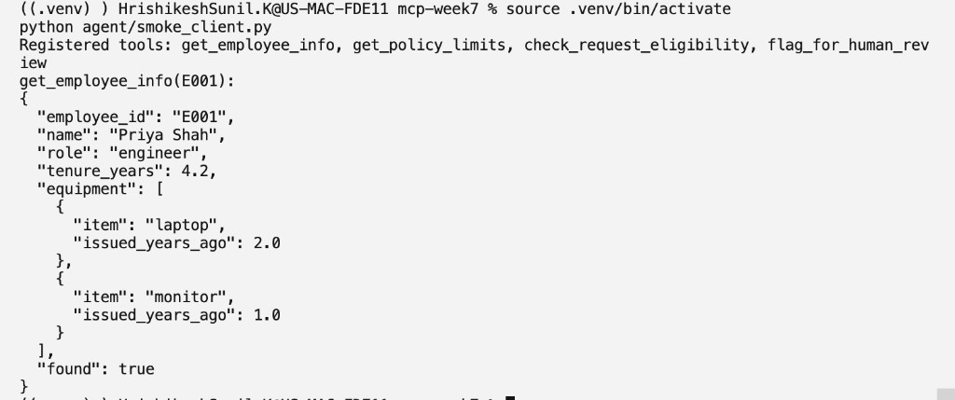

MCP server code, all four tools
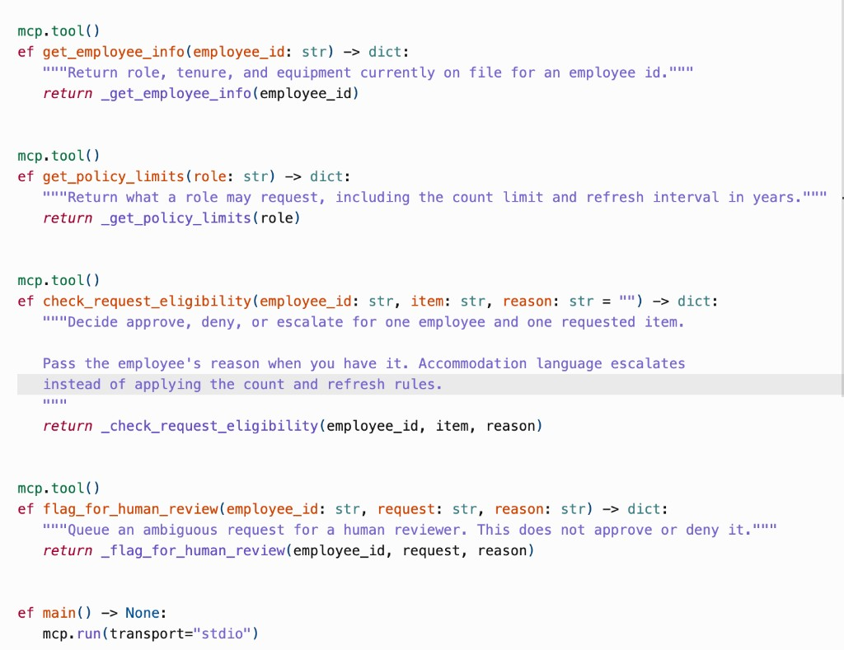

Unit tests for each tool, and a passing test run
tests/test_service.py
"""Unit tests for the equipment tools' underlying functions, not the MCP transport."""

import json

from equipment_requests.service import (
check_request_eligibility,
flag_for_human_review,
get_employee_info,
get_policy_limits,
)

def test_get_employee_info_returns_role_tenure_and_equipment():
info = get_employee_info("e002")
assert info["found"] is True
assert info["name"] == "Luis Ortega"
assert info["role"] == "engineer"
assert info["tenure_years"] == 1.1
assert info["equipment"] == [{"item": "laptop", "issued_years_ago": 1.1}]

def test_get_employee_info_unknown_id():
info = get_employee_info("E999")
assert info == {
"found": False,
"employee_id": "E999",
"error": "Employee not found",
}

def test_get_policy_limits_for_engineer_and_manager():
engineer = get_policy_limits("Engineer")
assert engineer["found"] is True
assert engineer["eligible_items"]["monitor"] == {"max_count": 1, "refresh_years": 3}
assert "docking_station" not in engineer["eligible_items"]

manager = get_policy_limits("manager")
assert manager["eligible_items"]["laptop"]["refresh_years"] == 2
assert manager["eligible_items"]["monitor"]["max_count"] == 2
assert manager["eligible_items"]["docking_station"]["refresh_years"] == 4

def test_get_policy_limits_unknown_role():
assert get_policy_limits("ceo")["found"] is False
assert get_policy_limits("ceo")["error"] == "Unknown role"

def test_approve_when_under_the_count_limit():
result = check_request_eligibility("E002", "monitor")
assert result["decision"] == "approve"
assert result["eligible"] is True
assert result["ambiguous"] is False
assert result["normalized_item"] == "monitor"

def test_approve_replacement_when_refresh_interval_has_elapsed():
result = check_request_eligibility("E007", "monitor")
assert result["decision"] == "approve"
assert "3.5" in result["reason"]
assert "3" in result["reason"]

def test_deny_second_monitor_before_refresh():
result = check_request_eligibility("E001", "second monitor")
assert result["decision"] == "deny"
assert result["eligible"] is False
assert result["normalized_item"] == "monitor"
assert "outside policy" in result["reason"]

def test_deny_intern_permanent_equipment():
result = check_request_eligibility("E004", "laptop")
assert result["decision"] == "deny"
assert "Interns are not eligible" in result["reason"]

def test_deny_item_the_role_cannot_have():
result = check_request_eligibility("E001", "docking station")
assert result["decision"] == "deny"
assert result["normalized_item"] == "docking_station"

def test_escalate_inside_the_six_month_window():
result = check_request_eligibility("E003", "laptop")
assert result["decision"] == "escalate"
assert result["eligible"] is None
assert result["ambiguous"] is True
assert "window" in result["reason"]

def test_escalate_unknown_employee():
result = check_request_eligibility("E999", "laptop")
assert result["decision"] == "escalate"
assert result["ambiguous"] is True

def test_escalate_item_not_in_catalog():
result = check_request_eligibility("E005", "graphics tablet")
assert result["decision"] == "escalate"
assert result["normalized_item"] is None
assert "catalog" in result["reason"]

def test_escalate_when_issue_age_is_missing():
result = check_request_eligibility("E006", "laptop")
assert result["decision"] == "escalate"
assert "no issue age" in result["reason"]

def test_accommodation_language_overrides_a_clear_deny():
result = check_request_eligibility(
"E001",
"monitor",
reason="I need this because of a wrist injury",
)
assert result["decision"] == "escalate"
assert "accommodation" in result["reason"]

def test_accommodation_and_unknown_item_are_both_cited():
result = check_request_eligibility(
"E005",
"graphics tablet",
reason="needed because of a wrist injury",
)
assert result["decision"] == "escalate"
assert "accommodation" in result["reason"]
assert "catalog" in result["reason"]

def test_ambiguous_phrase_naming_two_items_escalates():
result = check_request_eligibility("E002", "a dock for my laptop")
assert result["decision"] == "escalate"
assert result["normalized_item"] is None

def test_flag_for_human_review_appends_a_queued_record(tmp_path):
queue_path = tmp_path / "review_queue.json"
first = flag_for_human_review(
"e003",
"laptop replacement",
"Inside the refresh window",
queue_path=queue_path,
)
second = flag_for_human_review(
"E005",
"graphics tablet",
"Not in the catalog",
queue_path=queue_path,
)

assert first["status"] == "queued"
assert first["employee_id"] == "E003"
assert first["review_id"].startswith("RV-")
saved = json.loads(queue_path.read_text(encoding="utf-8"))
assert [row["review_id"] for row in saved] == [first["review_id"], second["review_id"]]
assert saved[1]["reason"] == "Not in the catalog"
pytest
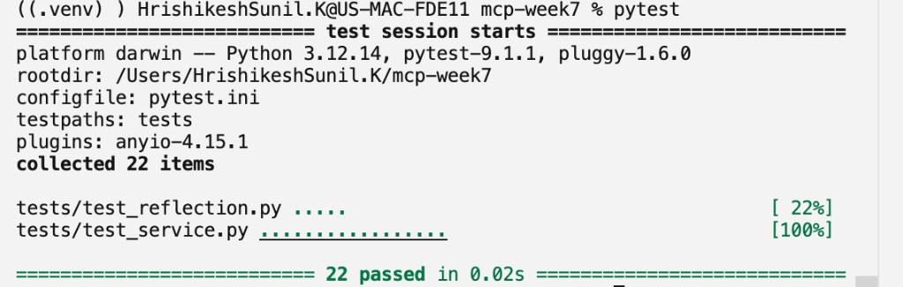

Agent code and MCP client connection

server_parameters
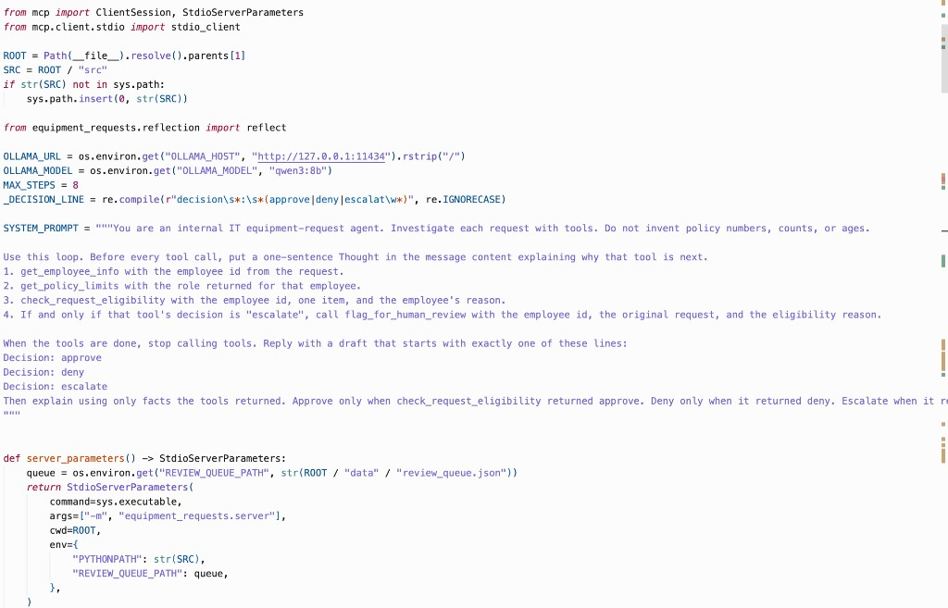

run_requests
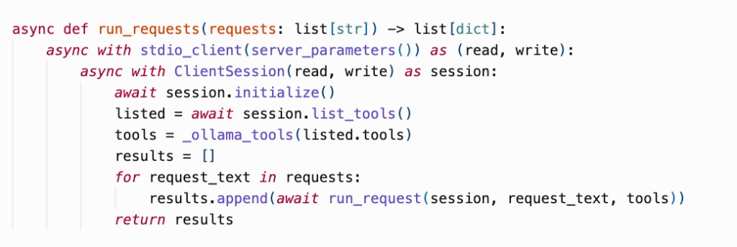

ReAct traces for all four requests
((.venv) ) HrishikeshSunil.K@US-MAC-FDE11 mcp-week7 % source .venv/bin/activate
python agent/demo.py
Model: qwen3:8b
========================================================================
Request: Employee E002 (Luis Ortega) needs a monitor for their desk.
========================================================================
Thought: I need to call get_employee_info before deciding.
Action: get_employee_info {"employee_id": "E002"}
Observation: {
"employee_id": "E002",
"name": "Luis Ortega",
"role": "engineer",
"tenure_years": 1.1,
"equipment": [
{
"item": "laptop",
"issued_years_ago": 1.1
}
],
"found": true
}
Thought: I need to call get_policy_limits before deciding.
Action: get_policy_limits {"role": "engineer"}
Observation: {
"found": true,
"role": "engineer",
"eligible_items": {
"laptop": {
"max_count": 1,
"refresh_years": 4
},
"monitor": {
"max_count": 1,
"refresh_years": 3
},
"headset": {
"max_count": 1,
"refresh_years": 2
},
"keyboard": {
"max_count": 1,
"refresh_years": 2
}
},
"near_threshold_years": 0.5,
"notes": "At the count limit, a request replaces the oldest unit once it reaches the refresh age."
}
Thought: I need to call check_request_eligibility before deciding.
Action: check_request_eligibility {"reason": "desk setup", "employee_id": "E002", "item": "monitor"}
Observation: {
"employee_id": "E002",
"item": "monitor",
"normalized_item": "monitor",
"decision": "approve",
"eligible": true,
"ambiguous": false,
"reason": "Luis Ortega (engineer) has 0 of 1 monitor(s) on file. The request is within the engineer limit."
}
Thought: Decision: approve
Luis Ortega (engineer) has 0 of 1 monitor(s) on file. The request is within the engineer limit.
Draft: Decision: approve
Luis Ortega (engineer) has 0 of 1 monitor(s) on file. The request is within the engineer limit.
------------------------------------------------------------------------
Reflection: {
"faithful": true,
"issues": []
}
Reflection confirmed the draft matches the tool results.
------------------------------------------------------------------------
Final decision: approve
Response: Decision: approve
Luis Ortega (engineer) has 0 of 1 monitor(s) on file. The request is within the engineer limit.

========================================================================
Request: Employee E001 (Priya Shah) needs a second monitor.
========================================================================
Thought: I need to call get_employee_info before deciding.
Action: get_employee_info {"employee_id": "E001"}
Observation: {
"employee_id": "E001",
"name": "Priya Shah",
"role": "engineer",
"tenure_years": 4.2,
"equipment": [
{
"item": "laptop",
"issued_years_ago": 2.0
},
{
"item": "monitor",
"issued_years_ago": 1.0
}
],
"found": true
}
Thought: I need to call get_policy_limits before deciding.
Action: get_policy_limits {"role": "engineer"}
Observation: {
"found": true,
"role": "engineer",
"eligible_items": {
"laptop": {
"max_count": 1,
"refresh_years": 4
},
"monitor": {
"max_count": 1,
"refresh_years": 3
},
"headset": {
"max_count": 1,
"refresh_years": 2
},
"keyboard": {
"max_count": 1,
"refresh_years": 2
}
},
"near_threshold_years": 0.5,
"notes": "At the count limit, a request replaces the oldest unit once it reaches the refresh age."
}
Thought: I need to call check_request_eligibility before deciding.
Action: check_request_eligibility {"reason": "Needs a second monitor for dual-screen work.", "employee_id": "E001", "item": "monitor"}
Observation: {
"employee_id": "E001",
"item": "monitor",
"normalized_item": "monitor",
"decision": "deny",
"eligible": false,
"ambiguous": false,
"reason": "Priya Shah (engineer) already has 1 monitor(s) on file (limit 1). The oldest was issued 1.0 years ago, and replacement is allowed every 3 years. The request is outside policy."
}
Thought: Decision: deny
Priya Shah (engineer) already has 1 monitor(s) on file (limit 1). The oldest was issued 1.0 years ago, and replacement is allowed every 3 years. The request is outside policy.
Draft: Decision: deny
Priya Shah (engineer) already has 1 monitor(s) on file (limit 1). The oldest was issued 1.0 years ago, and replacement is allowed every 3 years. The request is outside policy.
------------------------------------------------------------------------
Reflection: {
"faithful": true,
"issues": []
}
Reflection confirmed the draft matches the tool results.
------------------------------------------------------------------------
Final decision: deny
Response: Decision: deny
Priya Shah (engineer) already has 1 monitor(s) on file (limit 1). The oldest was issued 1.0 years ago, and replacement is allowed every 3 years. The request is outside policy.

========================================================================
Request: Employee E003 (Dana Okonkwo) wants a laptop replacement. The current laptop feels slow.
========================================================================
Thought: Thought: I need to retrieve the employee's information to determine their role and current equipment.
Action: get_employee_info {"employee_id": "E003"}
Observation: {
"employee_id": "E003",
"name": "Dana Okonkwo",
"role": "manager",
"tenure_years": 5.0,
"equipment": [
{
"item": "laptop",
"issued_years_ago": 1.6
},
{
"item": "monitor",
"issued_years_ago": 1.0
},
{
"item": "monitor",
"issued_years_ago": 2.5
}
],
"found": true
}
Thought: Thought: I need to determine the policy limits for the employee's role to check if a laptop replacement is eligible.
Action: get_policy_limits {"role": "manager"}
Observation: {
"found": true,
"role": "manager",
"eligible_items": {
"laptop": {
"max_count": 1,
"refresh_years": 2
},
"monitor": {
"max_count": 2,
"refresh_years": 3
},
"headset": {
"max_count": 1,
"refresh_years": 2
},
"keyboard": {
"max_count": 1,
"refresh_years": 2
},
"docking_station": {
"max_count": 1,
"refresh_years": 4
}
},
"near_threshold_years": 0.5,
"notes": "At the count limit, a request replaces the oldest unit once it reaches the refresh age."
}
Thought: Thought: I need to check if the request for a laptop replacement is eligible based on the employee's reason and policy limits.
Action: check_request_eligibility {"employee_id": "E003", "item": "laptop", "reason": "The current laptop feels slow"}
Observation: {
"employee_id": "E003",
"item": "laptop",
"normalized_item": "laptop",
"decision": "escalate",
"eligible": null,
"ambiguous": true,
"reason": "Dana Okonkwo (manager) is at the limit of 1 laptop(s). The oldest was issued 1.6 years ago and the refresh interval is 2 years, which is inside the 0.5-year window before eligibility. A reviewer should decide whether to make an exception."
}
Thought: Decision: escalate
The request from Dana Okonkwo (manager) is at the limit of 1 laptop(s). The oldest laptop was issued 1.6 years ago, and the refresh interval is 2 years. The system indicates that the request is ambiguous and should be reviewed by a human to determine whether an exception should be made.
Observation: check_request_eligibility returned escalate. Call flag_for_human_review now with the employee id, the original request, and the eligibility reason. After that tool returns, the draft must start with exactly: Decision: escalate
Thought: I need to call flag_for_human_review before deciding.
Action: flag_for_human_review {"request": "laptop replacement", "reason": "Dana Okonkwo (manager) is at the limit of 1 laptop(s). The oldest was issued 1.6 years ago and the refresh interval is 2 years, which is inside the 0.5-year window before eligibility. A reviewer should decide whether to make an exception.", "employee_id": "E003"}
Observation: {
"review_id": "RV-DE5958EC",
"employee_id": "E003",
"request": "laptop replacement",
"reason": "Dana Okonkwo (manager) is at the limit of 1 laptop(s). The oldest was issued 1.6 years ago and the refresh interval is 2 years, which is inside the 0.5-year window before eligibility. A reviewer should decide whether to make an exception.",
"status": "queued"
}
Thought: Decision: escalate
The request from Dana Okonkwo (manager) for a laptop replacement has been flagged for human review. The system determined that the employee is at the limit of 1 laptop(s), and the oldest laptop was issued 1.6 years ago, which is within the 0.5-year window before the refresh interval of 2 years. A reviewer will decide whether to make an exception.
Draft: Decision: escalate
The request from Dana Okonkwo (manager) for a laptop replacement has been flagged for human review. The system determined that the employee is at the limit of 1 laptop(s), and the oldest laptop was issued 1.6 years ago, which is within the 0.5-year window before the refresh interval of 2 years. A reviewer will decide whether to make an exception.
------------------------------------------------------------------------
Reflection: {
"faithful": true,
"issues": []
}
Reflection confirmed the draft matches the tool results.
------------------------------------------------------------------------
Final decision: escalate
Response: Decision: escalate
The request from Dana Okonkwo (manager) for a laptop replacement has been flagged for human review. The system determined that the employee is at the limit of 1 laptop(s), and the oldest laptop was issued 1.6 years ago, which is within the 0.5-year window before the refresh interval of 2 years. A reviewer will decide whether to make an exception.
Escalation: RV-DE5958EC: Dana Okonkwo (manager) is at the limit of 1 laptop(s). The oldest was issued 1.6 years ago and the refresh interval is 2 years, which is inside the 0.5-year window before eligibility. A reviewer should decide whether to make an exception.

========================================================================
Request: Employee E005 (Riley Chen) needs a graphics tablet because of a wrist injury.
========================================================================
Thought: I need to call get_employee_info before deciding.
Action: get_employee_info {"employee_id": "E005"}
Observation: {
"employee_id": "E005",
"name": "Riley Chen",
"role": "engineer",
"tenure_years": 6.0,
"equipment": [
{
"item": "laptop",
"issued_years_ago": 1.5
},
{
"item": "monitor",
"issued_years_ago": 1.2
},
{
"item": "headset",
"issued_years_ago": 0.5
},
{
"item": "keyboard",
"issued_years_ago": 0.8
}
],
"found": true
}
Thought: I need to call get_policy_limits before deciding.
Action: get_policy_limits {"role": "engineer"}
Observation: {
"found": true,
"role": "engineer",
"eligible_items": {
"laptop": {
"max_count": 1,
"refresh_years": 4
},
"monitor": {
"max_count": 1,
"refresh_years": 3
},
"headset": {
"max_count": 1,
"refresh_years": 2
},
"keyboard": {
"max_count": 1,
"refresh_years": 2
}
},
"near_threshold_years": 0.5,
"notes": "At the count limit, a request replaces the oldest unit once it reaches the refresh age."
}
Thought: I need to call check_request_eligibility before deciding.
Action: check_request_eligibility {"reason": "wrist injury", "employee_id": "E005", "item": "graphics tablet"}
Observation: {
"employee_id": "E005",
"item": "graphics tablet",
"normalized_item": null,
"decision": "escalate",
"eligible": null,
"ambiguous": true,
"reason": "Riley Chen requested graphics tablet with accommodation or exception language. Policy limits are not applied automatically to medical or accessibility requests. 'graphics tablet' is also not in the equipment catalog."
}
Thought: Decision: escalate
Riley Chen requested a graphics tablet due to a wrist injury, which is considered an accommodation request. The policy limits do not apply to such requests, and "graphics tablet" is not listed in the equipment catalog. The request has been flagged for human review.
Observation: check_request_eligibility returned escalate. Call flag_for_human_review now with the employee id, the original request, and the eligibility reason. After that tool returns, the draft must start with exactly: Decision: escalate
Thought: I need to call flag_for_human_review before deciding.
Action: flag_for_human_review {"reason": "wrist injury", "employee_id": "E005", "request": "graphics tablet"}
Observation: {
"review_id": "RV-E01E0BA4",
"employee_id": "E005",
"request": "graphics tablet",
"reason": "wrist injury",
"status": "queued"
}
Thought: Decision: escalate
Riley Chen requested a graphics tablet due to a wrist injury, which is considered an accommodation request. The policy limits do not apply to such requests, and "graphics tablet" is not listed in the equipment catalog. The request has been flagged for human review with review ID RV-E01E0BA4.
Draft: Decision: escalate
Riley Chen requested a graphics tablet due to a wrist injury, which is considered an accommodation request. The policy limits do not apply to such requests, and "graphics tablet" is not listed in the equipment catalog. The request has been flagged for human review with review ID RV-E01E0BA4.
------------------------------------------------------------------------
Reflection: {
"faithful": true,
"issues": []
}
Reflection confirmed the draft matches the tool results.
------------------------------------------------------------------------
Final decision: escalate
Response: Decision: escalate
Riley Chen requested a graphics tablet due to a wrist injury, which is considered an accommodation request. The policy limits do not apply to such requests, and "graphics tablet" is not listed in the equipment catalog. The request has been flagged for human review with review ID RV-E01E0BA4.
Escalation: RV-E01E0BA4: wrist injury

========================================================================
Summary
[ok] expected approve, got approve (reflection confirmed)
Employee E002 (Luis Ortega) needs a monitor for their desk.
[ok] expected deny, got deny (reflection confirmed)
Employee E001 (Priya Shah) needs a second monitor.
[ok] expected escalate, got escalate (reflection confirmed)
Employee E003 (Dana Okonkwo) wants a laptop replacement. The current laptop feels slow.
[ok] expected escalate, got escalate (reflection confirmed)
Employee E005 (Riley Chen) needs a graphics tablet because of a wrist injury.

Final decision for each request

E002
Final decision: approve
Response: Decision: approve
Luis Ortega (engineer) has 0 of 1 monitor(s) on file. The request is within the engineer limit.

E001
Final decision: deny
Response: Decision: deny
Priya Shah (engineer) already has 1 monitor(s) on file (limit 1). The oldest was issued 1.0 years ago, and replacement is allowed every 3 years. The request is outside policy.

E003
Final decision: escalate
Response: Decision: escalate
The request from Dana Okonkwo (manager) for a laptop replacement has been flagged for human review. The system determined that the employee is at the limit of 1 laptop(s), and the oldest laptop was issued 1.6 years ago, which is within the 0.5-year window before the refresh interval of 2 years. A reviewer will decide whether to make an exception.
Escalation: RV-DE5958EC: Dana Okonkwo (manager) is at the limit of 1 laptop(s). The oldest was issued 1.6 years ago and the refresh interval is 2 years, which is inside the 0.5-year window before eligibility. A reviewer should decide whether to make an exception.

E005
Final decision: escalate
Response: Decision: escalate
Riley Chen requested a graphics tablet due to a wrist injury, which is considered an accommodation request. The policy limits do not apply to such requests, and "graphics tablet" is not listed in the equipment catalog. The request has been flagged for human review with review ID RV-E01E0BA4.
Escalation: RV-E01E0BA4: wrist injury

Summary
[ok] expected approve, got approve (reflection confirmed)
Employee E002 (Luis Ortega) needs a monitor for their desk.
[ok] expected deny, got deny (reflection confirmed)
Employee E001 (Priya Shah) needs a second monitor.
[ok] expected escalate, got escalate (reflection confirmed)
Employee E003 (Dana Okonkwo) wants a laptop replacement. The current laptop feels slow.
[ok] expected escalate, got escalate (reflection confirmed)
Employee E005 (Riley Chen) needs a graphics tablet because of a wrist injury.

Reflection confirming a draft
E001, second monitor. The draft repeats the eligibility result, and reflection confirms it.
Draft: Decision: deny
Priya Shah (engineer) already has 1 monitor(s) on file (limit 1). The oldest was issued 1.0 years ago, and replacement is allowed every 3 years. The request is outside policy.
------------------------------------------------------------------------
Reflection: {
"faithful": true,
"issues": []
}
Reflection confirmed the draft matches the tool results.

Passing pipeline run
