Setup Of Project

For Installation of a SAN’S PROJECT the requirement specified in the hardware and software requirement section must be meet.

CREATION OF DATABASE AND TABLES:

Step 1: Create the database that’s name is ‘jms’.

Step 2:Log On SQL Plus in the Oracle 8i with
User Name : system
Password : manager
HotString : jms

Step 3:Now write the following coding for creation User :
get f:\san\createUser
run
exit

Step 4:Again Log On SQL Plus in the Oracle 8i with
User Name : hrishi
Password : jms
HotString : jms

Step 5:Now write the following coding for creation of Table Space :
get f\san\tableSpace
run

Step 6:(a) Open the file f:\san\sequence\createSquence.
(b) Copy all the contents of the file.
(c) Paste the contents on the SQL Plus.

Step 7:(a) Again Open the file f:\san\Table\TTTable.doc
(b) Copy all the contents of the file.
(c) Paste the contents on the SQL Plus.

Step 8: Now exit from SQL Plus.

Note: In above F drive is mention which is CDROM drive it can vary
system to system.

INSTALLATION OF VB FORM :

Step 1: If any program of V Basic then the close all.

Step 2: Run the Setup file which allocated in the f:\san\setup\setup

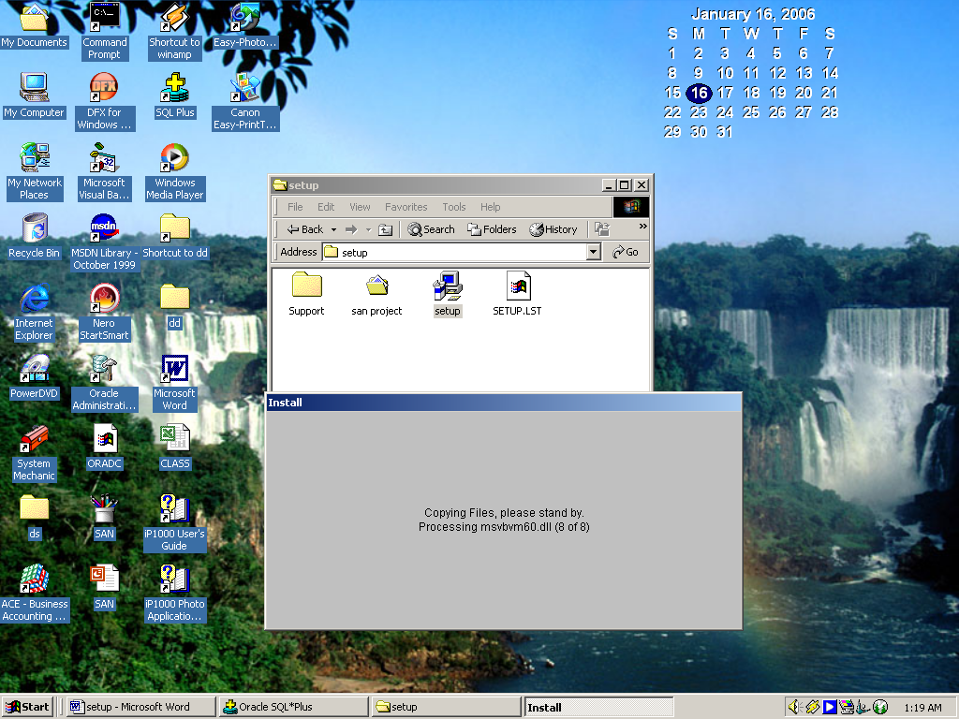

Step 3: On welcome window click on the Ok for setup otherwise click
ExitSetup for exit from Setup of a SAN’S PROJECT.

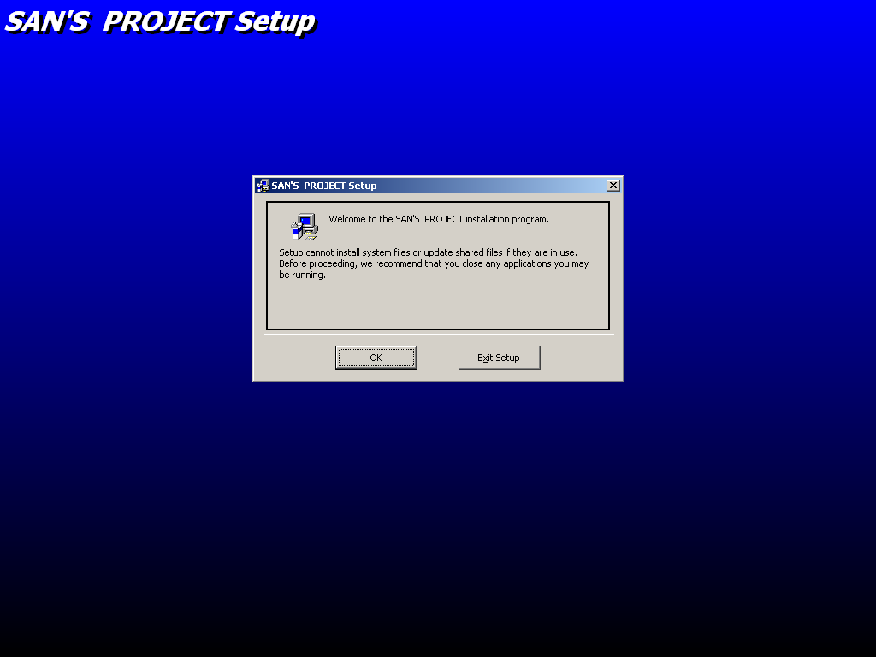

Step 4: Specify the location of installation.

Step 5: Choose the group of the program.

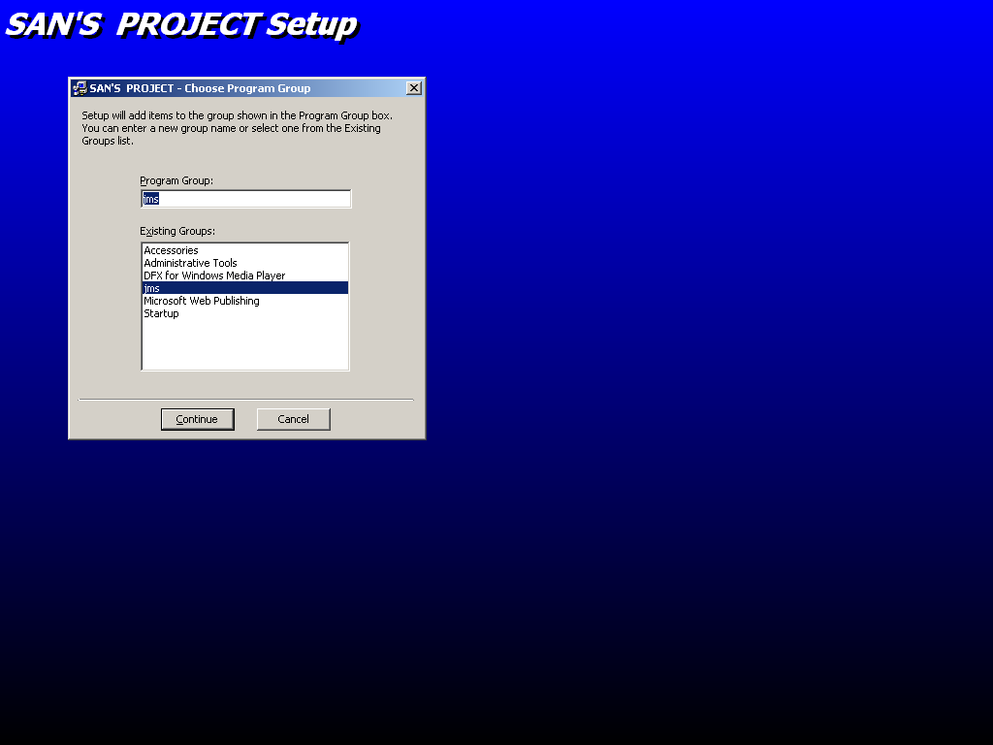

Step 5: After the successfully installation of the a SAN’S PROJECT
will get this window.

