Week 4: Predictive Modeling and Optimization in Logistics Systems
Yuva Intern – Power BI Internship | Technical Project Report
Dataset: 1,200 simulated shipment records | Target: delivery duration in minutes

1. Objective and Problem Definition
The objective is to develop and evaluate a Python regression model that forecasts delivery duration for logistics shipments, then use the predictions to propose practical operational optimization strategies. Predicting delivery duration can support ETA planning, exception alerts, staffing, and transport-mode decisions. This report uses simulated data only; the results demonstrate a technical workflow and must not be represented as real company performance.

2. Data Simulation, Features, and Target
A reproducible dataset of 1,200 hypothetical shipments was generated with NumPy and Pandas using a fixed random seed. Each record includes route distance, shipment weight and volume, transport mode, destination zone, traffic level, weather condition, dispatch hour, transportation cost, and observed delivery duration.
Field | Role | Description
Delivery_Duration_min | Target | Elapsed delivery duration in minutes
Distance_km | Numeric feature | Route distance
Shipment_Weight_kg | Numeric feature | Shipment weight
Shipment_Volume_units | Numeric feature | Number of units in the shipment
Transport_Mode | Categorical feature | Road, Air, or Rail
Destination_Zone | Categorical feature | Destination region
Traffic_Level | Categorical feature | Low, Medium, or High
Weather_Condition | Categorical feature | Clear, Rain, or Storm
Dispatch_Hour | Numeric feature | Hour of dispatch
Transportation_Cost_INR | Numeric feature | Simulated transportation cost
The target is continuous, so regression is appropriate. Shipment_ID is an identifier and is excluded from model features to avoid teaching the model an arbitrary ID pattern.

3. Data Preparation and Analysis Flow
- Generate the hypothetical dataset with plausible relationships among distance, transport mode, traffic, weather, and delivery duration.
- Separate the target (Delivery_Duration_min) from input features.
- Split the data into 80% training and 20% held-out test data using random_state=42.
- Impute missing numerical values with the median and categorical values with the most frequent category; the generated dataset is complete, but the pipeline is robust to missing values.
- Standardize numerical variables and one-hot encode categorical variables using a scikit-learn ColumnTransformer.
- Train baseline regression models, evaluate test-set metrics, tune Random Forest with 5-fold cross-validation, and inspect prediction/residual charts.
- Use a what-if scenario to estimate the model's predicted duration change when traffic severity is reduced by one category.

4. Model Selection and Rationale
Three initial models were compared. Linear Regression provides a simple, interpretable baseline but may underfit nonlinear interactions. Decision Tree Regression can capture nonlinear patterns and interactions but may overfit. Random Forest combines multiple trees and generally handles nonlinear relationships more robustly. A tuned Random Forest was also tested using GridSearchCV.

5. Evaluation Metrics and Validation
MAE (Mean Absolute Error) reports the average absolute prediction error in minutes and is easy to interpret operationally. RMSE (Root Mean Squared Error) penalizes larger misses more heavily. R-squared measures the fraction of target variance explained relative to a mean baseline; it can be negative on a test set if a model performs poorly. The held-out test set is reserved for final evaluation. Five-fold shuffled cross-validation is used only on the training set for hyperparameter selection.

6. Model Performance Results
Model | MAE (min) | RMSE (min) | R-squared
Linear Regression | 17.57 | 22.43 | 0.849
Tuned Random Forest | 20.24 | 25.76 | 0.801
Random Forest | 20.30 | 25.77 | 0.801
Decision Tree | 24.52 | 31.55 | 0.701
The lowest test RMSE among the evaluated rows was achieved by **Linear Regression** (MAE 17.57 minutes, RMSE 22.43 minutes, R-squared 0.849). Lower MAE/RMSE are better; higher R-squared is generally better. Since the data are simulated from engineered relationships, these scores should be treated as a demonstration rather than a guarantee of real-world accuracy.
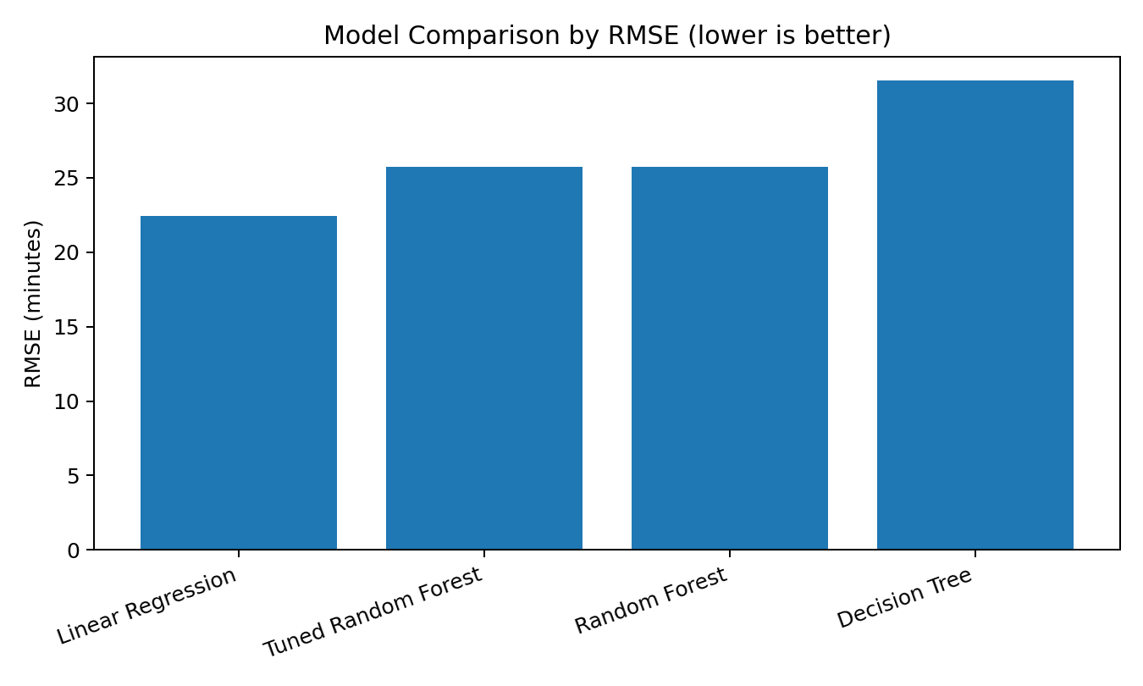
Figure 1. Model comparison by test RMSE. This chart provides a quick visual comparison of prediction error across models.

7. Prediction Quality and Error Analysis
The actual-versus-predicted plot compares forecasts with observed target values. Points close to the diagonal represent accurate predictions; larger distances from the diagonal indicate larger errors. The residual plot checks whether errors are centered around zero and whether error spread changes across predicted durations.
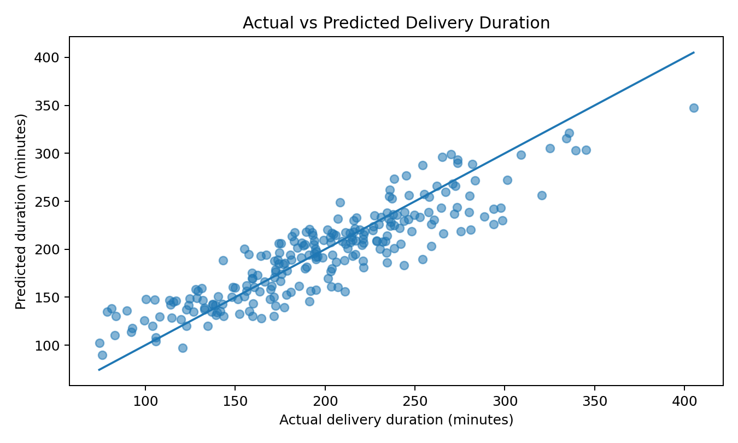
Figure 2. Actual versus predicted delivery duration for the tuned Random Forest.
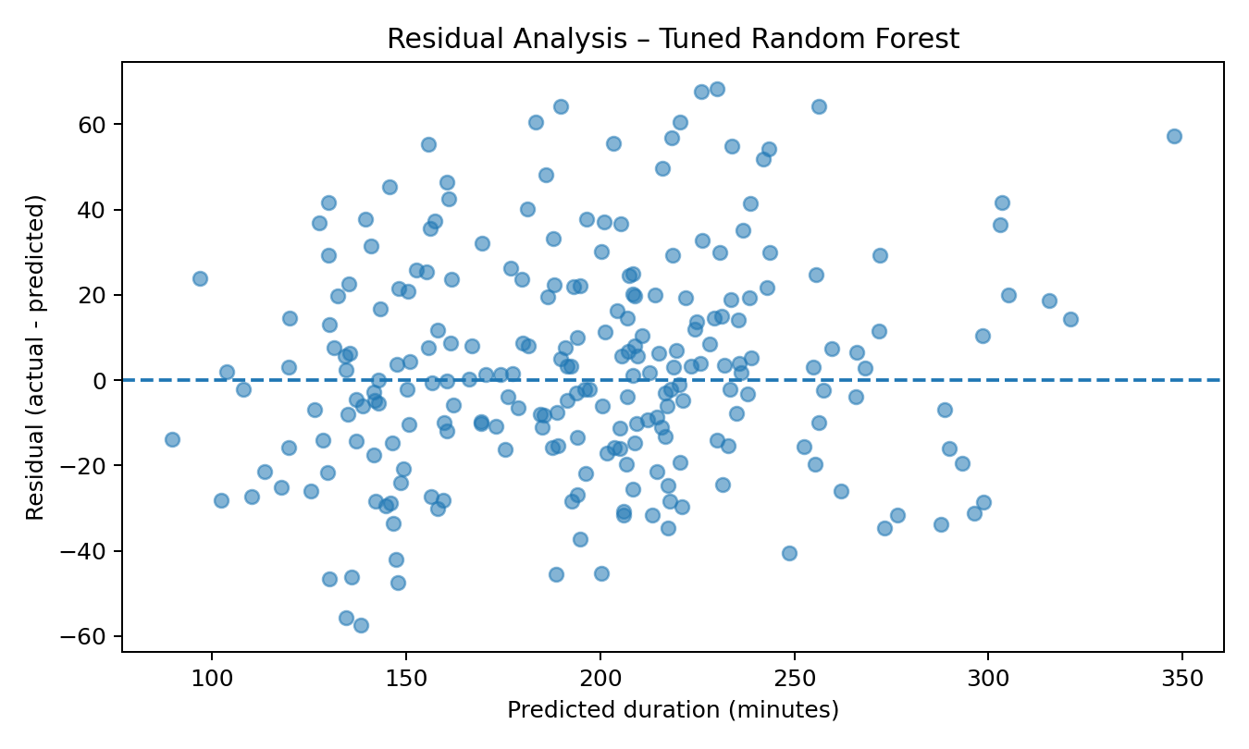
Figure 3. Residual analysis. Residuals are actual minus predicted duration; patterns or increasing spread may indicate remaining model limitations.
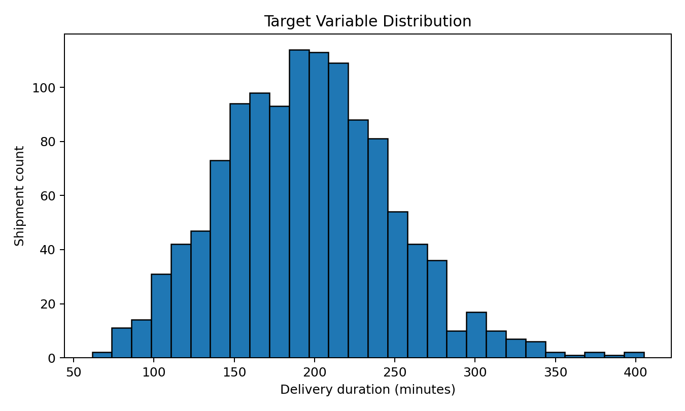
Figure 4. Distribution of the target variable, used to understand the range and concentration of delivery durations before modeling.

8. Optimization Strategy and What-if Scenario
Prediction alone does not optimize operations; forecasts must be converted into decisions. Recommended strategies include:
- ETA-based exception management: flag shipments whose predicted duration is likely to exceed the agreed delivery target, then prioritize proactive customer updates and dispatcher review.
- Resource allocation: use expected shipment workload and predicted delivery duration by zone and time window to align driver shifts, depot staffing, and loading capacity.
- Route and dispatch planning: investigate high predicted duration cases with traffic, weather, distance, and dispatch-hour context. Use route optimization tools and operational constraints before changing routes.
- Mode selection: compare predicted duration and total cost for feasible transport modes; select the least-cost option that still meets the service-level target rather than choosing by cost alone.
- Continuous monitoring: track MAE/RMSE over time and retrain only after checking data quality, drift, and operational changes.
A simple what-if test changed each test shipment's traffic category down one level (High→Medium, Medium→Low, Low→Low) and compared model predictions. Baseline mean predicted duration was 194.9 minutes; the reduced-traffic scenario mean was 181.5 minutes, a modeled difference of 13.5 minutes (6.9%). This is a simulated scenario, not proof that a company can directly reduce traffic or achieve this improvement. In practice, traffic-aware dispatching, time-window planning, and alternate-route selection would need operational validation.
Scenario | Mean predicted duration (min) | Difference vs baseline (min)
Baseline predictions | 194.94 | 0.00
Reduced traffic scenario | 181.46 | 13.49

9. Python Code Excerpts
# Train/test split and model pipeline
X_train, X_test, y_train, y_test = train_test_split(
X, y, test_size=0.20, random_state=42
)
model = Pipeline([
("preprocess", preprocessor),
("model", RandomForestRegressor(random_state=42))
])
model.fit(X_train, y_train)
pred = model.predict(X_test)
mae = mean_absolute_error(y_test, pred)
rmse = mean_squared_error(y_test, pred) ** 0.5
r2 = r2_score(y_test, pred)
# Hyperparameter tuning with 5-fold CV
grid = GridSearchCV(
model,
{"model__n_estimators": [120, 180],
"model__max_depth": [None, 14],
"model__min_samples_leaf": [1, 3]},
cv=KFold(n_splits=5, shuffle=True, random_state=42),
scoring="neg_mean_absolute_error"
)
grid.fit(X_train, y_train)
The full runnable script is supplied separately as `logistics_model.py`. It performs preprocessing, trains the candidate models, tunes Random Forest, saves a metrics CSV, and generates an actual-versus-predicted plot.

10. GitHub Requirement – Compulsory Technical Submission
Because this is a technical/software-related task, the internship note says a GitHub repository URL is compulsory for certificate eligibility. The project files have been organized with a README, Python script, requirements file, simulated dataset, and outputs. However, a real repository URL must be created under your GitHub account; I cannot truthfully provide a repository URL before it exists.
- Sign in to GitHub and choose New repository.
- Name it `yuva-intern-week4-logistics-predictive-model` and choose Public if your internship accepts public repositories.
- Create the repository, then upload all files from the supplied ZIP (including the `outputs` folder) using Add file → Upload files, or push them with Git from VS Code.
- Commit the upload, open the repository page, and copy the real URL, for example the URL displayed in your browser after creation.
- Paste that actual URL into the internship submission form. Do not submit a placeholder URL.
Suggested repository URL format only: https://github.com/YOUR-USERNAME/yuva-intern-week4-logistics-predictive-model

11. Limitations and Responsible Use
The dataset is synthetic, and the model's learned patterns reflect the simulation rules. Transportation cost is included as a predictor, but in a real deployment its availability at prediction time must be verified to prevent data leakage. Weather and traffic values must likewise be known at the time an ETA is produced. Before deployment, train and validate with real historical data, use time-based validation to mimic future forecasting, assess error by route and mode, and monitor drift.

12. Conclusion
This task demonstrates a complete predictive analytics workflow for logistics: define the target, simulate and prepare data, compare regression models, evaluate performance with MAE/RMSE/R-squared, tune a model using cross-validation, inspect errors visually, and translate forecasts into operational optimization ideas. The most useful business application is likely ETA exception management and better allocation of dispatch and delivery resources. Real-world use requires verified data, operational testing, and ongoing model monitoring.

Appendix: Reproducibility Files
Included project files: logistics_predictive_dataset.csv, logistics_model.py, requirements.txt, README.md, model_performance.csv, optimization_scenario.csv, and the four output figures. The dataset and all reported results are generated for this assignment.

