Which of the following are sets? Justify your answer.

1. The collection of all the months of a year beginning with the letterJ.
2. The collection of ten most talented writers of India.
3. A collection of novels written by the writer Munshi Prem Chand.
4. A collection of most dangerous animals of the world.

A={1,2,3,4,5}

1)SET OF NATURAL NUMBERS LESS THAN 10

A={1,2,3,4,5,6,7,8,9}

A={7,8,9,1,2,3,4,5,6}

2)THE SET OF PRIME NATURAL NUMBERS

A={2,3,5,7,……..}

3)SET OF VOWELS IN ALPHABETS

B={a,e,i,o,u}

4)set of positive integers less than 100

S={1,2,3,…..99}

5)set of integers less than 0

S={……,-3,-2,-1}

6)THE SET OF VOWELS IN WORD ”Equation”

A={a,e,i,o,u}

7)set of all natural numbers such that 4x+9<50

4x<41

X<41/4

X<10.25 N={1,2,3,4,5,6,7,8,9,10}

2)Set builder form/Rule form

P(x)

A={x:(|)p(x)}

1)set of vowels in English alphabet

V={x:x is vowel in alphabet}

2)set of all natural numbers less than 10

A={x:X $ɛ$ N,x<10}

3)x is set of positive integer with divisor of 9

A={x:Xɛz+,9%x=0}

4)set of all odd positive integers less than 10

S={xƐZ+:x is an odd integer and x<10}

Or S={x:x is odd integer less than 10}

5)set of all positive rational numbers

Q+={xƐR:x=p/q for p and q being positive}

6}A={14,21,28,35,42…….98}

A={x:x is set of natural numbers greater than 7 which are multiple of 7 and less than 100}

A={x:XɛN,x%7=0,7<x<100}

7)set of reciprocal natural numbers

A={x:x=1/n,nɛN}

8)B={53,59,61,67,71,73,79,83,89,97}

B={x:x is prime number,50<x<100}

**Example practice**

1. Write {x x:is an integer and −3 ≤ x<7} in roster form

A={-3,-2,-1,0,1,2,3,4,5,6}

1. Write set A= { 3, 6, 9, 12, 15} in set-builder form

A={x:x

1. Write set A= {1, 4, 9, ..., 100} in set-builder form.

A={x:x=n2,Nɛn,n<11}

1. Write set D={1/2,2/5,3/10,4/17,5/26,6/37,7/50} in set-builder form

D={x:x=n/n2+1,Nɛn and n<=7}

1. “The set of all odd natural numbers’’ in set builder form.

{x:x=2n-1,nɛN}

1)Finite set

A={1,2,3,4,5}

X2=25

{-5,5}

Cardinal

A={1,2,3,4,5}

n(A)=5

Set of squares of natural numbers

A={1,4,9,16,25……}

Empty/null/void

{}

A={x:x is natural number less than 1}={}

Singleton

{1},{-5},{6}

A={x:x+8=0,xɛZ}

{-8}

Equivalent set

n(A)=n(B)

A={a,b,c,d} B={1,2,3,4}

Equal set

A=B

A=/B

A={1,4,5} B={1,1,4,5} B={1,4,5}

**Example Practice:**

Identify which of the following set is an empty set, singleton set, infinite set or equal sets.

(i)A= {x:xis a girl being living on the Jupiter}={}

(ii)B={x:x is a letter in the word ‘‘MARS’’}={M,A,R,S}

(iii)C={ y:yis a letter in the word ‘‘ARMS’’}={A,R,M,S}

(iv)D={x:3x-2=0,xɛQ}{2/3}

(v)E={x:xɛN and x is an odd number}{1,3,5,7…….}

Subset

AC B

{x:Xɛa ->Xɛb}

A C/ B

Superset

BƆ A

A CB ,B C A,A=B

{x:Xɛa <-> Xɛb}

Proper Subset

A CB ,A=/B

A C B

A={x: x ia even natural number}{2,4,6,8,….}

B={x: x is natural number}{1,2,3,4,5….}

A C A O/ C A

Subset of set =2 n

Proper subset =2 n-1 1 {1}

A={1,2,3}

Subsets={1},{2},{3},{1,2},{1,3}{2,3}{1,2,3}{}

Proper subset

A C B B C C ,A C C

Operations

1)Creation of sets

2)union

A={1,2,3,4,5}

B={3,4,5,6}

A U B={1,2,3,4,5,6} {x:xƐ A or Xɛb}

3)Intersection

{3,4,5}{x:xƐ A and xƐ B}

4)Difference

A-B={1,2}{x:xɛA and xƐ/B} A∩B’

B-A={6} B∩A’

5)Complement

A’=U-A

6)Subset

**Example practice**

Which of the following pairs of sets are equal? Justify your answer.

(i)A= {x :xis a letter of the word ‘‘LOYAL’’}

B={x:x is a letter of the word ‘‘ALLOY’’}

(ii)A={x: x∈Z and x2 <=8},={-2,-1,0,1,2}

B={x :x∈R and x2-4x+ 3= 0}={1,3}

Let A={1, 2, {3, 4}, 5}. Which of the following statements are incorrect and why?

(i){3, 4}⊂A {{3,4}}

(ii){3, 4}∈A

(iii){{3 ,4 }} ⊂A

(iv)1∈A (v)1⊂A (vi){1, 2, 5}⊂A (vii){1, 2, 5}∈A (viii)φ ⊂A (ix)φ ∈A (x){ φ } ⊂A

n( A)

P(A)

A={1,2,3}

2n=8{{1}

A=EMPTY SET

P(A)={O/} FOR Set S |S| 2S ={X:X C S} 2|S| ,|S|=n

A={O/}

P(A)={{O/},O/} CARDINALITY OF SET=|A|

If A C B ,P(A) C P(B)

P(B)∩P(A)=P(A∩B)

P(AUB) =/P(A)U P(B)

A={1,2}

P(A)={{1},{2},{1,2},O/}

B={2,3}

P(B)={{2},{3},{2,3},O/}

P(A) UP(B)={{1},{2},{3},{1,2},{2,3},O/}

P(AUB}={

IF A={ 1,2 ,3 } then find the power set of A.

LetA={1 ,2 ,3 ,4 },B={1 ,2 ,3}andC={ 2,4 }.

Find all sets X satisfying each pair of conditions

(i)X⊆B andX⊆/ C

XCB=X EP(B)

P(A)={

(ii)X⊆B,X≠B and XC/C

LetA={a,b, {c,d},e}. Which of the following statements is/are true?

1. {c,d}∈A
2. (ii) {{c,d}}⊂A

Representation of subsets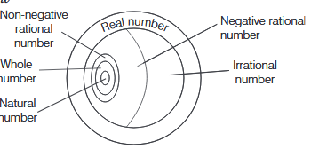

**Cardinality**

If S = { ∅, {∅}, {∅,{∅}} },

If S = ∅,

If S = {3,3,3,3,3}

Draw the Venn diagrams to illustrate the following relationship among sets E, M and U, where E is the set of students studying English in a school, M is the set of students studying Mathematics in the same school and U is the set of all students in that school.

1. All the students who study Mathematics also study English, but some students who study English do not study Mathematics.
2. Not all students study Mathematics, but every student studying English studies Mathematics.

**Union**

Find the union of each of the following pairs of sets.

(i)A={a, e, I, o, u} B={a ,c ,d }

(ii)A={1,3,5} B={2 ,4 ,6 }

(iii)A={x :x is a natural number and1<x≤5}and B={x : x is a natural number and5<x≤10}

IfA={1 ,3 ,5 ,7,9 }and B={ 2,3 ,6 ,8 ,9 }then findA∩B.

(ii) IfA={e,f ,g }and B= φ, then findA∩B.

(iii) IfA={x: x=3n, n∈Z} andB={x:x =4n, n∈Z} then findA∩B.

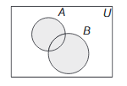AUB

Some Properties of Union of Sets

(i)AUB=BUA[commutative law]

(ii)(AUB)UC=AU(BUC)[associative law]

iii) AUφ=A[law of identity element,φis the identity of∪]

(iv)AUA=A[idempotent law]

(v)U∪A=U[law ofU]

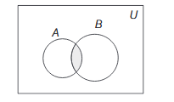A∩B

i)A∩B=B∩A[commutative law]

(ii)(A∩B)∩C=A∩(B∩C)[associative law]

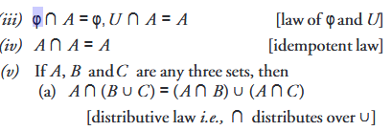



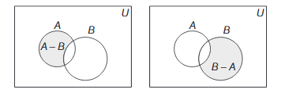

Some Properties of Intersection of Sets

(i)A-B=A∩B’

(ii)B-A=B∩A′

(iii)A-B⊆A (iv)B-ACB

**Example practice**

1. If X={a, b, c, d, e, f}and Y={ f, b, d, g, h, k}, then find X – Y and Y – X.
2. (ii) IfA={1 ,2 ,3 ,4 ,5}andB={2 ,4 ,6 }, then find A-B andB-A.

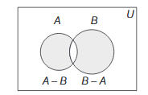(A-B)U(B-A)

**Complement Law**

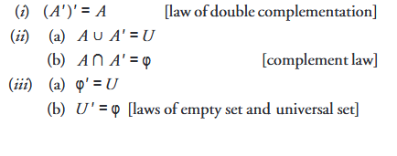

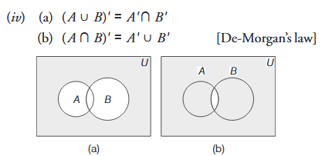

**Practice Examples**

Prove that (A∩B’)’U (B ∩C)=A’U B.

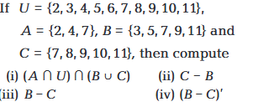

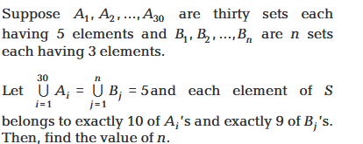

Locating elements in Venn Diagram

U = {1, 2, 3, 4, 5, 6, 7, 8, 9, 10}

A = {2, 3, 4, 5, 6}

B = {4, 6, 8}

LetS=Set of points inside the square,T=Set ofpoints inside the triangle andC=Set of points inside the circle. If the triangle and circle intersect each other and are contained in a square. Then, prove that S TCS∪∪=, by Venn diagram

**Inclusion Principle**

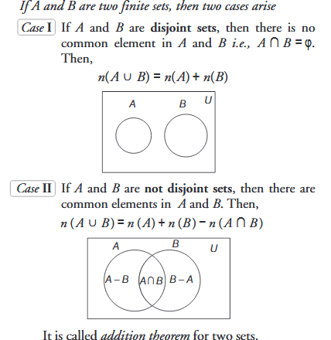

1)By using operations

**Worked Out Problems**

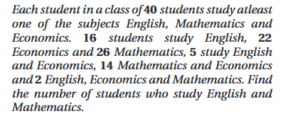

2)Using Venn Diagram

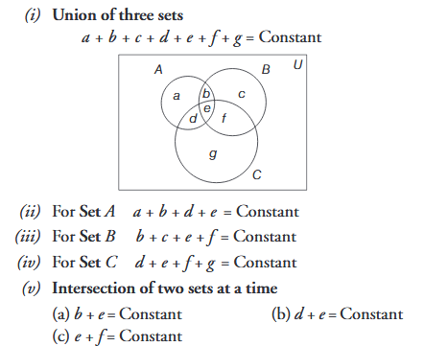

In a survey of25students, it was foundthat15had taken Maths,12had taken Physics,11had taken Chemistry,5had taken Maths andChemistry,9had taken Maths and Physics,4hadtaken Physics and Chemistry and3had taken allthe three subjects. Find the number of students thathad taken

1. only Chemistry.
2. only Maths.
3. only Physics.
4. Physics and Chemistry but not Maths.
5. Maths and Physics but not Chemistry.
6. only one of the subject.
7. atleast one of the three subjects.
8. None of the subjects.