Cs101 Project Documentation

Dangerous Dave

Team Members

1.   Hrishikesh Kulkarni 14D170009

2.   Karthik Sankaran      140110032

3.   Onkar Gadade       14D170012

4.   Mahesh Ambekar 14D110009

Table Of Contents

1. Introduction.........................................................................................3
2. Problem Statement.............................................................................4
3. Requirements......................................................................................5
4. Implementation....................................................................................6
5. Testing Strategy and Data...................................................................7
6. Discussion of System..........................................................................13
7. Future Work.........................................................................................15
8. Conclusion...........................................................................................16
9. References..........................................................................................17

Introduction

In today’s technology driven world, computer games are the things in demand. Especially the graphic intensive ones. This is because of the way in which they are designed not only tests your hand- eye coordination but also provides a virtual roller coaster of excitement.

And so, in our project of Dangerous Dave we plan to give the player a fun, anxiety and pressure filled experience which leaves you with an appetite for more at the end.

It sure does please a developer of game , when someone enjoys his creation!

Problem statement

The aim of the project is to develop a game which is fun for all ages and to challenges the users’ ability to think fast with fast  hand-eye  co-ordination.

The game consists of 2 levels in which  the player , dave , has to jump on platforms , dodge comets and aliens to make it to the door without losing any life.

There is time based scoreing on the top right corner of the corner which is continuously decreasing from a predetermined score  . Watch out!  as you have to reach the door before the score goes down to zero.

Your score will be the score when and if you complete the level .

The component of our game –

1. Brick : this fundamental unit used for walls, ceiling as well as      platforms

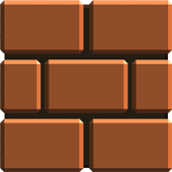

2. Dave : the main character of the game who listens to all your commands .



3. The exit door : it is the way out , the  place you have to reach in any level.



4. The comet : the comets come in randomly . they can be destroyred using bullets . and also be dodged.



5. The skull  enemies : these are moving in specific path in the game. You can destroy them with bullets but only temporarily as they can come back any time randomly.



6. The fireline : the fireline cannot be destroyed by bullets and can be avoided.



7. No. of lives :  the dave only has a single life and if you die then you again have start from level 1.

Software requirement

Allegro 5 (graphic library ) : since our game is on slighty higher graphic level , we    cant use graphics.h and hence need a more sophisticated package like allegro 5

, Codeblocks : any version of codeblocks , preferably  latest version . it can be downloaded from their sites

Implementation

1. **FUNCTIONALITY**

When the source code is run , the first thing that comes on the screen. The main menu is controlled by mouse. In the main menu , there are the following options :

1. **Play** : you can start playing the game if you click this button.

2. **Help** : if this bar is clicked , it opens the help section which contains the instructions to play as well as the game credits.

It also contains a back button to come back to main menu.

3. **Highscores** : if this tab is clicked , it opens a display which shows the top 5 highscores.

To calculate the score

  If you can’t finish the first level before the score becomes zero or die due to the comets , then you final score is 0

  If you complete the first level before the score in top right corner runs out  but die in the second level , your final score will be your first level score

 If you complete both levels successfully , your final score is the sum of the two scores as a new tally starts running in the second level.

4. Exit  : the exit tab when clicked takes you out of the game.

(B)             **JUMP :**

Jumping poses a problem here. Dave can jump only when he is standing on a surface. Also once he jumps, he cannot keep going up, he has to come down at some time. If he collides with some obstacle while jumping, he has to reverse his velocity

1. **COLLOSION DETECTION :**

Many various solid objects are present in this game. Dave himself, monsters, comets, bricks and bullets. If Dave collides with monsters or comets or even fire, he loses a life. If Dave fires a bullet, it can collide and terminate comets and monsters. Dave also cannot move through walls.

**Testing Strategy and Data**

1. Main menu screen : the first thing that comes when to compile the code

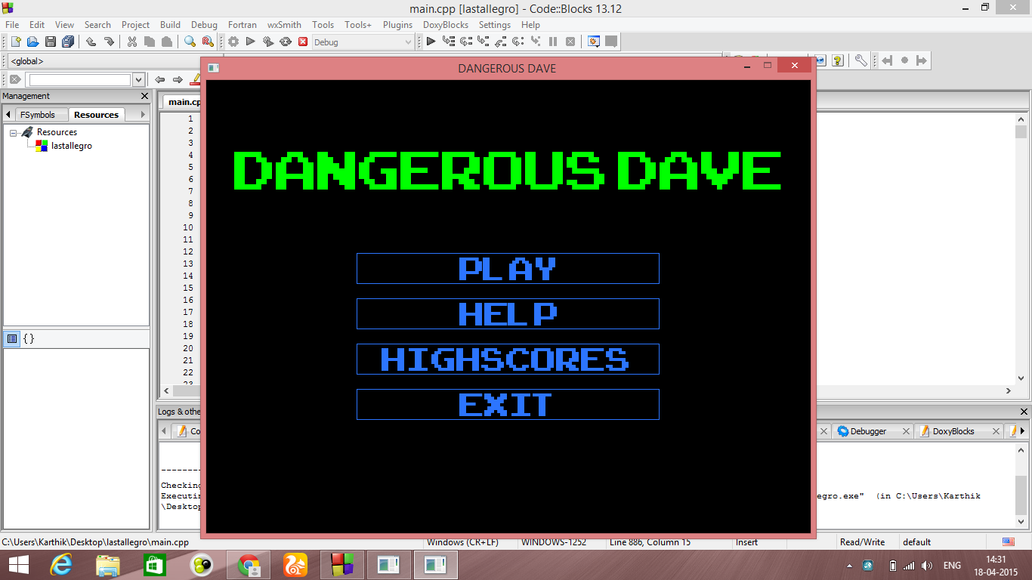

1. Help menu : contains basic instructions and credits of the game

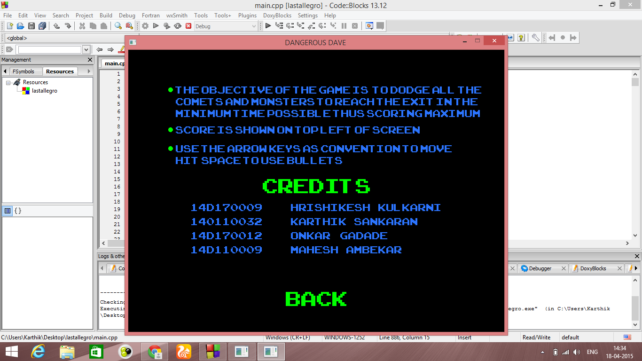

1. Game : once you click play game , level 1 starts , notice the score bar at the top right and the comets

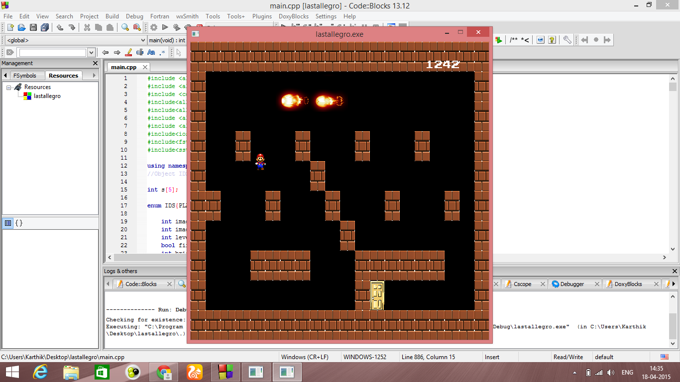

If you reach the door you go into next level, where there are monsters and fire as well

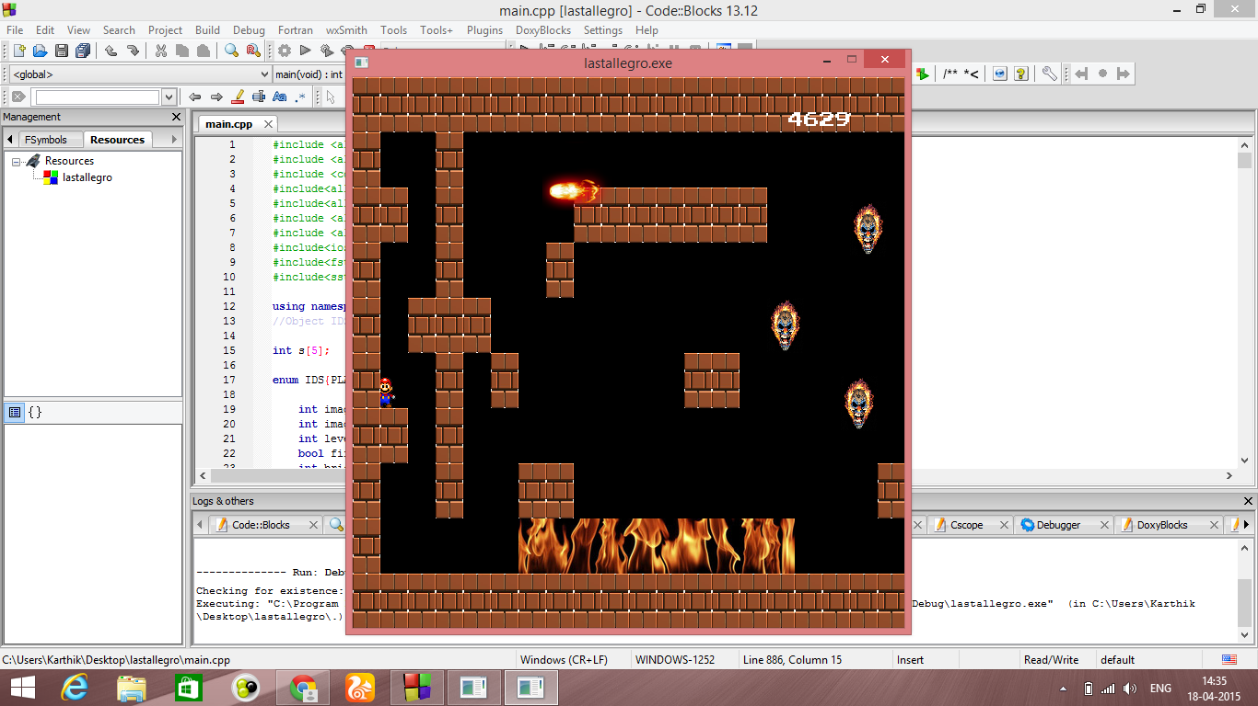

Notice the screen shifting second part of this level.

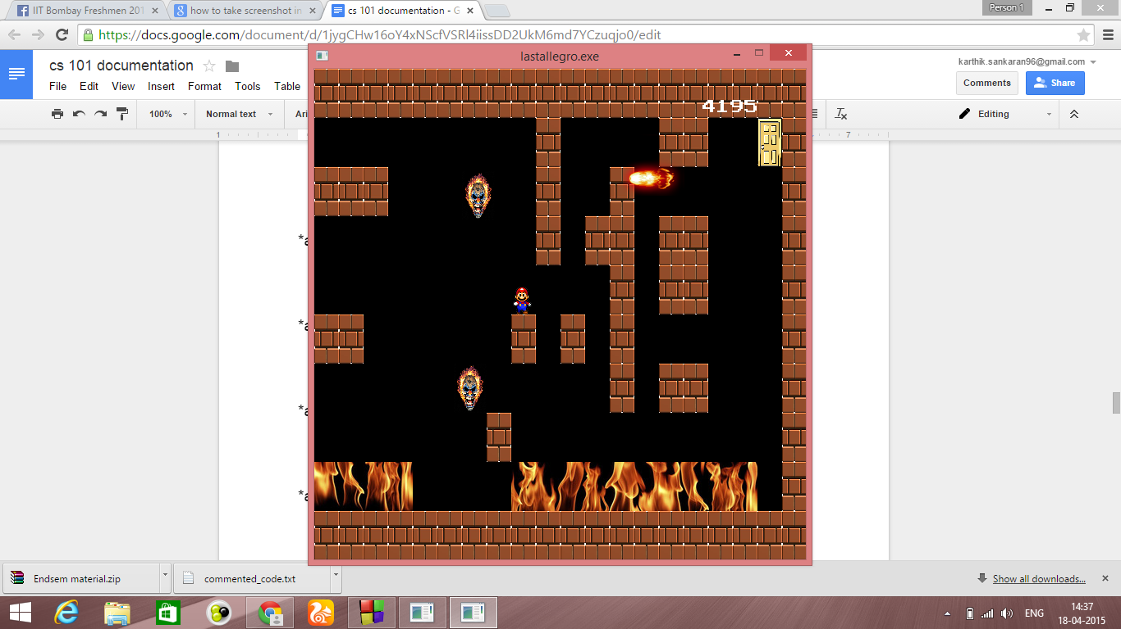

If you die anywhere in the middle , this screen pops up

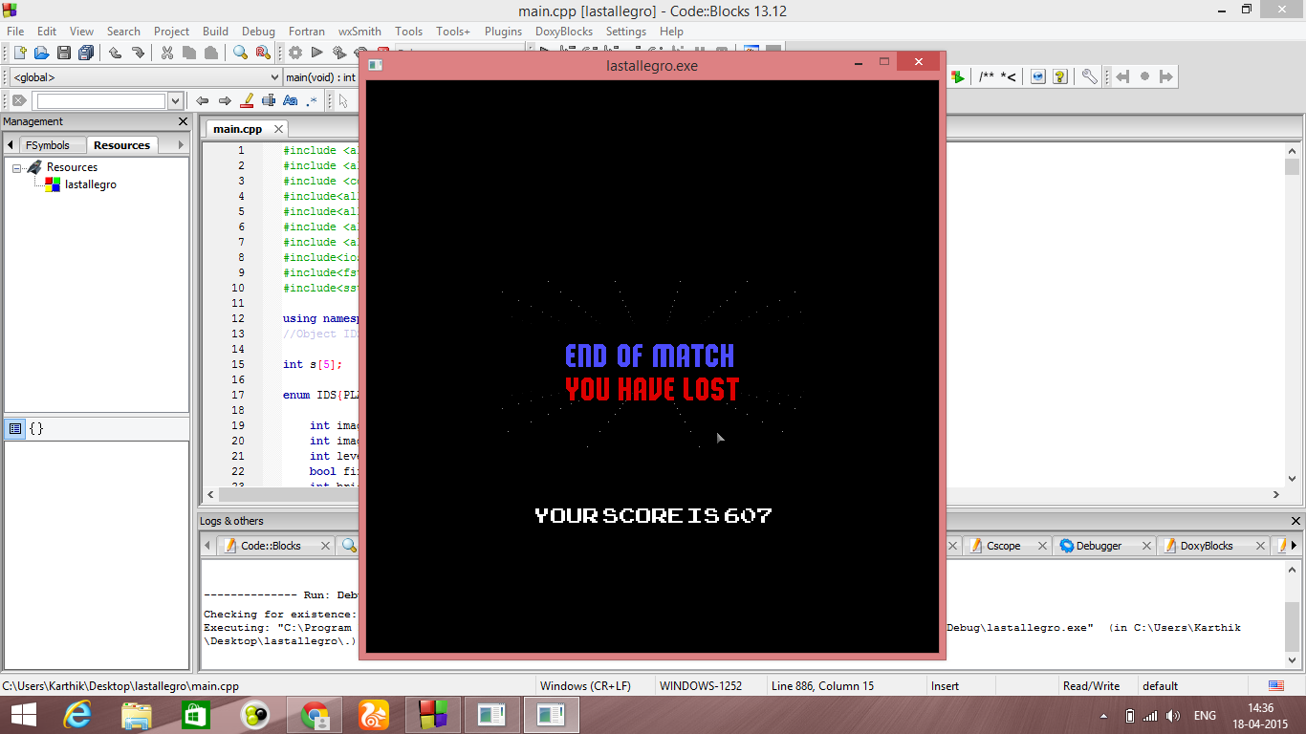

If you reach the finish by reaching the last door , this is what is shown after which you return to main menu again

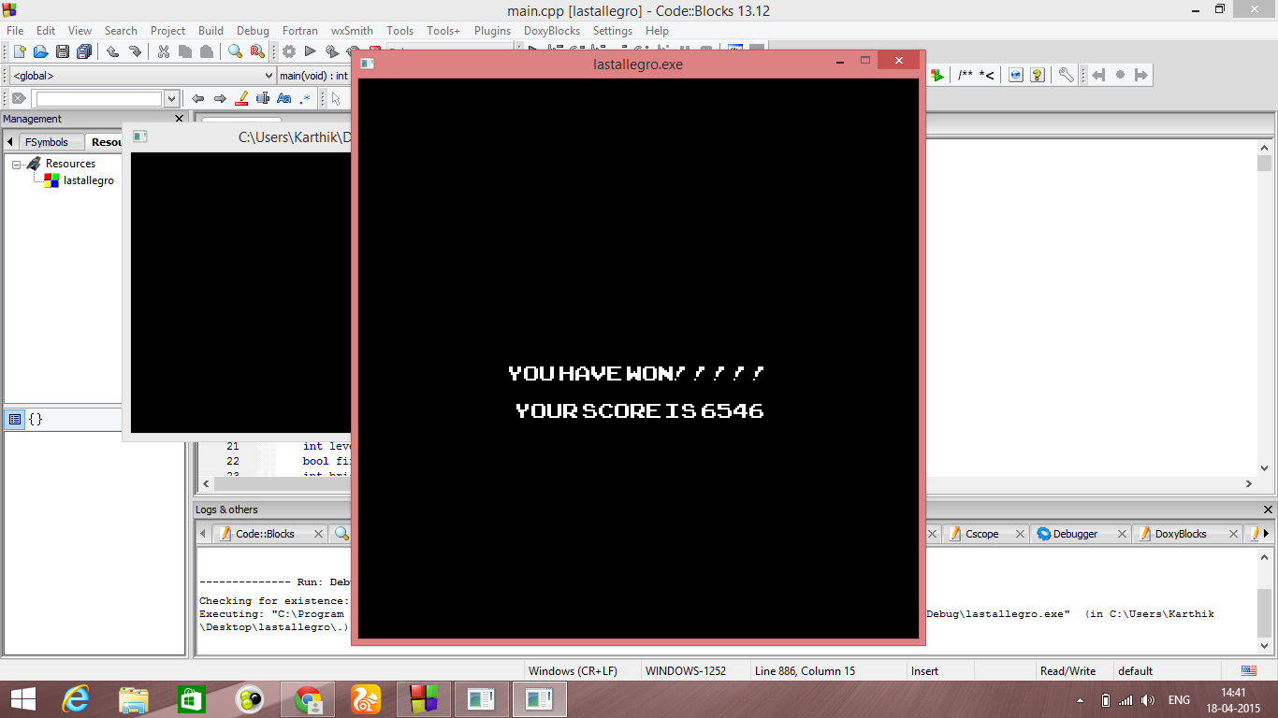

You can see your score compared with your previous score in the high score tab

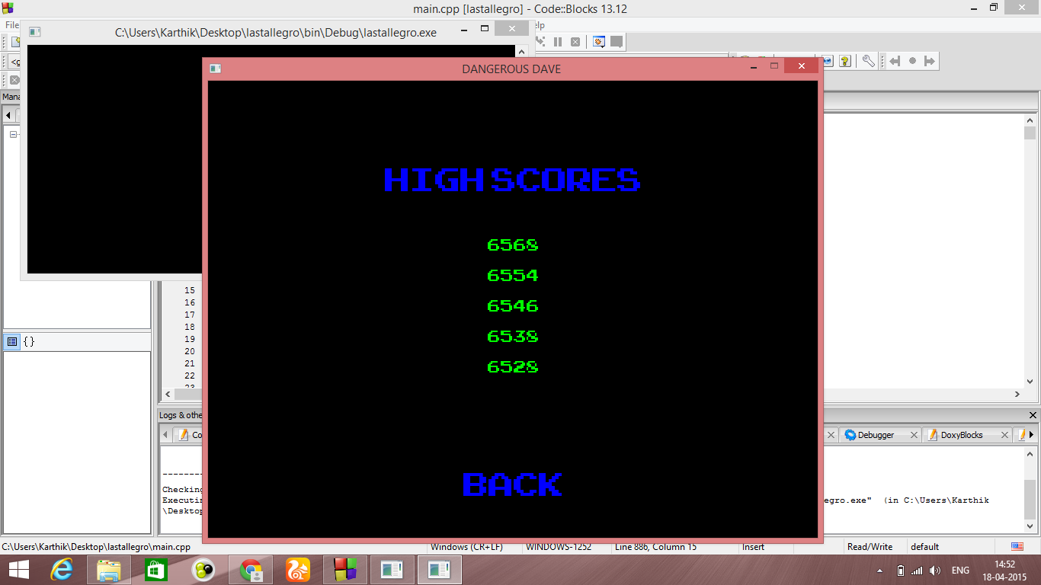

**DISCUSSION OF SYSTEM**

A) What worked according to plan :

a. The jump part :

We were able to master the jump part of the code although it was very difficult , for this a loop was run to check all the bricks and find one on which dave is standing. If it finds one, Dave can jump. Once dave jumps, he can move up for a maximum of 3 seconds(a timer is kept for this). Once the timer reaches 0 and moves into the negative region, Dave starts coming down.

b. The platform part :

The platform was also a tough task as we had to write different conditions depending from where the player approaches a given platform. If he moves right or left, Dave may confront the brick walls. He may also hit the ceilings of bricks while jumping. For all this, seperate loops are run to see if Dave hits a wall in every single frame.

c.   The moving screen :

The moving screen was a challenge which we were going to face and we knew about it from the beginning .We solved this issue creating bool variable named ‘firstscreen’.It has true value when the player is in the first part of level. And as soon as he reaches the end of this screen(crosses a particular x coordinate) it changes to false.And according to that we update positions of bricks, player position(start of the second screen),shift monster to back,etc. On the other hand if the player want to come to the first part of level again then he only has to come at the very start position of this screen, this will change the ‘firstscreen’ true. And this will update the similar required changes again. And hence the problem was solved.

B) What we used more than the SRS

The comets :

  We didn’t think we would include the comets in the game but after playing the game we realised that it could be made  a bit more interesting by adding the same .

Future work

This game can be taken ahead in the future to make many more interesting levels and monsters and it will surely make the game more addictive .

It can also be enhanced to enter your name with the highscore itself which will surely make it more competitive .

**FUTURE WORK**

1. In future, we plan to add more levels to the game with exciting maps.
2. We would also change the background of each level and make it more adventurous
3. Installing sound effects like when the player jumps or background music
4. Adding jetpacks so that you don’t have to jump always
5. Adding aliens which themselves shoot

**CONCLUSION**

In conclusion , we would like to thank our TA as well as professor , because this whole experience of game development has taught us a lot .

It gives immense pleasure to see someone playing the game and actually enjoying .

This project has also enabled us to expand our mind and presents us with the opportunity to develop a game whenever we want .

**REFERENCES**

1. Youtube.com – codingmadeeasy
2. [www.allegro.cc](http://www.allegro.cc)
3. [www.fixbyproximity.com](http://www.fixbyproximity.com)
4. Abhiram ranade
5. C++ by sumita arora
6. https://github.com/hrishikesh268/CS-101-project-grp-no-164

THANK YOU