Software Requirements Specification

<Project Name>

<Version>

<Date>

Team No
Sl.No | Name | USN#

Revision History

Date | Description | Author | Approver | Comments
<date> | <Version 1> | <Your Name> | <Approver’s Name> | <First Revision>

Table of Contents

Revision History i
Document Approval i
1. Introduction 1
1.1 Purpose 1
1.2 Scope 1
1.3 Definitions, Acronyms, and Abbreviations 1
2. General Description 1
2.1 Product Perspective 1
2.2 Product Features 3
2.3 User Characteristics 4
2.4 Operating Environment 4
2.5 General Constraints 5
2.6 Assumptions and Dependencies 5
2.7 Documentation 5
3. Specific Requirements 5
3.1 Functional Requirements 6
3.2 Non-Functional Requirements 6
3.3 External Interface Requirements 6
3.3.1 User Interfaces 6
3.3.2 Hardware and Software in terms of how they would interact or how they would be executed 6
3.3.3 Software Interfaces 6
4 Appendix A: Glossary 7

1. Introduction
The introduction to the Software Requirement Specification (SRS) document should provide an overview of the complete SRS document.
While writing this document please remember that this document should contain all of the information needed by a software engineer to adequately Architect, design and implement the software product described by the requirements listed in this document. (Note: the following subsection annotates are largely taken from the IEEE Guide to SRS).

1.1 Purpose and Intended Audience
What is the purpose of this SRS and the (intended) audience for which it is written?

1.2 Scope
This subsection should:
(1) Identify the software product(s) to be produced by name; for example, Host DBMS, Report Generator, etc
(2) Explain what the software product(s) will, and, if necessary, will not do
(3) Describe the application of the software being specified. As a portion of this, it should:

Eg. TimeSheetManager is a web-based application that will allow users to manage their timesheets and leave through an intuitive, easy-to-use interface. The system will also allow reports on that data to be easily generated, printed or exported.
This will not have support for running on a Mobile (Android/ios devices)

1.3 Definitions, Acronyms, and Abbreviations
This subsection should provide the definitions of all terms, acronyms, and abbreviations required to properly interpret the SRS. This information may be provided by reference to one or more appendixes in the SRS or by reference to other documents.

Eg. TSM – Time Sheet Manager

2. General Description
This section of the SRS should describe the general factors that affect 'the product and its requirements. It should be made clear that this section does not state specific requirements; it only makes those requirements easier to understand.

2.1 Product Perspective
This subsection of the SRS puts the product into perspective with other related products or
Projects. This also provides big picture diagram of the product keeping both the structure and the high level (mostly but not limited to external) interactions. This is more of the background

Eg.
TSM is a new system that replaces the current system hosted on Strictly Business servers for managing timesheets and leave time. The context diagram in Figure 1 illustrates the external entities and system interfaces. The system is expected to evolve over at least three releases, ultimately allowing for complete streamlining of the payroll process, mobile phone support

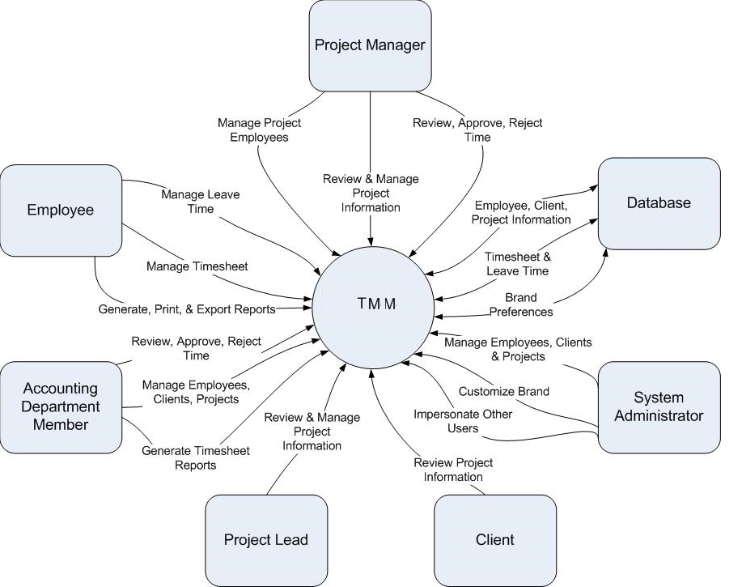

Figure 1

Context diagram for TMM.
Note: Project Manager, Project Lead, and Accounting Department Member are all specialized forms of Employee and have access to all Employee actions in addition to their own specialized actions. System Administrators have access to all actions within the system in addition to their own specialized actions.

2.2 Product Features
Eg.

FE-1: Data and application hosting on Google Apps
FE-2: Log and submit time spent on projects and clients
FE-3: Manage leave time
FE-4: Generate, print and export reports
FE-5: Employee management
FE-6: Time approval and rejection with notification
FE-7: Integration of Google Calendar, Mail and Talk
FE-8: Brand customization
FE-9: Time management through Android application
FE-10: Impersonate other users
FE-11: Project/Client Management

See Figure 2 for the relationship between these features. Please note that this document covers all features.

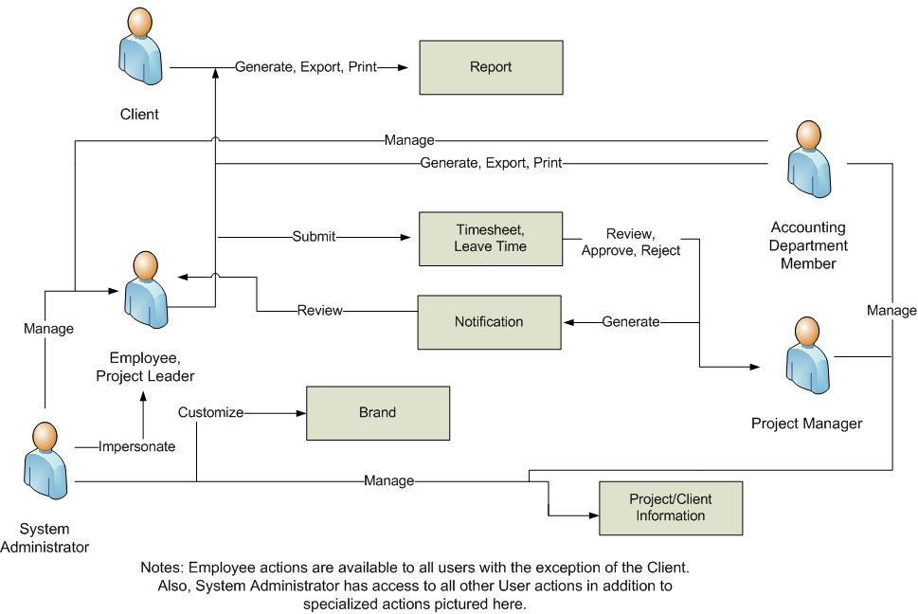
Figure 1
Major features and how they relate.

2.3 User Characteristics
This subsection of the SRS should describe those general characteristics of the eventual users of the product that will affect the specific requirements in other words this describes the characteristics of whoever is going to use this product/result of the project.

Eg:
Employee (favored) | The Employee is the person or people who work for the business using TMM and need to log time spent on clients/projects and manage leave. They will also use the new system to manage company email, schedule business meetings in the calendar, and communicate with other employees through instant messenger. Some might have to be trained to use the new system. Employees will have the ability to generate reports associated with their own work only.
Project Manager (favored) | A Project Manager is a special employee or group of employees which are in charge of managing a particular project. Project Managers will use the new system in the same way as a regular user, but will also need the ability to view project status and approve/reject timesheets. Project Managers will also need the ability to manage employees associated with their projects as well. Project Managers will have the ability to generate reports associated with their own work as well as the projects which they manage.
Project Lead | A Project Lead is a special employee or group of employees who are the lead on a particular project or projects. They will have the ability to approve/reject time in the event that the Project Manager is unable to do so. Project Leads, like Project Managers, will have the ability to generate reports associated with their own work as well as the projects which they are leading.
System Administrator | The Administrator is the person or people who will have any and all the privileges of all other user types. They will be able to impersonate other employees within the system. They will also have the authority to edit the branding and manage/generate reports regarding all projects/employees.
Accounting Department Member | The Accounting Department Member is the person or group of people that will be in charge of all payroll activities. They will need to have the ability to generate timesheet reports.
Client | The client is the person or people who are employing the talents of the business using TMM. They will use the new system to view the remaining time and status reports associated with all their current project(s).

2.4 Operating Environment
OE-1: | System is not dependent on geographical areas.
OE-2: | System shall operate in newest versions of all web browsers.
OE-3: | There should be no constraint on users being able to access the system at a given time.
OE-4: | Data is generated by online forms and stored in the Google App Engine database.
OE-5: | Continuous service is preferred, but as long as there is no data loss, minor service interruptions can be tolerated.
OE-6: | Personal data will be stored in the database, so the Google App Engine database must be secure.
OE-7: | jQuery javascript library will be needed to create the user interface for the system.

2.5 Constraints
This subsection of the SRS should provide a general description of any other items that will
limit the developer’s options for designing the system.
This could include Design and Implementation Constraints too.
Eg.
CO-1: | All data shall be stored on Google App Engine.
CO-2: | User interface shall be composed using jQuery javascript library.

2.6 Assumptions and Dependencies
This subsection of the SRS should list each of the factors that affect the requirements stated in the SRS. These factors are not design constraints on the software but are, rather, any changes to them that can affect the requirements in the SRS.
Eg an assumption might be that a specific operating system will be available on the hardware designated for the software product. If, in fact, the operating system is not available, the SRS would then have to change accordingly.
AS-1: | No more than 500 MB of data stored on Google App Engine.
AS-2: | No more than 5 million page views monthly.
AS-3: | Users have a Google Account with which they can login.
AS-4: | Users have javascript enabled.
DE-1: | Free Google App Engine account.
DE-2: | jQuery javascript library (for user interface).

2.7 Documentation
Eg. No user documentation information at this time.

3. Specific Requirements
This will be the largest and most important section of the SRS. The customer requirements will be embodied within Section 2, but this section will give the D-requirements that are used to guide the project’s software design, implementation, and testing.

Each requirement in this section should be:
- Correct
- Traceable (both forward and backward to prior/future artifacts)
- Unambiguous
- Verifiable (i.e., testable)
- Prioritized (with respect to importance and/or stability)
- Complete
- Consistent
- Uniquely identifiable (usually via numbering like 3.4.5.6)

Attention should be paid to the carefully organize the requirements presented in this section so that they may easily accessed and understood. Furthermore, this SRS is not the software design document, therefore one should avoid the tendency to over-constrain (and therefore design) the software project within this SRS.

All requirement will need to have an unique Identifier which will need to be traced through Architecture, Design, Implementation & Testing (Supporting Requirement Traceability Matrix)

Eg.

3.1 Functional Requirements
FR1 | Time Review | The system shall allow a user who is logged in to review their time.
FR2 | Time Review Log | The system shall allow a user who is logged in to log time.
FR3 | Time Review Submit | The system shall allow a user who is logged in to submit time.
FR4 | Time Submit Incomplete | The system shall check to see if all required information is present, and prompt the user to fill out missing data and resubmit.
FR5 | Time Submit Duplicate | The system shall copy selected time submission to new day(s).

You could add a functional description of feature expected, and its stimulus and response which can help in the specification of the requirements

3.2 Non-Functional Requirements
Non-functional requirements may exist for the following attributes. Often these requirements must be achieved at a system-wide level rather than at a unit level. State the requirements in the following sections in measurable terms (e.g., 95% of transaction shall be processed in less than a second, system downtime may not exceed 1 minute per day, > 30 day MTBF value, etc) if they are relavent.

NF1
NF2… as above

These could be Performance, Reliability, Availability, Security, Maintainability, Portability, Software Quality Attributes etc.

4 External Interface Requirements

4.1 User Interfaces

Eg.

UI-1: Web application shall permit complete navigation and food item selection using the keyboard alone, in addition to using mouse and keyboard combinations.

4.2 Hardware and Software in terms of how they would interact or how they would be executed

4.2.1 Software Interfaces
Eg.
SI-1: Time Management System
SI-1.1: The time management system shall transmit data to be stored on Google App Engine.
SI-1.2: Upon completion, system will display notification to user of result of data transmission.
SI-1.3: If applicable, system will then generate notification to be displayed.

SI-2: Database - The system shall communicate with a database through a programmatic interface for the following operations:
SI-2.1: To manage employee, client, and project data.
SI-2.2: To allow a user to submit timesheets/leave time.
SI-2.3: To allow an administrator/project manager to approve/reject time.
SI-2.4: To store brand and theme preferences.

4.2.2 Hardware Interfaces
If any.

4.2.3 Communication Interfaces
CI-1: The system shall send a notification to the user to inform them of time approval or rejection.
CI-2: The system shall send an email message to confirm registration with the system.
CI-3: The system shall send a notification to inform the user of new email messages, instant messages, or calendar event invitations.

5 Appendix A: Glossary
No glossary terms available at this time.

