**Q1:** END DATE – 16 dec 2008

TOTAL DURATION – 250 Days.

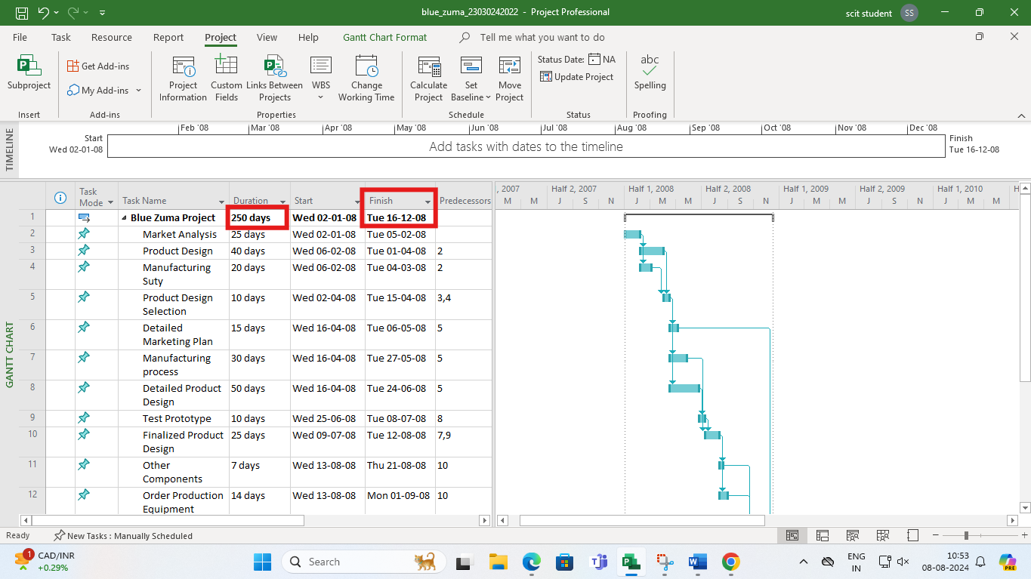

**Q2:** Critical Tasks:

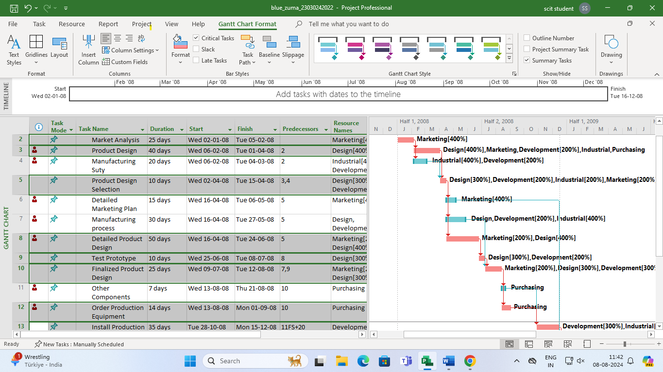

ON adding the resources it was found that some of the resources were over allocated and hence the identified departments were identified and extra required resources are added.

Q3: for slack.

Created Early and late start and finish column, then Start and Finish slack and total slack.

Detailed marketing [plan has the highest Slack.

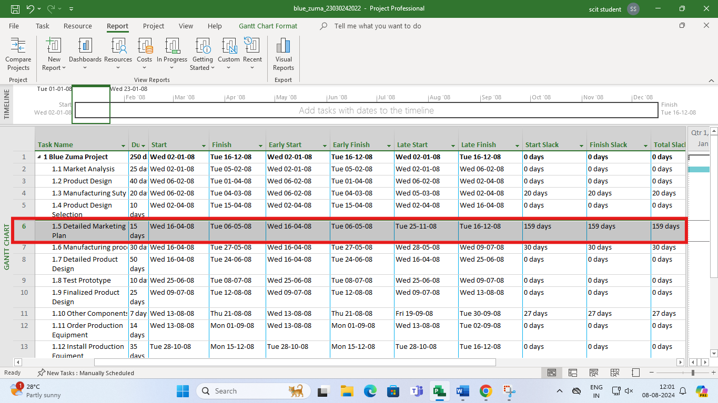

Q4: The SENSITIVITY: THE MORE N UMBER OF SLACKLS,. The less sensitive is the project

1. Switch to gant chart view
2. VIEW TAB
3. TABLES -> Schedule