Group 5 Final Project
CS559-WS1
HRISHI MEHTA, TYLER JOHNSON, DAWEI XU
2024

Results

Section 2:

BIC Scores Analysis
The Bayesian Information Criterion (BIC) is used to select the optimal model among a set of models. BIC provides a way to evaluate the model fit and complexity, penalizing models with more parameters. Lower BIC scores indicate a better model. We used BIC scores to determine the appropriate number of clusters for the data, as depicted in the following plot. When looking at the BIC plot and the silhouette plots, 5 clusters are common across the two and will be used as our optimal K.
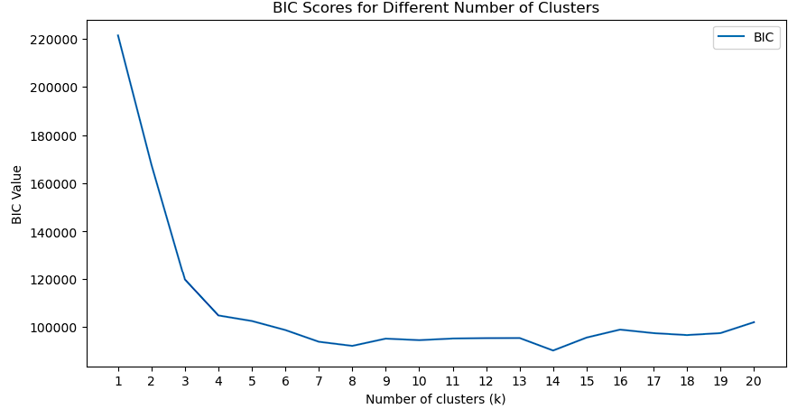
Figure 1: Bayesian Information Criterion plot indicating optimal cluster number of 4-5.
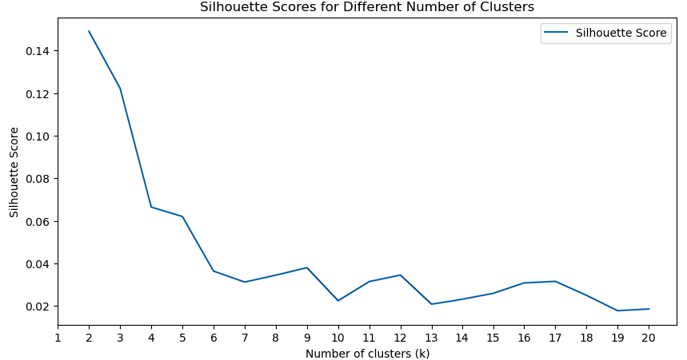
Figure 2: Silhouette Scores plot indicating optimal cluster number of 5-6.

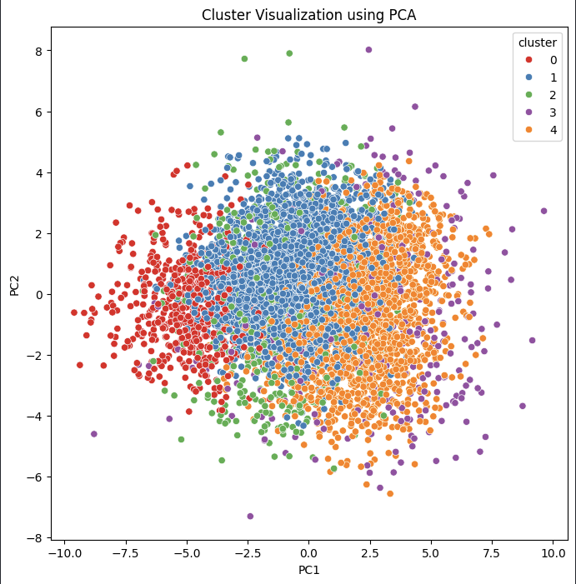
Figure 3: PCA Cluster visualization showing 5 clusters normalized and scaled around 0.

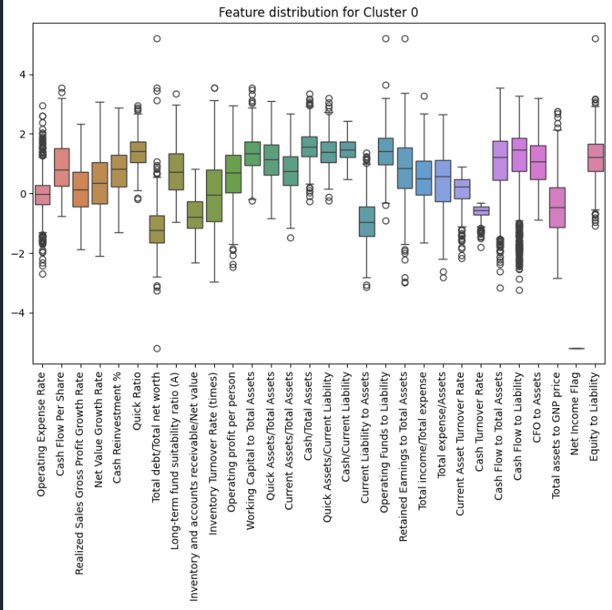
Figure 4: Feature Distribution Cluster 0.

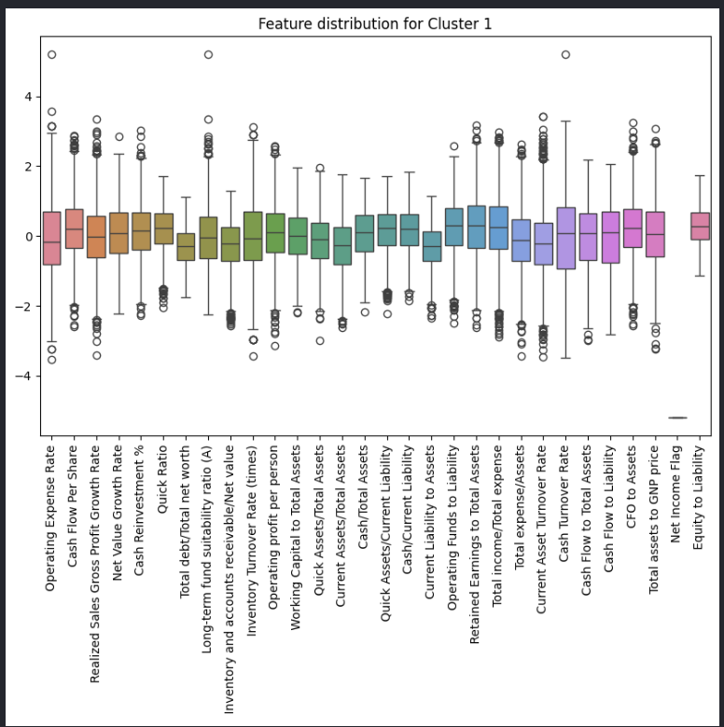
Figure 5: Feature Distribution Cluster 1.

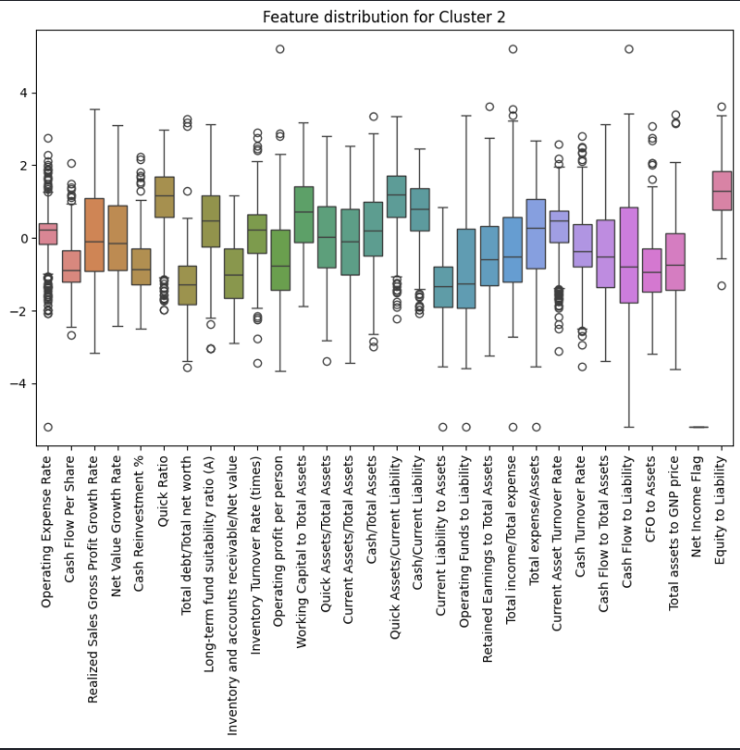
Figure 6: Feature Distribution Cluster 2.

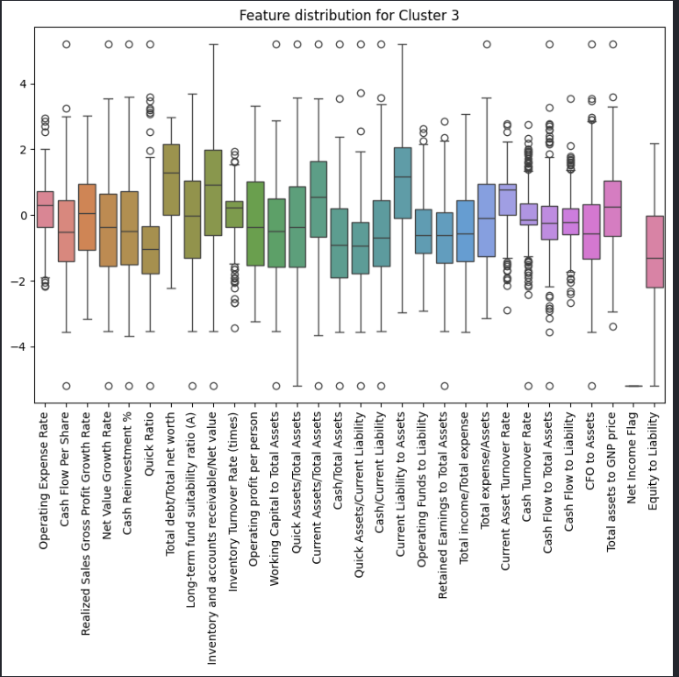
Figure 7: Feature Distribution Cluster 3.

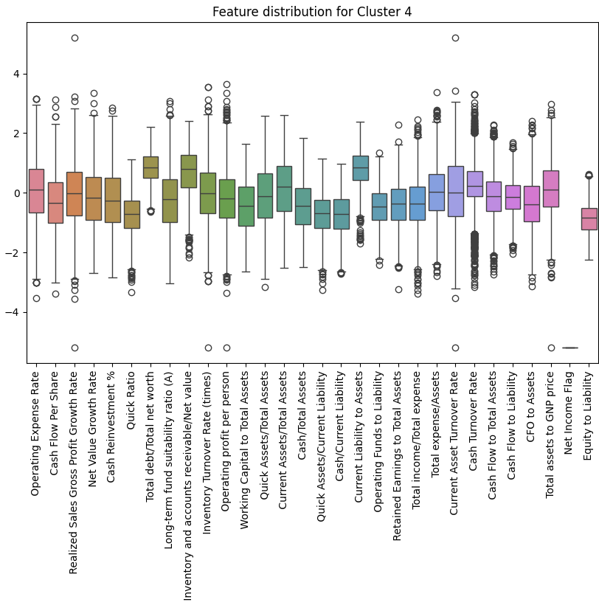
Figure 8: Feature Distribution Cluster 4.

Section 3 and 4:
Table 1: Section 3_4 Accuracy Score Results.
ID | Student | Average Accuracy score base models | accuracy score Meta model | accuracy score k-fold CV (best) | N features
0 | Dawei Xu | 0.36 [5(14)] | 0.63 [12(7)] | 0.81[54(12)] | 31
1 | Dawei Xu | 0.0 [0(1)] | 0.0 [0(1)] | - | 31
2 | Tyler Johnson | 0.0 [0(1)] | 0.0 [0(3)] | 0.81[50(12)] | 20
3 | Tyler Johnson | 0.33 [3(9)] | 0.6 [6(4)] | - | 20
4 | Hrishi Mehta | 0.56(13[10)] | 0.50[9(9)] | 0.89[34(4)] | 20
Note:
Average Accuracy Score across base models are calculated as followings: Sum up TP(TT) from all confusion matrices of base models, sum up TP+FN(TT+TF) from all confusion matrices of base models. Both got divided by number of models and rounded to closest integer to produce average numbers of TP and (TP+FN), then using equation 1:
accuracy score = TT/(TT+TF) which is TP/(TP+FN) in common notation. So, accuracy score is recall/sensitivity of our model.

Section 5:

Choosing the best model from several good options involved evaluating the performance of each model based on metrics. In our case, our K-fold GNB (Gaussian Naive Bayes) model is identified as the best choice. Gaussian Naive Bayes is chosen due to its efficiency in handling datasets where features are assumed to have a Gaussian Distribution. It is effective when features are independent or when there is a weak correlation between them. The data was split into 5 fold, which helps in validating the models effectiveness across all the different subsets. The accuracy score for this model ranged from approximately 83% to 85% across different folds with an average of about 84.23%. The recall scores, which varied more, ranged from about 74% to 85.7% with an average of about 81.3%. High recall in this context is vital as missing a potentially bankrupt company could be more detrimental than a false alarm. This model provided a 0.89 recall evaluating over 20 features. GNB is exceptionally good at performing over independent data and when features are weakly correlated. Running the GNB through 5 folds helps reduce any bias in the model by averaging across the folds and reducing the variance.
Note:
This csv: train_data_22_features.csv, is a reduced dataframe of features by manually reducing features based on our feature importance calculation in Part 2.

Section 6:

Accuracy Score Meta Model (Train) | Meta Model N-features | Accuracy Score (KFold) | K-Fold N-features
0.63 | 31 | 0.89

