SaaS Cohort Retention & Scenario Model
Project Documentation Report

Prepared by: Hrishin Debnath
Data Analytics Portfolio Project

1. Executive Summary
Every subscription company keeps a simple record: who paid, how much, each month. On its own it is just rows of numbers. This project turns that record into three clear answers: are we keeping our customers, are we keeping their revenue, and what could next year look like. It all runs inside an ordinary Excel file, with no programming and no macros, so it works even on a locked-down work computer.
A note on the data, stated up front: the numbers come from a realistic but invented dataset, not a real company, because no suitable real dataset is both detailed enough and small enough to use here. The behaviour is lifelike, so the conclusions are reasonable, but the exact figures are for illustration. Section 5 explains this fully.
The headline finding is a gap that a single number would have hidden. By the end of the first year the company has lost about three customers in every ten, yet it keeps about ninety-five cents of every revenue dollar it started with. The customers who stay spend more, and that growth almost cancels out the ones who leave. In plain terms, the product makes money well but loses customers too soon, so the most valuable thing the company can do is stop customers leaving early.

The project in one table
What we measured | What we found
Customers, months, and records | 2,000 customers, 24 months, 17,585 records
Customers still active after 12 months | about 70%
Revenue kept after 12 months | about 95%
Average revenue per customer each month | about $204
How long a customer stays, on average | about 34 months
Lifetime value of a customer | about $5,555
Next year revenue retention (worst, likely, best) | about 83% / 95% / 110%

2. What This Project Does, in Plain Words
Imagine a company that sells software on a monthly subscription, like a streaming service. Every month, some customers stay and pay, some upgrade to a bigger plan, some downgrade, and some cancel. Over two years that creates a long list of who paid what, each month.
On its own that list is just rows of numbers. This project reads the list and answers questions a business owner actually cares about:
- Of the customers who joined in a given month, how many are still here a year later?
- Even if some leave, is the money holding up, because the ones who stay are spending more?
- A typical customer is worth how much to us over their whole time with us?
- If next year is better or worse than expected, what is the realistic range we should plan for?
The result is a single Excel file that answers all four and updates itself when new data arrives.

3. Key Terms, Explained Simply
These are the only words you need. Each is explained the way you would explain it to a friend.
- Subscription revenue (MRR): the predictable money a customer pays each month. If 100 customers each pay 50 dollars, monthly revenue is 5,000 dollars.
- Cohort: a group of customers who joined in the same month. Like a school class that started in the same year, you can follow them as a group over time.
- Churn: a customer cancelling and leaving. High churn means customers are walking out the door.
- Logo retention: the share of a group of customers who are still around after some months. It counts heads, not money. If 100 joined and 70 remain after a year, logo retention is 70 percent.
- Net revenue retention (NRR): the share of the money you keep from a group, after some leave and others spend more. It counts dollars, not heads. You can lose customers and still keep most of the money if the survivors upgrade.
- ARPA: average revenue per account, the typical monthly payment per active customer.
- Lifetime value (LTV): the total profit an average customer brings over their whole time as a customer. Pay more to win customers than this, and you lose money.
- Gross margin: the share of revenue left after the direct cost of delivering the service. Here it is set at 80 percent.
- Monte Carlo simulation: running the future a thousand times with slightly different luck each time, to get a range of outcomes instead of one guess. Like rolling dice many times to learn the odds.

4. The Business Problem and Goal
Subscription companies usually report retention as one blended number, such as 85 percent. That single figure is misleading. It mixes brand-new customers with long-standing ones, hides whether newer customers behave differently, and says nothing about the revenue behind those customers. A finance team also needs to refresh the answer every month on their own, without help from engineers and without the small programs (macros) that company security often blocks.
The goal of this project was to build one tool that:
- Shows customer retention properly, group by group, instead of as a single blended average.
- Shows revenue retention, so leaders can see churn and upgrades netted against each other.
- Works out the money side: revenue per customer, how long they stay, and their lifetime value.
- Gives a realistic range for next year, not a single number, so plans account for good and bad cases.
And it had to do all of this in plain Excel, with no programming, so it survives a locked-down work laptop.

5. The Data

5.1 What the data is, and why it is invented
The starting point is a record with one row for every customer in every month they were active. When a customer cancels, their rows simply stop, and that gap is exactly how the tool detects that they left.
The data is invented on purpose. No widely available real dataset is both a proper month-by-month subscription record and small enough to work with in Excel. The common public datasets are either a single snapshot with no monthly history, which makes group-by-group analysis impossible, or they are enormous, far beyond what a spreadsheet can hold. So the data was generated from a documented set of realistic rules. For a portfolio piece this is a strength, because building believable data means understanding how real customers actually behave.

5.2 What each column means
Column | In plain words
customer_id | A label for each customer
signup_month | The month the customer joined (this sets their group)
activity_month | The month the row is about
mrr | What the customer paid that month
plan_tier | Their plan: Starter, Pro, or Enterprise
region | Where they are: NA, EMEA, APAC, or LATAM

5.3 How the data was made
Each customer is created in a joining month and then followed month by month. In any month they might stay the same, upgrade, downgrade, or cancel. The rules that shape it:
- A small chance of cancelling each month, higher in the first two months, which is how real new customers behave.
- A modest chance of upgrading, which raises their payment, and a smaller chance of downgrading.
- Joining numbers that grow gently over the two years.
The result is 17,585 records covering 2,000 customers over 24 months. The mix of plans is roughly 1,077 Starter, 732 Pro, and 191 Enterprise customers. Because the rules use a fixed starting point, the exact same data is produced every time, so the project is fully reproducible.

6. How the Project Was Built (Step by Step)
The build follows seven steps. Each is described in plain terms here. The exact code for the technical steps sits in the appendix.
- Bring the data in and tidy it. Every monthly CSV in a folder is loaded, combined, and cleaned automatically, so columns have the right type and dates are read correctly. This step is set up once and replays whenever new data arrives.
- Work out each customer's age. For every row the tool calculates how many months it has been since that customer joined. This single number, the customer's tenure, is the backbone of everything else.
- Build the retention table. Customers are grouped by joining month, and the tool counts how many are still active at each age. That produces the cohort retention table you will see as a heatmap.
- Build the revenue retention table. The same grouping is repeated, but adding up money instead of counting customers, which gives net revenue retention.
- Work out the money per customer. From average payments and the retention curve, the tool derives revenue per customer, how long customers stay, and lifetime value, overall and by plan and region.
- Run the what-if simulation. A thousand possible versions of next year are generated, each with slightly different churn and upgrade rates, to produce a range of outcomes.
- Put it on a dashboard. The key numbers and charts are gathered on one screen, with a small panel that double-checks the figures add up.

7. The Ideas Behind Each Measure

7.1 How cohort retention works
Every customer is lined up at their own starting point, month zero. The tool then asks, for each later month, how many of that group are still active, as a share of where they started. Lining everyone up this way removes the distortion of mixing new and old customers, so you can fairly compare a group that joined recently with one that joined a year ago.

7.2 How net revenue retention works
Net revenue retention follows the same groups but tracks money. Take the revenue a group brought in its first month, then look at the revenue from that same group later. If some customers left but the rest upgraded enough, the later revenue can be almost as high, or even higher.
A simple example: a group starts at 100,000 dollars of monthly revenue. Over the next year some customers cancel, which would pull revenue down to, say, 75,000. But the customers who stayed upgraded, adding 20,000 back. The group now brings 95,000 dollars, so net revenue retention is 95 percent, even though a quarter of the original customers left.

7.3 How lifetime value works
Lifetime value combines three things: how much a customer pays each month, the share of that which is profit (the margin), and how long they stay. Multiply them together and you get the total profit an average customer brings. How long they stay comes from the churn rate: if a small percentage leave each month, the average stay is simply one divided by that percentage.

7.4 How the simulation works
Nobody knows exactly what churn and upgrades will be next year, so instead of one guess the tool runs a thousand. Each run picks a slightly different churn rate and upgrade rate from a sensible spread, works out the resulting revenue retention, and records it. A thousand runs together form a range, from a cautious worst case to an optimistic best case.

8. Findings, With Visuals

8.1 Customer retention over time
The heatmap below is the cohort retention table drawn in colour. Each row is a group of customers by joining month, and each column is how many months have passed since they joined. Darker green means most customers are still active; as you move right the colour fades, showing customers gradually leaving. The blank lower-right is simply because recent groups have not existed long enough to have those later months yet.
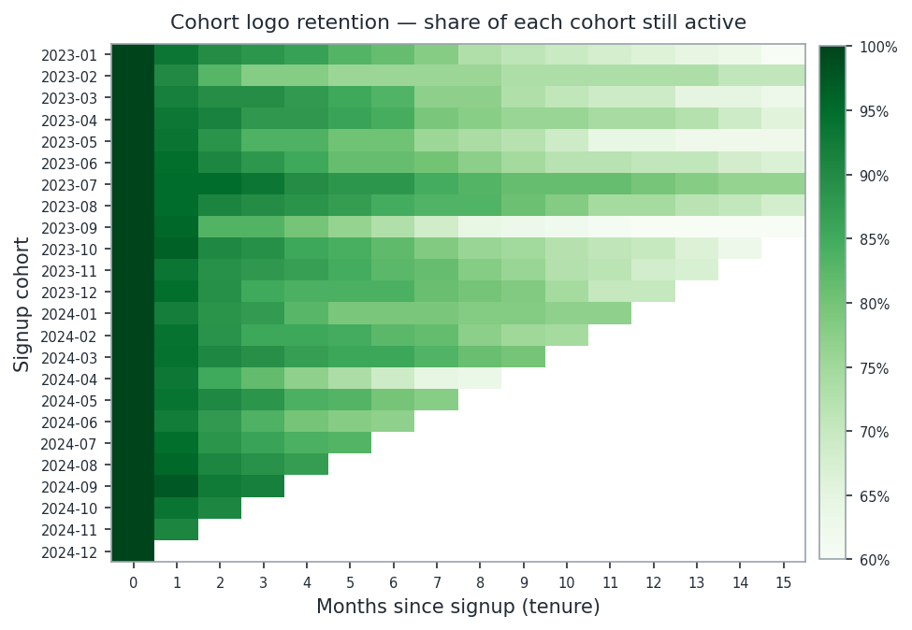
Figure 1. Cohort retention. Read each row left to right to watch a joining group shrink over time.
Across all groups, about 94% of customers are still active after one month, about 81% after six months, and about 70% after a year. The fade is steepest early, which says the company loses people soon after they join.

8.2 The gap that matters
The next chart puts customer retention and revenue retention on the same picture. The blue line is customers kept. The green line is revenue kept. The shaded space between them is the story of this whole project.
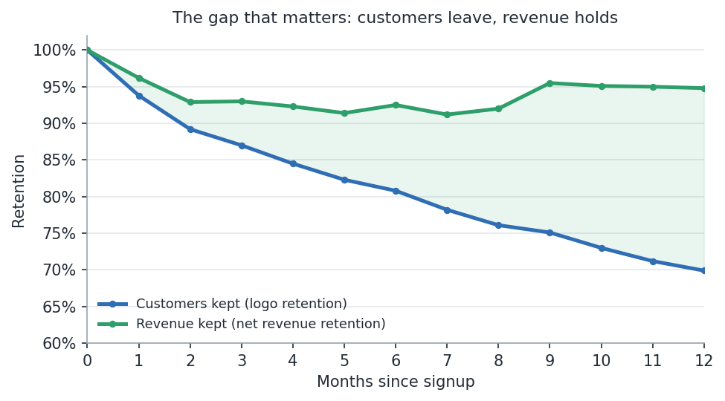
Figure 2. Customers leave (blue falls), but revenue holds up (green stays high). The gap is upgrades from the customers who stay.
Customer retention falls steadily to about 70% by month twelve, while revenue retention stays up near 95%. The customers who remain are upgrading fast enough to refill almost all the revenue lost to the ones who leave. The milestones are laid out below.
Months since joining | Customers still active | Revenue kept
1 | 94% | 96%
3 | 87% | 93%
6 | 81% | 92%
12 | 70% | 95%

8.3 The money per customer
The unit economics are healthy and fit the retention picture. A typical customer pays about $204 a month, stays about 34 months, and is worth about $5,555 in gross profit over their lifetime.
Measure | Value
Average revenue per customer per month | $204
Share of customers leaving each month | about 3%
Average time a customer stays | about 34 months
Gross margin (assumption) | 80%
Lifetime value per customer (gross) | about $5,555

Lifetime value differs sharply by plan. Enterprise customers are few but each is worth far more than a Starter customer.
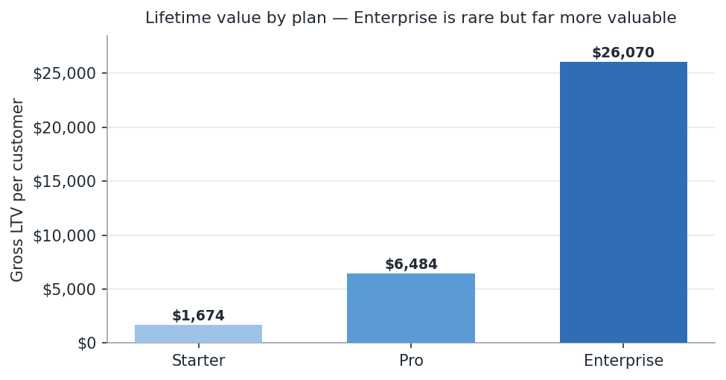
Figure 3. Lifetime value by plan. Enterprise customers are rare but highly valuable.

8.4 Where the customers are
Customers cluster in North America and EMEA, while the average payment is similar across all four regions. So region is useful for knowing where customers are, but it is not what drives revenue per customer; the plan they choose is.
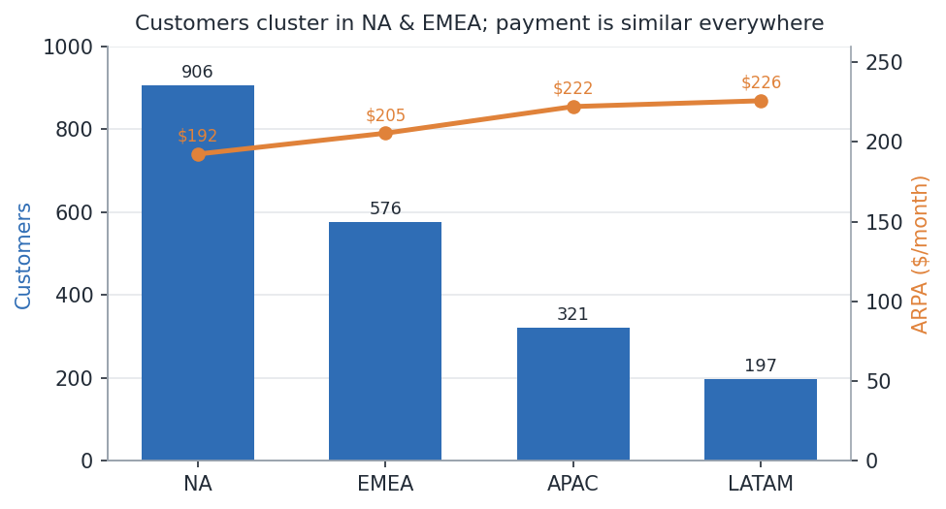
Figure 4. Customers and average payment by region.

8.5 The range for next year
The simulation produced a thousand possible outcomes for revenue retention next year. The chart shows them as a spread. Most cluster near the middle, with a realistic worst case and best case marked.
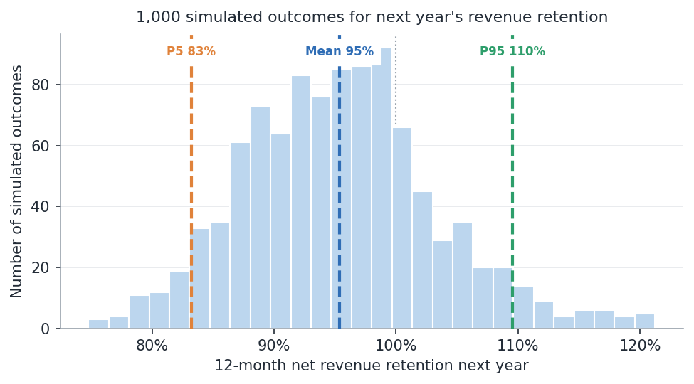
Figure 5. One thousand simulated outcomes for next year's revenue retention, with worst, average, and best cases marked.
The likely outcome sits near 95%, with a cautious worst case around 83% and an optimistic best case around 110%. About a quarter of the runs land at or above 100 percent, meaning the revenue base could grow on its own.
Outcome | Revenue kept next year
Likely (average) | about 95%
Cautious worst case (P5) | about 83%
Optimistic best case (P95) | about 110%
Chance the base grows on its own | about 25%

9. What This Means: Insights and Recommendations

9.1 The core insight
The problem to fix is early customer loss, not pricing. Revenue retention near 95% shows the product earns well and that upgrades are working. Customer retention near 70% shows people leave too soon. The most valuable action is keeping customers longer, because every customer kept also keeps their future upgrades.

9.2 Recommendations
- Focus on the first few months after a customer joins, where the drop-off is steepest, since that is where most customers are lost.
- Use the simulation to size the prize before spending. Lower the churn rate in the tool and watch the worst case rise; that shows what a retention effort is worth before any money is committed.
- Aim acquisition spending using lifetime value by plan. Enterprise customers are worth far more, so they justify more effort to win and keep.
- Start recording what it costs to win a customer, so lifetime value can be compared against acquisition cost and the picture becomes complete.

10. Limitations
- The data is invented, so the behaviour is realistic but the exact figures are for illustration.
- The cost of winning customers is not included, so lifetime value is shown before that cost.
- The simulation uses one churn rate and one upgrade rate per run, which shows the shape of outcomes rather than a precise forecast.
- Lifetime value by plan uses the overall average stay rather than a separate one for each plan.
- The simulation is built on a fixed set of random draws, so its numbers are reproducible and do not jump around.

11. Conclusion and Next Steps
The tool does what it set out to do. It turns a plain monthly record into clear views of customer retention, revenue retention, customer value, and a realistic range for the future, all in an ordinary Excel file that refreshes on its own. Its most useful message is the gap between losing customers and keeping revenue, which moves the conversation from pricing to keeping customers longer.
Sensible next steps would be to add the cost of winning customers, to look at churn separately for each plan and region, and to extend the same approach to larger datasets using a database if the volumes ever outgrow a spreadsheet.

12. Technical Appendix
This section is for technical readers. It contains the exact formulas and queries behind the project. Skipping it does not affect understanding the findings above.

A. The tools, and what each one is
- Power Query (M language): imports the raw files and cleans them on a repeatable basis.
- Power Pivot (DAX language): a data model where each metric is written once as a measure and reused anywhere.
- Dynamic array formulas: modern Excel formulas that spill results across many cells from one entry.
- Classic formulas: the shipped file uses ordinary functions such as COUNTIFS and SUMIFS so it opens with zero errors on any modern Excel.

B. Power Query: importing and cleaning the data
This query loads every monthly CSV from a folder, combines them, sets the column types, and adds the tenure column used everywhere else. FolderPath is a text parameter; point it at the repository's /ledger folder and Refresh All to update the model.
let
// FolderPath is a text parameter pointing at the folder of monthly CSVs.
Source = Folder.Files(FolderPath),
OnlyCsv = Table.SelectRows(Source, each Text.Lower([Extension]) = ".csv"),
// open and header-promote each file, so every file's own header row is consumed
Parsed = Table.AddColumn(OnlyCsv, "Data", each
Table.PromoteHeaders(
Csv.Document([Content], [Delimiter = ",", Encoding = 65001, QuoteStyle = QuoteStyle.Csv]),
[PromoteAllScalars = true]
)
),
Combined = Table.Combine(Parsed[Data]),
Typed = Table.TransformColumnTypes(Combined, {
{"customer_id", type text}, {"signup_month", type text},
{"activity_month", type text}, {"mrr", type number},
{"plan_tier", type text}, {"region", type text}
}),
AddSignup = Table.AddColumn(Typed, "signup_date", each Date.FromText([signup_month] & "-01"), type date),
AddActivity = Table.AddColumn(AddSignup, "activity_date", each Date.FromText([activity_month] & "-01"), type date),
AddTenure = Table.AddColumn(AddActivity,"tenure_months",
each (Date.Year([activity_date]) - Date.Year([signup_date])) * 12
+ (Date.Month([activity_date]) - Date.Month([signup_date])), Int64.Type)
in
AddTenure

C. Power Pivot: the DAX measures
Each measure is written once and works in any PivotTable, sliced by plan or region.
Total MRR := SUM ( Ledger[mrr] )
Active Customers := DISTINCTCOUNT ( Ledger[customer_id] )

Cohort Size :=
CALCULATE ( DISTINCTCOUNT ( Ledger[customer_id] ),
FILTER ( ALLEXCEPT ( Ledger, Ledger[signup_month] ), Ledger[tenure_months] = 0 ) )

Logo Retention % := DIVIDE ( [Active Customers], [Cohort Size] )

Starting MRR :=
CALCULATE ( [Total MRR],
FILTER ( ALLEXCEPT ( Ledger, Ledger[signup_month] ), Ledger[tenure_months] = 0 ) )

Net Revenue Retention % := DIVIDE ( [Total MRR], [Starting MRR] )
ARPA := DIVIDE ( [Total MRR], [Active Customers] )
Gross Margin := 0.80
Monthly Churn % := 1 - [Logo Retention %]
Avg Lifetime (months) := DIVIDE ( 1, [Monthly Churn %] )
LTV (gross) := [ARPA] * [Gross Margin] * [Avg Lifetime (months)]

The cohort triangle is then a PivotTable from the model with signup_month on rows, tenure_months on columns, and Net Revenue Retention % (or Logo Retention %) in values.

D. Dynamic array formulas (worksheet versions)
These use the workbook's defined names on the Data sheet, so they run in the shipped file. The Monte Carlo line draws a fresh random sample each time it recalculates.
= LET( n, 1000,
churn, mc_mean_churn + mc_sd_churn * NORM.S.INV(RANDARRAY(n)),
exp, mc_mean_exp + mc_sd_exp * NORM.S.INV(RANDARRAY(n)),
r, (1 - churn) * (1 + exp), r ^ 12 )

= SORT( UNIQUE( signupM ) ) // the list of cohorts
= FILTER( Data!A2:G17586, tier = "Enterprise" ) // slice the data live

E. Workbook structure
- Dashboard: headline numbers, the retention curve, the simulation chart, and a checks panel.
- Data: the raw record plus the tenure column.
- Assumptions: the inputs you can change (margin and the simulation settings).
- Cohort_Retention and NRR: the two triangle tables.
- LTV: revenue per customer, lifetime value, by plan and region.
- MonteCarlo: the thousand-run simulation and its summary.
- DynamicArray: the dynamic-array build of the simulation, plus the cohort list and the live data slice (LET, RANDARRAY, SORT, UNIQUE, FILTER).
- cohort triangle: the cohort retention and NRR triangles as a PivotTable built from the Power Pivot data model.

F. Reproducibility
The dataset is generated from a fixed starting point, and the simulation uses a fixed random sample, so both reproduce exactly. The shipped file was checked to contain zero formula errors, and the dashboard reconciles the customer count two independent ways. Every figure in this report was computed directly from the record and matches the workbook.

