Supplementary Material
Does Dhaka's Air Get Cleaner When the City Empties? A Nine-Year Natural Experiment Using Eid Holidays and Reference-Grade PM2.5 Data — H. Debnath
Table S1. Eid dates used in the analysis and the source of each date
Bangladesh sets Eid by local moon sighting, so it often celebrates one day after Saudi Arabia. Calendar websites such as timeanddate.com and calendarific.com give the Saudi date for Eid al-Fitr in 2016, 2018, and 2024. We corrected those three from press reports of the National Moon Sighting Committee's announcement. For Eid al-Adha, every date we checked against a press report (2018, 2021, and 2024) was right. Each listed date falls one day after the Saudi date. The other Eid al-Adha dates come from timeanddate.com and should still be spot-checked against a press report.
Holiday | Date (Bangladesh) | Source | Status
Eid al-Fitr | 7 Jul 2016 (Thu) | Anadolu Agency, 'Bangladesh blast kills 2 policemen on first day of Eid,' 7 Jul 2016; AP/Jakarta Post, 7 Jul 2016 (Eid prayers held 7 Jul) | Press
Eid al-Adha | 13 Sep 2016 (Tue) | timeanddate.com, 'Eid al-Adha in Bangladesh' (one day after Saudi Arabia, 12 Sep) | Aggregator; spot-check
Eid al-Fitr | 26 Jun 2017 (Mon) | Dhaka Tribune, 'Eid-ul-Fitr being celebrated in Bangladesh,' 26 Jun 2017 | Press
Eid al-Adha | 2 Sep 2017 (Sat) | timeanddate.com (one day after Saudi Arabia, 1 Sep) | Aggregator; spot-check
Eid al-Fitr | 16 Jun 2018 (Sat) | The Financial Express, 'Bangladesh celebrating Eid-ul-Fitr,' 16 Jun 2018 | Press
Eid al-Adha | 22 Aug 2018 (Wed) | Prothom Alo, 'Eid-ul-Azha 22 Aug,' 12 Aug 2018; Dhaka Tribune, 12 Aug 2018 | Press
Eid al-Fitr | 5 Jun 2019 (Wed) | timeanddate.com and calendarific.com both list 5 Jun; committee met Tue 4 Jun (The Financial Express, 3 Jun 2019) | Aggregator (2 sources); spot-check
Eid al-Adha | 12 Aug 2019 (Mon) | timeanddate.com (one day after Saudi Arabia, 11 Aug) | Aggregator; spot-check
Eid al-Fitr | 25 May 2020 (Mon) | UNB, 'Eid-ul-Fitr to be celebrated in Bangladesh on Monday,' 23 May 2020 | Press
Eid al-Adha | 1 Aug 2020 (Sat) | timeanddate.com (one day after Saudi Arabia, 31 Jul) | Aggregator; spot-check
Eid al-Fitr | 14 May 2021 (Fri) | UNB, 'Eid-ul-Fitr on Friday as Shawwal moon not sighted,' 12 May 2021 | Press
Eid al-Adha | 21 Jul 2021 (Wed) | UNB, 'Zilhajj moon sighted; Eid-ul-Azha on July 21,' 11 Jul 2021 | Press
Eid al-Fitr | 3 May 2022 (Tue) | UNB, 'Shawwal moon not sighted in Bangladesh, Eid on Tuesday,' 1 May 2022 | Press
Eid al-Adha | 10 Jul 2022 (Sun) | timeanddate.com (one day after Saudi Arabia, 9 Jul) | Aggregator; spot-check
Eid al-Fitr | 22 Apr 2023 (Sat) | Dhaka Tribune, 'Bangladesh to celebrate Eid-ul-Fitr Saturday,' 21 Apr 2023 | Press
Eid al-Adha | 29 Jun 2023 (Thu) | timeanddate.com (one day after Saudi Arabia, 28 Jun) | Aggregator; spot-check
Eid al-Fitr | 11 Apr 2024 (Thu) | Dhaka Tribune, 'Shawwal moon not sighted: Eid-ul-Fitr to be celebrated on Thursday,' 9 Apr 2024; The Business Standard, 9 Apr 2024 | Press
Eid al-Adha | 17 Jun 2024 (Mon) | Prothom Alo, 'Eid-ul-Azha on 17 June as moon sighted in Bangladesh,' 7 Jun 2024; Dhaka Tribune, 7 Jun 2024 | Press

Table S2. Per-holiday results (primary windows)
Eid window: days −1 to +3. Reference: days −21 to −8 and +8 to +21. Each mean is the daily-mean PM2.5 (µg/m³) averaged over the valid days in its window. A holiday counted if it had at least 4 valid Eid-window days and 14 valid reference days.
Holiday | Eid days | Eid mean | Ref. days | Ref. mean | Change (%) | Note
Eid al-Fitr 2016-07-07 | 5 | 17.7 | 28 | 31.7 | -44.1
Eid al-Adha 2016-09-13 | 5 | 31.2 | 27 | 44.5 | -29.8
Eid al-Fitr 2017-06-26 | 5 | 10.5 | 28 | 34.0 | -69.1
Eid al-Adha 2017-09-02 | 5 | 27.6 | 27 | 35.4 | -22.1
Eid al-Fitr 2018-06-16 | 4 | 38.4 | 26 | 35.4 | 8.5
Eid al-Adha 2018-08-22 | 0 | — | 13 | 40.8 | excluded | monitor outage (0 valid Eid-window days)
Eid al-Fitr 2019-06-05 | 5 | 15.0 | 28 | 44.0 | -66.0
Eid al-Adha 2019-08-12 | 5 | 17.7 | 28 | 30.3 | -41.6
Eid al-Fitr 2020-05-25 | 1 | 25.8 | 28 | 45.7 | excluded | only 1 valid Eid-window day
Eid al-Adha 2020-08-01 | 5 | 28.2 | 27 | 30.4 | -7.4
Eid al-Fitr 2021-05-14 | 5 | 34.3 | 28 | 64.9 | -47.2
Eid al-Adha 2021-07-21 | 5 | 16.1 | 28 | 32.0 | -49.9
Eid al-Fitr 2022-05-03 | 5 | 51.3 | 23 | 58.7 | -12.6
Eid al-Adha 2022-07-10 | 5 | 27.9 | 19 | 45.4 | -38.6
Eid al-Fitr 2023-04-22 | 5 | 55.3 | 28 | 98.0 | -43.5
Eid al-Adha 2023-06-29 | 5 | 23.6 | 28 | 46.4 | -49.2
Eid al-Fitr 2024-04-11 | 5 | 114.6 | 28 | 73.0 | 57.0
Eid al-Adha 2024-06-17 | 5 | 29.8 | 28 | 43.4 | -31.4

Pooled over the 16 holidays: -35.8% (95% CI -47.1% to -21.9%). Mean absolute change: -13.0 µg/m³.
Figure S1. Daily PM2.5 around each analysed holiday
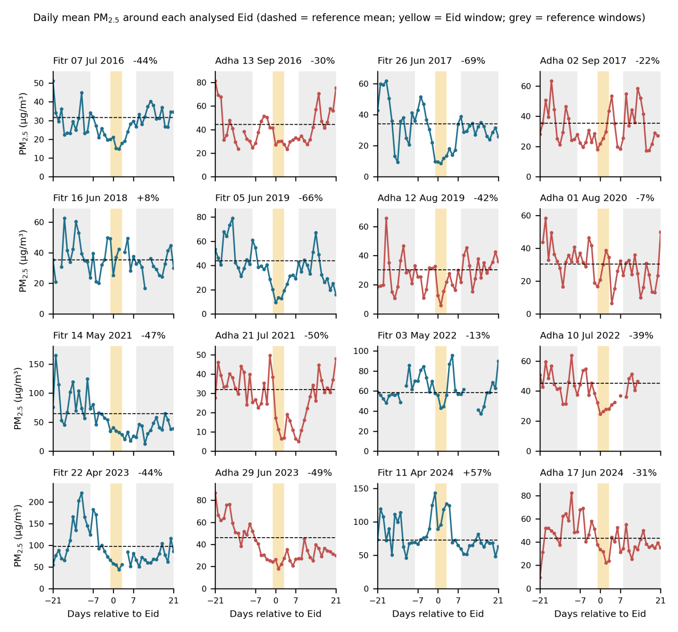
Figure S1. Daily mean PM2.5 (µg/m³) from 21 days before to 21 days after each of the 16 Eid holidays. Yellow: the Eid window (days −1 to +3). Grey: the reference windows. Dashed line: the holiday's reference mean. Each panel title gives the percentage change. Several spring holidays show a steep seasonal fall, Eid al-Fitr 2021 and 2023 for example. That is why the reference period uses equal spans before and after the holiday.
S3. Data processing notes
Source files. We used the AirNow 'Embassy Historical' hourly PM2.5 files for Dhaka (Dhaka_PM2.5_<year>_YTD.csv, 2016 to 2025), from the public GitHub archive cited in the main text. Three columns mattered: 'Date (LT)' for local time, 'Raw Conc.' in µg/m³, and 'QC Name'.
Cleaning. We dropped rows flagged 'Missing', 'Invalid', or 'Suspect' (2,342 rows), rows with a concentration at or below zero (43 rows), and 6 duplicate timestamps. That left 75,325 valid hours between 1 January 2016 and 24 March 2025. Each timestamp marks the end of its hourly averaging period, so we shifted every one back by an hour. That way each calendar day holds its own 24 hours. We computed a daily mean only for days with at least 18 valid hours, which kept 3,139 of 3,372 days.
Statistics. For each holiday we took ln(Eid-window mean / reference mean). The pooled estimate is the mean of these log ratios, converted to percent as 100·(exp(mean) − 1). The 95% CI comes from 10,000 bootstrap resamples of holidays. We added a one-sample t-test and a Wilcoxon signed-rank test on the log ratios, and a Mann-Whitney U test for Eid al-Fitr against Eid al-Adha. The placebo test ran 2,000 times. Each run drew one random date per holiday-year. A date had to sit at least 28 days from any Eid, with its full ±21-day span inside the record. The run then applied the same windows and inclusion rules. For the hourly profile, each hour is a percentage of its holiday's reference mean, averaged over Eid-window days (79 days) and reference days (429 days). The weekend benchmark is the mean log ratio of Friday-to-Saturday against Sunday-to-Thursday daily means within each calendar month, excluding Eid-window days (107 months). Random seed 20260922.
Table S3. Weather control (2016–2020 subset, 8 holidays)
We merged independent daily weather for Dhaka airport (NOAA Global Summary of the Day, station 419230) with the daily PM2.5 series. Row 1 repeats the main result for all 16 holidays. Rows 2 to 4 use the 8 holidays in 2016 to 2020 that have valid PM2.5 and weather. The regression is a day-level ordinary least squares fit of ln(PM2.5). Its terms are an Eid-window indicator, holiday fixed effects, and five standardized weather variables. Those are mean temperature, mean wind speed, maximum wind speed, ln(1 + precipitation), and relative humidity. The reported effect is the Eid coefficient. The deweathering model is a random forest trained on reference-window days only, using weather plus day-of-year terms. It predicts each day's weather-expected PM2.5, and the effect is the pooled Eid-minus-reference residual.
Estimate | n | Change (%) | 95% CI (%) | p
All 16 holidays (main result) | 16 | -35.8 | -47.1 to -21.9 | < 0.001
8 holidays 2016–2020, raw (per-holiday) | 5 | -33.6 | -51.4 to -7.1 | 0.097
Day-level regression, no weather terms | 189 | -38.6 | -47.4 to -28.4 | < 0.001
Day-level regression, weather-adjusted | 189 | -41.8 | -49.3 to -33.3 | < 0.001
Deweathered (random forest) | 5 | -39.2 | -55.7 to -17.7 | 0.054

Weather balance (Eid window against reference, Mann-Whitney U): precipitation p = 0.9, wind speed p = 0.7, temperature p = 0.8, relative humidity p = 0.9. The Eid and reference periods cannot be told apart on any weather variable. So the equal-length before-and-after design already removes weather confounding. Adjusting for weather shifts the estimate by a few points and, if anything, strengthens it. Weather coverage in the merged 2016 to 2020 record is 70% of days. Row 2 is underpowered: requiring both PM2.5 and weather on the same day leaves only 5 holidays with enough valid days. The day-level regression in rows 3 and 4 pools all 189 window-days and is well powered.
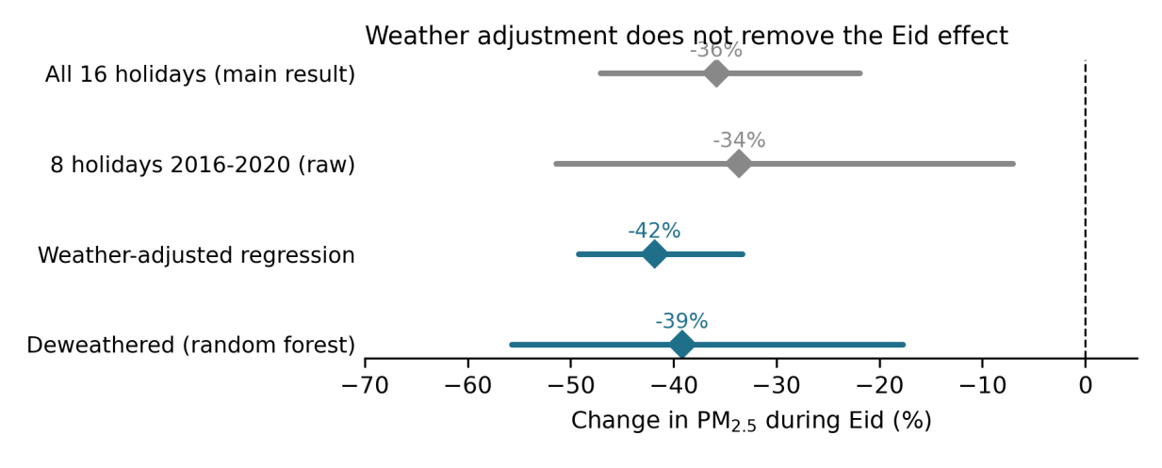
Figure S2. The Eid effect under weather adjustment (2016 to 2020). Grey: unadjusted estimates. Blue: weather-adjusted regression and random-forest deweathering. Diamonds are point estimates and bars are 95% confidence intervals. Adjusting for weather does not move the estimate toward zero.
S4. Weather-control methods (detail for Table S3)
Weather source: NOAA Global Summary of the Day (GSOD), station 419230-99999 (Dhaka), from a public GitHub mirror of the NOAA archive. The mirror ends in 2020, which sets the 2016 to 2020 window. GSOD .op files give daily mean temperature, mean dew point, mean and maximum wind speed, and precipitation in imperial units. We converted them to SI and computed relative humidity from temperature and dew point with the Magnus formula. The airport is a different microsite from the embassy monitor. But citywide weather governs dispersion and washout, and that is what the control targets. Random seed 20260922. The code is weather_control.py in the archive. The recommended extension is a full-period version using ERA5 reanalysis fields, which cover every year.
S5. Software and reproducibility
Python 3 with pandas, NumPy, SciPy, Matplotlib, and scikit-learn. The archive is at https://github.com/hrishinthecoder/dhaka-eid-pm25. It holds five scripts. eid_analysis.py does the cleaning, event study, placebo test, and sensitivity analyses. make_figures.py and make_figures_col.py draw Figures 1, 2, and S1. weather_control.py and make_figS2.py run the weather adjustment in Table S3 and draw Figure S2, using the GSOD Dhaka weather files. The archive also holds the ten raw yearly CSV files and the processed outputs. Those outputs are daily_pm25_dhaka_embassy.csv (daily means and valid-hour counts), per_event_results.csv, event_study_curve.csv, diurnal_relative.csv, diurnal_absolute.csv, results.json, and weather_control.json. Running the scripts in order regenerates every number and figure in the manuscript.
S6. Use of AI
During the preparation of this work, Anthropic’s Claude (Opus 4.8) was used to assist with idealization and initial drafting.

