# Customer Segmentation Using RFM Analysis

Project Overview:

This project uses RFM (Recency, Frequency, Monetary) analysis on a synthetic Online Retail-style dataset to segment customers into actionable groups for marketing and retention.

## Methodology

Data generation to mimic retail transactions; feature engineering for Amount; RFM aggregation per customer; quintile-based R, F, M scoring (Recency reversed); rule-driven segmentation; and business-focused visualization.

## Key Insights

|  |  |  |  |  |
| --- | --- | --- | --- | --- |
| Segment | Customers | Avg Recency (days) | Avg Frequency | Revenue Share (%) |
| At Risk | 158 | 161.9 | 5.87 | 7.42 |
| Can't Lose Them | 213 | 156.2 | 8.00 | 14.45 |
| Champions | 306 | 66.5 | 8.75 | 23.81 |
| Hibernating | 173 | 155.9 | 3.77 | 4.59 |
| Lost | 162 | 208.4 | 2.61 | 3.43 |
| Loyal Customers | 257 | 66.6 | 6.60 | 12.48 |
| Needs Attention | 346 | 113.1 | 6.90 | 19.75 |
| Others | 190 | 129.5 | 4.10 | 7.21 |
| Potential Loyalists | 97 | 71.4 | 4.66 | 4.35 |
| Promising | 53 | 86.7 | 3.19 | 1.42 |
| Recent Customers | 43 | 49.8 | 3.00 | 1.08 |

Visuals

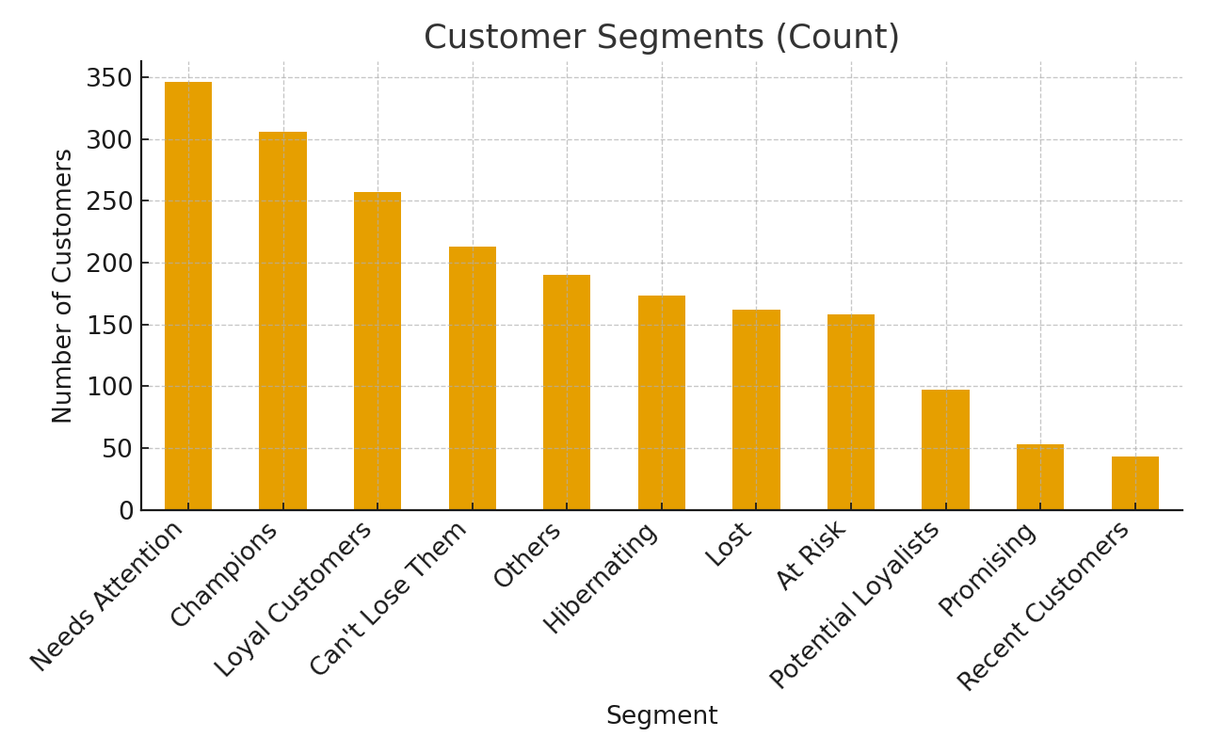

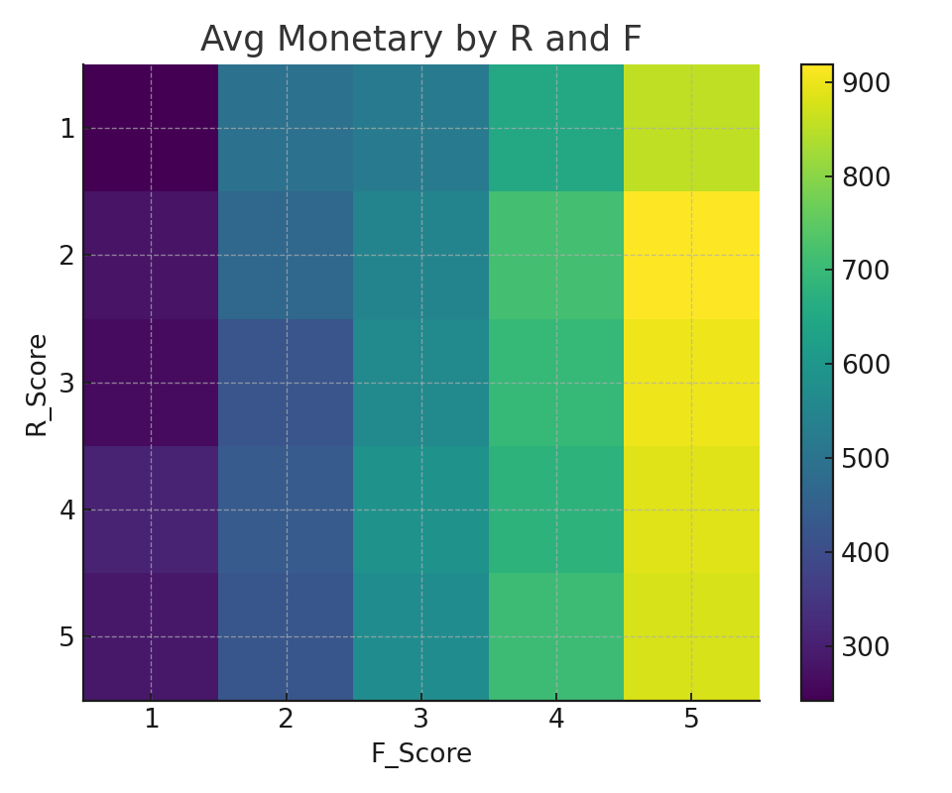

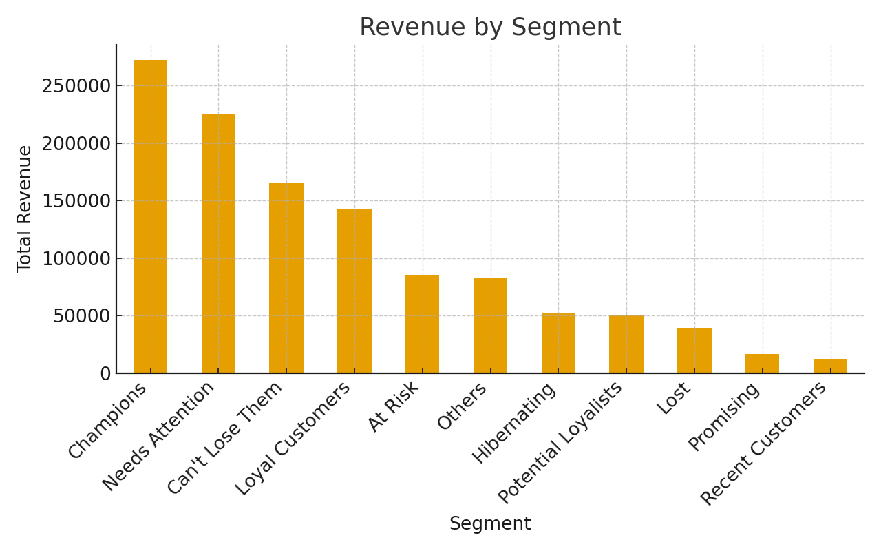

## Segment Definitions & Marketing Recommendations

* Champions
* VIP tiers & exclusives
* Early access to launches
* Premium support
* Loyal Customers
* Points/rewards
* Referral bonuses
* Bundles/subscriptions
* Potential Loyalists
* Onboarding & education
* Cross/upsell offers
* Threshold coupons
* At Risk
* Win-back promotions
* Abandonment reminders
* Feedback to reduce friction
* Can't Lose Them
* High-touch outreach
* Retention discounts
* Renewal incentives
* Hibernating
* Low-cost channels (email/SMS)
* Seasonal nudges
* Content marketing
* Lost
* Occasional check-ins
* Remove from costly ads
* Collect feedback to improve fit