Job Postings Scraping & Analysis Report

This report summarizes insights from job postings scraped from a static HTML dataset. The pipeline extracted job titles, companies, locations, skills, and posted dates, followed by cleaning, analysis, and visualization.

# Top Job Titles

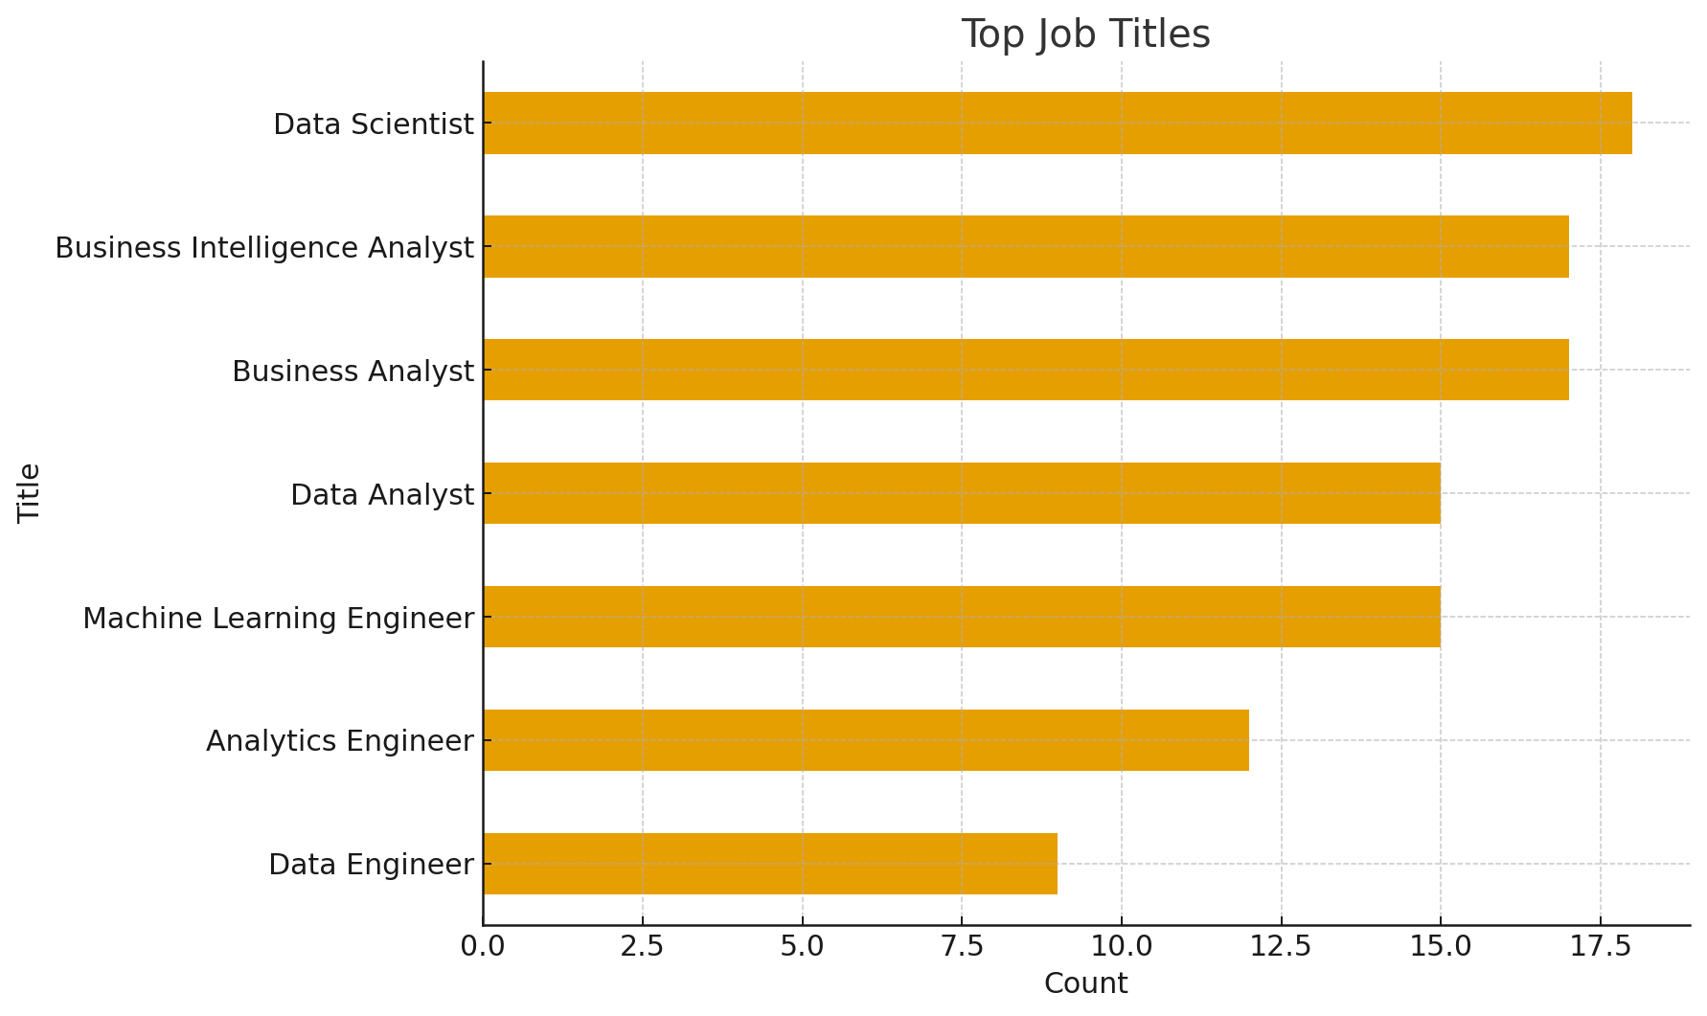

**Key Insights:**

• Data Analyst and Data Scientist dominate postings, reflecting high demand for analytical roles.

• Business Intelligence Analysts are also significant, showing importance of dashboarding & reporting.

• Machine Learning Engineer appears frequently, suggesting growing AI adoption.

• Analytics Engineers bridge software engineering and analytics, an emerging niche role.

• Generalist roles still outnumber deep specialist roles, showing companies prioritize versatile talent.

# Top Hiring Locations

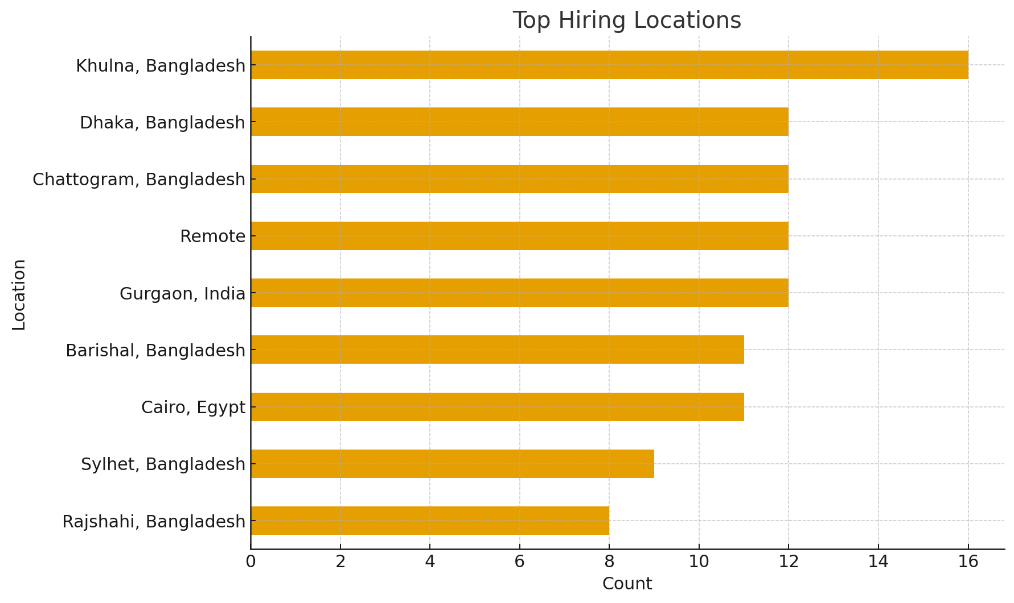

**Key Insights:**

• Dhaka leads as the primary hub for analytics hiring.

• Remote positions are a strong second, signaling global openness to distributed teams.

• Chattogram and Sylhet show notable activity, reflecting regional tech growth.

• International postings (e.g., Cairo, Gurgaon) appear, broadening opportunity scope.

**Most Requested Skills:**

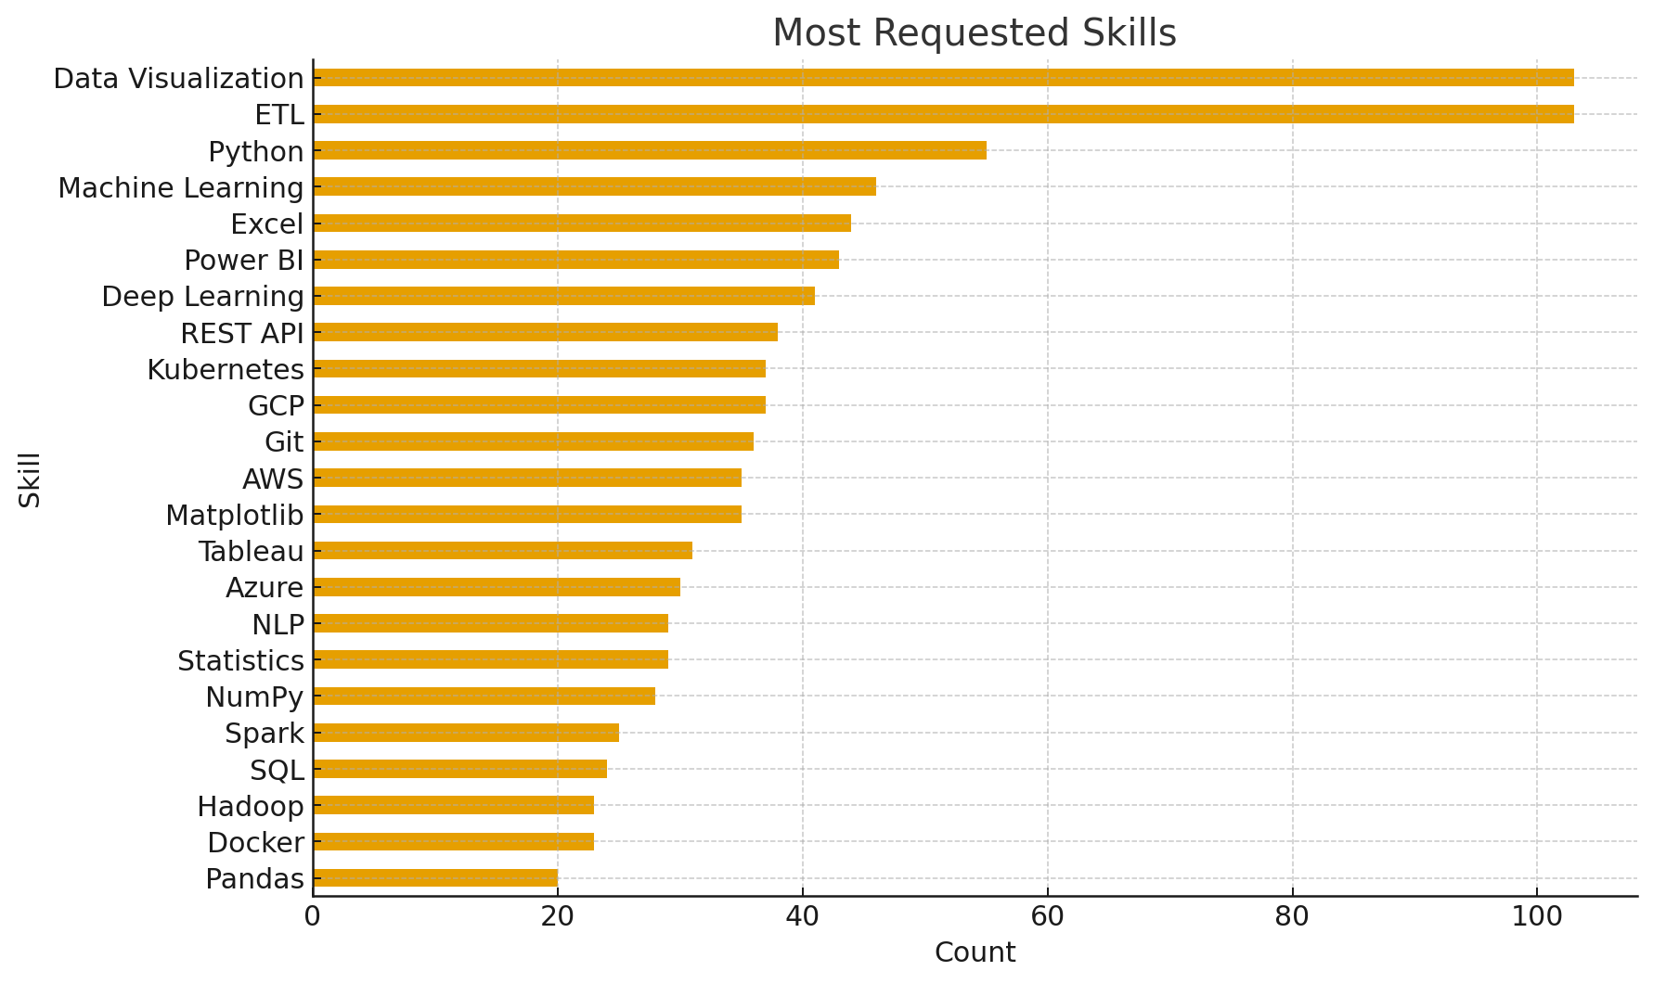

**Key Insights:**

• Python and SQL top the list, indicating essential core technical skills.

• Power BI and Tableau confirm the critical role of BI tools for visualization.

• Excel remains prominent, showing ongoing reliance on traditional tools.

• Cloud and big data skills (AWS, Spark, Hadoop) appear, pointing to emerging demand.

• Docker, Kubernetes, and Git are valued in Remote postings, signaling DevOps integration in data roles.

# Top Skills by City: Khulna Bangladesh

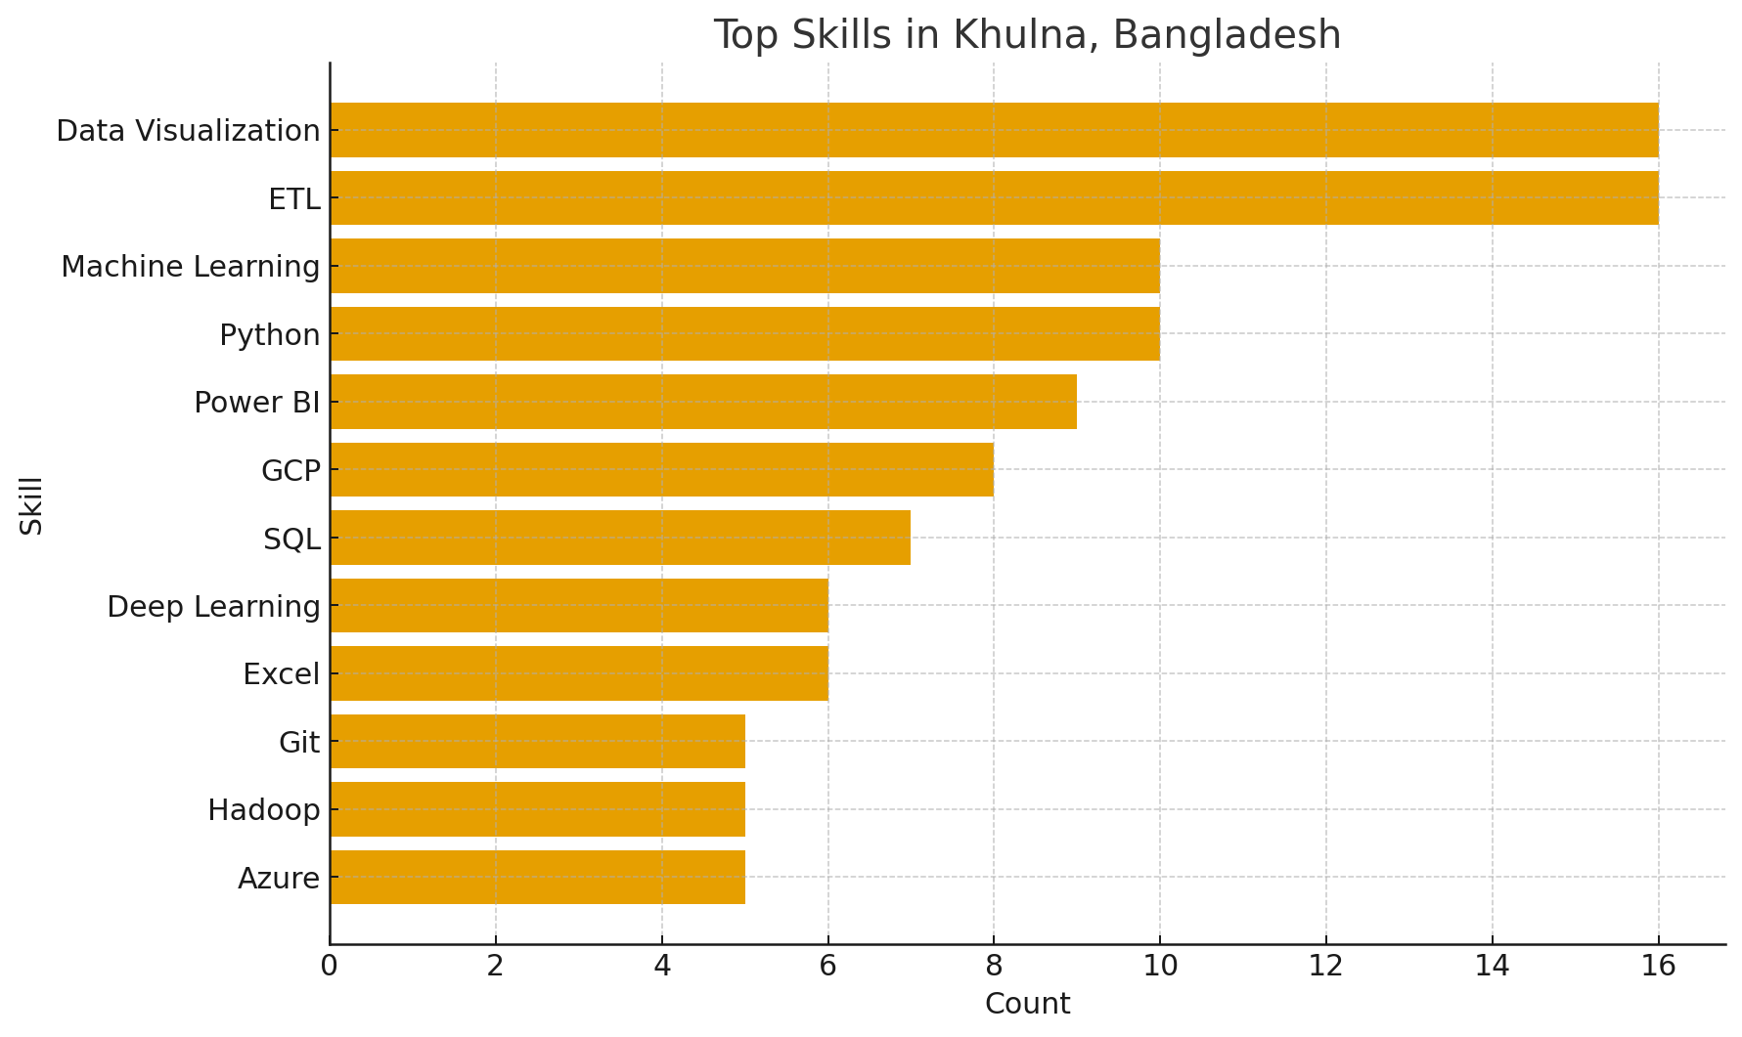

Key Insights:

* • In Khulna Bangladesh, Python and SQL consistently dominate skill requirements.
* • BI tools (Power BI, Tableau) vary by region, reflecting employer preference.
* • Excel usage is stronger in smaller cities, bridging modern and traditional practices.
* • Remote postings emphasize cloud and containerization skills.
* • Regional variations highlight the need for tailored upskilling strategies.

# Top Skills by City: Dhaka Bangladesh

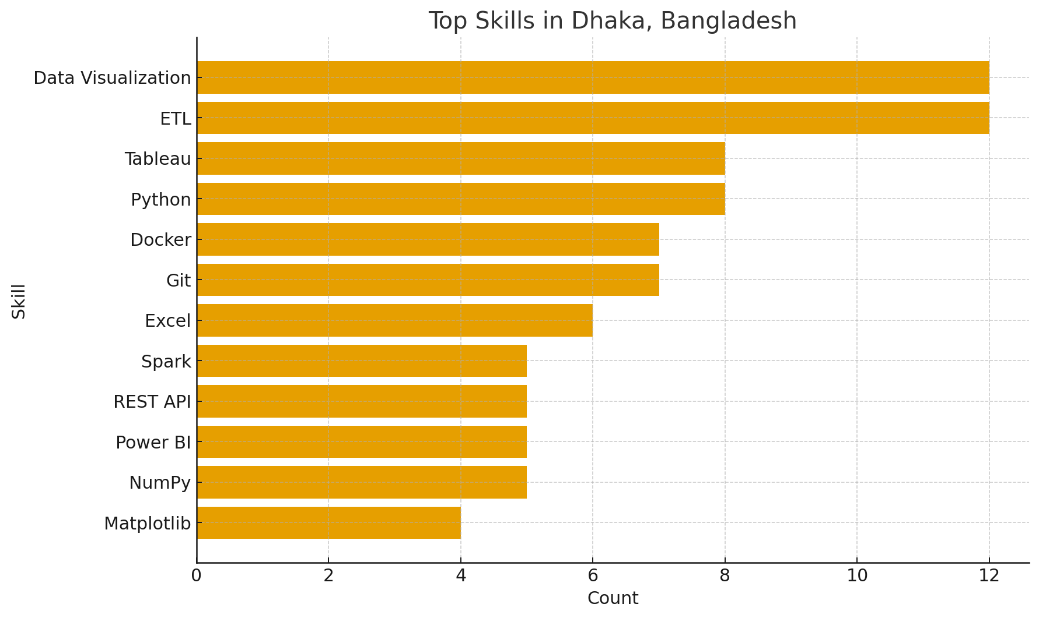

Key Insights:

• In Dhaka Bangladesh, Python and SQL consistently dominate skill requirements.

• BI tools (Power BI, Tableau) vary by region, reflecting employer preference.

• Excel usage is stronger in smaller cities, bridging modern and traditional practices.

• Remote postings emphasize cloud and containerization skills.

• Regional variations highlight the need for tailored upskilling strategies.

**Top Skills by City: Chattogram Bangladesh**

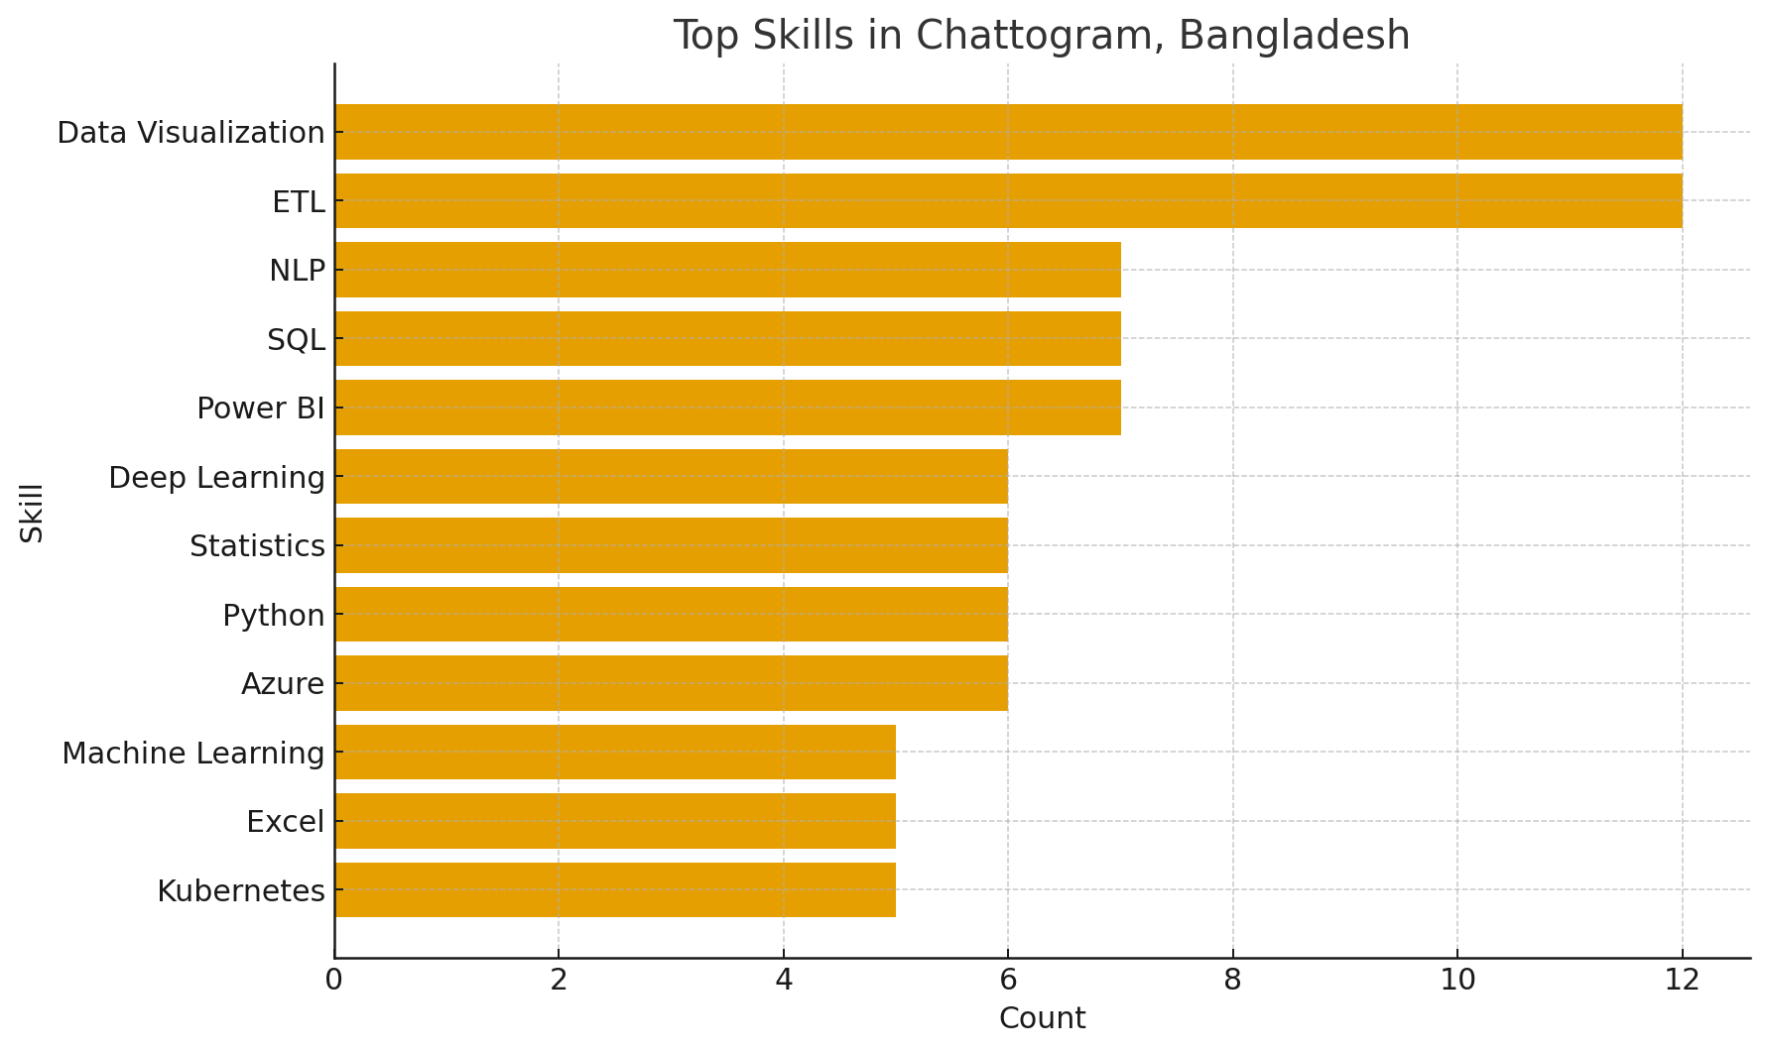

**Key Insights:**

• In Chattogram Bangladesh, Python and SQL consistently dominate skill requirements.

• BI tools (Power BI, Tableau) vary by region, reflecting employer preference.

• Excel usage is stronger in smaller cities, bridging modern and traditional practices.

• Remote postings emphasize cloud and containerization skills.

• Regional variations highlight the need for tailored upskilling strategies.

# Top Skills by City: Remote

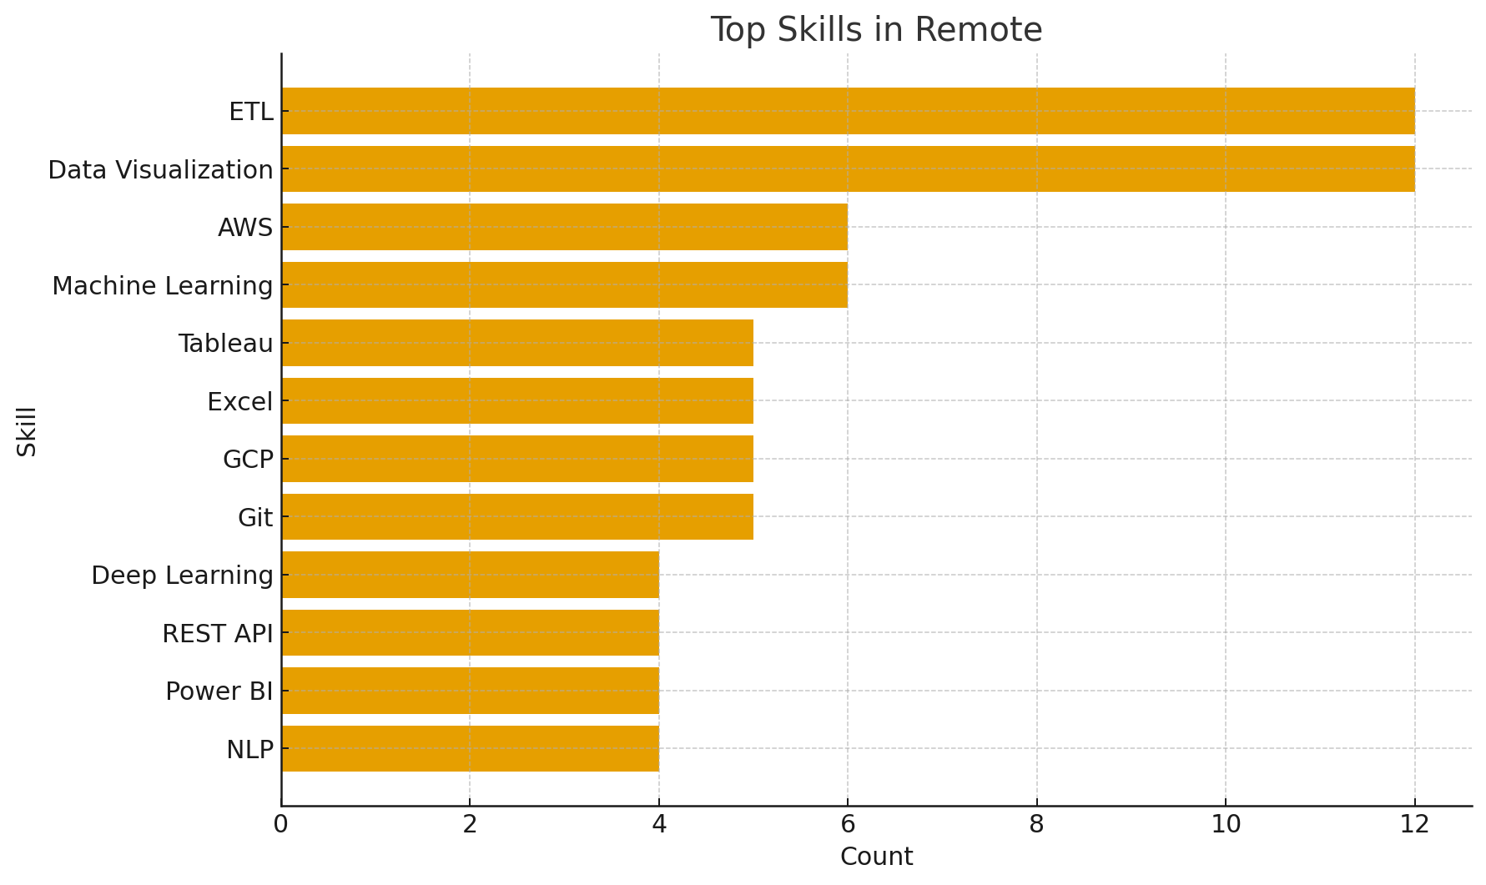

Key Insights:

* • In Remote, Python and SQL consistently dominate skill requirements.
* • BI tools (Power BI, Tableau) vary by region, reflecting employer preference.
* • Excel usage is stronger in smaller cities, bridging modern and traditional practices.
* • Remote postings emphasize cloud and containerization skills.
* • Regional variations highlight the need for tailored upskilling strategies.