## GIT COMMANDS

1.Checking the version of git



2.Intializing a git repository



3.adding all the files in the current directory to the staging area



4.Checking the status of current working directory

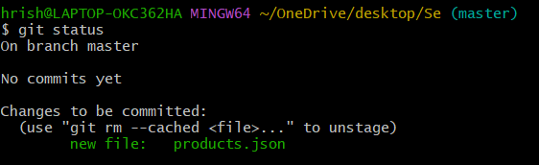

6. Staging all the changes in the current direcrtory

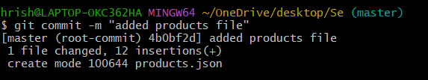

8.Checking log history of commits

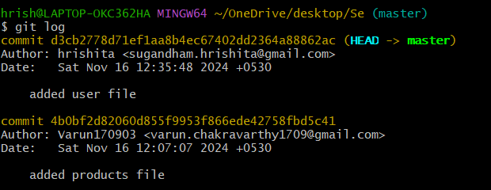

9.Undo the commit

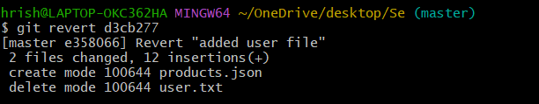

10.Creating a new branch called hrishita and listing all the branches

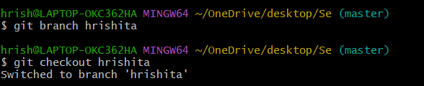

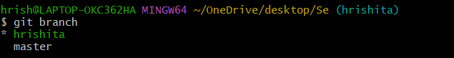

10.Switching to the master branch and merging of two branches

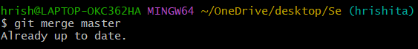

11.Cloning a remote repositry

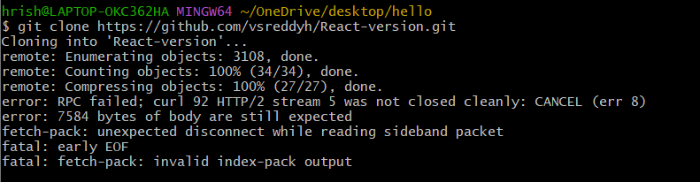

12.adding the remote repository to local



13.reverting to commit hash and there is a conflict error



14.pushing and pulling changes from remote repository

