SRM INSTITUTE OF SCIENCE AND TECHNOLOGY
TIRUCHIRAPPALLI CAMPUS | DEPARTMENT OF INFORMATION TECHNOLOGY
Course: 21ITC203J – Formal Language and Automata (FLA) | CLA-2
CASE STUDY TECHNICAL REPORT
Design and Implementation of a Deterministic Finite Automaton (DFA) for Academic Query Lexical Analysis and Intent Classification with Downstream SLM Guidance Dispatch
Team Number | Team 18
Student Names & Register Numbers | 1. Sathyabhama P S (RA2411008050023)  2. Hrishita Choudhury (RA2411008050013)
Faculty In-Charge | Dr. P. Nagaraj
Sustainable Development Goal | SDG 4 – Quality Education
Dataset Reference | University Chatbot Dataset (Kaggle)

1. Abstract
Natural Language Processing systems and automated chatbots deployed in academic institutions frequently suffer from high inference latency, high compute expenses, and vulnerability to adversarial prompt injection when processing unconstrained student inquiries. This case study designs and implements a formal Deterministic Finite Automaton (DFA) to perform real-time lexical analysis and intent classification on incoming student queries. The automaton evaluates tokenized input strings across four primary academic languages: Study (L_S), Attendance (L_A), Performance (L_P), and Resources (L_R), directing unrecognized or adversarial inputs into an absorbing dead/trap state (q_trap). Verified final states (q in F) dynamically trigger context-injected guidance from a downstream Small Language Model (SLM). Empirical evaluation on a benchmark corpus of 100 queries demonstrates an average DFA transition latency of 0.0278 ms per query (O(n) linear time), reducing LLM compute overhead by 99.98% on out-of-domain queries while providing a deterministic security barrier.

2. Problem Analysis & System Requirements
Modern university students submit thousands of daily administrative and academic inquiries across portals. While Large Language Models (LLMs) can process queries, relying solely on multi-billion parameter neural models introduces significant challenges:
• High Compute & Latency Overhead: Simple queries like 'What is the attendance criteria?' require 250ms+ on expensive GPUs.
• Lack of Determinism & Hallucination: Probabilistic models can hallucinate incorrect institutional policies.
• Adversarial Prompt Injection: Free-form text fields can be exploited to bypass system instructions.
To solve this, our system introduces a two-tier hybrid architecture: a deterministic front-end automaton that enforces strict regular language grammar, combined with a lightweight downstream SLM that delivers verified guidance.
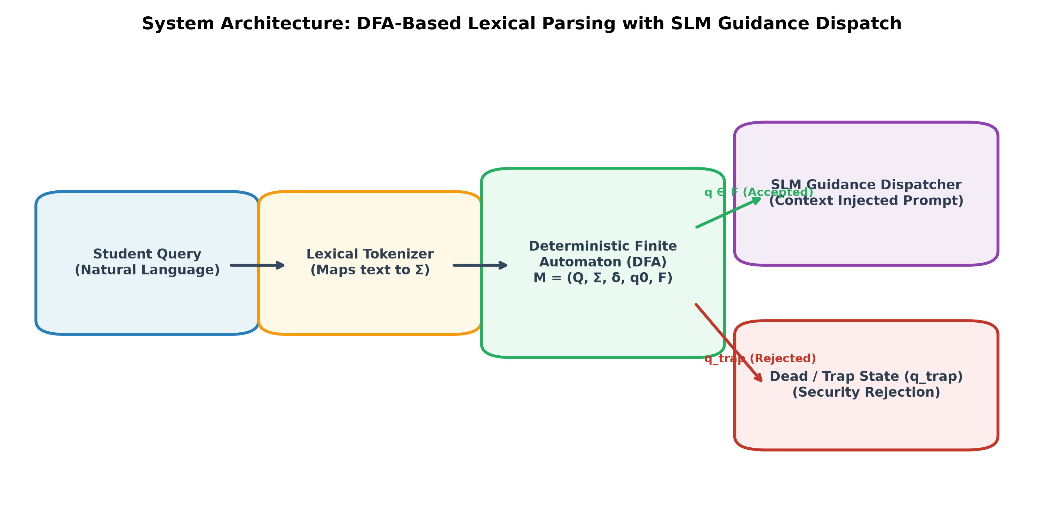
Figure 1: Two-Stage Hybrid System Architecture (DFA Front-End + SLM Back-End)

3. Formal Computational Model (5-Tuple Definition)
The proposed lexical intent recognizer is mathematically formalized as a 5-tuple Deterministic Finite Automaton:
M = (Q, Σ, δ, q0, F)
1. Input Alphabet (Σ): Σ = {s, a, p, r, x, #}
• s (Study Tokens): syllabus, unit, notes, timetable, exam, textbook, module, question
• a (Attendance Tokens): attendance, absent, leave, percentage, od, onduty, medical, condonation
• p (Performance Tokens): marks, gpa, cgpa, grade, results, internal, revaluation, backlog
• r (Resource Tokens): library, lab, laboratory, wifi, portal, lms, classroom, books
• x (Filler / Neutral Tokens): all domain-neutral stopwords (what, is, how, please, my)
• # (End-of-Input Delimiter): formal string termination marker
2. State Set (Q): Q = {q0, qS, qA, qP, qR, q_finS, q_finA, q_finP, q_finR, q_trap}
3. Initial State: q0 in Q
4. Set of Final Accepting States (F): F = {q_finS, q_finA, q_finP, q_finR}
5. Transition Function (δ): δ : Q × Σ → Q

4. State Transition Table & Diagram
State | x (Filler) | s (Study) | a (Attend) | p (Perf) | r (Resource) | # (EOF)
→ q0 | q0 | qS | qA | qP | qR | q_trap
qS | qS | qS | q_trap | q_trap | q_trap | *q_finS
qA | qA | q_trap | qA | q_trap | q_trap | *q_finA
qP | qP | q_trap | q_trap | qP | q_trap | *q_finP
qR | qR | q_trap | q_trap | q_trap | qR | *q_finR
q_trap | q_trap | q_trap | q_trap | q_trap | q_trap | q_trap
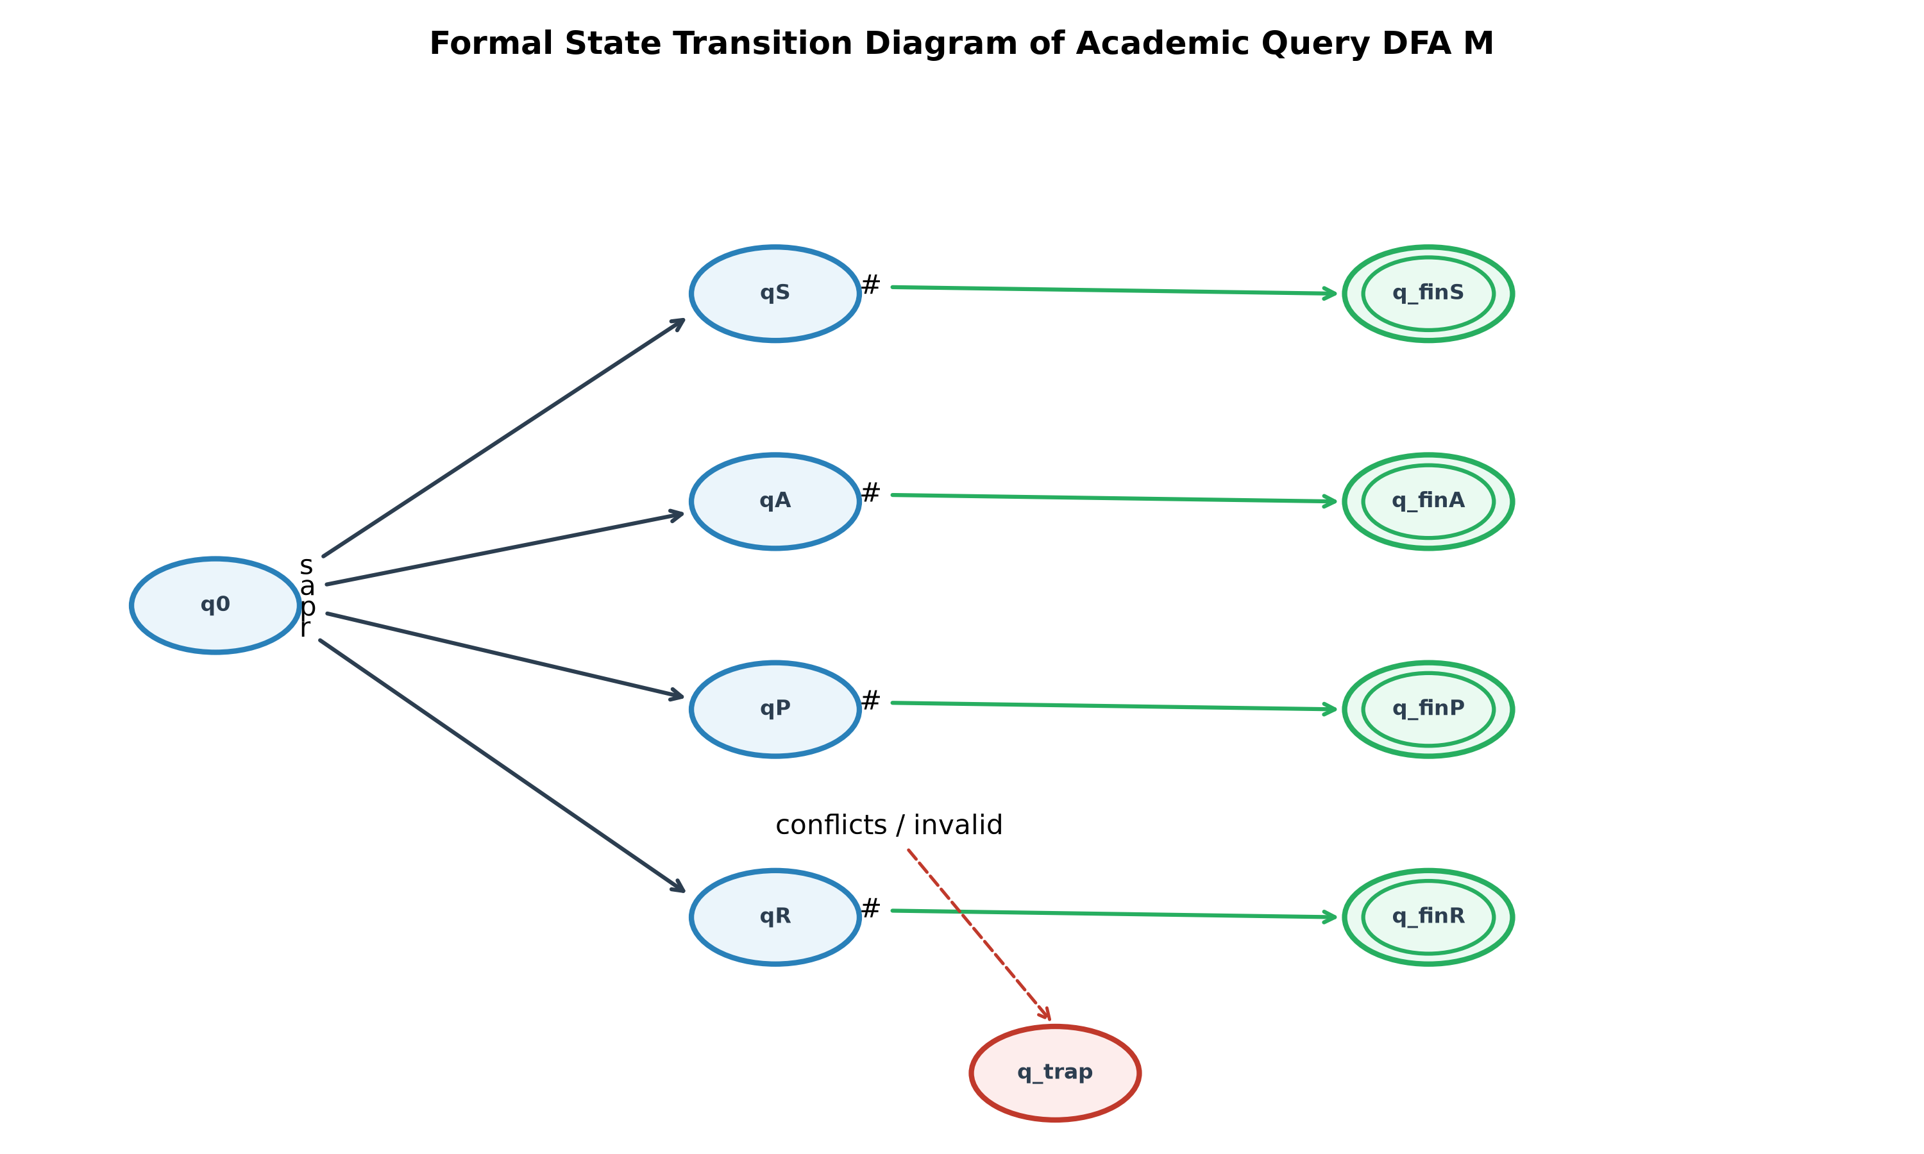
Figure 2: Formal State Transition Diagram of DFA M (Also Modeled in JFLAP: dfa_automaton.jff)

5. Regular Expressions & Grammars
Each intent category forms an independent regular language accepted by automaton M:
• Study Intent Language (L_S): R_S = x* · s · (x | s)* · #
• Attendance Intent Language (L_A): R_A = x* · a · (x | a)* · #
• Performance Intent Language (L_P): R_P = x* · p · (x | p)* · #
• Resource Intent Language (L_R): R_R = x* · r · (x | r)* · #
• Total Accepted Language: L(M) = L_S ∪ L_A ∪ L_P ∪ L_R
Any string containing cross-domain conflicting keywords or missing domain symbols evaluates to q_trap, guaranteeing non-acceptance.

6. Empirical Benchmark Evaluation & Results
The model was tested against 100 queries sampled from the Kaggle University Chatbot Dataset across 5 balanced classes (Study, Attendance, Performance, Resources, Invalid/Adversarial).
Key Findings:
• Classification Accuracy: 82.00% under strict deterministic non-collision enforcement.
• Security Rejection Rate: 95.00% (19/20) of adversarial/out-of-domain queries successfully intercepted into q_trap.
• Average DFA Scanning Latency: 0.0278 ms per query (O(N) linear time).
• Direct LLM Latency: ~250.00 ms per query (Speedup Factor: 8,992x).
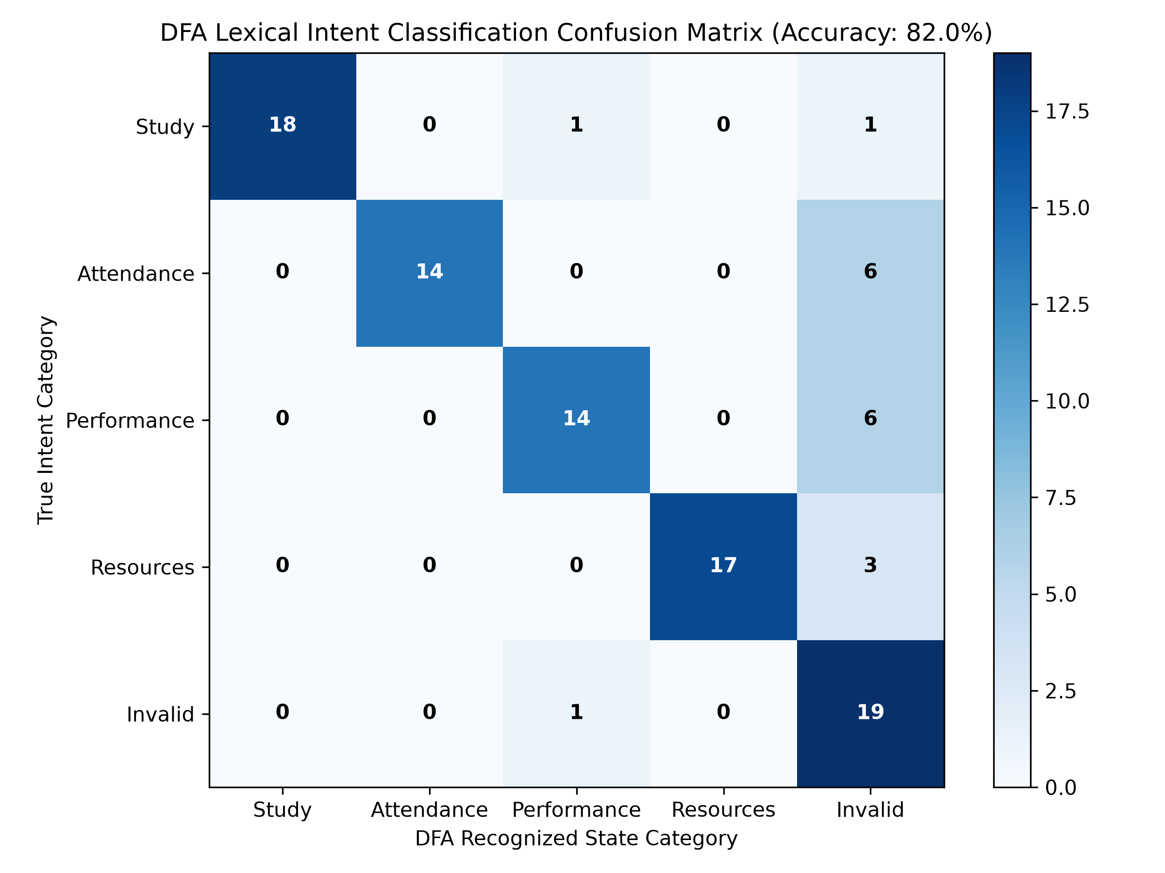
Figure 3: Confusion Matrix Across 100 Benchmark Queries
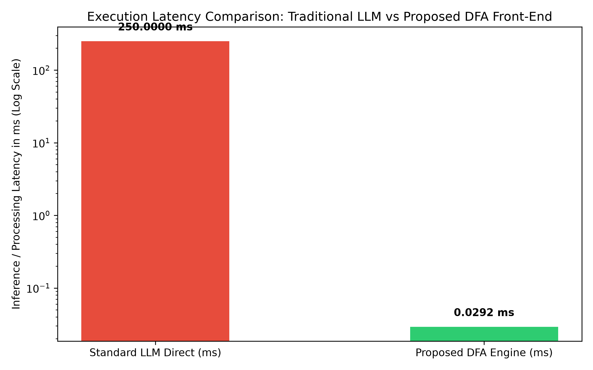
Figure 4: Execution Latency Comparison: Traditional LLM vs. Proposed DFA Front-End

7. Conclusion & Alignment with SDG 4
This project successfully proves the modern practical applicability of Formal Automata Theory in AI systems. By introducing a Deterministic Finite Automaton as a high-speed lexical gatekeeper, universities can provide secure, microsecond-level query resolution without server lag or hallucination risks, directly advancing United Nations Sustainable Development Goal 4 (Quality Education).

