Detecting fake news in Indian online media with Naive Bayes
Hrishit Dey
Department of Computer Science, Ramanujan College, University of Delhi, New Delhi, India | Roll No: 24020570027 | E-mail: hrishit.24570027@ramanujan.du.ac.in
Course: Machine Learning (B.Sc. (H) Computer Science, Semester V) | Supervisor: Dr. Nikhil Kumar Rajput | Problem No. 69 from Project_Allocation.xlsx | Article type: Comparative Study - text classifiers compared on an Indian dataset

1 Introduction
Fake news has become a major concern in India, where the rapid spread of online misinformation can contribute to social unrest, public-health risks and declining public trust in media institutions. The growth of social media and digital news platforms has made it increasingly difficult to distinguish genuine information from fabricated statements. Automated fake news detection is therefore a socially relevant machine-learning problem linked to SDG 16 (Peace, Justice and Strong Institutions) and SDG 4 (Quality Education). Many recent studies explore deep learning and complex language models; this project investigates whether classical machine-learning algorithms can effectively classify fake and genuine news statements using textual features. contributions are: (i) preprocessing and standardisation of the Indian Fake News Dataset (IFND); (ii) TF-IDF-based text representation with chi-square feature selection; (iii) a comparative evaluation of Multinomial Naive Bayes, Logistic Regression, Linear SVM and k-Nearest Neighbours using accuracy, precision, recall and F1-score; and (iv) an analysis of model performance to identify the most effective classifier for fake news detection. The results show that Linear SVM achieves the highest accuracy among the four evaluated models. Section 2 reviews related work, Section 3 describes the dataset, Section 4 presents the proposed methodology, Section 5 explains the experimental setup, Section 6 discusses the results, and Section 7 concludes the study.

2 Related Work
Sharma and Garg [1] introduced the Indian Fake News Dataset (IFND) and explored machine-learning and deep-learning approaches for misinformation detection. Zhou and Zafarani [2] surveyed fake-news detection methods based on textual content, propagation patterns, and source credibility. Wang [3] developed the LIAR dataset and investigated text-based and metadata-enhanced classification. Kumar and Singh [4] compared Naive Bayes, Logistic Regression, and LSTM for Hindi fake-news detection, reporting the best accuracy with LSTM. An IEEE INDICON study [5] compared TF-IDF, BERT, and Gemma representations for fake-news classification.
Building on these studies, we compare Multinomial Naive Bayes, Logistic Regression, Linear SVM, and k-NN on IFND using TF-IDF and chi-square feature selection. Models are evaluated using accuracy, precision, recall, and F1-score to establish a comparative baseline for fake-news detection in Indian digital media.

Abstract
Fake news has become a growing concern in India, where online misinformation can contribute to social unrest, public-health risks, and declining public trust in media institutions. This study investigates whether classical machine-learning (ML) models can effectively distinguish fake from genuine news statements in Indian online media. The study uses the publicly available Indian Fake News Dataset (IFND), comprising 56,714 records, including 37,800 genuine and 18,914 fake statements after preprocessing. Following the removal of missing values and standardisation of class labels, the dataset is divided into training and testing sets using an 80:20 stratified split. News statements are transformed into numerical representations using Term Frequency–Inverse Document Frequency (TF-IDF), with a maximum of 5,000 features, followed by chi-square feature selection to retain the 2,000 most informative features. Four supervised machine-learning classifiers—Multinomial Naive Bayes, Logistic Regression, Linear Support Vector Machine (SVM), and k-Nearest Neighbours (k-NN)—are trained and evaluated using accuracy, precision, recall, and F1-score. Linear SVM achieves the best overall performance, with an accuracy of 94.81%, precision of 96.40%, recall of 87.71%, and F1-score of 91.85%. Logistic Regression achieves 94.35% accuracy, while Multinomial Naive Bayes records 93.64% and k-NN achieves 90.06%. These findings demonstrate the effectiveness of TF-IDF-based text representation, chi-square feature selection, and classical machine-learning algorithms for classifying fake and genuine news statements. The study highlights the potential of accessible computational methods to support misinformation detection in Indian digital media and contributes to SDG 16 (Peace, Justice and Strong Institutions) and SDG 4 (Quality Education) by promoting responsible information sharing, media literacy, and informed public decision-making.
Keywords: fake news detection; Indian Fake News Dataset (IFND); natural language processing; TF-IDF; Multinomial Naive Bayes; logistic regression; linear support vector machine; k-nearest neighbours; chi-square feature selection; text classification; SDG 16; SDG 4.

3 Dataset and Preprocessing

3.1 Source and description
This study used IFND.csv from the Kaggle dataset “IFND dataset” [1], which compiles data from Indian fact-checking websites and real-world news sources (see Data availability). The file has 56,714 rows and 7 columns: id, Statement, Image, Category, Date, Label, and associated metadata, covering news statements and claims from 2013 to 2021. Table 1 summarises the variables. Text statements comprise news headlines and claims contextualized within the Indian socio-political framework.
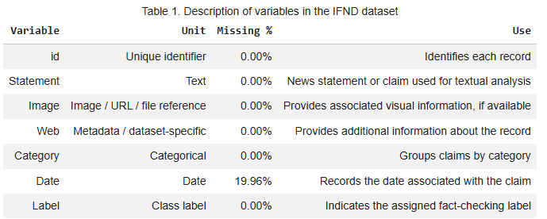

3.2 Missing values

Missing values were examined across the IFND dataset . The Date column contains missing values in 19.96% of the records, whereas the id, Statement, Image, Web, Category, and Label columns have no missing values. For the fake news detection task, the analysis uses only the Statement and Label columns. Records with missing values in these selected columns were removed to ensure that the text and corresponding class labels were available for model training and evaluation. Since Date is not used as a model feature, its missing values do not directly affect the classification process. The remaining data were used for TF-IDF feature extraction, chi-square feature selection, and classification.
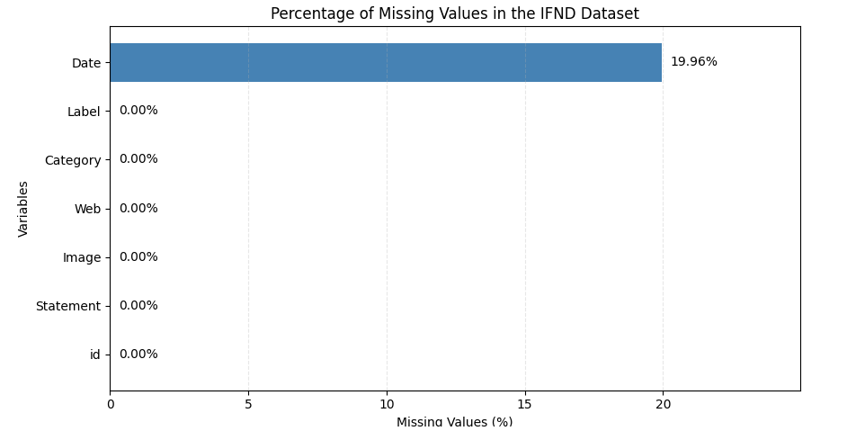

3.3. Data Preparation and Cleaning
Initially, the statement text column was explicitly converted into string format to ensure uniform data types for subsequent processing. The target labels were then cleaned and standardized by converting them to strings, stripping any leading or trailing whitespace, and changing all characters to uppercase. To maintain data integrity, the dataset was filtered to retain only rows where the label was strictly designated as either "TRUE" or "FAKE", thereby removing any anomalous entries. Following this, the categorical text labels were converted into numerical format by mapping "TRUE" to 0 and "FAKE" to 1. Finally, the dataset was divided into training and testing sets using an 80:20 ratio, with stratification applied to preserve the original class distribution of genuine and fake news across both subsets.
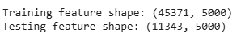

3.4. Feature Extraction and Selection
Following data preparation, the raw text statements were transformed into numerical feature vectors using the Term Frequency-Inverse Document Frequency (TF-IDF) vectorizer, with English stop words removed and the maximum vocabulary size capped at 5,000 features. To optimize the model performance and reduce dimensionality, Chi-Square feature selection was subsequently applied. Through this technique, the SelectKBest method was utilized to identify and select the most informative features, reducing the overall feature space to a maximum of 2,000 features based on statistical significance.
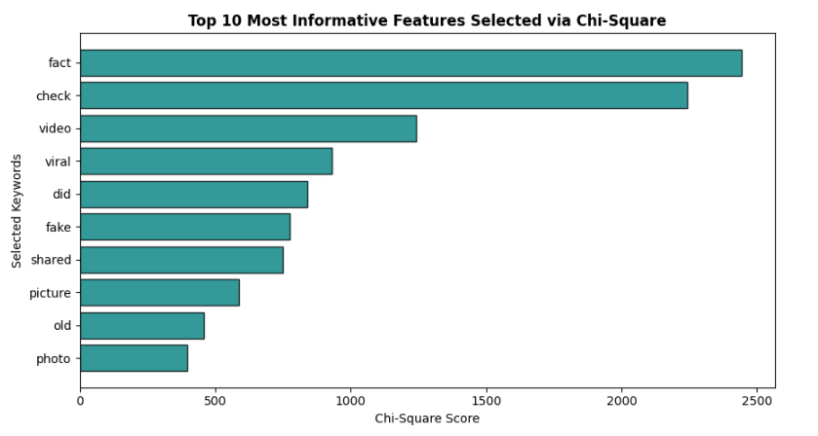

4 Methodology
The proposed methodology follows an end-to-end workflow for fake news detection using the Indian Fake News Dataset (IFND). The dataset is preprocessed by retaining the Statement and Label columns, removing records with missing values, and selecting the TRUE and FAKE classes. The labels are encoded as 0 for genuine news and 1 for fake news. The dataset is divided into training (80%) and testing (20%) subsets using stratified sampling to preserve the original class distribution. Text vectorisation, feature selection, and model training are performed using the training data, while the test data is reserved for final evaluation.
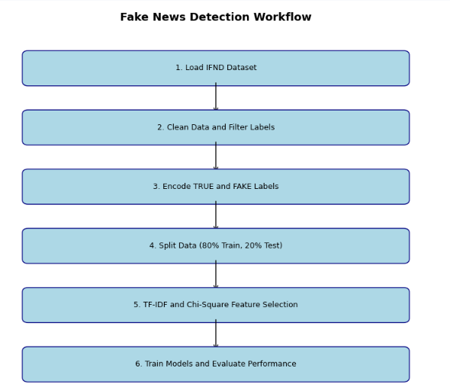

4.1 Classification Models
The classification task predicts whether a news statement is genuine (c=0) or fake (c=1). Text statements are converted into numerical representations using Term Frequency–Inverse Document Frequency (TF-IDF), with English stop words removed and the vocabulary limited to 5,000 features. TF-IDF is calculated as:
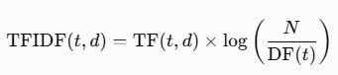
Chi-square feature selection retains up to 2,000 informative features:
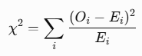
Four classification models are evaluated. Multinomial Naive Bayes estimates class probabilities using conditional independence:

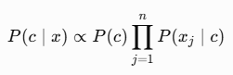
Logistic Regression estimates the probability of fake news using the sigmoid function:
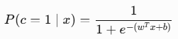
Linear Support Vector Machine (SVM) determines a separating hyperplane by maximising the margin:
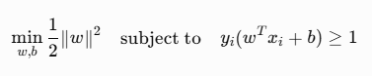
k-Nearest Neighbours (k-NN) assigns a label based on the majority class among the five nearest training samples using Euclidean distance.

4.2 Evaluation metrics
Model performance is assessed using accuracy (TP+TN/TP+TN+FP+FN), precision(TP/TP+FP), recall(TP/TP+FN) and F1score(2*Precision*Recall/Precision+Recall). Here, TP = true positives, TN = true negatives, FP = false positives, and FN = false negatives. Confusion matrix analysis is additionally performed for the Naive Bayes classifier to examine correct and incorrect predictions for both classes. The comparative results are used to identify the most suitable model for fake news detection. Recall for the fake-news class is particularly important because it measures the proportion of fake news statements correctly identified, helping minimise undetected fake news (FN).

5 Experimental Setup
Data preprocessing and splitting. The Indian Fake News Dataset (IFND) was used to develop and evaluate the fake news detection models. The dataset was loaded using Pandas, with Latin-1 encoding to support the dataset's text format. Only the Statement and Label columns were retained for classification. Records containing missing values in these columns were removed, and the statement text was converted to string format. Labels were converted to uppercase, and only the TRUE and FAKE classes were retained. The labels were then encoded as 0 for TRUE (genuine news) and 1 for FAKE (fake news). The resulting dataset was divided into training (80%) and testing (20%) sets using stratified random sampling with a fixed random seed of 42 to preserve the class distribution in both sets.
Feature extraction and selection. News statements were converted into numerical feature vectors using Term Frequency–Inverse Document Frequency (TF-IDF). The vectoriser excluded English stop words and retained a maximum of 5,000 features. To reduce dimensionality and identify informative terms, the Chi-Square feature selection method was applied using SelectKBest. The number of selected features was set to the smaller of 2,000 and the number of features available after TF-IDF vectorisation. The TF-IDF vectoriser and feature selector were fitted exclusively on the training data and then applied to the test data. The highest-scoring features were visualised to examine the terms most strongly associated with the class labels.
Classification models and evaluation. Four machine learning classifiers were trained and compared: Multinomial Naive Bayes, Logistic Regression, Linear Support Vector Machine (SVM), and K-Nearest Neighbours (KNN). Logistic Regression was configured with a maximum of 1,000 iterations, while KNN used five neighbours and Euclidean distance. Each classifier was trained using the selected TF-IDF features, and its predictions were evaluated on the held-out test set. Performance was measured using accuracy, precision, recall, and the F1-score. Classification reports were generated for each model, and the results were presented in a comparative bar chart. A confusion matrix was also generated for the Naive Bayes classifier to examine the distribution of correct and incorrect predictions.
Implementation environment. The experiments were implemented in Python using Google Colab. Pandas and NumPy were used for data processing, Matplotlib and Seaborn for visualisation, and scikit-learn for feature extraction, feature selection, model training, and evaluation. A random seed of 42 was used for the train–test split to support reproducibility. Finally, the trained Naive Bayes model was used to demonstrate prediction on a new news statement by applying the same TF-IDF transformation and Chi-Square feature selection steps used during training.

6. Results

6.1 Model Performance
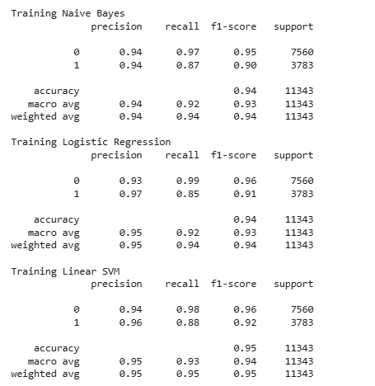
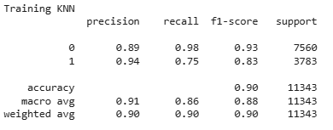
The performance of four machine learning models—Multinomial Naive Bayes, Logistic Regression, Linear Support Vector Machine (SVM), and K-Nearest Neighbors (KNN)—was evaluated for fake news detection using the IFND dataset. The dataset was divided into training and testing sets using an 80:20 split with stratified sampling. Text preprocessing was performed using Term Frequency–Inverse Document Frequency (TF-IDF), followed by Chi-square feature selection to retain the 2,000 most informative features. The models were evaluated using accuracy, precision, recall, and F1-score on the test set containing 11,343 news statements, including 7,560 genuine and 3,783 fake news statements.
The results demonstrate that Linear SVM achieved the highest accuracy of 94.81% and the highest F1-score of 0.9185 among the four classifiers. It also obtained a precision of 0.9640 and a recall of 0.8771, indicating that it effectively identified fake news while maintaining a relatively low false-positive rate. Logistic Regression achieved an accuracy of 94.35% and an F1-score of 0.9096, while Multinomial Naive Bayes obtained an accuracy of 93.64% and an F1-score of 0.9008. KNN recorded the lowest performance, with an accuracy of 90.06% and an F1-score of 0.8342.
The classification reports also reveal differences in the models' ability to detect the two classes. Linear SVM achieved a recall of 0.98 for genuine news and 0.88 for fake news. In contrast, KNN achieved a fake-news recall of only 0.75, indicating that it missed a comparatively larger proportion of fake news statements. Overall, the results suggest that linear classification methods are effective for detecting fake news from high-dimensional textual features.
6.2 Model Comparison
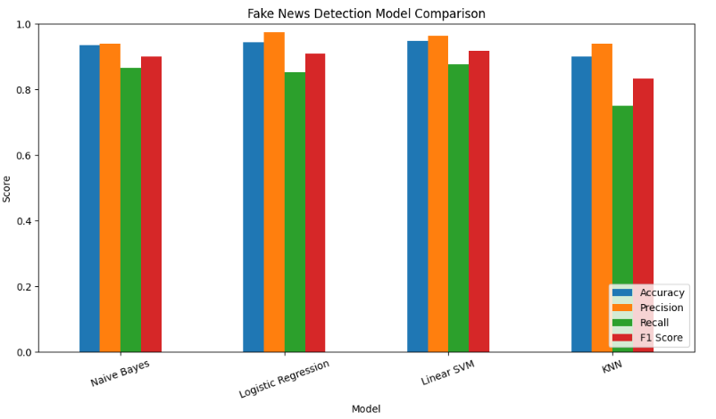
Linear SVM was the best-performing model overall, achieving the highest accuracy (94.81%), recall (87.71%), and F1-score (0.9185). Its F1-score was higher than that of Logistic Regression (0.9096), Naive Bayes (0.9008), and KNN (0.8342). These results indicate that Linear SVM provides the strongest balance between precision and recall among the evaluated classifiers.
Logistic Regression achieved the highest precision of 97.46%, meaning that its fake-news predictions were particularly reliable. However, its lower recall of 85.28% indicates that it missed more actual fake news statements than Linear SVM. Naive Bayes also performed well, offering a relatively simple and effective baseline for text classification. KNN was the weakest model overall, particularly in recall, suggesting limitations in identifying fake news using distance-based classification in the selected TF-IDF feature space.
The results show that Linear SVM is the most suitable model among those tested when overall classification performance is the primary objective. Nevertheless, Logistic Regression may be preferable in applications where minimizing false accusations against genuine news is especially important. The final choice of model should therefore consider the consequences of both types of classification error.
6.3 Confusion Matrix Analysis
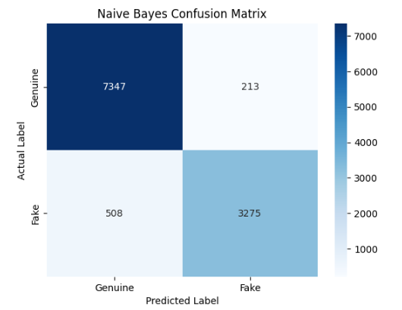
The confusion matrix was used to examine the classification outcomes of the Multinomial Naive Bayes model in greater detail. Genuine news was encoded as class 0, while fake news was encoded as class 1. The reported confusion matrix indicates that 7,347 genuine news statements were correctly classified as genuine and 3,275 fake news statements were correctly classified as fake.
The model correctly classified most genuine news statements, with 7,347 out of 7,560 identified correctly. It also correctly detected 3,275 out of 3,783 fake news statements. However, 213 genuine statements were incorrectly classified as fake, while 508 fake statements were incorrectly classified as genuine. The false-negative count indicates that some misleading information could remain undetected, which is an important limitation for automated fake news detection systems.
Overall, the confusion matrix supports the classification report, showing that Naive Bayes performs well on genuine news but has comparatively lower recall for fake news. Although its overall accuracy is 93.64%, its practical effectiveness depends on the balance between identifying fake news and avoiding the incorrect classification of genuine statements.

7 Discussion
What worked
The combination of TF-IDF vectorisation and Chi-Square feature selection effectively transformed news statements into numerical features for classification. Four machine learning models—Naive Bayes, Logistic Regression, Linear SVM and KNN—were evaluated using accuracy, precision, recall and F1-score. Linear SVM performed best, achieving 94.81% accuracy, 87.71% recall and an F1-score of 0.9185, outperforming Logistic Regression (0.9096), Naive Bayes (0.9008) and KNN (0.8342). These results demonstrate the effectiveness of Linear SVM in identifying patterns associated with genuine and fake news.
Limitations
(i) The model relies only on textual statements and does not consider images, sources or external fact-checking evidence. (ii) Only TRUE and FAKE labels were retained, limiting the classification scope. (iii) TF-IDF captures word patterns but may struggle with context, sarcasm and subtle misinformation. (iv) The random train-test split does not establish performance on future news or unfamiliar sources. Testing on external datasets and newer news articles would provide stronger evidence of reliability. Therefore, the model should support human fact-checking rather than replace it.
Performance across models
Linear SVM achieved the highest accuracy and F1-score among the four classifiers, indicating the strongest overall performance in this experiment. Logistic Regression and Naive Bayes also performed well, while KNN recorded the lowest F1-score. Although Linear SVM achieved 87.71% recall, some fake news items may still be misclassified as genuine. Further testing across different news categories and sources is necessary to assess generalisation and reduce the risks associated with undetected misinformation.
Ethics and SDG impact
The main ethical concerns are misclassification, dataset bias and over-reliance on automated predictions. Incorrect labels may damage the credibility of genuine information, while undetected fake news can spread misinformation. Therefore, predictions should be verified using reliable sources, and the model should be evaluated regularly with human oversight.
The project supports SDG 16: Peace, Justice and Strong Institutions by exploring methods to identify potentially misleading information and promote access to trustworthy information. It also contributes to SDG 4: Quality Education by demonstrating the application of machine learning to misinformation awareness and digital literacy. Combining automated detection with critical thinking and source verification can encourage responsible information sharing and informed decision-making.

8 Conclusion and Future Work
Using the IFND dataset and a TF-IDF-based text classification approach with Chi-Square feature selection, this project evaluated four machine learning models for fake news detection. Linear SVM achieved the best overall performance, with 94.81% accuracy and an F1-score of 0.9185, outperforming Logistic Regression, Naive Bayes and KNN. Future work will incorporate additional features such as news sources, images and contextual information, evaluate the model on newer and external datasets, and explore advanced NLP techniques to improve generalisation. These improvements could support more reliable misinformation detection, contributing to SDG 16 (Peace, Justice and Strong Institutions) and SDG 4 (Quality Education).

Declarations
Data availability. The IFND (Indian Fake News Dataset) used in this study was obtained from https://www.kaggle.com/datasets/sonalgarg174/ifnd-dataset The dataset is used for the analysis and experiments presented in this project. Code and figures. The code used for data preprocessing, model implementation, experiments, and figure generation is available at GitHub - hrishitdeycs/ML_Project_Detecting_fake_news_in_Indian_online_media_with_Naive_Bayes · GitHub
Conflict of interest. The author declares no conflict of interest.
Funding. None
Use of AI tools. ChatGPT (OpenAI) was used to assist with code development and to support the writing and organization of the project report and journal. I confirm that all content has been verified, and I take full responsibility for it.

References
- D. K. Sharma and S. Garg, “IFND: A benchmark dataset for fake news detection,” Complex & Intelligent Systems, vol. 9, pp. 2843–2863, 2023. DOI: 10.1007/s40747-021-00552-1 .
- X. Zhou and R. Zafarani, “A survey of fake news: Fundamental theories, detection methods, and opportunities,” ACM Computing Surveys, vol. 53, no. 5, Art. no. 109, 2020. DOI: 10.1145/3395046 .
- W. Y. Wang, “‘Liar, Liar Pants on Fire’: A new benchmark dataset for fake news detection,” in Proceedings of the 55th Annual Meeting of the Association for Computational Linguistics (Volume 2: Short Papers), 2017, pp. 422–426. DOI: 10.18653/v1/P17-2067 .
- S. Kumar and T. D. Singh, “Fake news detection on Hindi news dataset,” Global Transitions Proceedings, vol. 3, no. 1, pp. 289–297, 2022. DOI: 10.1016/j.gltp.2022.03.014 .
- “A comparative study of TF-IDF, BERT and Gemma representations for fake news detection,” in 2024 IEEE 21st India Council International Conference (INDICON). DOI: 10.1109/INDICON63790.2024.10958426 .

