Multi-sensor Human Energy Expenditure Estimation
using Ensemble Learning

Ivana Kiprijanovska, Simon Stankoski, Hristijan Gjoreski
Faculty of Electrical Engineering and Information Technologies,
University of Ss. Cyril and Methodius in Skopje, Macedonia
kiprijanovskai@gmail.com, simonstankoski997@gmail.com, hristijang@feit.ukim.edu.mk

Abstract—Measuring and monitoring energy expenditure is an important part of many medical and sports applications. Accurate estimation is a difficult task, primarily because it requires a lot of equipment, which makes it impractical for everyday use. However, the increasing accessibility of different sensors opens up the possibility of new methods for energy expenditure estimation. This paper presents two machine learning approaches, single-regression and ensemble-regression learning, for energy expenditure estimation of individuals wearing equipment consisting of two 3-axis accelerometers, a Zephyr sensor and a BodyMedia sensor. Since it is important to obtain proper multi-sensor measurements without great effort, the previously designed models were tested on data provided by the Zephyr and BodyMedia sensor in combination with accelerometers separately. The results showed that the ensemble methods outperformed the single regression methods, in terms of lower Root Mean Square Error and Mean Absolute Error. Additionally, the performance achieved by the Zephyr device is better than the BodyMedia device and is comparable with the performance achieved by the model that uses the data from all the devices.
Keywords—energy expenditure estimation; wearable sensors; machine learning

Introduction
Today’s technological innovations have become an inseparable part of our everyday life, mainly because they make our life easier and increase the quality of life. Technology keeps changing and affecting our lifestyle. The usefulness of modernization in the daily life cannot be denied. However, different modern life style patterns have negative effects on people’s health.
One of the biggest health problems in the world is obesity [1]. The technological revolution has led to weight gain becoming unavoidable for the majority of the population. To prevent weight gain, energy intake or calorie intake must be balanced with EE. EE is the amount of energy a person uses to carry out regular bodily functions, such as breathing, digestion, circulating blood or any kind of physical movement. EE is most often measured in calories, a unit of heat. Human EE directly reflects the intensity of physical activity, which means that its proper measurement plays an important role in the prevention or treatment of several lifestyle-related diseases and metabolic disorders, for example diabetes [2]. Patients need to quantify activity-related EE to improve activity – based health management. Estimation of human EE in sports contributes to performance analyses. Energy balance is essential for maintaining the demands of training, optimum athletic performance and fast recovery. Hence, the measurement of daily EE is an important aspect of research on human health and nutrition, especially in modern times.
EE is determined by the individuals’ daily behavior and consequently, total daily EE can vary from person to person depending on body size, gender, body composition, genetics, and activity level. Therefore, an accurate and convenient approach of EE estimation is required. There are various approaches that can reliably estimate the EE. Direct and indirect calorimetric methods for measuring EE require laboratory conditions or wearing lots of equipment. For that reasons, they are rather impractical for everyday use. With the increasing accessibility of various sensors, monitoring systems are becoming a practical solution for measuring the EE. Such systems primarily measure the physical activity with accelerometers, but can include additional sensor measurements, such as heart rate, breath rate, body temperature etc.
The main challenge in this study is how to estimate the EE from wearable sensor outputs accurately with single and ensemble regression learning. Such a model, for example, can be implemented in mobile applications that can assist individuals in maintaining a healthy lifestyle.

Related Work
Automatic EE estimation started with supervised ML, i.e., regression learning. In particular, linear regression was used to map a single accelerometer output to EE [3][4]). The accelerometer output was often expressed in “counts”, an aggregate acceleration measure reported by devices such as ActiGraph. To estimate the EE, investigators used these "counts" to develop linear regression models.
The problem with these approaches was that single-regression approaches cannot accurately estimate the EE. Crouter et al. [5] used the acceleration counts in order to divide the activities into three categories and assigned different EE estimations. The advances in the accelerometer-based recognition of activity type allowed finer-grained activities as the context for EE estimation [6][7]. Lester et al. [8] used a Naive Bayes classification model to first recognize three activities (rest, walking and running) from the accelerometer's data, and then to apply the appropriate regression equations in order to estimate the EE. However, even with these three types of sensors (accelerometer, GPS, and barometer) they still encountered two problems: (i) EE underestimation of activities that are not characterized by acceleration, but are still energy demanding, e.g., carrying a box and (ii) EE underestimation of activities that follow an intense activity, i.e., the "cool-down" effect (sitting after intense running). Both problems can be solved by sensing other physiological parameters such as the heart rate and breath rate [9][10]. This may seem as an additional burden to the user because it requires additional sensors attached to him/her. However, today's commercial wearable devices already provide multiple sensors packed in a single enclosure, e.g., BodyMedia, Basis, Empatica wristband, etc.
The BodyMedia armband sensor uses both multiple sensors and multiple regression models. Vyas et al., [11], proposed a method that uses an activity recognition model that recognizes dozens of activities which are used as the context, and then it combines multiple regression models according to the probabilities for the recognized activities. They showed that by using multiple sensors: an accelerometer, two thermometers, GSR and heat-flux sensors, the estimation of the EE significantly improves. Additionally, a recent review showed that it is the most accurate EE estimation consumer device [12].
The aforementioned studies showed that: (i) using multiple regression models for different user's activities (i.e., context) outperforms single-regression approaches, and (ii) using multiple features extracted from multiple sensor data provides more accurate EE estimation than using only acceleration data (even when multiple acceleration features are extracted). In this work we provide a multi-sensor analysis on the data provided by 2 accelerometers, BodyMedia device and a Zephyr device. Additionally, we analyze two regression learning approaches: single regression and ensemble-based.

Data
We used publicly available dataset for this research [13], which is one of the largest ones that include multiple sensor modalities. The dataset was recorded by 10 healthy participants wearing equipment that consists of:
- Two three-axis Shimmer accelerometers to measure the accelerations of the user placed on the chest and the right thigh. The placement was chosen as a trade-off between the physical obtrusiveness and the performance achieved for the recognition of the user’s activities [1][14].
- A Zephyr BioHarness sensor, sports strap worn on the chest. It measured user's heart rate, breath rate, and chest skin temperature.
- BodyMedia sensor is a state-of-the-art commercial sensor for EE estimation, which was worn on the left upper arm as suggested by the manufacturer. It served as a benchmark for comparison of the EE estimation, and additionally it provided the user's galvanic skin response (sweating rate), ambient temperature and arm skin temperature.
- Cosmed K4b2 indirect calorimetry measured the oxygen uptake (VO2) during each activity was measured breath-by-breath and averaged every ten seconds. A flexible Hans-Rudolph face mask held in place by a head harness covered each user’s nose and mouth and measured the volume of inspired and expired air.
Each of these sensors provides different information that has been used for extracting eight features (attributes):
- Basic activity recognized by a classification model [14], using the data provided from the accelerometers. The activity is recognized as one of the following: lying, walking, sitting, standing, kneeling, on all fours, transition, leaning, cycling, and running.
- Breath rate as provided by the Zephyr sensor.
- Heart rate as provided by the Zephyr sensor.
- Chest skin temperature as provided by the Zephyr sensor
- Galvanic skin response (GSR) as provided by the BodyMedia sensor.
- Near body temperature as provided by the BodyMedia sensor.
- Arm skin temperature as provided by the BodyMedia sensor.
- The EE estimation in METs as provided by the COSMED (indirect calorimeter device). This feature is the ground truth which is later used to train the regression models.

Methods
The feature vectors are used as input to regression algorithms in order to learn a regression model that will correctly estimate the EE. The target EE estimation is provided by the COSMED and is given in METs (metabolic equivalents of task), which is a physiological measure expressing the energy cost of physical activities. One MET is defined as the energy expended by an average person seated at rest. If a person is doing an activity that requires three METs, it means that by doing that activity, the person burns three times as many calories per minute as he would by just sitting (resting).
For the development of our EE estimation model we tried two different approaches: single regression approach and ensemble approach. With the single regression approach, five machine learning algorithms as implemented in the WEKA toolkit were used: Linear Regression [15], Support Vector Regression (SVR) – linear and non-linear [16], M5P model trees [17], Artificial Neural Network [18] and k – Nearest Neighbors (kNN) [19]. On the other hand, the ensemble approach combines several base learners in order to produce one optimal predictive model. Three types of ensemble methods were used: Bagging [20], Boosting [21][22] and Stacking [23].
Bagging is a simple ensemble method in which many independent models are built, each using a random subset of the training data set [20]. Then they are combined using a model averaging technique. It is designed to improve the stability of the model and reduce its variance. We tested this technique with three different base learners: SVR, M5P and Artificial Neural Network.
Boosting is an ensemble technique in which the prediction models are not made independently, but sequentially [21][22]. The subsequent predictors attempt to correct the errors of the previous predictors. We used two algorithms for this type of ensemble method: Additive Regression and XGBoost. Both methods are based on Gradient Boosting algorithm. This algorithm in the first iteration learns a model from the data and analyzes the errors. In the next iterations the algorithm focuses on these errors and tries to fit a model to the errors (residuals) of the previous iteration. Once it reaches a stage where the residuals don’t fit any pattern that can be modeled, the iterations stop. The final prediction is accomplished by adding the predicted residuals of the models to the first model where we have our class predicted. XGBoost (eXtreme Gradient Boosting) is a highly sophisticated gradient boosting algorithm. It has implemented regularization which reduces over fitting and in-built routine that handles missing values. As well as that, it implements parallel processing which makes it much faster than other gradient algorithms.
Stacking (also called meta-ensemble) is an ensemble technique which combines information from multiple predictive models to generate a new model [23]. Most often the Stacking model outperform each of the individual models due its ability to highlight each base model where it performs best and discredit it where it performs poorly. For this reason, Stacking is most effective when the base models are significantly different.

Experimental Setup
In order to evaluate and compare the different algorithms, we used leave-one-person-out cross-validation technique. This is a commonly used evaluation technique, where the model is intended to be used on users different from the ones used for training. Therefore, the models were trained on the data of nine people and tested on the remaining 10th person. This procedure was repeated ten times, once for each person.
For the evaluation metrics we used Root Mean Squared Error (RMSE) and Mean Absolute Error (MAE), since they are the most common metrics used to measure performance for regression tasks. They are defined as follows:

$RMSE=\sqrt{\frac{1}{q}\sum_{1}^{q}{{\left({EE}_{estimated}- {EE}_{true}\right)}^{2}}}$ (1)
$MAE= \frac{1}{q}\sum_{1}^{q}{|{EE}_{estimated}-{EE}_{true}|}$ (2)
Where q is the number of data samples, ${EE}_{estimated}$ is the value predicted by the model, and ${EE}_{true}$ is the EE value provided by the COSMED device.
Both MAE and RMSE express average model prediction error in units of the variable of interest. Both metrics can range from 0 to infinity and are indifferent to the direction of errors. They are negatively – oriented scores, which means lower values are better. However, there are some differences between these two errors. In fact, the RMSE gives a relatively high weight to large errors. Because in our regression problem, the predicted values are in a small range from 0 to approximately 12, large errors are particularly undesirable. That is why we focused more on the RMSE because it penalizes large errors more.

Experimental results
The results obtained for the single-regression approach with 6 machine learning algorithms are shown in Figure 1 (RMSE) and Figure 2 (MAE). The results show that the algorithms that use simple linear or polynomial learning functions (Linear Regression, SVR), give better results than the more complex algorithm such as ANN. This result stems from the fact that ANN is more susceptible to over fitting, which means it fails to generalize well when presented with unseen data. The same happens with M5P algorithm. However, when we changed its default minimum number of instances per leaf, from 4 to 55, we got better results, avoiding the over fitting.
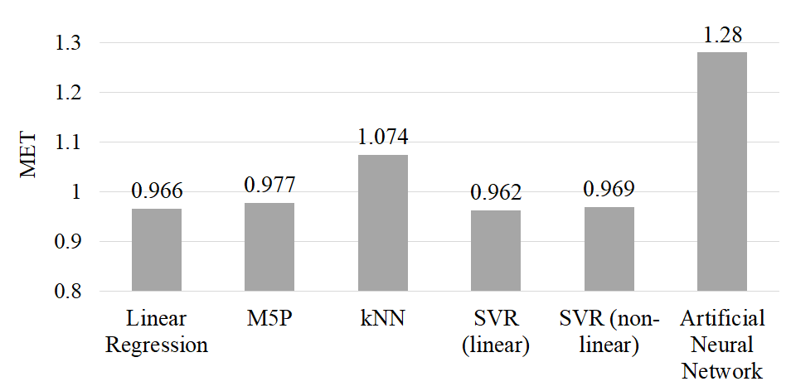
Figure 1 Root Mean Square Error (RMSE) for EE estimation using single regression algorithms.
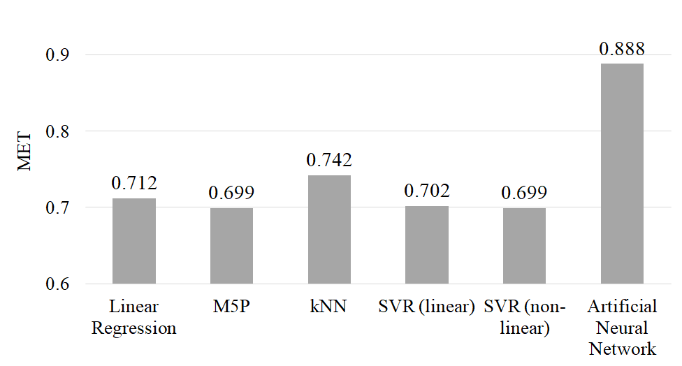
Figure 2 Mean Absolute Error (MAE) for EE estimation using single regression algorithms.
Next, we tested three ensemble-based methods. Each method was tested with different base learner (the same algorithms from the single-regression approach), and the best performing are shown in Figure 3 (RMSE) and Figure 4 (MAE). Almost every ensemble method resulted with improved performance compared to the single regression approach. The XGBoost method uses linear kernel. The stacking method uses XGBoost and linear regression as base learners and M5P as a meta-classifier. For both Bagging and Additive Regression methods we used SVR (linear) as base learner.
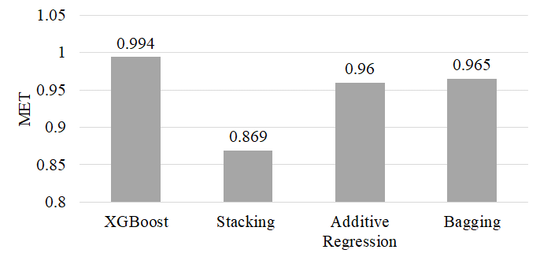
Figure 3 Root Mean Square Error (RMSE) for EE estimation using ensemble methods
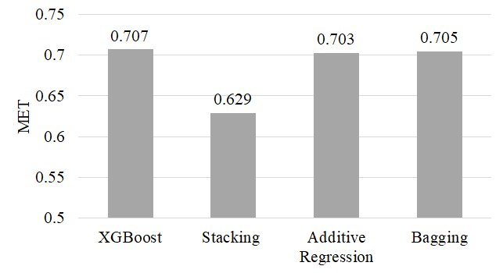
Figure 4 Mean Absolute Error (MAE) for EE estimation using ensemble methods.
The results show that the Stacking method outperforms (has lower RMSE and MAE) all of the methods from the ensemble approach, as well as the algorithms used in single-regression approach. We speculate that the reason for this is its ability to generalize better, but also because it allows testing and choosing the best combinations of base and meta learners.
Figure 5 and Figure 6 show the estimations for the best two Stacking methods. Figure 5 shows the estimations for the Stacking method where we used Additive regression (M5P) and SVR (nonlinear) as base learners, and linear regression as a meta-learner. This is the second best model, with RMSE = 0.928 MET and MAE = 0.680 MET. Figure 6 shows the best performing Stacking model, with RMSE = 0.869 MET and MAE = 0.629 MET. It uses XGBoost and linear regression as base learners, and M5P as a meta-classifier.
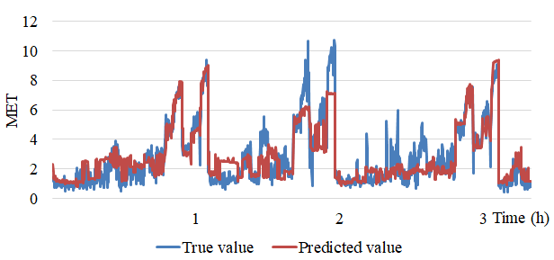
Figure 5 Comparison of true and predicted values for EE using Stacking (SVM-nonlinear and Additive Regression-M5P as base learners and Linear Regression as meta-classifier) for the first two thousand instances.

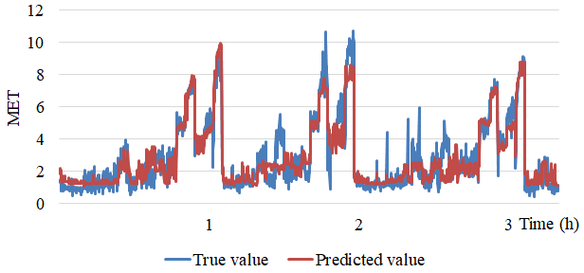
Figure 6 Comparison of true and predicted values for EE using Stacking (XGBoost-gblinear and Linear Regression as base learners and M5P as meta classifier) for the first two thousand instances.
In both figures one can note that the worst performance was achieved for the second user (between 1.5h and 2.5h). We speculate that the reason for this are the high values of heart and breath rate for some activities compared to the other users. However, the last Stacking method which included XGBoost as base learner got quite good results even for this user.

Sensor-based Analysis
Accurate and real-time EE estimation is important in everyday life. With increasing the number of sensors for getting accurate data, the EE estimation becomes more intrusive. Therefore, we tested the same models using data provided from each sensor (Zephyr and BodyMedia) separately, in combination with accelerometers.
The best results from single regression approach and ensemble approach are shown in Figure 7 and Figure 8. The results show that the Zephyr sensor in combination with accelerometers gives results that are close with the results achieved by the previous models which used the complete dataset. That was quite expected since heart rate and breath rate are highly correlated with the EE. However, the results achieved using data provided by the BodyMedia sensor show that the information about the near body temperature, arm skin temperature and galvanic skin response alone is not sufficient for accurate EE estimation.
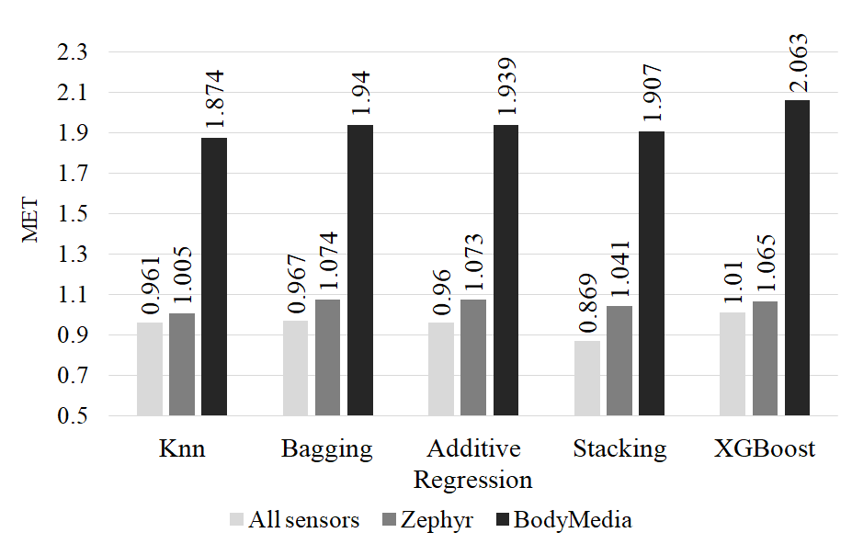
Figure 7 Comparison of Root Mean Square Error (RMSE) of All sensors, Zephyr and BodyMedia sensors data combined with accelerometers data.
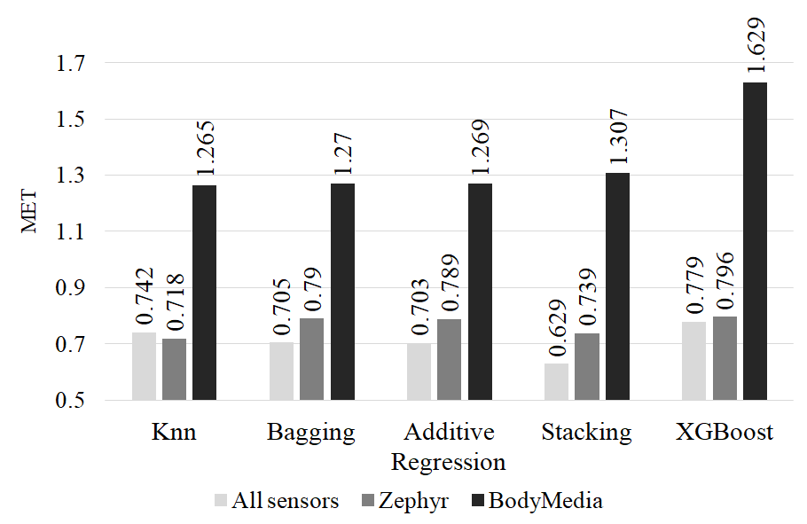
Figure 8 Comparison between Mean Absolute Error (MAE) of All sensors dataset, Zephyr and BodyMedia sensors data combined with accelerometers data.

Conclusion
In this study, we compared two machine learning approaches (single and ensemble learning) for estimating EE using data provided from multiple wearable sensors. The results showed that the ensemble-based methods significantly outperform single regression approach. The best performing model is the Stacking model which uses linear regression and XGBoost as base learners, with M5P as a meta-learner. It achieved lowest RMSE (0.869 MET) and lowest MAE (0.629 MET), which is a significant improvement over the other single regression and other ensemble models. The results showed that the worst performance is achieved for the EE estimation for the second person, who has wrongly predicted activity based on the accelerometers data. However, the Stacking method was able to minimize the errors for this person.
Additionally, we performed sensor-based analysis that showed which sensors and devices are estimating the energy expenditure with better performance. The performance achieved by the Zephyr device is better than the BodyMedia device and is comparable with the performance achieved by the model that uses the data from all the devices.
Since these methods were developed using data from relatively small number of people, i.e., ten, it remains an open question for future research whether these models will fit different profiles of people performing similar or different activities.

References
- S. Rossner Obesity: The disease of the twenty-first century, International Journal of Obesity (2002) 26, Suppl 4, S2–S4
- Caron N., Peyrot N., Caderby T., Verkindt C., Dalleau G. Energy expenditure in people with diabetes mellitus: A review. Front. Nutr. 2016;3:56. doi: 10.3389/fnut.2016.00056.
- Freedson PS, Pober D, Janz KF. Calibration of accelerometer output for children. Med Sci Sports Exerc. 2005; 37(11):S523–30.
- Swartz A, Strath SJ, Bassett DJ, O'Brien W, King GA, Ainsworth BE. Estimation of energy expenditure using CSA accelerometers at hip and wrist sites. Med Sci Sports Exerc. 2000 Sep;32(9):S450–6.
- Crouter SE, Clowers KG, Bassett DR Jr. A novel method for using accelerometer data to predict energy expenditure. J Appl Physiol. 2006; 100(4):1324–31.
- Luštrek M, Cvetković B, Kozina S. Energy expenditure estimation with wearable accelerometers. In: Proceedings of the International Symposium on Circuits and Systems, ISCAS; 2012 May 20-23: Seoul (Korea); 2012. p. 5–8.
- Albinali F, Intille SS, Haskell, W, Rosenberger, M. Using wearable activity type detection to improve physical activity energy expenditure estimation. In: Proceedings of the 12th ACM international conference on Ubiquitous computing, Ubicomp, 2010. p. 311–320.
- Lester J, Hartung C, Pina L, Libby R, Borriello G, Duncan G. Validated caloric expenditure estimation using a single body-worn sensor. In: Proceedings of the 11th ACM international conference on Ubiquitous computing, Ubicomp; 2009 Sep 30-Oct 03: Orlando (Florida, United States of America); 2009. p. 225–234.
- Gjoreski H, Kaluža B, Gams M, Milić R, Luštrek M. Ensembles of multiple sensors for human energy expenditure estimation. In: Proceedings of the 2013 ACM international joint conference on Pervasive and ubiquitous computing, UbiComp, 2013 Sep 8-12: Zurich (Switzerland); 2013 p. 359–362.
- H. Gjoreski, B. Kaluža, M. Gams, Radoje Milić, M. Luštrek. Context-based Ensemble Method for Human Energy Expenditure Estimation. Applied Soft Computing, December 2015, Pages 960–970.
- Vyas N, Farringdon J, Andre D, Stivoric J. Machine learning and sensor fusion for estimating continuous energy expenditure. In: Proceedings of the 23rd Conference on Innovative Applications of Artificial Intelligence, IAAI; 2011, Aug 9-11: San Francisco (California, USA), 2011, p. 1613–1620.
- M.Gjoreski, H. Gjoreski, M. Luštrek, M. Gams. How Accurately Can Your Wrist Device Recognize Daily Activities and Detect Falls? Sensors, December 2015, Sensors 2016, 16(6), 800.
- AmI repository: https://dis.ijs.si/ami-repository/index.php?d=16. [Accessed, May 2018]
- Kozina S, Gjoreski H, Gams M, Luštrek M. Three-layer activity recognition combining domain knowledge and meta-classification. Journal of medical and biological engineering. 2013; 33(4).
- David A. Freedman (2009). Statistical Models: Theory and Practice. Cambridge University Press. p. 26.
- S. K. Shevade, S.S. Keerthi, C. Bhattacharyya, K.R.K. Murthy: Improvements to the SMO Algorithm for SVM Regression. In: IEEE Transactions on Neural Networks, 1999.
- Y. Wang, I. H. Witten: Induction of model trees for predicting continuous classes. In: Poster papers of the 9th European Conference on Machine Learning, 1997.
- Jürgen Schmidhuber (2014) Deep learning in neural networks: An overview, The Swiss AI Lab IDSIA, University of Lugano & SUPSI, 6928 Manno-Lugano, Switzerland
- D. Aha, D. Kibler (1991). Instance-based learning algorithms. Machine Learning. 6:37-66.
- Breiman L, “Bagging Predictors,” Machine Learning; 1996. 24(2): p. 123–140
- Jerome H. Friedman, Stochastic gradient boosting, Computational Statistics & Data Analysis, v.38 n.4, 28 February 2002.
- Friedman, J.H.: Greedy function approximation: a gradient boosting machine. Ann. Stat. 1189-1232 (2001)
- David H. Wolpert (1992). Stacked generalization. Neural Networks. 5:241-259.

