Lokaverkefni GAGN2VG05CU

**Project**

Project overview ..................................................................................................1

Problems in existing system .................................................................................2

Solution to the problem ........................................................................................3

New system objectives .........................................................................................4

**System Development**

List of events ........................................................................................................5

List of actors .........................................................................................................6

Context diagram ...................................................................................................7

Data flow Diagrams DFD0,DFD1 ........................................................................8

ER-model in UML ................................................................................................9

**MySQL Database**

List of entities and attributes ..............................................................................10

ER-Diagram ........................................................................................................11

ER Mapping ........................................................................................................12

Attributes Data Types .........................................................................................13

SQL code ............................................................................................................14

Project Overview:

The Atlantic hotel is using a crap manual system to handle hotel business processes which is really not clever as the current system is file based and the management of the hotel must put much effort on securing those files, andthey can be damaged by fire or stolen. Looking for some old reservations can take alot of time since there is no easy way to look it up. As a software engineers, we want to make this easier for you by creating a database system that will save you alot of hours with storing your records and keeping everything clean together.

It will be User-friendly interfaces which will provide guests with an online web based GUI to search for room categories and availability, bookings, faciliate hotel staff management and more.

Problems in existing system:

1: Hotel business processes are stored manually in a cabinet which could get destroyed by fire.

2: Alot of effort is put in to secure the files.

3: Files will always keep growing and that requires more trees to be cut down to make paper ☹.

4: Files coule be stolen by anyone who has access or steals keys to the access.

5: Checking previous room records takes long time and effort.

6: Guests can not look for rooms and make reservation by them selves.

7: calculations of bills and inventory items are done manually and can cause accuracy problems.

Solution to the problem:

Solution to the problem can be done with what i have mentioned here above and that would help improve these things :

* To enable online booking via the internet.
* Increase security to avoid unauthoriezed access to guest records.
* To enable automated data entry methods.
* Enable fast and easy retrieval of guest records and data for fast reference activities.
* Ensure efficient and reliable communication within the hotel.
* Back up facility provided in case of data loss.
* Cost benefits

New System Objectives:

* Old system is manually, new system will be automatic
* In the new system there will be much more security
* User friendly system that is easy to use for everyone.
* Guest details.
* Reservation details.
* Inventory management details.
* Room services.
* Staff management.
* Our system will be awesome.

List Of Events:

* Reserve rooms.
* Conduct meetings.
* Celebrate cocktail parties.
* Weddings.
* Birthdays.

List Of Actors:

* Guests
* Employees

Context Diagram:

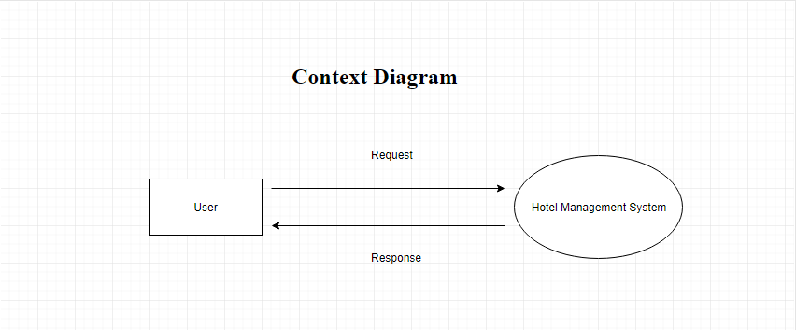

Data Flow Diagram Level 0:

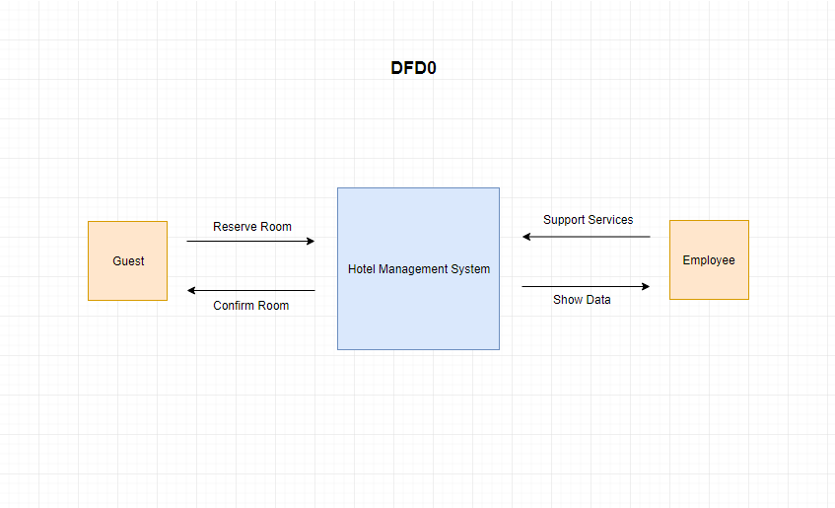

Data Flow diagram Level 1:

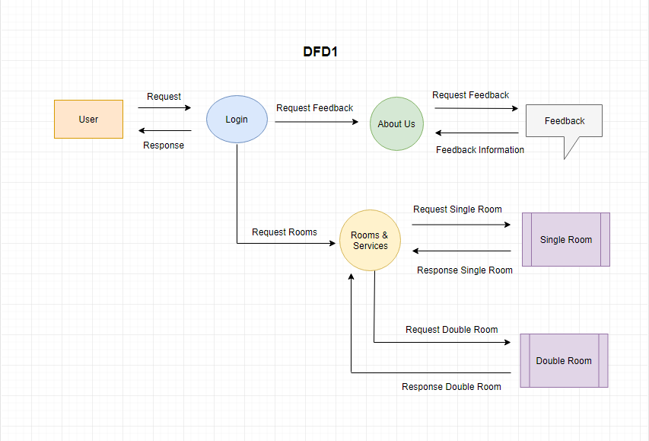

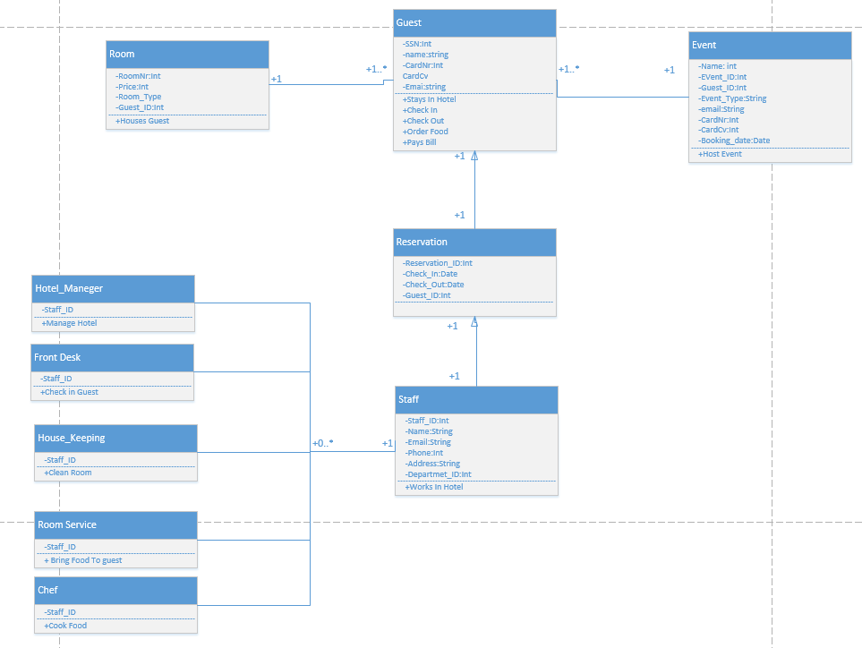ER-model in UML:

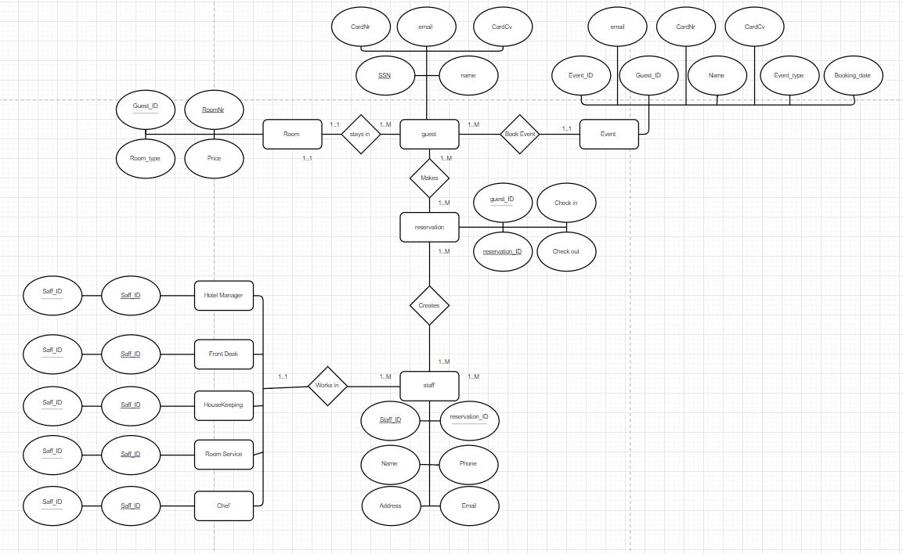Er Diagram:

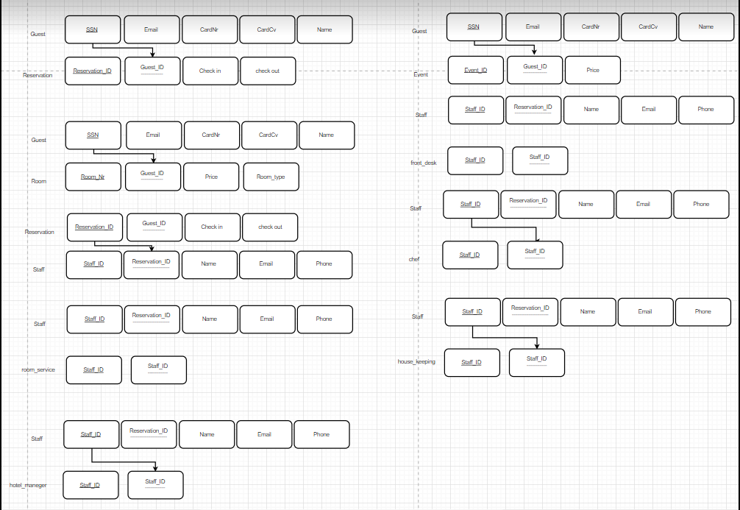ER Mapping:

SQL Code:

create table staff

(

staff_id int primary key not null,

Name varchar(50),

phone int,

address varchar(50),

email varchar(50)

);

CREATE TABLE IF NOT EXISTS 'hopverkefni'

(

ID int(11) NOT NULL AUTO_INCREMENT PRIMARY KEY,

name varchar(60) NOT NULL,

email varchar(60) NOT NULL,

roomType varchar(60) NOT NULL,

doa varchar(60) NOT NULL,

dol varchar(60) NOT NULL,

cardNum varchar(60) NOT NULL,

cv varchar(60) NOT NULL,

);

create table departments

(

departments_ID int primary key not null,

hotel_maneger int,

front_desk int,

chef int,

house_keeping int,

room_service int,

staff_ID int,

foreign key (staff_ID) references staff(staff_ID)

);

create table guest

(

SSN int primary key not null,

name varchar(50),

CardNr int,

CardCv int,

email varchar(50)

);

create table reservation

(

reservation_ID int primary key not null,

check_in date,

check_out date,

guest_ID int,

foreign key (guest_ID) references guest(SSN)

);

create table room

(

roomNr int primary key not null,

price int,

RoomType int,

guest_ID int,

foreign key (guest_ID) references guest(SSN)

);

create table Event

(

Event_ID int primary key not null,

Name varchar(50),

Email varchar(50),

Event_Type varchar(60),

guest_ID int,

CardNr int,

CardCv int,

Booking_date date,

foreign key (guest_ID) references guest(SSN)

);

create table Hotel_Manager

(

Staff_ID int primary key not null,

foreign key (Staff_ID) references staff(Staff_ID)

);

create table

(

Staff_ID int primary key not null,

foreign key (Staff_ID) references staff(Staff_ID)

);

create table Front_Desk

(

Staff_ID int not null primary key,

foreign key (Staff_ID) references staff(Staff_ID)

);

create table HouseKeeping

(

Staff_ID int primary key not null,

foreign key (Staff_ID) references staff(Staff_ID)

);

create table Room_Service

(

Staff_ID int primary key not null,

foreign key (Staff_ID) references staff(Staff_ID)

);

create table Chef

(

Staff_ID int primary key not null,

foreign key (Staff_ID) references staff(Staff_ID)

);

-------------------------------------------------------------------

insert into staff()

values

(1,"Aron",8482690,"aaa","aront@hotmail.com"),

(2,"Jon",6451645,"afasdf","jon@gmail.com"),

(3,"petur",845460,"pp","Petur@hotmail.com"),

(4,"atli",1235234,"at","atli.com"),

(5,"johanna",123123,"jp","jonna.com");