PROGRAMMING AND ALGORITHMS ASSIGNMENT

|  |  |
| --- | --- |
| Submitted by, | Submitted to, |
| Student name | Teacher’s name |
| Ethical Hacking | Programming and algorithms 1 |
| ID |  |
|  |  |
|  |  |
|  |  |
|  |  |

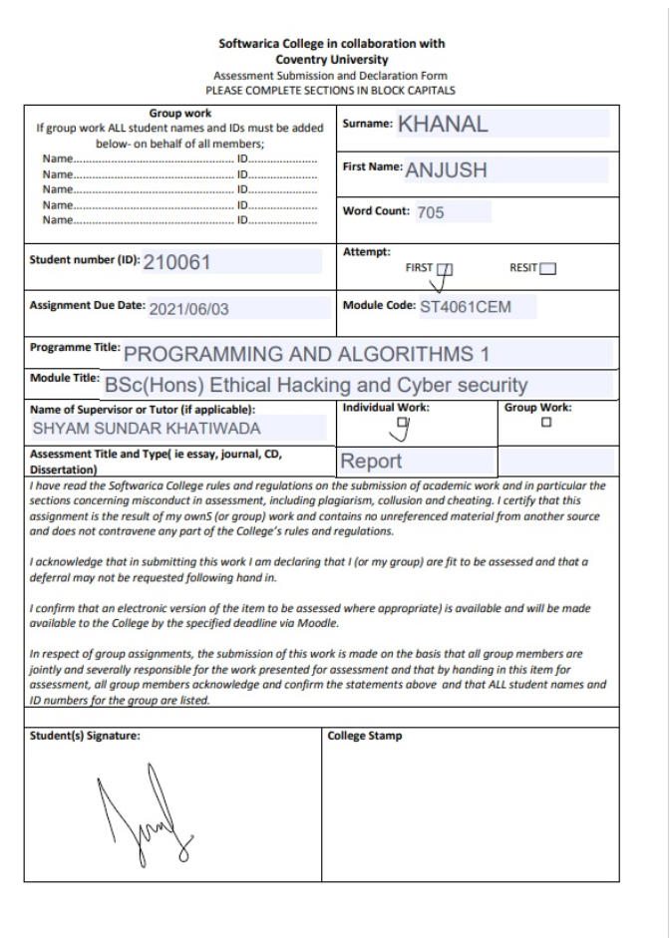

**Table of contents**

Introduction, problem statement and system requirements............…………………………………………. page4

Screenshots of Interface……………………………………………………………………………………………………………...page 5

**Tkinter and root window………………………………………………………………………………………………………………page 6,7**

Button 1, its functions and its testing……………………………………………………………………………………………page 8

Button 2, its functions and its testing……………………………………………………………………………………………page 9

Button 3, its functions and its testing……………………………………………………………………………………………page 10

Button 4, its functions and its testing……………………………………………………………………………………………page 11

Whole code………………………………………………………………………………………………………………………….... page 12,13

Conclusion……………………………………………………………………………………………………………………………………page14

References……………………………………………………………………………………………………………………………………page 15

**Introduction**

Python is a widely used general-purpose high-level programming language which was created by Guido van Rossum and was first released in 1991. It is an object-oriented programming language. Python is comparatively easier than other programming languages.

For my assignment, I made a registration form In GUI (Graphical User Interface). I focused more on the interface that a user gets. I used tkinter for my GUI. For my form I did 4 entries i.e. First name, Last name, Age, and grade. My theme for it is “Inter School Guitar Competition”. I also put an image in the background for nice interface for the form. I programmed 4 buttons in the application with 4 unique commands of each. I created 3 windows in total in which the other 2 windows comes after clicking the required buttons.

**Problem Statement**

In my project, I created a form to make data entry easier. There are some minor problems like coordination and much more. I wish to improve it in the future.

**System Requirements**

* Python 3 or higher
* Operating system: Windows, Mac, Linux
* Required library: tkinter

Screenshots of Interface:

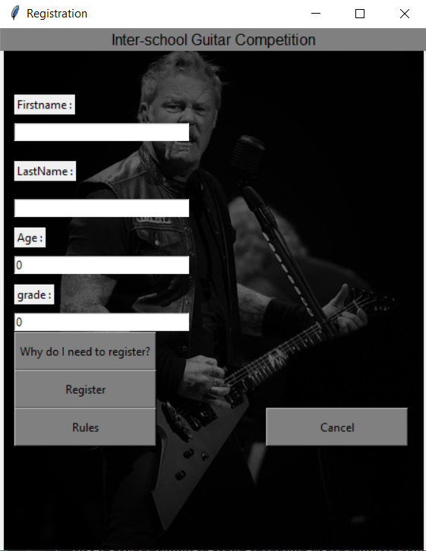 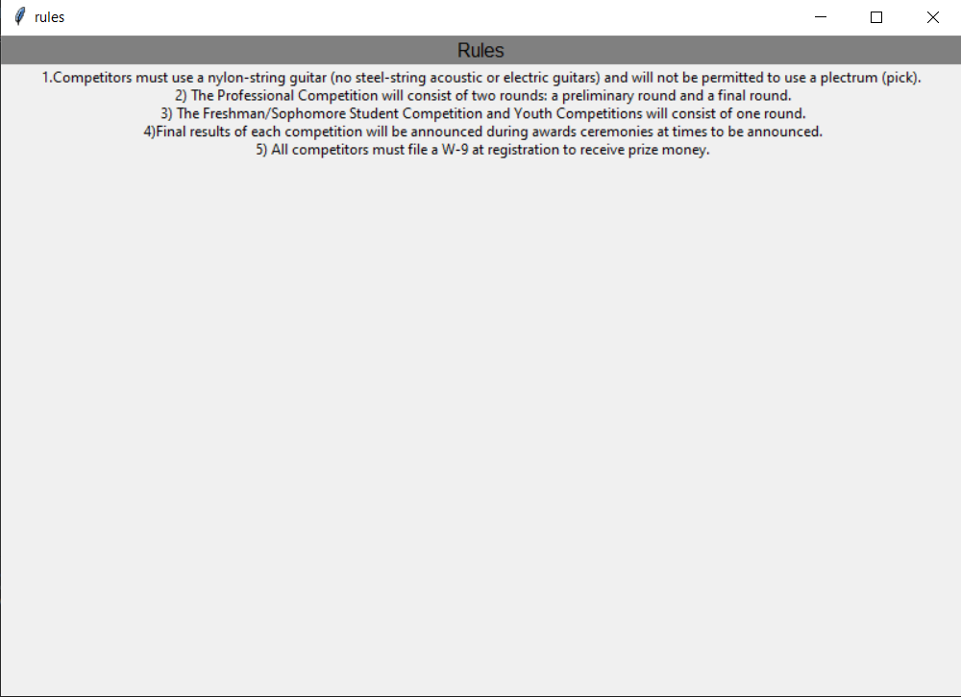

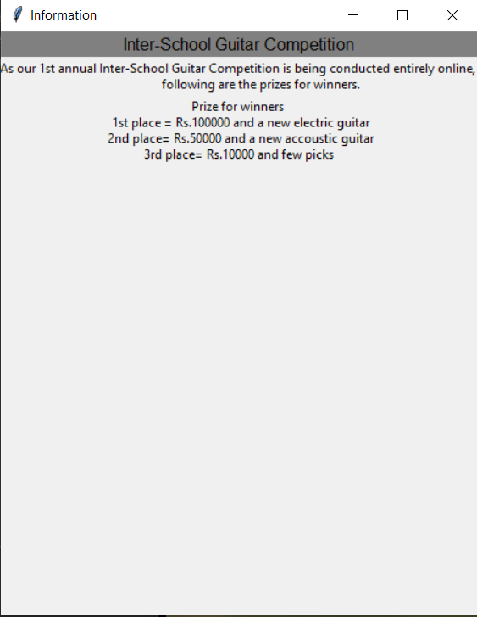



First of all, I imported tkinter from library.

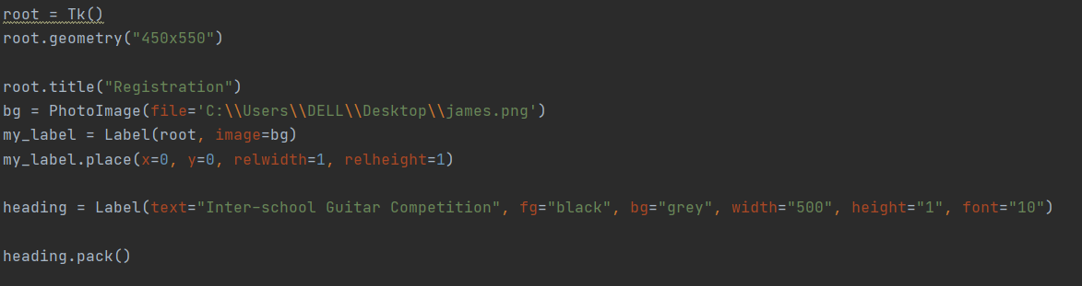

After that I gave my window size and a title and gave it a background image in (.png) file. And gave it a heading.

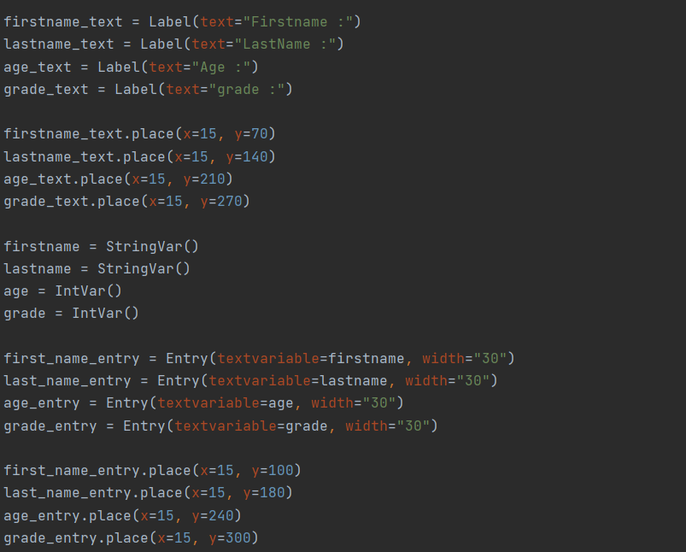

Now I started to fill the window with first name, last name, age, and grade along with its text boxes. I gave string variable to first name and last name and Integer variable to first name and last name. I gave appropriate coordination to the functions through which the text and text box in the form appear in an attractive way.

**Buttons and its testing**

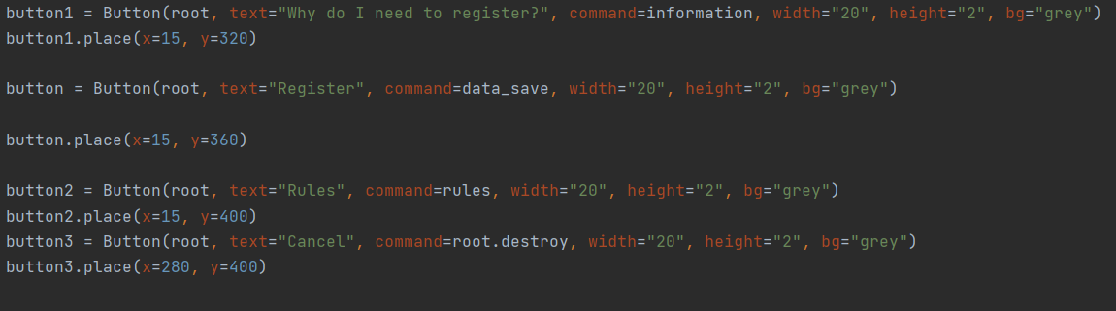

**1st button**

As in the screenshot, “button1” is the first button which command is “information” function. I made a function in the program named “information”. This button shows the information about the reason to fill the form. I used the same size for the main window and the information window. The code of function is given below: -

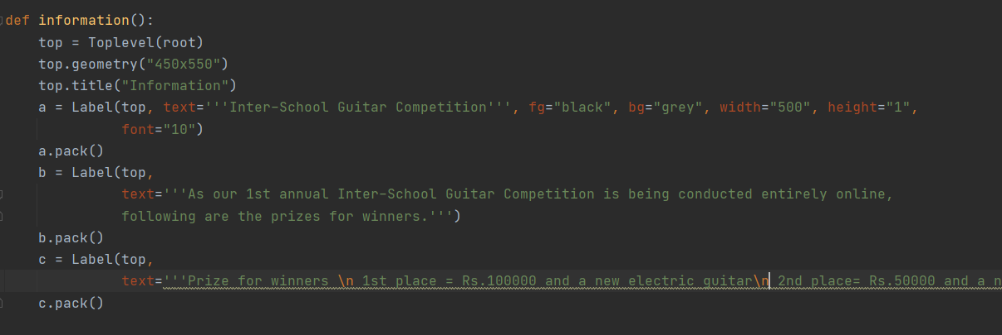

**Testing the first button**

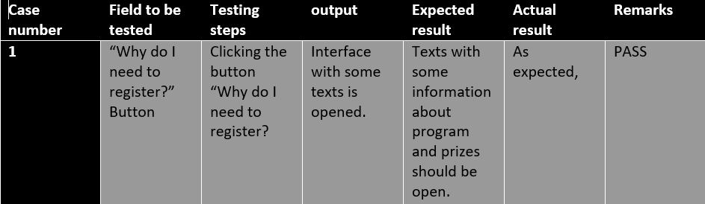

**2nd button**

As in the main screenshot above, “button” is the second button which command is “data_save” function. I made a function in the program named “data_save”. This button saves the data that has been entered in the form In text (.txt) file. The “data_save” function contains file handling codes in which I have opened file and wrote on it. I passed the variable as firstname, lastname, age and grade. The code of function is given below: 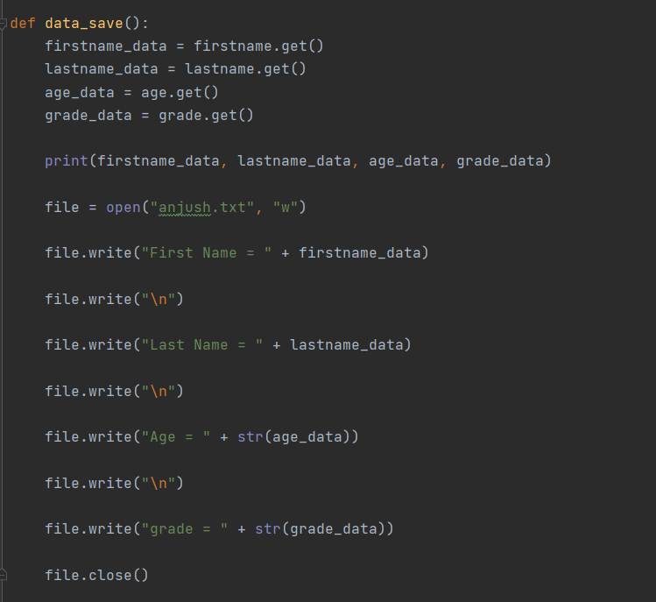

**Testing of 2nd button**

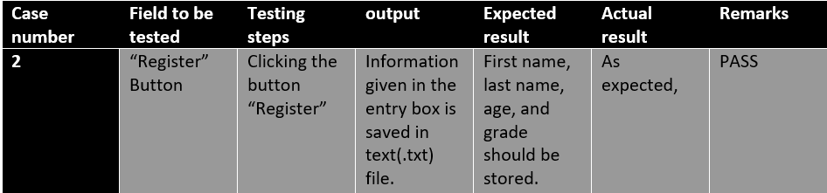

**3rd button**

As in the main screenshot above, “button2” is the third button which command is “rules” function. I made a function in the program named “rules”. This function opens another window and shows rules for the competition. It is a little bigger than other windows. The code of the function is given below:

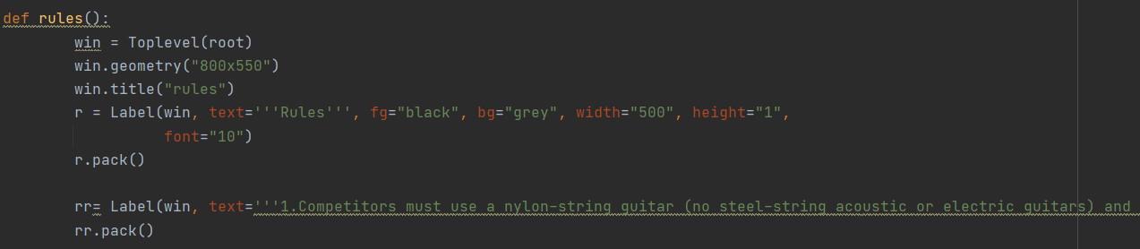

**Testing of 3rd button**

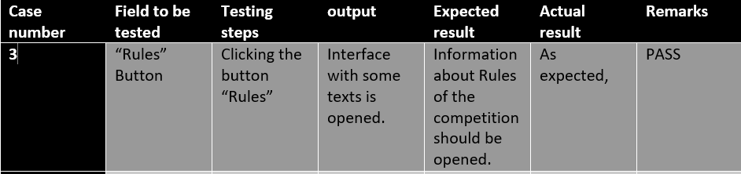

**4th button**

As in the main screenshot above, “button3” is the second button which command is “cancel” function. I made a function in the program named “cancel”. Its command is “root.destroy”. The destroy command destroys the current interface. So by clicking this button, the window gets closed. The code of the function is given below:



**Testing of 4th button**

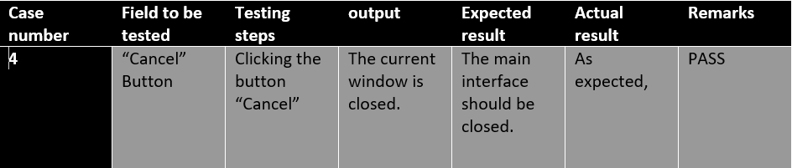

**Whole code**



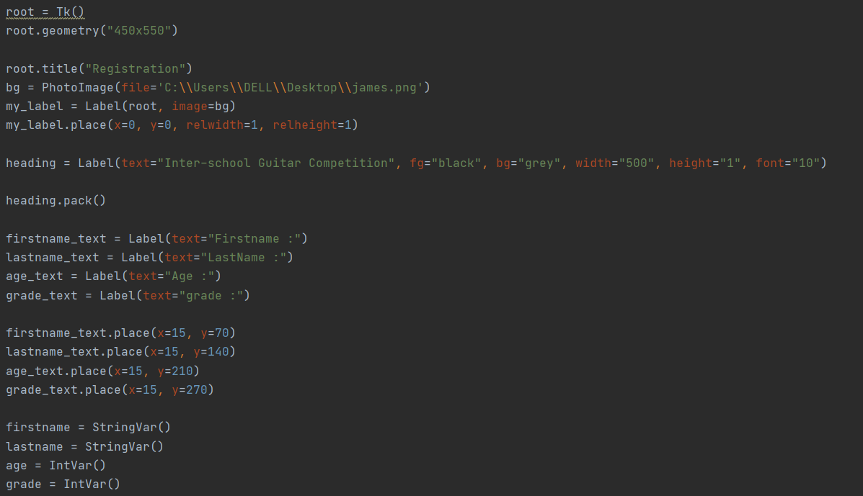

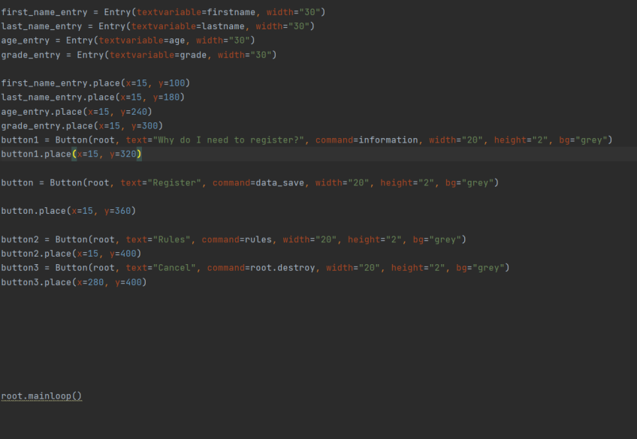

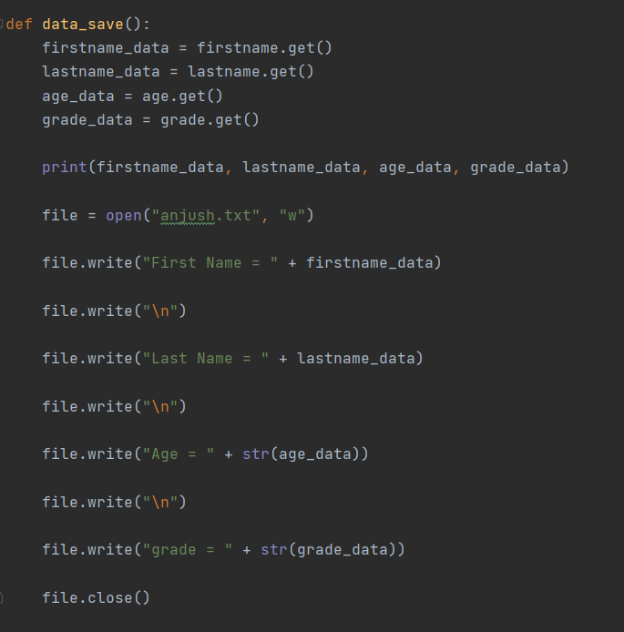

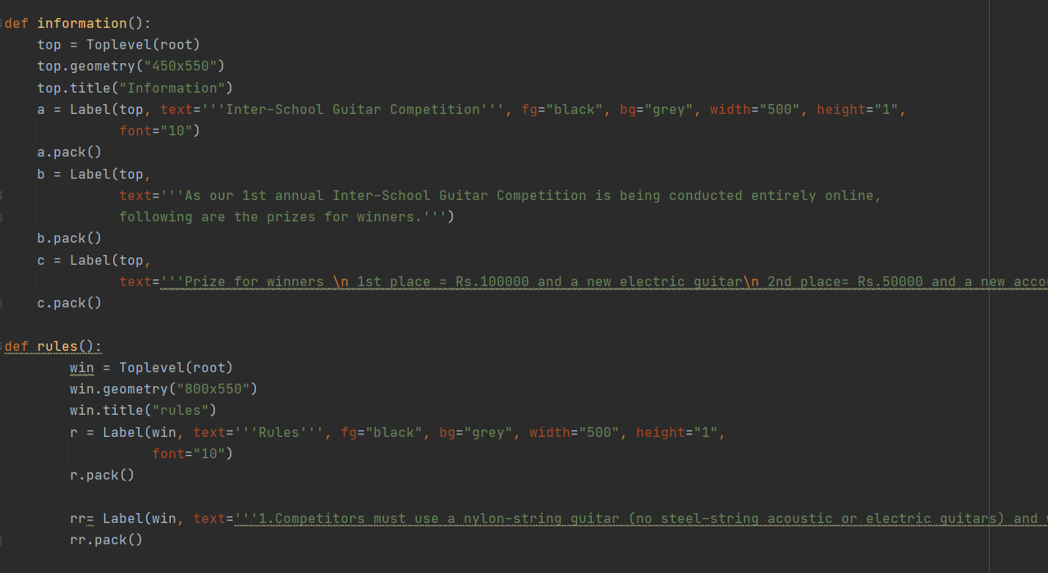

**Conclusion**

We can make an application for registration form from the code that I did for the assignment. It is GUI based and it is linked with file handling. The app is finished by using functions like tkinter, Toplevel, button and many more. We have used different windows and different widgets. I got to know about lots of new things about python programming. A lots of research was done for the sake of the assignment.

References:

[https://www.geeksforgeeks.org/python-language-introduction/#:~:text=Python%20is%20a%20widely%20used,in%20fewer%20lines%20of%20code](https://www.geeksforgeeks.org/python-language-introduction/" \l ":~:text=Python%20is%20a%20widely%20used,in%20fewer%20lines%20of%20code).

<https://docs.python.org/3/library/tkinter.html>

<https://www.tutorialspoint.com/python/tk_toplevel.htm>