**_____________________________________________**

**Software Requirements Specification**

**for**

**Programme and Curriculum Management**

**Prepared by: ARPIT GUPTA** [**20bcs041@iiitdmj.ac.in**](mailto:20bcs041@iiitdmj.ac.in)

**ANIKET PRASAD** [**20bcs029@iiitdmj.ac.in**](mailto:20bcs029@iiitdmj.ac.in)

**February 4, 2023**

# **Table of Contents**

**1. Introduction 2**

1.1 Purpose 2

1.2 Product Scope 2

1.3 References 2

**2. Overall Description 3**

2.1 Product Perspective 3

2.2 Product Functions 3

2.3 User Classes and Characteristics 4

2.4 Assumptions and Dependencies 5

**3. External Interface Requirements 5**

3.1 User Interfaces 5

3.3 Software Interfaces 5

**4. System Features (Functional Requirements) 6**

4.1 User Interaction 6

4.2 Acad Admin Interaction 7

**5. List of Open Issues 10**

# **1. Introduction**

## **1.1 Purpose**

The objectives of this application is to provide addition of new Programmes, and management of Curriculum for the different Programmes offered by the Institute. Each Programme could update its Curriculum for a batch/batches.

## **1.2 Product Scope**

The scope of the application covers the entire Programmes & its Curriculums offered by the Institute. Where the user can view their requirements curriculum and programme.

## **1.3 References**

Websites:

[**https://www.iiitdmj.ac.in/academics/curriculum.php**](https://www.iiitdmj.ac.in/academics/curriculum.php)

[**https://www.iiitdmj.ac.in/academics/programme.php**](https://www.iiitdmj.ac.in/academics/programme.php)

[**http://www.uml-diagrams.org/use-case-include.html**](http://www.uml-diagrams.org/use-case-include.html)

[**http://pmblog.accompa.com/2009/10/08/use-case-template-example-requirementsmanagement-basics/**](http://pmblog.accompa.com/2009/10/08/use-case-template-example-requirementsmanagement-basics/)

# **2. Overall Description**

## **2.1 Product Perspective**

Programme and Curriculum management for an Institute is a cumbersome task. Institute Curriculum is updated for the betterment i.e., to provide a rich educational curriculum to the students of their respective Programmes. Therefore managing different versions of the curriculum needs to be digitized, helping both Institute and students to better know their Curriculum.

In the current scenario, the updated curriculum for the different batches is published in a PDF document, showing the available set of courses for each semester for the different Programmes.

With this application, the User when logged in, can view all the Programmes the Institute can offer, and its respective Curriculum. The Students get to know the available courses for any Semester of a Curriculum. Acad Admin can update the Curriculum, making the updated Curriculum easily available for the User to see.

## **2.2 Product Functions**

* Users can view the updated Curriculum and the different Programmes the Institute can offer. Users can view any Curriculum of any Programme..
* The Acad Admin takes the responsibilities to update the Curriculum of a respective Programme.
* The Acad Admin takes the responsibilities to add a new Programme which the Institute can offer.
* The Acad Admin takes the responsibilities to add/update a Course of a specific semester of a particular Curriculum of a particular Programme.

## **2.3 User Classes and Characteristics**

We specify the functional requirements for the module using the use cases. The figure represents the use case diagram for the module features.

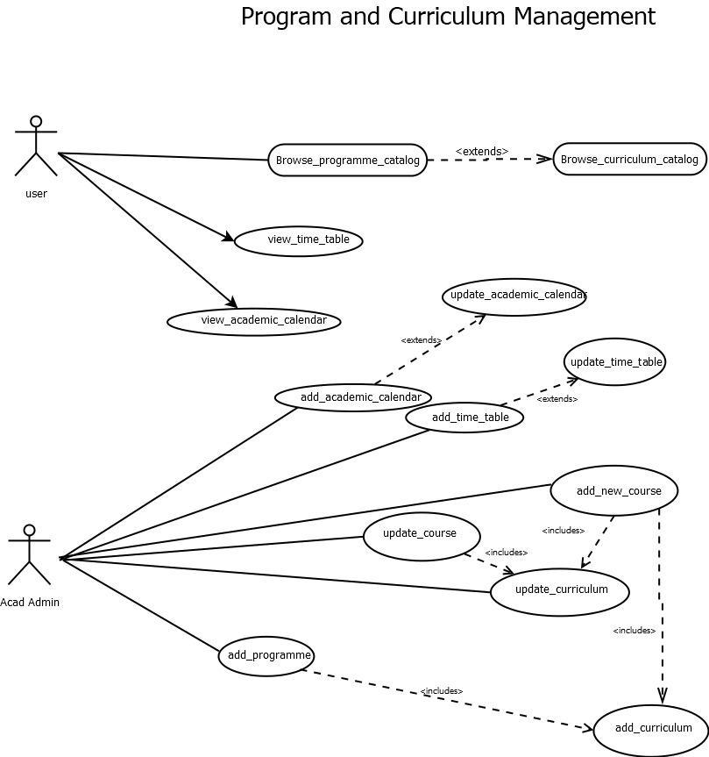

## 

## **2.4 Assumption and Dependencies**

* All Users are given their credentials by the Admin.
* A User can view the current (or updated) Curriculum of any Programme the Institute can offer.
* The Acad admin can add or update any Course of any Curriculum of any Programme.
* The Acad admin can add or update any Curriculum of any Programme.
* The Acad admin can add but cannot update any Programme.
* The Institute can have any number of Programmes. But every Programme requires at least a Curriculum.
* A Programme can have any number of Curriculums, but only one Curriculum is assigned to a specific student batch. No student batch can be assigned to more than one Curriculum.
* Every Curriculum has a fixed number of Semesters.

# **3. External Interface Requirements**

## **3.1 User Interface**

A user will be logged in with the password and user-id he/she has with him/her and proceeding further to his home page (Programme and Curriculum Management Module) where he/she will be shown his/her profile by default beside that the programme name (B-Tech/B-Des, M-Tech/M-Des, etc) will be also displayed. Then the user has to click on any program. After clicking, a new page will come, where he/she needs to fill in the details of the branch, batch, semester, etc in order to view the particular curriculum.

## **3.2 Software Interface**

The system will be interacting with a database written in Django and will be working on web browsers like Google Chrome, Mozilla Firefox, Microsoft Edge etc.

# **4. System Features (Functional Requirements)**

## **4.1 System features for the User (System Feature- 1)**

### **4.1.1 Browse_programme_catalog**

| **UC id** | **UC#1** |
| --- | --- |
| **Use case name** | **Browse_programme_catalog** |
| **Actor** | **Student, Acad Admin** |
| **Description** | **The user of the system can browse the available programme categorically.**  **https://www.iiitdmj.ac.in/academics/programme.php** |
| **Precondition** | **The user must be logged-in** |
| **Main flow** | 1. **The Actor logs into the system.** 2. **The Actor then opens the Programme and Curriculum module.** 3. **The Actor can see the available Programmes the Institute can offer.** |
| **Post Condition** | **The necessary details of the Programmes are displayed.** |

### **4.1.2 Browse_curriculum_catalog**

| **UC id** | **UC#2** |
| --- | --- |
| **Use case name** | **Browse_curriculum_catalog** |
| **Actor** | **Student, Acad Admin** |
| **Description** | **The user of the system can browse the available curriculum categorically.**  **https://www.iiitdmj.ac.in/academics/curriculum.php** |
| **Precondition** | **The user must be logged-in** |
| **Main flow** | 1. **The Actor logs into the system.** 2. **The Actor then opens the Programme and Curriculum module.** 3. **The Actor then selects the desired Programme.[S1]** 4. **The Actor then selects the desired Curriculum.** 5. **The Actor is now able to see the different Courses available for the different Semesters.** |
| **Sub flow** | **S1. Extend ‘Browse_programme_catalog’** |
| **Post Condition** | **The necessary details of the different Curriculums with their courses are displayed.** |

### **4.1.3 view_time_table**

| **UC id** | **UC#3** |
| --- | --- |
| **Use case name** | **view_time_table** |
| **Actor** | **Student** |
| **Description** | **The user of the system can see the time table.** |
| **Precondition** | **The user must be logged-in** |
| **Main flow** | 1. **The Actor must login to the system** 2. **The Actor should open the academic module** 3. **The Actor should click on the current semester.** 4. **Then Actor should click on the time table to see the time table.** |
| **Post Condition** | **The respective time table is shown.** |

### 

### 

### **4.1.4 view_academic_calendar**

| **UC id** | **UC#4** |
| --- | --- |
| **Use case name** | **view_academic_calendar** |
| **Actor** | **Student** |
| **Description** | **The user of the system can see the time table.** |
| **Precondition** | **The user must be logged-in** |
| **Main flow** | 1. **The actor must login to the system** 2. **The actor should open the academic module.** 3. **The actor should click on the current semester.** 4. **Then actor should click on the academic calendar to see the curriculum.** |
| **Post Condition** | **The respective calendar is shown.** |

## **4.2 System features for Acad Admin (System Feature- 2)**

### **4.2.1 Add_new_course**

| **UC id** | **UC#5** |
| --- | --- |
| **Use case name** | **add_new_course** |
| **Actor** | **Acad Admin** |
| **Description** | **The Acad Admin can add a new course that is not included in the curriculum along with faculty who will be teaching.** |
| **Precondition** | **The Acad Admin must be logged-in** |
| **Main flow** | 1. **The Actor logs into the system.** 2. **The Actor then opens the Programme and Curriculum module.** 3. **Actor clicks on the ‘Add new course’ option.** 4. **Actor then selects the Programme.** 5. **Actor enters the course name along with all the meta data like Course code Faculty name, etc** 6. **After that, the Actor can add the syllabus of a particular course.** 7. **After successfully filling the details, the Actor clicks on Submit.** |
| **Post Condition** | **The course code is generated and the course is saved in the Database.** |

### **4.2.2 Update_course**

| **UC id** | **UC#6** |
| --- | --- |
| **Use case name** | **update_course** |
| **Actor** | **Acad Admin** |
| **Description** | **The Acad Admin can update an already added course or can update the faculty who is teaching a particular course.** |
| **Precondition** | **The Acad Admin must be logged-in.**  **The Acad Admin must know the code of course to be updated.** |
| **Main flow** | 1. **The Actor logs into the system.** 2. **The Actor then opens the Programme and Curriculum module.** 3. **Actor clicks on the ‘Update new course’ option.** 4. **Acad Admin enters the course code.** 5. **Acad Admin can update the necessary meta-data of the course.** 6. **After that, they can update the syllabus of a particular course.** 7. **After successfully updating the details, the Actor clicks on Submit.** |
| **Post Condition** | **The course is updated and saved in the Database.** |

### **4.2.3 Update_curriculum**

| **UC id** | **UC#7** |
| --- | --- |
| **Use case name** | **update_curriculum** |
| **Actor** | **Acad Admin** |
| **Description** | **The Academics Incharge can update the curriculum, in respect of no. of credits, no. of course/lab, in each semester with respect to particular discipline of a particular year.**  **Guidelines: https://www.iiitdmj.ac.in/academics/download/UG%20Curriculum_2016%20onwards.pdf** |
| **Precondition** | **The Acad Admin gets a notification after every 3 to 5 years, that the curriculum needs to get changed.**  **The Acad Admin must be logged-in.** |
| **Main flow** | * **The Actor logs into the system.** * **The Actor then opens the Programme and Curriculum module.** * **Actor clicks on the ‘Update curriculum’ option.** * **Acad Admin Selects the desired.** * **Then, they can change the no. of discipline/elective course, labs in each Semester, Academic load of a particular course.** * **After successfully updating the details, click on Submit. [S1][S2]** |
| **Sub Flow** | **S1. Include ‘add_new_courses’**  **S2. Include ‘update_courses’** |
| **Post Condition** | **The curriculum is updated and saved in the Database.** |

### **4.2.4 Add_curriculum**

| **UC id** | **UC#8** |
| --- | --- |
| **Use case name** | **add_curriculum** |
| **Actor** | **Acad Admin** |
| **Description** | **The academic in charge can add a new curriculum and with a new Branch, and mention the no. of credits, no. of course/lab, in each semester with respect to Branch of a particular year.**  **Guidelines: https://www.iiitdmj.ac.in/academics/download/UG%20Curriculum_2016%20onwards.pdf** |
| **Precondition** | **The Acad Admin must be logged-in.** |
| **Main flow** | 1. **The Actor logs into the system.** 2. **The Actor then opens the Programme and Curriculum module.** 3. **Actor clicks on the ‘Add curriculum’ option.** 4. **Actor mentions the no. of Semesters.** 5. **Then, the Actor can add the no. of disciplines/elective course, labs in each Semester, and the Academic load of a particular course.** 6. **After successfully adding the details, click on Submit. [S1][S2]** |
| **Sub Flow** | **S1. Include ‘add_new_courses’**  **S2. Include ‘update_courses’** |
| **Post Condition** | **The new curriculum is added into the Database.** |

### **4.2.5 Add_programme**

| **UC id** | **UC#9** |
| --- | --- |
| **Use case name** | **add_programme** |
| **Actor** | **Acad Admin** |
| **Description** | **The Academics Incharge can add a programme to the list of programmes the Institute can offer.** |
| **Precondition** | **The Acad Admin must be logged-in.** |
| **Main flow** | 1. **The Actor logs into the system.** 2. **The Actor then opens the Programme and Curriculum module.Actor clicks on the ‘Add Programme’ option.** 3. **Actor adds the discipline, batch year, and the no. of semesters.** 4. **Then, they can add courses/elective courses, or labs in each Semester, and the Academic load of a particular course.** 5. **After successfully updating the details, click on Submit. [S1]** |
| **Sub Flow** | **S1. Include ‘add_curriculum’** |
| **Post Condition** | **The programme & curriculum is generated and saved in the Database.** |

### 

### **4.2.6 add_time_table**

| **UC id** | **UC#10** |
| --- | --- |
| **Use case name** | **add_time_table** |
| **Actor** | **Acad Admin** |
| **Description** | **The Academics Incharge (admin) can add academic time table.** |
| **Precondition** | **The Acad Admin must be logged-in.** |
| **Main flow** | 1. **The Actor logs into the system.** 2. **The Actor then opens the academic module and click on time table option.** 3. **The actor fill the programme, batch and branch.** 4. **The actor then upload the pdf of the time table.** 5. **After successfully updating the details, click on Submit.** |
| **Post Condition** | **The time table is saved in the Database.** |

### **4.2.7 add_academic_calendar**

| **UC id** | **UC#11** |
| --- | --- |
| **Use case name** | **add_academic_calendar** |
| **Actor** | **Acad-admin** |
| **Description** | **The Academics Incharge (admin) can add academic calendar.** |
| **Precondition** | **The Acad Admin must be logged-in.** |
| **Main flow** | 1. **The Actor logs into the system.** 2. **The Actor then opens the academic module and then click on academic calendar option.** 3. **Then Actor clicks on the more option .** 4. **Then actor enter the description from date and to date.** 5. **After successfully filling the details, click on Submit.** |
| **Post Condition** | **The new entry is added in academic calendar in the Database.** |

### **4.2.6 update_academic_calendar**

| **UC id** | **UC#12** |
| --- | --- |
| **Use case name** | **update_academic_calendar** |
| **Actor** | **Acad-admin** |
| **Description** | **The Academics Incharge (admin) can update academic calendar.** |
| **Precondition** | **The Acad Admin must be logged-in.** |
| **Main flow** | 1. **The Actor logs into the system.** 2. **The Actor then opens the academic module and then click on academic calendar option.** 3. **Then actor clicks on the update button on the side of each row.** 4. **Then actor updates the respective detail which he need to update.** 5. **After successfully filling the details, click on Submit.** |
| **Post Condition** | **The academic calendar is updated in the Database.** |

# **5. List of Open Issues**

| **S. No** | **Issue Details** | **Category** | **Solution** | **Comments** |
| --- | --- | --- | --- | --- |
| 1. |  |  |  |  |
| 2. |  |  |  |  |