**Software Requirements Specification**

**For**

**Admin-1 Department Module**

<version 1.3>

**Team Members**

Harshit Singh

Hrishikesh Shinde

Mohit Chauhan

Napan Vijayvargiya

Prashant Chauhan

Rajat Goyal

Satvik Patel

Thakur Ashiwani

**Table of Contents**

1. Introduction……………………………………………………3
   1. Purpose……………………………………………………….….3
   2. Product Scope…………………………………………………3
   3. References………………………………………………………3
2. Overall Description…………………………………………3
   1. Product Perspective……………………………………....3
   2. Product Function………………………………………….…3
   3. User Classes and Characteristics………………….....4
   4. Assumption and Dependencies……………………….6
3. External Interface Requirements…….…….………6
   1. User Interfaces……………………………………………….6
   2. Software Interfaces………………………………………..6
4. System Features (Functional Requirements)……..6
   1. Use case Description for user as an actor……….7
   2. Use case Description for Student as an actor….7
   3. Use case Description for Faculty as an actor……8
   4. Use case Description for Admin as an actor…….9
5. **Introduction**
   1. **Purpose**

This document specifies various requirements for the “ Department module” of the Institute ERP being developed. The Department module would provide a platform where all the students of IIITDMJ can view the details of various departments and register in a particular department. They would receive timely notifications regarding any meetings, webinars and the necessary announcements made by the faculties. The faculty can view and modify student data and this system would provide an automated and hassle-free alternative to the existing manual application procedure.

* 1. **Product Scope**

This software will be mostly used by the students of IIITDM Jabalpur to get all the necessary details about the Admin department. They also get the feature to edit their profile.

* 1. **References**

<https://www.iiitdmj.ac.in/administration/administrative_structure.php>

<https://www.iiitdmj.ac.in/administration/administration.php>

1. **Overall Description**
   1. **Product Perspective**

The admin-1 department portal is a new system that replaces the current manual and tedious processes for various administrative activities. The system is expected to evolve over further releases and develop into a fully automated system thereby minimizing manual efforts and paperwork.

* 1. **Product Function**

1. The Department module can be accessed over all platforms using the majority available web browsers.
2. The System shall permit user access from the institute Fusion website. Any user from outside the college will not able to access the portal.
   1. **User Classes and Characteristics**

Following are the users of the module

User: A user is the person who has logged in the system. He is able to browse through the announcements of all the departments and view the complaint status. (For CSE Department instead of announcement and request there is Alumni and track record ) .

Student: A student of IIITDM Jabalpur who first logs into the system. He is able to browse through the details of the student, faculty, Alumni and the departments can view the announcement made by admin/faculty and can make a complaint or query to the department .

Faculty: The main purpose of the Faculty is to make announcement for the student and follow the administration announcement department . Faculty can see all the navigation menu as seen by Student. Faculty can view Alumni

Admin: People responsible for circulating notification / making announcement regarding meetings/webinar/conferences. Each Department has different admin and the respective admin can make the announcement /edit/save as draft for that department .

**Use Case Diagram**

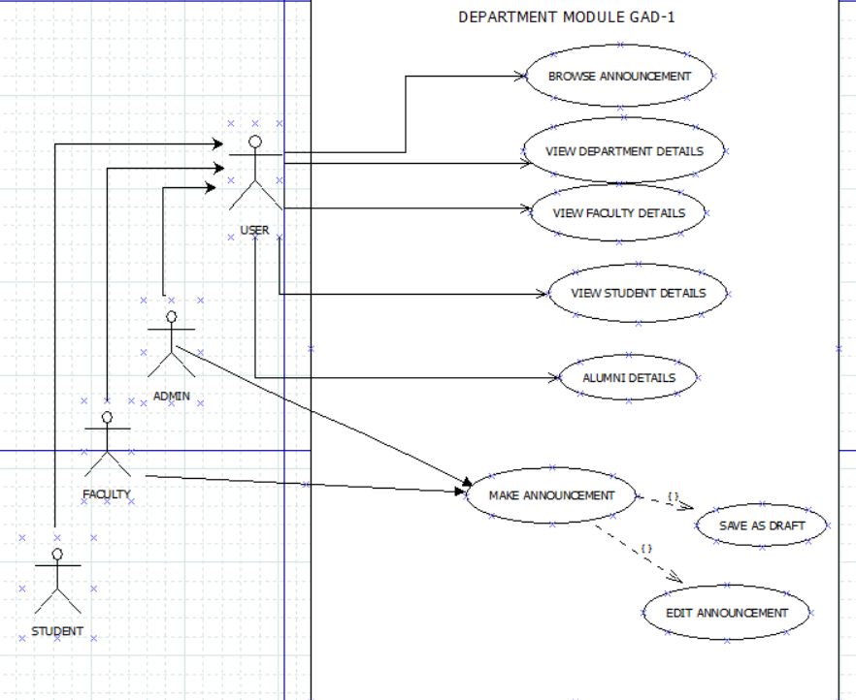

LINK TO DIA FILE:- <https://drive.google.com/file/d/1eD9VcubxdUEBcsJBU9K1sSQzaFjZNYu7/view?usp=share_link>

* 1. **Assumptions and Dependencies**

1. It is assumed that all the details provided by the students are accurate and up to date.
2. It is a dependency that for the portal to function properly, the entire student keeps their profiles updated all times whenever required.

3.**External Interface Requirement**

3.1 **User Interfaces**

1. The interface shall be based on the web and has to be run from web server.

2. The module shall take initial load time depending on internet connection strength which also depends on the media from which it is run.

3. The user interface - simple and easy to use

3.2 **Software Interfaces**

1. The module is linked with the database and some other module

to query and update the data.

1. The performance shall very loosely depend upon hardware components of the user given a web-browser minimum-requirements are met.
2. A lot of data has to be queried from the database which may lead to decrease in response time of the pages to load if too much user requests the services from the system.

4. **System Features**

We specify the functional requirements for the module using use cases. The section represents the use case diagram for the module features.

* 1. Use Case Description for a User as an actor to system

Use Case #1

| UC ID | UC#1 | |
| --- | --- | --- |
| Use case name | Browse announcement | |
| Description | Use of the system can browse the available notifications/announcement | |
| Actor | Admin,Student,Faculty | |
| Precondition | The user must be logged in and the system is having the updated information of all the department and announcement made. | |
| Main Flow | 1. | Actor logs into the system and opens Department Page. |
| 2. | Actor selects the Browse announcement option |
| Post condition | The necessary details of the department are displayed .  The system returns to the actor’s dashboard | |
| Alternate Flow | nil | |
| Sub flow | nil | |
| Global Alternate flow | GA1 | The actor can return to the dashboard at any time by clicking in the dashboard button. |

4.2 Use case description for Admin (extending User) as an actor to the system.

Use case #2

| UC ID | UC#2 | |
| --- | --- | --- |
| Use case name | make new announcement | |
| Description | Admin can make new announcement related to department for student and Faculty related to that specific department | |
| Actor | Admin | |
| Precondition | Admin logged in ,opened Department module | |
| Main Flow | 1. | Admin selects the “Make Announcement “ tab |
| 2. | Admin types the announcement and clicks publish |
| Post condition | The announcement made by the admin is visible to the faculty and students under the “browse announcement “ option. | |
| Alternate Flow | The Admin can “Save the announcement as draft” | |
| Sub flow | The Admin can “Edit the announcement ” . | |
| Global Alternate flow | GA1 | The actor can return to the dashboard at any time by clicking in the dashboard button. |
| Post condition : the system returns to the actor’s dashboard. |

4.3 Use case description for Faculty (extending User) as an actor to the system.

Use case#3

| UC ID | UC#3 | |
| --- | --- | --- |
| Use case name | make new announcement | |
| Description | Faculty can make new announcement related to department for student and Admin related to that specific department | |
| Actor | Faculty | |
| Precondition | Faculty logged in ,opened Department module | |
| Main Flow | 1. | Faculty selects the “Make Announcement “ tab |
| 2. | Faculty types the announcement and clicks publish |
| Post condition | The announcement made by the faculty is visible to the admin and students under the “browse announcement “ option. | |
| Alternate Flow | The Faculty can “Save the announcement as draft” | |
| Sub flow | The Faculty can “Edit the announcement ” . | |
| Global Alternate flow | GA1 | The actor can return to the dashboard at any time by clicking in the dashboard button. |
| Post condition : the system returns to the actor’s dashboard. |

4.4 Use case Diagram and description for Students (extended user) as actor to the system.

Use case #4

| UC ID | UC#4 | |
| --- | --- | --- |
| Use case name | view student detail | |
| Description | The actor can view the student registered in respective departments in the institute according to the batches. | |
| Actor | Student | |
| Precondition | Actor logged in, opens Department module and system has updated information of the students. | |
| Main Flow | 1. | Student selects the respective department on the main page of the module. |
| 2. | Student clicks the students tab and selects the batches |
| 3. | Student clicks on the respective batch to view the details |
| Post condition | List of the student for the selected option are displayed | |
| Alternate Flow | nil | |
| Sub flow | nil | |
| Global Alternate flow | GA1 | The actor can return to the dashboard at any time by clicking in the dashboard button. |
| Post condition : the system returns to the actor’s dashboard. |

Use case #5

| UC ID | UC#5 | |
| --- | --- | --- |
| Use case name | view faculty detail | |
| Description | The actor can view the faculty registered in respective departments in the institute according to the department. | |
| Actor | Student | |
| Precondition | Actor logged in, opens Department module and system has updated information of the faculties. | |
| Main Flow | 1. | Student selects the respective department on the main page of the module. |
| 2. | Student selects the “Faculty tab”. |
| 3. | Student clicks on the view faculty to view the details |
| Post condition | List of the faculties for the selected option are displayed | |
| Alternate Flow | nil | |
| Sub flow | nil | |
| Global Alternate flow | GA1 | The actor can return to the dashboard at any time by clicking in the dashboard button. |
| Post condition : the system returns to the actor’s dashboard. |

Use case #6

| UC ID | UC#6 | |
| --- | --- | --- |
| Use case name | view department details | |
| Description | The actor can view the faculty registered in respective departments in the institute according to the department. | |
| Actor | Student | |
| Precondition | Student logged in, opens Department module and system has updated information of the department. | |
| Main Flow | 1. | Student selects the respective department on the main page of the module. |
| Post condition | List of the department for the selected option are displayed | |
| Alternate Flow | nil | |
| Sub flow | nil | |
| Global Alternate flow | GA1 | The actor can return to the dashboard at any time by clicking in the dashboard button. |
| Post condition : the system returns to the actor’s dashboard. |

Use case #7

| UC ID | UC#7 | |
| --- | --- | --- |
| Use case name | Alumni details | |
| Description | The actor can view the Alumni registered in respective departments of the institute according to the department. | |
| Actor | Student,Faculty | |
| Precondition | Actor logged in, opens Department module and system has updated information of the Alumni. | |
| Main Flow | 1. | Actor selects the respective department on the main page of the module. |
| 2. | Actor selects the “Alumni tab”. |
| 3. | Actor clicks on the view Alumni to view the details |
| Post condition | List of the Alumni for the selected option are displayed | |
| Alternate Flow | nil | |
| Sub flow | nil | |
| Global Alternate flow | GA1 | The actor can return to the dashboard at any time by clicking in the dashboard button. |
| Post condition : the system returns to the actor’s dashboard. |