**Software Requirements Specification**

**for**

HR-1

**Prepared by**

**Group Number:** *1*

| Ankit Mishra | 2018027 |
| --- | --- |
| Apoorv Jain | 2018318 |
| Shubham Jhanwar | 2018375 |
| Yash Shah | 2018390 |

**Date: 31/01/2021**

**Revisions**

| **Version** | **Primary Author(s)** | **Description of Version** | **Date Completed** |
| --- | --- | --- | --- |
| 1.0 | Ankit Kumar Mishra  Apoorv Jain  Shubham Jhanwar  Yash Shah | Developed the first version of SRS describing the core functions of the HR-1 module. | 31/01/2021 |
| 2.0 | Ankit Kumar Mishra  Apoorv Jain  Shubham Jhanwar  Yash Shah | Replaced the Functional Requirements with Use-Cases to remove redundancy.  Updated version giving more understanding of the problem. | 08/02/2021 |
| 3.0 | Ankit Kumar Mishra  Apoorv Jain  Shubham Jhanwar  Yash Shah | Updated the role of admin in the system. | 23/03/2021 |

# **Introduction**

This section gives a scope, description, and overview of everything included in this SRS document. Also, the purpose for this document is described and a list of abbreviations and definitions is provided*.*

## **Purpose**

## The purpose of this document is to give a detailed description of the requirements for the “HR-1” module of “Fusion” software. It will illustrate the purpose and complete declaration for the development of the system. It will also explain system constraints. This document is primarily intended to be proposed to a customer for its approval and a reference for developing the first version of the system for the development team.

## **Product Scope**

The HR-1 module consists of many activities, This software product will have a limited scope as some of the activities are taken care of by other software. This software will take care of the following activities:

* CPDA (Cumulative Professional Development Allowance)
* LTC (Leave Travel Concession)
* Appraisal

## **Definitions, Acronyms, and Abbreviations**

Table 1 - Definitions

| **Term** | **Definition** |
| --- | --- |
| User | Someone who interacts with the application. |
| LTC | Leave Travel Concession |
| CPDA | Cumulative Professional Development Allowance |
| Appraisal | A formal assessment of the performance of an employee over a particular period. |
| Faculty | The teaching or research staff of university departments |
| Staff | All the people employed by a particular organization. |
| Director | A person who is in charge of an organization. |
| Dealing Asstt. | Deals with the receipts. |
| HOD | Head of Department |
| AR | Assistant Registrar |
| DR | Deputy Registrar |
| Stakeholder | Any person who has interaction with the system who is not a developer. |
| Registrar | An official is responsible for keeping a register or official records. |
| SRS | Software Requirements Specification |
| Admin | Assigns reviewers to applications. |

## 

## **References and Acknowledgments**

[1] IEEE Software Engineering Standards Committee, “IEEE Std 830-1998, IEEE Recommended Practice for Software Requirements Specifications”, October 20, 1998.

[2] “Fusion” - Open Source Software,

https://github.com/FusionIIIT/Fusion

# **Overall Description**

This section will give an overview of the whole system. The system will be explained in its context to show how the system interacts with other systems and introduce the basic functionality of it. It will also describe what type of stakeholders will use the system and what functionality is available for each type. At last, the constraints and assumptions for the system will be presented.

## **Product** Perspective

HR-1 Module is software designed to manage different administrative procedures related to the faculties of PDPM IIITDM Jabalpur.

The software is designed to provide automated features to the faculties and Administration Staff, to handle different faculties’ activities.

The different activities that come under this module are CPDA, LTC, and Appraisal.

## **Product Funct**ions

* Faculty/Staff can apply for LTC, CPDA, and Appraisal through the web interface.
* The superiors can view the applications, approve and give reviews/remarks on them.
* Faculty/Staff can see the status of the application on their profile.

**2.3 User Classes and Characteristics**

Three types of users interact with the system: Users of the module, approval Authorities, and administrators. Each of these three types of users has a different use of the system so each of them has its own requirements.

The users which include the Faculty and Staff Members can only use the web application to submit their application. This means that the user has to be able to select the form, fill in the details, and then submit it.

The authorities will use the web portal to verify the details of the applicant (user) and then decide whether to approve or reject that application.

The administrators are managing the overall system so that there is no incorrect information within it. The administrator can manage the information for each application as well as the details of users and the approval authorities.

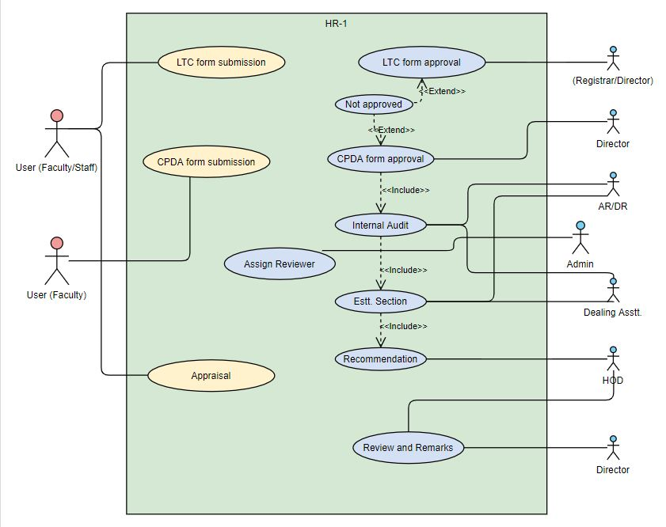

## 2.4 **Assumptions and Dependencies**

Our assumption about the product is that the Users using this module are already registered and their details are stored in the database.

If they aren’t, then it is the responsibility of the User and the Administrator to add the details.

# External Interface Requirements

This section provides a detailed description of all inputs into and outputs from the system. It also gives a description of the software and communication interfaces and provides basic prototypes of the user interface.

### 3.1 **User Interfaces**

The user interface for the users (faculty/staff) will include a page consisting of the 3 forms (in the form of buttons) that are included in this module. Once clicking any of the forms, it will open and can be filled out.

The user interface for the admins (Director/HOD/etc) will include a page consisting of the form applications that have been filled by other faculty/staff members. They can view and approve/reject the applications through the view, approve/reject buttons respectively.

### 3.2 **Software Interfaces**

The web portal communicates with the database in order to get information about the users and their activities. The communication between the database and the web portal consists of operations concerning both reading and modifying the data.

.

# 4 System Features (Functional Requirements)

This section includes the requirements that specify all the fundamental actions of the software system.

### 4.1 **Use Case #1**

| Use Case ID | UC#1 |
| --- | --- |
| Use Case Name | LTC form submission |
| Description | This use case describes the interaction between Faculty/Staff with the system to apply for LTC. |
| Actor | Faculty/Staff |
| Precondition | The Faculty/Staff must be logged in to the system. |
| Main Flow | 1. Faculty/Staff clicks on the LTC option on the panel on the right side. 2. LTC request form opens where Faculty/Staff fills the details. 3. Faculty/Staff clicks on the submit button. |
| Postcondition | Faculty/Staff is redirected to the requests page having pending status on LTC request. |
| Alternate Flow |  |
| Postcondition |  |
| Sub Flow |  |
| Postcondition |  |

### 

### 4.2 Use Case #2

| Use Case ID | UC#2 |
| --- | --- |
| Use Case Name | LTC approval |
| Description | This use case describes the interaction between the Registrar/Director with the system to approve or reject an LTC request. |
| Actor | Registrar/Director |
| Precondition | The Registrar/Director must be logged in the system. |
| Main Flow | 1. The Registrar/Director clicks on the LTC option on the panel on the right side. 2. The Registrar/Director clicks on the LTC requests tab on the left side panel. 3. A list of requests opens up and the registrar/director opens a request. 4. The Registrar/Director clicks on the APPROVE button. |
| Postcondition | The Registrar/Director is redirected to the LTC request page.  Faculty/Staff can see the approved status on his profile. |
| Alternate Flow | The Registrar/Director clicks on the REJECT button. |
| Postcondition | The Registrar/Director is redirected to the LTC request page.  Faculty/Staff can see not approved status with remarks on his profile. |
| Sub Flow |  |
| Postcondition |  |

**4.3 Use Case #3**

| Use Case ID | UC#3 |
| --- | --- |
| Use Case Name | CPDA form submission |
| Description | This use case describes the interaction between Faculty/Staff with the system to apply for CPDA. |
| Actor | Faculty/Staff |
| Precondition | The Faculty/Staff must be logged in to the system. |
| Main Flow | 1. Faculty/Staff clicks on the CPDA option on the panel on the right side. 2. CPDA request form opens where Faculty/Staff fills the details. 3. Faculty/Staff clicks on the submit button. |
| Postcondition | Faculty/Staff is redirected to the requests page having pending status on CPDA request. |
| Alternate Flow |  |
| Postcondition |  |
| Sub Flow |  |
| Postcondition |  |

**4.4 Use Case #4**

| Use Case ID | UC#4 |
| --- | --- |
| Use Case Name | HOD_Recommendation |
| Description | This use case describes the interaction between the HOD with the system to forward a CPDA request, |
| Actor | HOD |
| Precondition | The HOD must be logged in the system. |
| Main Flow | 1. The HOD clicks on the CPDA option on the panel on the right side. 2. The HOD clicks on the CPDA requests tab on the left side panel. 3. A list of requests opens up and HOD opens a request. 4. The HOD clicks on the APPROVE button. |
| Postcondition | The HOD is redirected to the CPDA request page.  The application is forwarded to Estt. Section. |
| Alternate Flow | The HOD clicks on the REJECT button. |
| Postcondition | The HOD is redirected to the CPDA request page.  Faculty/Staff can see not approved status with remarks on their profile. |
| Sub Flow |  |
| Postcondition |  |

**4.5 Use Case #5**

| Use Case ID | UC#5 |
| --- | --- |
| Use Case Name | Estt. Section |
| Description | This use case describes the interaction between the AR/DR and Dealing Asstt. with the system to forward a CPDA request, |
| Actor | AR/DR, Dealing Asstt. |
| Precondition | The AR/DR, Dealing Asstt. must be logged in the system. |
| Main Flow | 1. The AR/DR, Dealing Asstt. clicks on the CPDA option on the panel on the right side. 2. The AR/DR, Dealing Asstt. clicks on the CPDA requests tab on the left side panel. 3. A list of requests open up and AR/DR, Dealing Asstt. opens a request. 4. The AR/DR, Dealing Asstt. clicks on the APPROVE button. |
| Postcondition | The AR/DR, Dealing Asstt. is redirected to the CPDA request page.  The application is forwarded to Internal Audit. |
| Alternate Flow | The AR/DR, Dealing Asstt. clicks on the REJECT button. |
| Postcondition | The AR/DR, Dealing Asstt. is redirected to the CPDA request page.  Faculty/Staff can see not approved status with remarks on their profile. |
| Sub Flow |  |
| Postcondition |  |

**4.6 Use Case #6**

| Use Case ID | UC#6 |
| --- | --- |
| Use Case Name | Internal Audit |
| Description | This use case describes the interaction between the AR/DR and Dealing Asstt. with the system to forward a CPDA request |
| Actor | AR/DR, Dealing Asstt. |
| Precondition | The AR/DR, Dealing Asstt. must be logged in the system. |
| Main Flow | 1. The AR/DR, Dealing Asstt. clicks on the CPDA option on the panel on the right side. 2. The AR/DR, Dealing Asstt. clicks on the CPDA requests tab on the left side panel. 3. A list of requests opens up and AR/DR, Dealing Asstt. opens a request. 4. The AR/DR, Dealing Asstt. clicks on the APPROVE button. |
| Postcondition | The AR/DR, Dealing Asstt. is redirected to the CPDA request page.  The application is forwarded to the Director. |
| Alternate Flow | The AR/DR, Dealing Asstt. clicks on the REJECT button. |
| Postcondition | The AR/DR, Dealing Asstt. is redirected to the CPDA request page.  Faculty/Staff can see not approved status with remarks on their profile. |
| Sub Flow |  |
| Postcondition |  |

**4.7 Use Case #7**

| Use Case ID | UC#7 |
| --- | --- |
| Use Case Name | CPDA form approval |
| Description | This use case describes the interaction between the Director with the system to approve a CPDA request |
| Actor | Director |
| Precondition | The Director must be logged in to the system. |
| Main Flow | 1. The Director clicks on the CPDA option on the panel on the right side. 2. The Director clicks on the CPDA requests tab on the left side panel. 3. A list of requests opens up and the Director opens a request. 4. The Director clicks on the APPROVE button. |
| Postcondition | The Director is redirected to the CPDA request page.  Faculty/Staff can see the approved status on their profile. |
| Alternate Flow | 1. The AR/DR clicks on the REJECT button. |
| Postcondition | The AR/DR is redirected to the CPDA request page.  Faculty/Staff can see not approved status with remarks on their profile. |
| Sub Flow |  |
| Postcondition |  |

**4.8 Use Case #8**

| Use Case ID | UC#8 |
| --- | --- |
| Use Case Name | Appraisal |
| Description | This use case describes the interaction between Faculty/Staff with the system to apply for Appraisal. |
| Actor | Faculty/Staff |
| Precondition | The faculty/staff must be logged in to the system. |
| Main Flow | 1. Faculty/Staff clicks on the Appraisal option on the panel on the right side. 2. The appraisal request form opens where Faculty/Staff fills in the details. 3. Faculty/Staff clicks on the submit button. |
| Postcondition | Faculty/Staff is redirected to the requests page having pending status on Appraisal request. |
| Alternate Flow |  |
| Postcondition |  |
| Sub Flow |  |
| Postcondition |  |

**4.9 Use Case #9**

| Use Case ID | UC#9 |
| --- | --- |
| Use Case Name | Review and Remarks |
| Description | This use case describes the interaction between the Director, HOD with the system to review and give remarks on an appraisal request |
| Actor | Director, HOD |
| Precondition | The Director, HOD must be logged in the system. |
| Main Flow | 1. The HOD, Director clicks on the Appraisal option on the panel on the right side. 2. The HOD, Director clicks on the Appraisal requests tab on the left side panel. 3. A list of requests opens up and the HOD, Director opens a request. 4. The HOD, Director clicks on the APPROVE button. |
| Postcondition | The Director, HOD is redirected to the Appraisal request page.  Faculty/Staff can see the submitted status on their profile along with the remarks provided. |
| Alternate Flow |  |
| Postcondition |  |
| Sub Flow |  |
| Postcondition |  |

**4.10 Use Case #10**

| Use Case ID | UC#10 |
| --- | --- |
| Use Case Name | Assign Reviewer |
| Description | This use case describes the interaction of the Admin with the system to assign applications to authorities to review and give remarks on an application. |
| Actor | Admin |
| Precondition | The Admin must be logged in the system. |
| Main Flow | 1. The Admin clicks on the CPDA/LTC/Appraisal option on the panel on the right side. 2. A list of requests opens up and the admin opens a request. 3. The Admin can assign the role of reviewing the application to other users by filling up a form. 4. The Admin clicks on the ASSIGN button. |
| Postcondition | The Admin is redirected to the requests page.  Faculty/Staff can see the submitted status on their profile along with the remarks provided. |
| Alternate Flow |  |
| Postcondition |  |
| Sub Flow |  |
| Postcondition |  |

**Appendix A – LTC Form**

**PDPM** 

**Indian Institute of Information Technology,**

**Design & Manufacturing Jabalpur**

**(An Institute Established by MHRD, Govt. of India)**

**Dumna Airport Road, PO: Khamaria, Jabalpur 482 005 India**

**APPLICATION FOR GRANT OF L.T.C**

**(TO BE SUBMITTED IN DUPLICATE)**

Block year: P.F. No………………………… Basic Pay Rs……………………

1. Name_______________________________________________________

2. Designation___________________________________________________

3. Department/Section_____________________________________________

4. (a) Whether leave is required for availing L.T.C.? Yes__________________ No:____________ (b) (i) If so, duration of leave applied for From__________________ To:_____________ (ii) Date of departure of family, if not availing himself _______________________ (c) Nature of leave________________________________

(d) Purpose_______________________________________

5. Whether L.T.C. is desired for going to home town or elsewhere? Home Town/Elsewhere (The place of the visit be also mentioned) Place

6. Address during leave____________________________________________________________ ____________________________________________________________ ____________________________________________________________ 7. Mode: Rail/Road ____________________________________________________________

8.

(i) Details of family members for whom L.T.C. for this block has already been availed: a. ___________________________________

b. ___________________________________

c. ___________________________________

(ii) Details of family members who will avail L.T.C.

(a) Self

(b) Wife

(c) Children

| S. No. | Full Name | Age |
| --- | --- | --- |
|  |  |  |
|  |  |  |
|  |  |  |
|  |  |  |
|  |  |  |
|  |  |  |

(d) Dependent parents, minor brothers, and sisters residing with the applicant:

| S. No. | Full Name | Age | Why fully dependent? |
| --- | --- | --- | --- |
|  |  |  |  |
|  |  |  |  |
|  |  |  |  |
|  |  |  |  |
|  |  |  |  |
|  |  |  |  |

9 Amount of advance required, if any:

(i) Certified that family members for whom the L.T.C. is claimed are residing with me and are wholly dependent upon me.

_____________________________________________________________________________________ (ii) Certified that the previous L.T.C. advance drawn by me on ……………………….. has been adjusted in the month of ………………………...............................................................................

10. Date: ___/___/_____

11. Phone Number for contact ____________________ Signature

12. Specific recommendation of the Head of Department/Section

Approved/ Not Approved

Director/ Registrar

**Appendix B – CPDA Form**

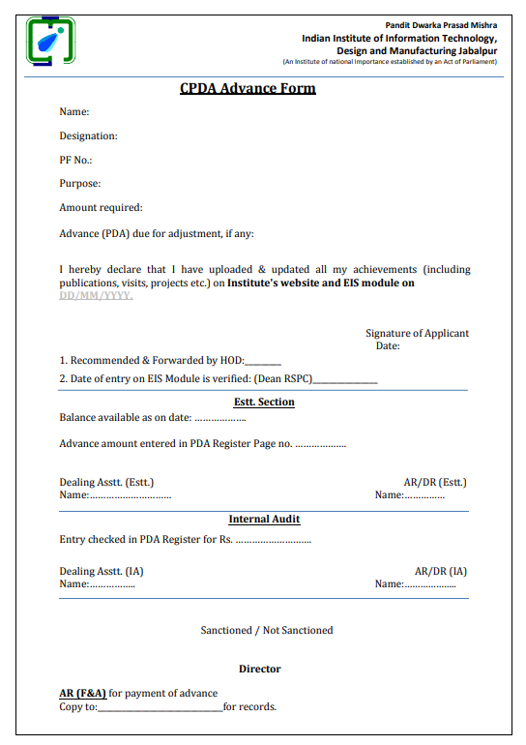

**Appendix C – Appraisal Form**

