**HEALTH CENTER SRS** (updated jan 2023)

**TEAM:**

Akshay Chavan

Pradeep Kushwaha

Kokkirala Abhinav

Divyansh Khetan

Siddharth Chawla

Sujeet Kumar

Ayush Anand

Priyesh Markam

**Ta:**

Rohan Dhanraj Atale

**Mentor:**

Dr. Atul Gupta

**Table of Contents:**

**1. Introduction**

1.1 Purpose

1.2 Module Scope

1.3 References

**2. Overall Decription**

2.1 Functional Requirements Specification

2.2 User Classes And Characteristics

**3. System Features**

**4. Non-Fuctional Requirements**

4.1 Performance Requirements

4.2 Safety Requirements

4.3 Software Quality Attributes

**5. List Of Open Issues (Unresolved Issues)**

**6. Future Work**

**1.Introduction**

**1.1 Purpose**

The purpose of the project entitled as **PRIMARY HEALTH CENTRE MANAGEMENT SYSTEM** is to computerize the Office Management and to manage different activities related to Primary Health Centre of PDPM IIITDM Jabalpur. We aim to develop software which is user-friendly, simple, fast, and cost – effective. The system includes registration of patients, storing their details into the system and also maintaining the records of medical stock inventory. It includes a facility to view all the previous appointments and prescriptions of the patient. User can search availability of a doctor and timings of their availability. Traditionally, it was done manually.

**1.2 Module Scope**

The users of this module will be the registered students of the Institute (PDPM IIITDM Jabalpur), Faculty Members and the members of the PHC Committee.

This software system will be a web-based Health Care Management System to be used by the above-mentioned people. Interface will enable students to get appointment for consulting doctors, Request for ambulance service, to keep a track of their prescription

history, feedback given, admission in hospital, prescribed medicine, view doctor’s Schedule, submit Feedback. The compounder will be able to update Doctor’s schedule, check the stock detail, prescribe patients, get admitted to hospital and respond to student feedback A relational database will be used for handling all the data such as stock, prescription, student IDs, student feedback, etc.

* 1. **References**
* PHC Committee Members
* Dr. Atul Gupta

Associate professor , CSE IIITDMJ

**2. Overall Description**

**2.1 Functional Requirements Specification**

The Primary Health Centre Management System can be entered using an assigned username and password. It is accessible either by students, faculty and staff or by compounders. Only compounders can add information about addition or removal of doctors into the

database. The data can be retrieved easily. The compounder can view all the appointments made by a patient for today’s date as well as all the future appointments also. He can also check the appointments made for the ambulance services and all the hospital admissions. When the patient comes for check-up, he updates the prescription given by the doctor into the database. He maintains the records of the medicine stock which includes information about current availability of all the medicines, all the expired medicine, threshold stock of the medicine which has to be ordered. He can add details of new medicines present in the stock as well. The compounder can view the schedule of the doctor availability as well as edit the schedule if there are any changes proposed.

The patient who can be any of the student or faculty or staff also can exercise various functions. They can view the schedule of the doctors available to decide their slot for check-up or treatment. They can apply for appointment to notify their coming for a check-up or treatment. They have added advantage of viewing all their previous prescriptions which includes the disease and their medications given along with the date of treatment. They can also book an ambulance in case of requirement. Along with all these they can give

feedback or register complaints regarding any services they availed from the Primary Health Centre.

Listed above are all the functionalities that can be performed by various users of our system. The system provides additional feature of storing and retrieving the past history of various illness and medications prescribed to keep track of the patient’s medical history by doctor as well as the patient itself.

**2.2 User Classes and Characteristics**

There are two types of users that interact with the system.

They are:

* Patient
* Compounder

Each of these two types of users has different use of the system so each of them has their own requirements.

1. **Patient**: A person who has been registered with PDPM IIITDM Jabalpur either student, staff or faculty.

* Apply Appointment of the doctors available.
* Request for an Ambulance when needed.
* Give Feedback on the Health Centre.
* Views all the prescriptions given to him/her by compounder.
* Views all the ambulance requests made by him/her.
* Views all the hospital admissions.
* Views all the appointments.
* Views feedback given.
* Views the schedule of the doctor.
* Patient can apply for bill relief

2. **Compounder**: A person who is appointed to give medicine to students when doctor is not available and maintain all records.

* Views the feedbacks made by patients and give response for them.
* Views all today’s appointments made by patients.
* Views all future appointments made by patients.
* Views all the ambulance requests made by patients.
* Views all hospital admissions of patients.
* Prescribe medicines to patients who made appointments.
* Prescribe medicines to patients who have not made appointment if requested.
* Add the patients into database if they are admitted in hospitals.
* Add the stock of medicines if medicines are brought.
* Adds new medicines if they are brought.
* Views the list of expired medicines available.
* Views the list of live medicines available.
* Views the threshold stock of medicine.
* Views the schedule of doctors.
* Edits the schedule of doctors.
* Views the doctors list available.
* Adds the doctor into list of doctors available if a new doctor is appointed in college.
* Removes the doctor in the list if he is not working in the college any more.
* compounder can view n approve patient bill relief

**3. System Feature Complete System**



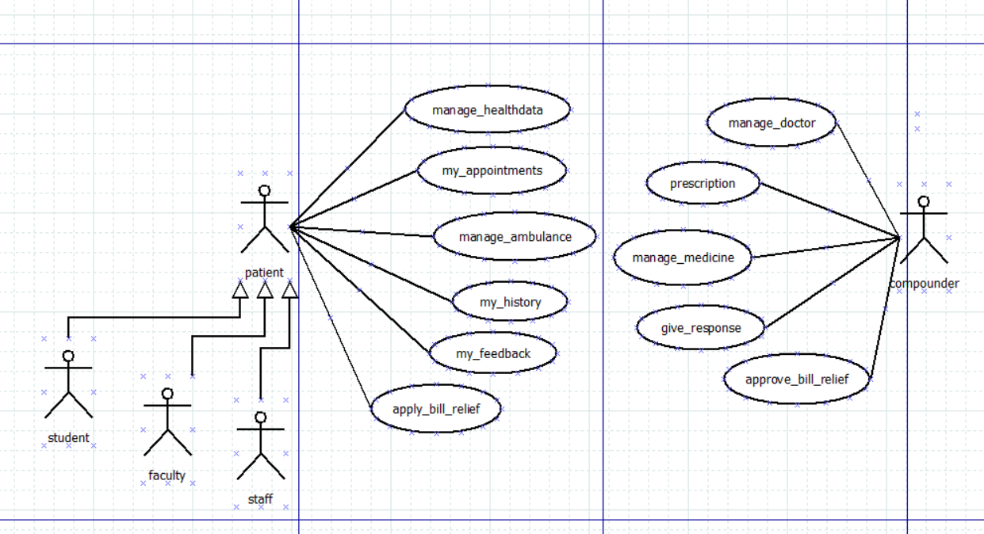

** UML needs to be updated**

**Functional Requirements**

**Use Cases**

| **UC ID** | UC#1 | |
| --- | --- | --- |
| **Use Case Name** | **manage_healthdata** | |
| **Description** | Patient can update his/her healthdata such as age ,weight ,height and gender to get prescription accordingly | |
| **Actors** | Patient | |
| **Pre-Condition** | User is logged in | |
| **Main Flow** | 1 | Patient clicks manage_healthdata and and update information | |
| 2 | Patient clicks submit and saves the updated information. | |
| **Post-Condition** | Successfully saved view after saving . | |
| **Sub-Flow** | NIL | |
| **\*Global Alternate Flow** | NIL | |

| **UC ID** | UC#2 | |
| --- | --- | --- |
| **Use Case Name** | **my_appointments** | |
| **Description** | Patient can apply/cancle or see the current status of his/her appointments | |
| **Actors** | Patient | |
| **Pre-Condition** | User is logged in | |
| **Main Flow** | 1 | Patient clicks on my_appointments. | |
| 2 | He can apply for appointments and cancel if he wanted, or he can also see the status of appointments and that appointment day and time details. | |
| **Post-Condition** | Successfully applied or cancelled on respective apply or cancel operation. | |
| **Sub-Flow** | NIL | |
| **\*Global Alternate Flow** | NIL | |

| **UC ID** | UC#3 | |
| --- | --- | --- |
| **Use Case Name** | **manage_ambulance** | |
| **Description** | Patient can request for ambulance or can also see the status of ambulance. | |
| **Actors** | Patient | |
| **Pre-Condition** | User is logged in | |
| **Main Flow** | 1 | Patient can apply for ambulance. | |
| 2 | Patient can view the status of ambulance. | |
| **Post-Condition** | Successfully requested prompted on requesting. | |
| **Sub-Flow** | NIL | |
| **\*Global Alternate Flow** | NIL | |

| **UC ID** | UC#4 | |
| --- | --- | --- |
| **Use Case Name** | **my_history** | |
| **Description** | Patient can see his or her medical prescription history. | |
| **Actors** | Patient | |
| **Pre-Condition** | User is logged in | |
| **Main Flow** | 1 | Patient clicks on my_history. | |
| 2 | And can see his history. | |
| **Post-Condition** | NIL | |
| **Sub-Flow** | NIL | |
| **\*Global Alternate Flow** | NIL | |

| **UC ID** | UC#5 | |
| --- | --- | --- |
| **Use Case Name** | **my_feedback** | |
| **Description** | Patient can give any feedback and ask for any query in this section and can view doctors response on that. | |
| **Actors** | Patient | |
| **Pre-Condition** | User is logged in | |
| **Main Flow** | 1 | Patient clicks on my_feedback. | |
| 2 | And he can give feedback or ask any query. | |
| **Post-Condition** | NIL | |
| **Sub-Flow** | NIL | |
| **\*Global Alternate Flow** | NIL | |

| **UC ID** | UC#6 | |
| --- | --- | --- |
| **Use Case Name** | **apply_bill_relief** | |
| **Description** | Patient can apply for bill relief | |
| **Actors** | Patient | |
| **Pre-Condition** | User is logged in | |
| **Main Flow** | 1 | Patient can click on apply . | |
| 2 | And can see approval has done or not. | |
| **Post-Condition** | Successfully applied after clicking apply for bill relief. | |
| **Sub-Flow** | NIL | |
| **\*Global Alternate Flow** | NIL | |

| **UC ID** | UC#7 | |
| --- | --- | --- |
| **Use Case Name** | **manage_doctor** | |
| **Description** | Compounder can manage doctor. | |
| **Actors** | compounder | |
| **Pre-Condition** | User is logged in | |
| **Main Flow** | 1 | Compounder can add/remove doctor. |
| 2 | Compounder and manage appointments. |
| 3 | Compounder can submit action. |
| **Post-Condition** | The form is successfully submitted | |
| **Sub-Flow** | NIL | |

| **UC ID** | UC#8 | |
| --- | --- | --- |
| **Use Case Name** | **prescription** | |
| **Description** | Compounder can prescribe. | |
| **Actors** | compounder | |
| **Pre-Condition** | User is logged in | |
| **Main Flow** | 1 | Compounder can prescribe |
| 2 | Compounder can prescribe with appointment or without appointment. |
| 3 | Compounder can submit action. |
| **Post-Condition** | The form is successfully submitted | |
| **Sub-Flow** | NIL | |

| **UC ID** | UC#9 | |
| --- | --- | --- |
| **Use Case Name** | **manage_medicine** | |
| **Description** | Compounder can manage medicine’s stock and remove expired ones. | |
| **Actors** | compounder | |
| **Pre-Condition** | User is logged in | |
| **Main Flow** | 1 | Compounder can update stock info. |
| 2 | Compounder can remove expired one or can arrange for out of stock medicines. |
| 3 | Compounder can submit action. |
| **Post-Condition** | The form is successfully submitted | |
| **Sub-Flow** | NIL | |

| **UC ID** | UC#10 | |
| --- | --- | --- |
| **Use Case Name** | **give_response** | |
| **Description** | Compounder reply to patient’s feedback. | |
| **Actors** | compounder | |
| **Pre-Condition** | User is logged in | |
| **Main Flow** | 1 | Compounder can reply for patients feedback or complaints. |
|
| 2 | Compounder can submit response. |
| **Post-Condition** | The response is successfully submitted | |
| **Sub-Flow** | NIL | |

| **UC ID** | UC#11 | |
| --- | --- | --- |
| **Use Case Name** | **approve_bill_relief** | |
| **Description** | Compounder verify and approve patients bill relief , if has patient has taken treatment from recommended doctor or hospital outside the campus. | |
| **Actors** | compounder | |
| **Pre-Condition** | User is logged in | |
| **Main Flow** | 1 | Compounder can verify the details. |
|
| 2 | Compounder can approve and submit status. |
| **Post-Condition** | The response is successfully submitted | |
| **Sub-Flow** | NIL | |

**4. Non-functional Requirements**

**4.1 Performance Requirements**

∙ The database should be designed in such a manner that it can handle heavy loads on the server.

**4.2 Safety Requirements**

The different safety requirements are as follows:

∙ More than three attempts at login and failure will produce a red flag to system administrator.

∙ Logs and checkpoints in the database should be used to handle transaction failures.

∙ Backup and recovery features should be present in the database.

∙ There should be a mechanism to handle loss of data over the network.

∙ When transferring password over the network, the method used must be secure.

**4.3 Software Quality Attributes**

The different software quality attributes are as follows:

∙ Availability: The software should be made available 24 X 7.

∙ Correctness: When carrying out calculations, the software should be precise till 3 places after decimal.

∙ Maintainability: The software should be designed in such a manner so that when incorporating new changes, it should be an easy task.

∙ Reliability: The software should be reliable as it contains personal information of students, faculty and institute related information.

∙ Usability: The user interfaces should be designed in such a manner so that they are interactive and user can easily interpret different functions of the software without studying any user manual.

**5. Open Issues:**

| **S.No.** | **Issue Details** | **Category** | **How it can resolve?** |
| --- | --- | --- | --- |
| 1 | For single appointment multiple prescriptions can be given | Programming limitation |  |

**Lessons Learned:**

* Team work
* Time Management
* Art of Debugging
* Working under pressure

**6. Future Work**

1)Wherever medicine appears it should come along with expiry date

Eg: In Prescription

2)There should a connection between appointments if there is a revisit suggested by doctor

3)There should be download button for Prescription

4)There should be options for patient to apply for bill relief

5)there should be also an option for compounder to view and approve patient bill relief after his verification.