**Software Requirements Specification**

**for**

HA-1-Hostel Management

**Revision History**

| **Name** | **Date** | **Reason for Changes** | **Version** |
| --- | --- | --- | --- |
| HM_1.0 | 23, March 2023 | Initial SRS | V1.0 |

**TEAM MEMBERS**:

SAKSHAM YADAV

20BCS191

DINESH KUMAR

20BCS078

YASH GOEL

20BCS245

MERAVATH PAVAN KUMAR

20BCS130

##### CHANDA ASRITA

##### 20BCS63

# Introduction

## Purpose

HA-1-Hostel Management Module is software designed to manage different activities related to the hostels’ activities of PDPM IIITDM Jabalpur. The software is designed to provide automated features to the Warden and Caretaker, to provide a platform to interact with the Students and Hostel Staffs. The different activities that come under the HA-1- Hostel Management module are view staff information, check & book guest room, view & edit guards shift, notices, and attendance to manage hostel related activities.

## Module Scope

The user of this module will be the Warden/Caretaker/Student. This software system will be a web-based system to be used by the users.

Interface will enable the **Warden** to view staff’s info, **Caretaker** to create notice, check guest room, check attendance, view & edit guards shift and **Students** to get notice, book guest room.

## References

* Staff Member of Hostel
* Dr. Atul Gupta

Associate Professor, Head of Computer Sc. & Engineering, Indian Institute of Information Technology Design and Manufacturing, Jabalpur.

# Overall Description

## Module Perspective

This module will be a platform for caretaker and warden to function daily official task in smooth working environment; he will have an eagle eye on every staff member, guards of hostel and student profile as well. This will also provide a platform to students as well to connect with caretaker and warden of their respective hostel.

## Module Functions

* + Student profile can be accessed.
  + Student regular hostel attendance will be stored.
  + Caretaker will have information about every staff’s and guard’s shift.
  + Notice can be float through a dashboard.
  + Physical reporting and leaving data will be stored.
  + Guest room can be booked by student.

## User Classes and Characteristics

* + Student can view their allotted room, books guest rooms and also view other’s room using roll number or name.
  + Student can see the notice board.
  + Caretaker can keep tab on attendance record, guest room booking record.
  + Warden/caretaker can view the staff’s detail and view their working shifts.
  + Warden/caretaker can schedule Events and meetings for students.

## Assumptions and Dependencies

We assume that the warden, caretaker and student of their respective hostel will be given the user id and password by the admin.

# External Interface Requirements

## User Interfaces

### Warden Interface

Warden will be at home page after logging in with user id and password, proceeding further to portal where he can view staff, can send notice to everyone and can view message from caretaker as well.

### Caretaker Interface

Caretaker will be at home page after logging in with user id and password, proceeding further to portal where he can view guard’s shift, allotted rooms to students, can verify booking of guest room, can check attendance of students can send notice to everyone and can view notice from warden as well.

### Student Interface

Student will be at home page after logging in with user id and password, proceeding further to portal where he can view notice board, allotted rooms to students and can book guest room as well.

## Software Interfaces

The system will be interacting with a database written in Django (Python Framework) and will be working on web browsers like Google Chrome, Mozilla Firefox, Safari etc.

# Use Case Diagram

## Use Case Diagram for Hostel Management Module

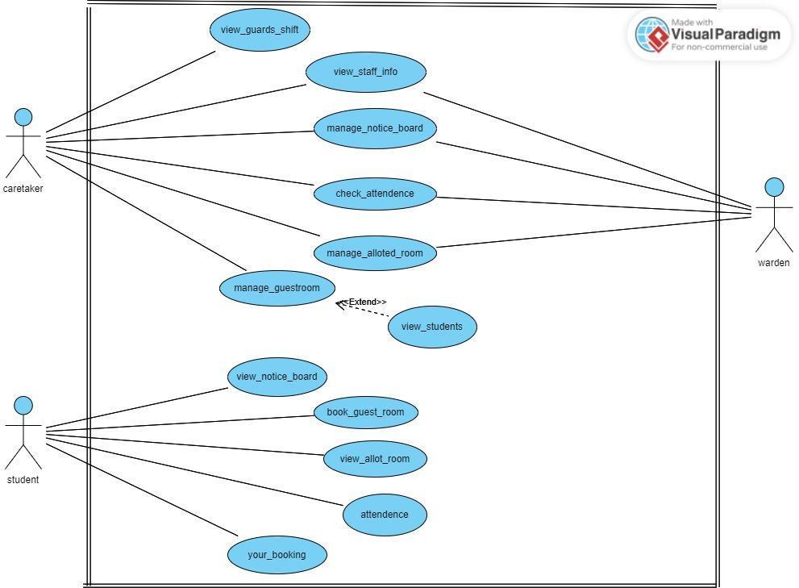

**Use Case Description**

### Manage Allotted Room

| **UC ID** | UC#1 |
| --- | --- |
| **Use case Name** | Manage allotted room |
| **Description** | This use case shows that students can view the allotted rooms |
| **Actor** | Caretaker/Warden, Student |
| **Precondition** | Actor must be logged in. |
| **Main Flow** | Actor can check the allotted room using roll number |
| **Post conditions** | The List of Allotted Rooms Will be visible on Notice Board. |
| **Alternate Flow** | NIL |
| **Sub Flow** | NIL |
| **Global Alternate**  **Flow** | NIL |

**Upload Allotted Room**

| **UC ID** | UC#2 |
| --- | --- |
| **Use case Name** | Upload Allotted Room |
| **Description** | This use case shows that the Admin will be able to upload the room details allotted to each student. |
| **Actor** | Admin |
| **Precondition** | Actor must be logged in. |
| **Main Flow** | Actor can upload the excel sheet of required data. |
| **Post conditions** | The List of Allotted Rooms Will be visible on Notice Board. |
| **Alternate Flow** | NIL |
| **Sub Flow** | NIL |
| **Global Alternate**  **Flow** | NIL |

### Book Guest Room

| **UC ID** | UC#3 |
| --- | --- |
| **Use case Name** | Booking Guest room |
| **Description** | This use case shows that the student can book the guest room. |
| **Actor** | Student |
| **Precondition** | The student must be logged in, and Room should be available to book. |
| **Main Flow** | 1. The Student clicks on Book Guest Room in left side panel. 2. The student fills the Form. |

|  | 3. The Student clicks on Submit button. |
| --- | --- |
| **Post conditions** | Notification to the Caretaker. |
| **Alternate**  **Flow** | NIL |
| **Sub Flow** | NIL |
| **Global**  **Alternate Flow** | NIL |

**Staffs and Guards shift**

| **UC ID** | UC#4 |
| --- | --- |
| **Use case Name** | Staff’s info and shift |
| **Description** | The actor will be able to see the information regarding the staff member of hostel |
| **Actor** | Caretaker/Warden |
| **Precondition** | The actor must be logged in. |
| **Main Flow** | 1. Actor will click on “staff’s detail” option. 2. Then all the details of staffs and their shift will be visible. |
| **Post conditions** | Actor and warden will be able to see all staff members |
| **Alternate Flow** | NIL |
| **Sub Flow** | NIL |
| **Global**  **Alternate Flow** | NIL |

**Attendance**

| **UC Id** | UC #5 | |
| --- | --- | --- |
| **Use Case Name** | Attendance | |
| **Description** | Student’s attendance record can be kept for future reference | |
| **Actor** | Student | |
| **Precondition** | Caretaker must be logged in. | |
| **Main Flow** | 1 | Caretaker can check the attendance record |
| **Post conditions** | Nil | |
| **Alternate Flow** | Nil | |
| **Sub Flow** | Nil | |
| **Global**  **Alternate Flow** | Nil | |

### Hostel Notice Board

| **UC Id** | UC #6 | |
| --- | --- | --- |
| **Use Case Name** | Manage Notice Board | |
| **Description** | User can drop a notice which can be seen by every student residing in particular hostel. | |
| **Actor** | Caretaker/ Warden | |
| **Precondition** | Caretaker/ Warden must be logged in the system. | |
| **Main Flow** | 1 | Caretaker will drop a notice to convey any information. |
| 2 | Notification will be sent to the student(s). |
| **Post conditions** | Notification must be sent to the student(s). | |
| **Alternate Flow** | Nil | |
| **Sub Flow** | Nil | |
| **Global Alternate Flow** | Nil | |

**Guest Room Record**

| **UC Id** | UC #7 | | |
| --- | --- | --- | --- |
| **Use Case Name** | Manage Guestroom | | |
| **Description** | Caretaker has its own separate record of booking of guest room, there he can see respected student profile along with room number and booking date. | | |
| **Actor** | Caretaker | | |
| **Precondition** | Caretaker must be logged in the system. | | |
| **Main Flow** | 1 | Caretaker will have to click the Guest Book Room record. |  |
| 2 | After clicking the button he will be able to see all details of booked guest room | Altern(A1) |
| **Post conditions** | Notification must be sent to the student(s). | | |
| **Alternate Flow** | (A1)Actor can see respected student profile. | | |
| **Sub Flow** | Nil | | |
| **Global Alternate Flow** | Nil | | |

###### Allot Rooms

| **UC Id** | UC #8 | | |
| --- | --- | --- | --- |
| **Use Case Name** | Allot rooms | | |
| **Description** | This use case shows that the admin will be able to Allot the room details allotted to each student. | | |
| **Actor** | Admin | | |
| **Precondition** | Admin must be logged in the system. | | |
| **Main Flow** | 1 | 1. Admin will have to click the Room record. |
| 2 | 1. After clicking the button, he will be able to Allot the rooms to respective student |
| **Post conditions** | Admin will set the details of allotted rooms to caretaker | | |
| **Alternate Flow** | Actor can see respected student profile. | | |
| **Sub Flow** | Nil | | |
| **Global Alternate Flow** | Nil | | |

###### Your bookings

| **UC Id** | UC #9 | | |
| --- | --- | --- | --- |
| **Use Case Name** | Your_bookings | | |
| **Description** | This use case shows that the students will be able to see the room booking details accepted by caretaker. | | |
| **Actor** | Student | | |
| **Precondition** | Sudent must be logged in the system. | | |
| **Main Flow** | 1 | 1. Student will have to click the your bookings record. |
| 2 | 1. After clicking the button, he will be able to see the rooms booking status |
| **Post conditions** | Nil | | |
| **Alternate Flow** | Nil | | |
| **Sub Flow** | Nil | | |
| **Global Alternate Flow** | Nil | | |