**MODULE Name – Placement Cell**

**Problem Description** – This SRS provides a complete description of all the functions and constraints of the Placement Cell Module. It can be accessed by the students, Placement Chairman and Placement Officer. This software provides the facility to the organization to make the placement process fully software oriented and thus decrease the burden on people involved in the process.

This document is intended for The Placement officer and other faculties that are involved in the placement process and also for the software developers to understand their basic requirements that are supposed to be fulfilled by the software. Students can also refer to this document to meticulously understand their requirements, responsibilities and scope of their actions.

## STUDENT

## A student can Update his/her profile regularly so that the data can be extracted to generate his/her respective CV.

## A Final Year Student will receive a notification when a company visits the campus for placement and he fulfills the criteria. He/she can decide whether he/she wants to apply for the company or not.

## A Third-year Student will receive a notification when a company visits the campus for PBI. He/she can decide whether he/she wants to apply for the company or not.

## Any student can refer to the past data pertaining to the previous year's Placement Summary (Visiting Companies, Packages Offered, Alumni Information, Positions Offered).

## A student Can see the upcoming schedule of all the companies coming for Recruitment.

## Shortlisted Students will receive notifications regarding the Placement rounds and current status.

## PLACEMENT OFFICER

## The Placement Officer will update all the records associated with the Past Placements offered in the campus.

## The Placement Officer will regularly update the Upcoming Schedules of the companies.

## The Placement Officer will have the functionality to filter out the students according to the company requirements and then send them notification whether they want to sit in the interview or not.

## The Placement Officer will enter information regarding the students selected or shortlisted and also send the notifications to the respective students.

## The Placement Officer will enter information regarding the students who are pursuing higher studies and also their respective scores and details.

* Placement Officer can ban a student from appearing in any placement activity.
* Placement Officer can check the validity and authenticity of the data entered by the students.

## PLACEMENT CHAIRMAN

## The Placement Chairman can review all the activities of the placement officer.

## The Placement Chairman can record his visits to various companies.

## The Placement Chairman can advise The Placement officer to postpone the company's Visit to the campus.

## The Placement Chairman can provide a list of companies to the Placement Officer to later approach them for their Campus recruitment sessions.

1. **User (Actor) Characteristics** –

## STUDENT – A student is a person studying in PDPM IIITDM Jabalpur and must have a Roll Number and an official Institute Email-ID, which should be used for accessing the system.

**PLACEMENT OFFICER** *–* A Placement officer is the person who is in charge of contacting the company HR Executives for interview date and schedule of events. He/She should have a PF number and an official institute Email-ID, which should be used for accessing the system.

**PLACEMENT CHAIRMAN –** The Placement Chairman is the person who holds an upper authority in handling the Placement Cell Operations.He/She should have a PF number and an official institute Email-ID, which should be used for accessing the system.

1. **Use case diagram** (**also attach StarUML file in the submission**)

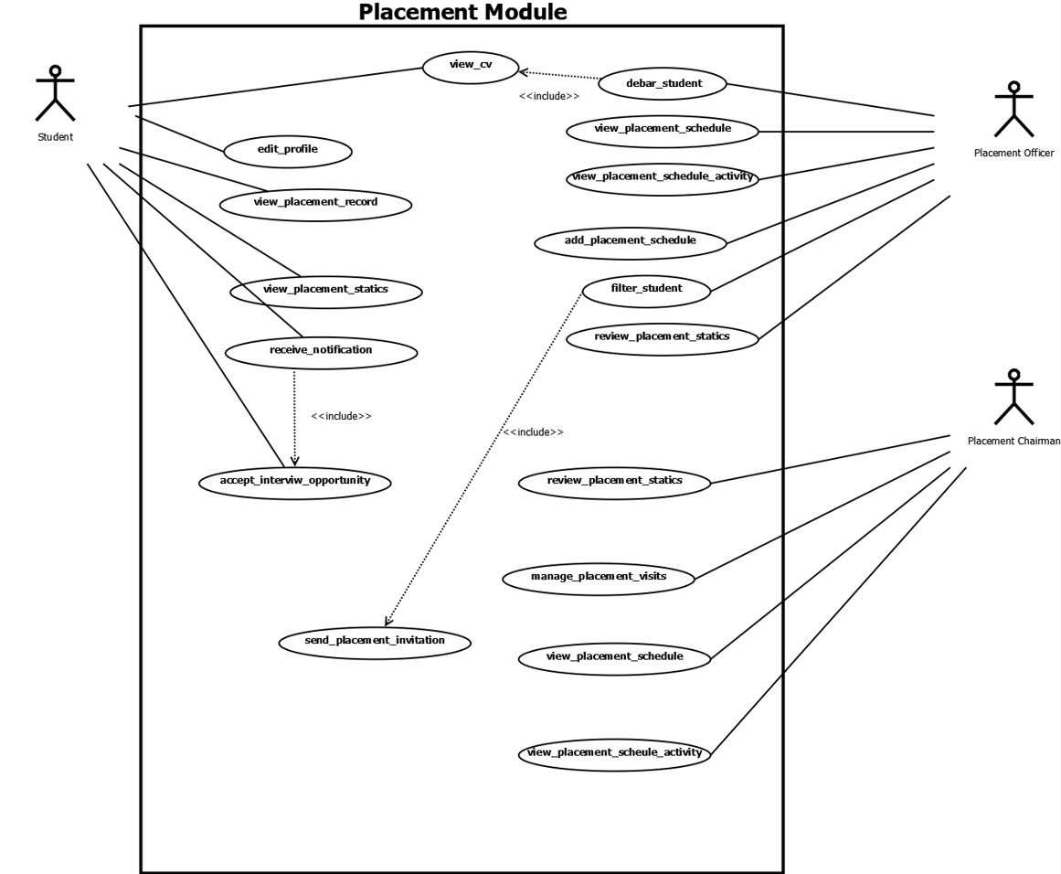

1. Use Cases Documentation

## System Feature 1

| Use Case ID | UC#1 | | |
| --- | --- | --- | --- |
| Use Case Name | edit_profile | | |
| Description | This use case represents the interaction of a student with the system to update his/her profile details. For this, the student has to fill up a form specifying his/her details. | | |
| Actor | Student | | |
| Precondition | The Student Must be logged into the dashboard. | | |
| Main Flow | 1 | | The student clicks on the dashboard tab. |
|  | 2 | | The system generates a form to be filled with the required details.  The student can also add his/her achievements, courses, publications, etc by clicking on respective tabs. |
|  | 3 | | The student fills-in the details [A1] |
|  | 4 | | The student clicks on the save profile button. [A2] |
|  | 5 | | The system returns to the Profile Section. |
| Post Conditions | The details are successfully received by the system and reflected in the database. | | |
| Alternate Flow | A1 | The system checks for the valid details. | |
|  |  | Post Condition: a message is displayed stating wrong details. | |
|  | A2 | The student chose not to submit (Cancel) | |
|  |  | Post Condition: The system returns to the Profile section. | |
| Sub Flow |  | NA | |
| Global Alternate Flow | GA 1 | The student can ‘cancel’ the procedure at any time by clicking on dashboard option | |
|  |  | Post-condition – The system returns to the student dashboard. | |

## System Feature 2

| Use Case ID | UC#2 | |
| --- | --- | --- |
| Use Case Name | view_cv | |
| Description | This use case represents the interaction of a student with the system to view his/her CV. | |
| Actor | Student | |
| Precondition | The Student Must be logged into the dashboard | |
| Main Flow | 1 | The student chose the option to go to the ‘Placement Module’. |
|  | 2 | The system presents an option to view the CV. He/she selects the relevant fields which he/she wants on the CV. |
|  | 3 | The student is redirected to a New Tab. |
|  | 4 | A report is generated with all the details pertaining to the student. |
| Post Conditions | NA | |
| Alternate Flow | NA | |
| Sub Flow | NA | |
| Global Alternate Flow | NA | |

## System Feature 3

| Use Case ID | UC#3 | | |
| --- | --- | --- | --- |
| Use Case Name | view_past_placement_records | | |
| Description | This use case represents the interaction of a student with the system to view past placement records and summary. For this, the student has to filter data according to his requirements. | | |
| Actor | Student | | |
| Precondition | The Student Must be logged into the dashboard. | | |
| Main Flow | 1 | | The student chose the option to go to the ‘Placement Module’. |
|  | 2 | | The system generates a screen showcasing all the valid placement cell facilities available to students. |
|  | 3 | | The student selects the Placement Statistics sidebar tab option. |
|  | 4 | | The system generates a screen consisting of filters (Company, Year; etc) to view specific data. The student enters filters. [A1] |
|  | 5 | | A list of records is generated. |
|  | 6 | | The student returns to the dashboard after viewing the records. |
| Post Conditions | NA | | |
| Alternate Flow | A1 | The system checks for the valid filters. | |
|  |  | Post Condition: a message is displayed stating wrong details or no matches. | |
| Sub Flow | NA | | |
| Global Alternate Flow | NA | | |

## System Feature 4

| Use Case ID | UC#4 | | |
| --- | --- | --- | --- |
| Use Case Name | recieve_notifications | | |
| Description | This use case represents the interaction of a student with the system to view and respond to his/her important notifications regarding the companies visiting and their interview schedule. | | |
| Actor | Student | | |
| Precondition | The Student Must be logged into the dashboard. | | |
| Main Flow | 1 | | The student goes to the placement module. |
|  | 2 | | The system generates the placement activity/ schedule page. |
|  | 3 | | The student can view his/her notifications in the right side panel. |
|  | 4 | | The student can respond to the important notifications from the notification panel itself. |
| Post Conditions | The response to the notifications is recorded in the database and is reflected at other valid screens. | | |
| Alternate Flow | NA | | |
| Sub Flow | NA | | |
| Global Alternate Flow | GA 1 | The student can return to the dashboard at any time by clicking on the dashboard option. | |
|  |  | Post-condition – The system returns to the student dashboard. | |

## System Feature 5

| Use Case ID | UC#5 | | |
| --- | --- | --- | --- |
| Use Case Name | debar_student | | |
| Description | This use case represents the interaction of a placement officer with the system to debar him/her from participating in placement cell activities and accepting placement cell opportunities. For this, the placement officer has to fill up several forms specifying his/her details. | | |
| Actor | Placement Officer | | |
| Precondition | The Placement Officer Must be logged into the system. | | |
| Main Flow | 1 | | The Placement officer goes to the placement cell and clicks on the student records tab. |
|  | 2 | | The system generates a screen with multiple filters to search the specific student. |
|  | 3 | | The Placement Officer searches for a student. |
|  | 4 | | The Placement Officer has two options available at this stage – 1)View Student profile CV 2)Debar Student [A1] |
|  | 5 | | The Placement Officer takes the necessary actions. |
| Post Conditions | The necessary actions are successfully received by the system and reflected in the database. | | |
| Alternate Flow | A1 | If the Student is already debarred, Option of Undoing banishment is available. | |
|  |  | Post Condition: The student is removed from banishment. | |
| Sub Flow |  | NA | |
| Global Alternate Flow | GA 1 | The student can ‘cancel’ the procedure at any time by clicking on dashboard option | |
|  |  | Post-condition – The system returns to the student dashboard. | |

## System Feature 6

| Use Case ID | UC#6 | | |
| --- | --- | --- | --- |
| Use Case Name | update_placement_records | | |
| Description | This use case represents the interaction of a Placement Officer with the system to update Placement Records. For this, the placement officer has to fill up a form specifying student details. | | |
| Actor | Placement Officer | | |
| Precondition | The Placement Officer Must be logged into the dashboard. | | |
| Main Flow | 1 | | The Placement Officer chose the Placement Module option. |
|  | 2 | | The Placement Officer selects the Past Records tab in the Placement Statistics Sidebar tab option. |
|  | 3 | | The Placement Officer can search the record to be deleted. Or simultaneously add a new record by clicking on the Add button. |
|  | 4 | | The Placement Officer clicks on the delete button corresponding to the respective student. |
|  | 5 | | The system returns to the Placement Module. |
| Post Conditions | The details are successfully received by the system and reflected in the database. | | |
| Alternate Flow | A1 | The placement officer selects Delete a record. | |
|  |  | Post Condition: respective actions are done. | |
| Sub Flow |  | NA | |
| Global Alternate Flow | GA 1 | The Placement Officer can ‘cancel’ the procedure at any time by clicking on the dashboard option. | |
|  |  | Post-condition – The system returns to the dashboard. | |

## System Feature 7

| Use Case ID | UC#7 | | |
| --- | --- | --- | --- |
| Use Case Name | add_placement_schedule | | |
| Description | This use case represents the interaction of a Placement Officer with the system to maintain Placement schedule. For this, the Placement officer has to fill up a form specifying dated events of any company. | | |
| Actor | Placement Officer | | |
| Precondition | The Placement Officer Must be logged into the dashboard. | | |
| Main Flow | 1 | | The Placement Officer chose the Placement Module option. |
|  | 2 | | The Placement Officer selects the Placement Schedule/activity tab from the Sidebar. |
|  | 3 | | The system generates a form to be filled with the event details.  On submitting, the event is scheduled. |
|  | 4 | | The system returns to the Placement Module. |
| Post Conditions | The details are successfully received by the system and reflected in the database. Notifications are sent to respective people. | | |
| Alternate Flow | NA | | |
| Sub Flow | NA | | |
| Global Alternate Flow | GA 1 | The Placement Officer can ‘cancel’ the procedure at any time by clicking on the dashboard option. | |
|  |  | Post-condition – The system returns to the dashboard. | |

## System Feature 8

| Use Case ID | UC#8 | | |
| --- | --- | --- | --- |
| Use Case Name | send_placement_invitation | | |
| Description | This use case represents the interaction of a Placement Officer with the system to maintain Placement schedule. For this, the Placement officer has to fill up a form specifying dated events of any company. | | |
| Actor | Placement Officer | | |
| Precondition | The Placement Officer Must be logged into the dashboard. | | |
| Main Flow | 1 | | The Placement Officer chose the Placement Module option. |
|  | 2 | | The Placement Officer selects the Student Records tab from the Sidebar. |
|  | 3 | | The system generates a form to be filled to search for the students. Students are searched by clicking on the search button. |
|  | 4 | | Placement Officer Clicks on the Send Invitation upper tab button.  Placement officer selects the company schedule from the dropdown and clicks on the send button. |
| Post Conditions | The details are successfully received by the system and reflected in the database. Notifications are sent to respective people. | | |
| Alternate Flow | NA | | |
| Sub Flow | NA | | |
| Global Alternate Flow | GA 1 | The Placement Officer can ‘cancel’ the procedure at any time by clicking on the dashboard option. | |
|  |  | Post-condition – The system returns to the dashboard. | |

## System Feature 9

| Use Case ID | UC#9 | | |
| --- | --- | --- | --- |
| Use Case Name | View_placement_schedule | | |
| Description | This use case represents the interaction of a Placement Officer/chairman with the system to maintain Placement schedule. For this, the Placement officer/chairman has to fill up a form specifying dated events of any company. | | |
| Actor | Placement Officer/chairman | | |
| Precondition | The Placement Officer/chairman Must be logged into the dashboard. | | |
| Main Flow | 1 | | The Placement Officer/chairman chose the Placement Module option. |
|  | 2 | | The Placement Officer/chairman selects the Placement activity / Schedule tab from the Sidebar. |
|  | 3 | | The system generates a list of the scheduled events in the chronological order. |
| Post Conditions | The details are successfully received by the system and reflected in the database. Notifications are sent to respective people. | | |
| Alternate Flow | NA | | |
| Sub Flow | NA | | |
| Global Alternate Flow | GA 1 | The Placement Officer/chairman can ‘cancel’ the procedure at any time by clicking on the dashboard option. | |
|  |  | Post-condition – The system returns to the dashboard. | |

## System Feature 10

| Use Case ID | UC#10 | | |
| --- | --- | --- | --- |
| Use Case Name | View_placement_schedule_activity | | |
| Description | For this, the student has to fill up a form specifying dated events of any company. | | |
| Actor | Student | | |
| Precondition | The Student Must be logged into the dashboard. | | |
| Main Flow | 1 | | The Student chose the Placement Module option. |
|  | 2 | | The Student selects the Placement activity / Schedule tab from the Sidebar. |
|  | 3 | | The system generates a list of the scheduled events in the chronological order along with the indication that he/she accepted/rejected the event invitation. |
| Post Conditions | The details are successfully received by the system and reflected in the database. Notifications are sent to respective people. | | |
| Alternate Flow | NA | | |
| Sub Flow | NA | | |
| Global Alternate Flow | GA 1 | The Placement Officer can ‘cancel’ the procedure at any time by clicking on the dashboard option. | |
|  |  | Post-condition – The system returns to the dashboard. | |

## System Feature 11

| Use Case ID | UC#11 | | |
| --- | --- | --- | --- |
| Use Case Name | filter_students | | |
| Description | This use case represents the interaction of a Placement Officer with the system to filter students according to specifications. | | |
| Actor | Placement Officer | | |
| Precondition | The Placement Officer Must be logged into the dashboard. | | |
| Main Flow | 1 | | The Placement Officer chose the Placement Module option. |
|  | 2 | | The Placement Officer selects the Search option in the Student Records Sidebar tab option. |
|  | 3 | | The Placement Officer can filter the students according to the specifications like GPA and Branch. |
|  | 4 | | After the filtering, the placement officer can view their CV’s or debar them. |
| Post Conditions | NA | | |
| Alternate Flow | NA | | |
| Sub Flow | NA | | |
| Global Alternate Flow | GA 1 | The Placement Officer can ‘cancel’ the procedure at any time by clicking on dashboard option. | |
|  |  | Post-condition – The system returns to the dashboard. | |

## System Feature 12

| Use Case ID | UC#12 | | |
| --- | --- | --- | --- |
| Use Case Name | manage_placement_visits | | |
| Description | This use case represent the interaction of a Placement Chairman with the system to record his/her visits. For this, the placement officer has to fill up a form. | | |
| Actor | Placement Chairman | | |
| Precondition | The Placement Chairman Must be logged into the dashboard. | | |
| Main Flow | 1 | | The Placement Chairman chose the Placement Module option. |
|  | 2 | | The Placement Chairman selects the Placement Visits sidebar tab option. |
|  | 3 | | The system generates a form to be filled with the required details when “Add a new visit” option is selected. [A1] |
|  | 4 | | The Placement Chairman fills-in the details. |
|  | 5 | | The Placement Chairman submits the form. |
|  | 6 | | The system returns to the Placement Module. |
| Post Conditions | The details are successfully received by the system and reflected in the database. | | |
| Alternate Flow | A1 | | Alternatively, from a list of previous Visits, any Visit record can be deleted by clicking on delete option |
| Sub Flow | NA | | |
| Global Alternate Flow | GA 1 | The Placement Chairman can ‘cancel’ the procedure at any time by clicking on dashboard option. | |
|  |  | Post-condition – The system returns to the dashboard. | |

## System Feature 13

| Use Case ID | UC#13 | | |
| --- | --- | --- | --- |
| Use Case Name | review_placement_statistics | | |
| Description | This use case represents the interaction of a Placement Officer/Chairman with the system to review Placement statistics. | | |
| Actor | Placement Officer/Chairman | | |
| Precondition | The Placement Officer/Chairman Must be logged into the dashboard. | | |
| Main Flow | 1 | | The Placement Officer/Chairman chose the Placement Module option. |
|  | 2 | | The Placement Officer/Chairman selects the Placement Statistics option. |
|  | 3 | | A screen displaying all the statistics in the Recent-First order is displayed. Records can also be filtered. |
|  | 4 | | Batch Statistics can be viewed by clicking on the Batch statistics tab. |
| Post Conditions | NA | | |
| Alternate Flow | NA | | |
| Sub Flow | NA | | |
| Global Alternate Flow | GA 1 | The Placement Officer can ‘cancel’ the procedure at any time by clicking on dashboard option. | |
|  |  | Post-condition – The system returns to the dashboard. | |

## System Feature 14

| Use Case ID | UC#14 | | |
| --- | --- | --- | --- |
| Use Case Name | review_placement_statistics | | |
| Description | This use case represents the interaction of a Student with the system to view Placement statistics. | | |
| Actor | Student | | |
| Precondition | The Student Must be logged into the dashboard. | | |
| Main Flow | 1 | | The Student chose the Placement Module option. |
|  | 2 | | The Student selects the Placement Statistics option. |
|  | 3 | | A screen displaying all the statistics in the Recent-First order is displayed. |
|  | 4 | | Batch Statistics can also be viewed by clicking on the Batch statistics tab. |
| Post Conditions | NA | | |
| Alternate Flow | NA | | |
| Sub Flow | NA | | |
| Global Alternate Flow | GA 1 | The Student can ‘cancel’ the procedure at any time by clicking on dashboard option. | |
|  |  | Post-condition – The system returns to the dashboard. | |

**Issues and Problems Faced**

* Lack of Cooperation between module teams sometimes regarding inter-module dependencies.
* Integration issues mainly introduced newer bugs which required unnecessary extra time for debugging.https://drive.google.com/file/d/1ViLcey_nx0jdVHw_tr7P1WEn27GOXk_h/view?usp=sharing

**Lessons Learned**

* Team Work (Divide and Conquer approach of working) is very effective when developing a very large software product.
* Industrial methods of software development are effective for delivering software well within limits.

**Overall Impression of the Project (Suggestions/Feedback)**

It was a tiresome yet wonderful experience working on the project fusion in collaboration. We learned many industrial level tools for developing software like GitHub. The training we received during this duration will help for our future endeavours.

More emphasis must be given on the features which are working fine to improve them. Example – UI is very unstable if we consider the entire fusion project.