

**School of Engineering and Technology**

**Atificial Itelligence and Machine Learning**

*(Practical File)*

**18BCS-OA132T**

***Submitted To: Submitted By:***

Faculty: Ms. Ujjwal Mann Name: Hrithik Malhotra

Roll Number: 170BTCCSE044

Branch: Computer Science&Engg.

Year/Sem: 3nd Year 5th Semester

**PRINT SCREEN**



OUTPUT



**ARITHMATIC OPERATORS/ASSIGNMENT**

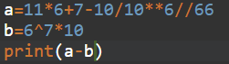

OUTPUT



**COMPARISON OPERATOR**

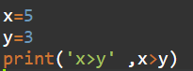

OUTPUT



**LOGICAL OPERATOR**

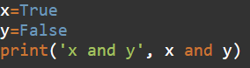

OUTPUT



**INDEXING AND SLICING**



OUTPUT





OUTPUT



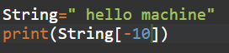

OUTPUT





OUTPUT





OUTPUT



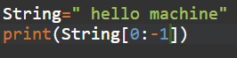

OUTPUT



**CONCATENATION**

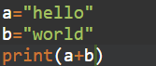

OUTPUT



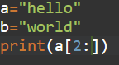

OUTPUT



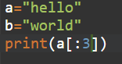

OUTPUT



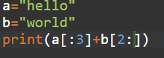

OUTPUT



**SPLIT AND JOIN**



OUTPUT



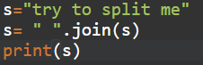

OUTPUT



**LOWER / UPPER FUNCTIONS**



OUTPUT





OUTPUT



**TUPLES OPERATIONS**



OUTPUT



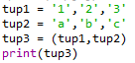

OUTPUT





OUTPUT





**SET OPERATIONS**



OUTPUT





OUTPUT





OUTPUT





OUTPUT





OUTPUT





OUTPUT



**DICTIONARY OPEARTIONS**

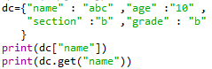

OUTPUT



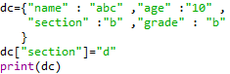

OUTPUT



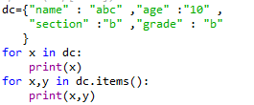

OUTPUT

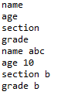

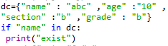

OUTPUT



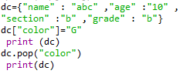

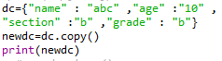

OUTPUT



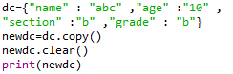

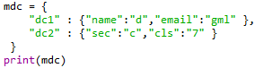

OUTPUT



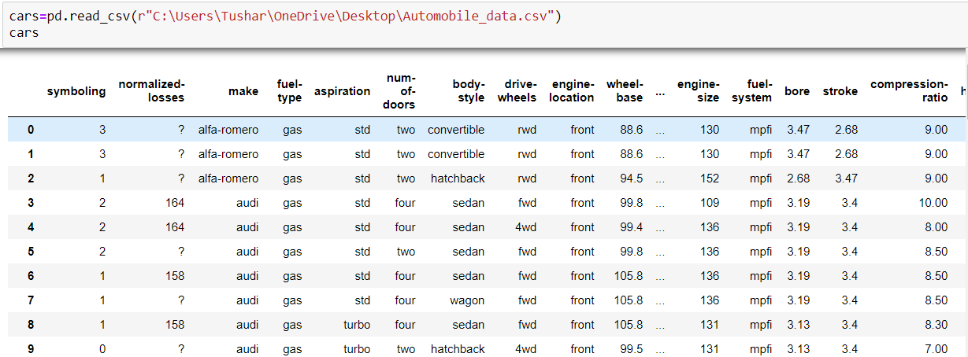

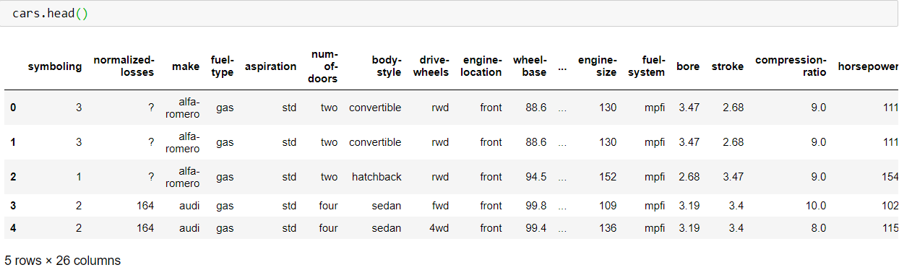

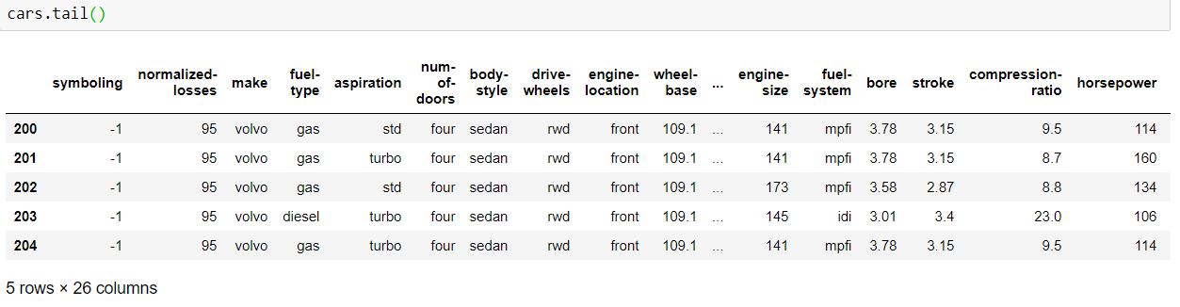

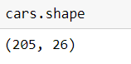

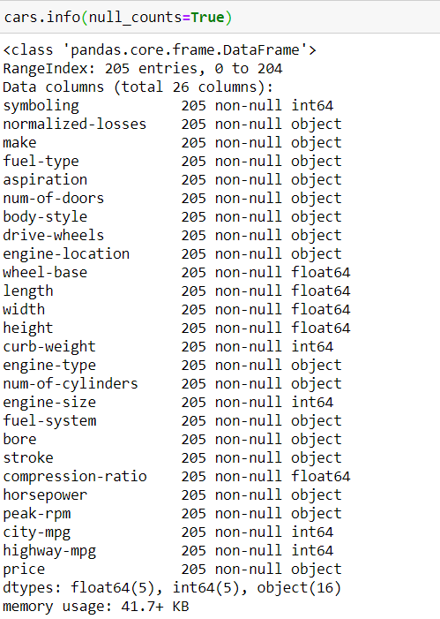

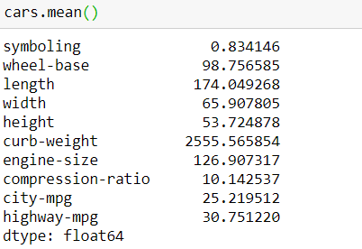

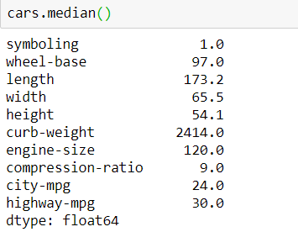

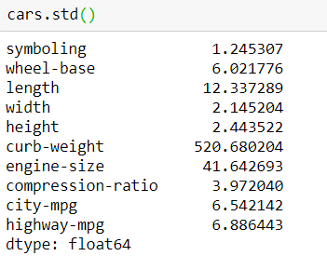

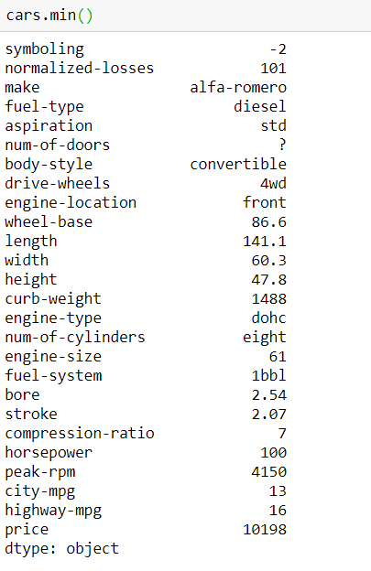

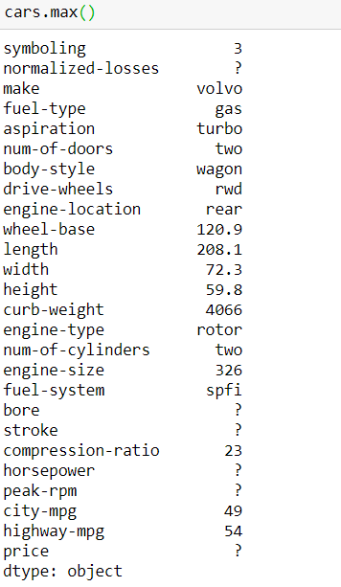

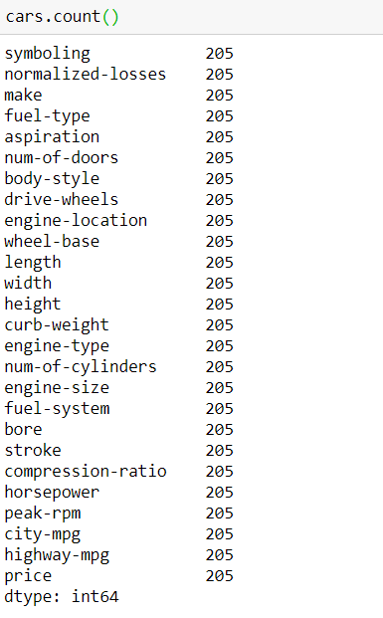

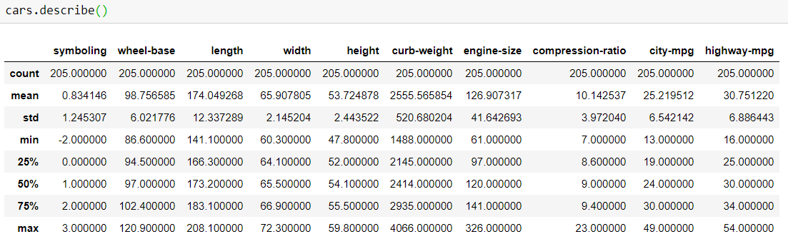

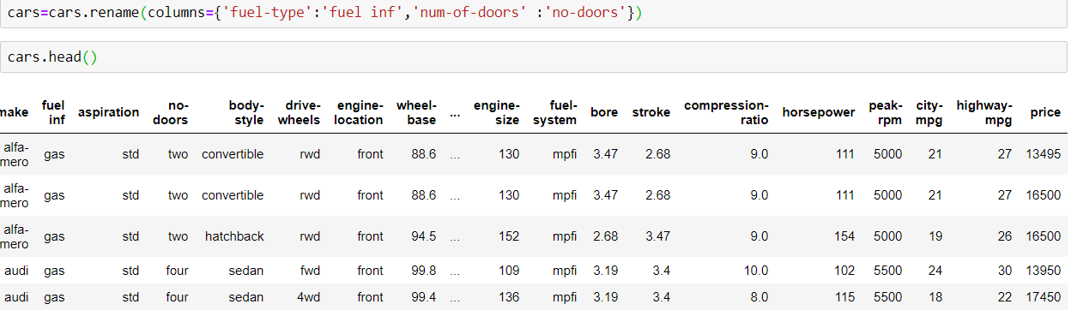

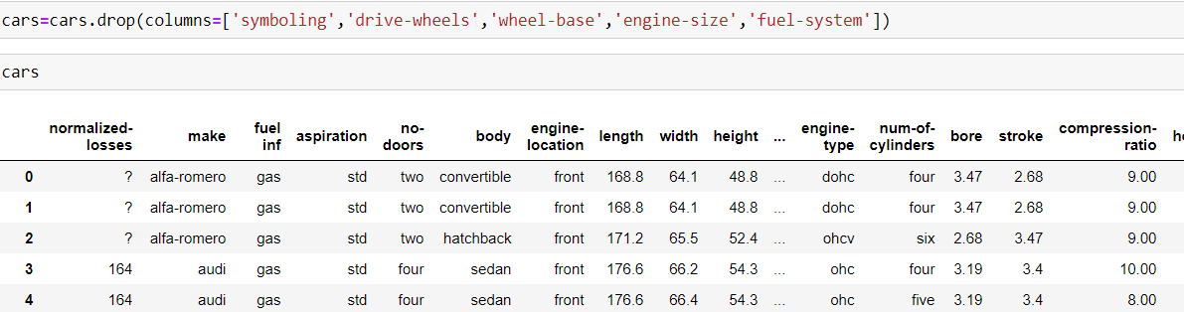

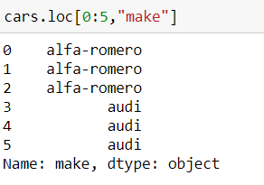

**MATPLOT LIBRARY**

