ENCODERS

COMPANY NAME: OMRON

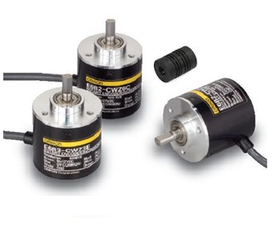

ENCODER

COMPANY NAME: AUTONICS

