SENSORS

COMPANY NAME: AUTONICS

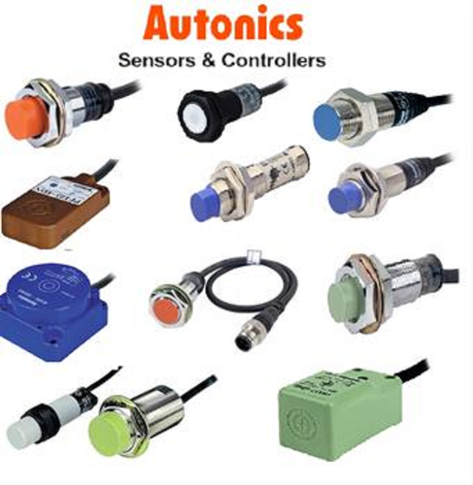

ALL WIDE RANGE OF SENSORS ARE AVIALABLE

SENSORS

COMPANY NAME: PEPPER+FUCHS

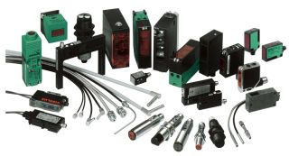

SENSORS

COMPANY NAME: OMRON

