POD2 — Plan of the Day
Entry Touchpoint: Data Construction, Cross-Dataset Comparison
and the Finalised Entry Dataset (Bhogapuram / VTZ)
Rebuilt end-to-end on the real product-owner data
Scope: Entry touchpoint only, pending Avra’s confirmation before replicating to other touchpoints.

Contents

1. Executive summary
This document records how the POD2 Entry dataset was rebuilt from scratch using only the datasets the product owner (Avra) shared, following the construct he walked us through. Every step is a simple, auditable calculation — there is no machine learning at this stage; modelling begins only after Avra confirms the Entry approach.
Three datasets were used: (1) June load actuals — real daily load factor and passenger volume by aircraft category; (2) HYD e-boarding — real passenger-level terminal-entry scan times; and (3) the digital twin — the generated Bhogapuram/VTZ schedule and passenger model.
Key findings:
- The twin reproduces the real fleet/volume structure almost exactly (aircraft mix within 0.2 percentage points of June actuals).
- The twin mis-models two behaviours: load factor is ~4 points low and flat across the week (real data rises Mon 78% → Sun 88%), and the terminal show-up window is too narrow (0% of passengers show up more than 150 minutes early, vs ~20% in the real e-boarding).
- Both were corrected in the finalised Entry dataset: real load factor by day-of-week, and passenger show-up driven by the measured e-boarding profile.
Finalised Entry result (VTZ S26 season): 5,820 departures, 873,509 entry passengers, peak requirement of 4 entry lanes. This dataset is ready to take to Avra for confirmation.

2. Background — the construct and the three datasets
Avra’s Entry construct is a chain of simple formulas: how many passengers a flight carries (seats × load factor), when those passengers show up at terminal entry (a show-up profile measured in minutes before departure), and therefore how much entry demand and how many lanes are needed in each time window. Each of our datasets covers part of this chain.
Note: Avra’s own dashboard is only a style template for how the analysis should look. It is not a POD dataset and is not used as a comparison series anywhere in this work.

Which dataset can speak to which Entry dimension
Dimension (Entry) | June loads | HYD e-boarding | Digital twin
Passenger volume | Real (daily) | Real, 2 days only | Modelled
Load factor | Real | No seat/LF field | Modelled
Aircraft mix | Real | Per-flight | Modelled
Entry show-up profile | None | Real | Modelled
Entry hourly demand | None | Real | Modelled
Consequence: June loads has no scan times, no per-passenger rows and no time-of-day, so it cannot participate in the Entry show-up / timing comparison at all — its only role at Entry is the upstream volume + load-factor input. The Entry show-up comparison is therefore two-way: HYD e-boarding (real) vs digital twin (modelled).

3. Step 1 — Isolate the clean June data
File / method: step1_june_data/extract_june.py reads only the trusted June “Acft” sheet from the workbook Avra shared (the second, July-labelled sheet is a calculated copy and was set aside). Output: june_load_daily.csv — a tidy table, one row per date × aircraft category × direction, with load factor and passenger count.
Outcome: 180 rows over 30 days (1–30 June). 220,886 total passengers (108,487 departing + 112,399 arriving). Aircraft mix: Category C narrow-body 95.3% of departing passengers, B (ATR-72) ~4.6%, A (9-seater) ~0.1%. Narrow-body departure load factor 82% on average, ranging 68–94% day to day.

4. Step 2 — Avra-style analysis on the June data
File / method: step2_june_analysis/analyze_june.py produces a four-panel dashboard on what the June data supports: passenger share by aircraft category, total passengers by date, departure load factor by day-of-week, and daily load factor across June.
Note: the June data has no per-passenger scan times, so the show-up profile (the minutes-before-departure chart) cannot be built here — that requires the e-boarding data in Step 3.
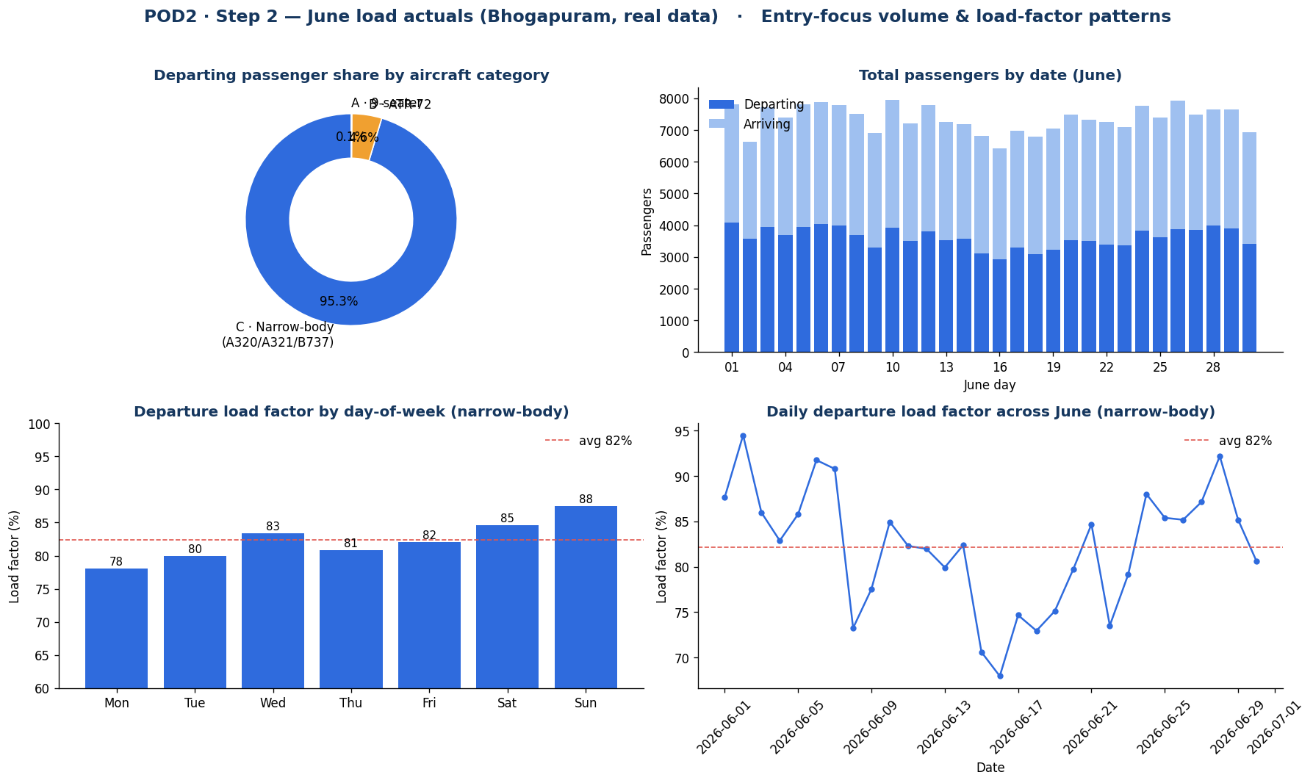
Step 2 — June load actuals: volume and load-factor patterns (real data).
Outcome: narrow-body departure load factor averages 82%; quietest day Monday (78%), busiest Sunday (88%) — a clear weekly rise that becomes important in Step 5.

5. Step 3 — Entry show-up profile from the HYD e-boarding
File / method: step3_ews_eboarding/analyze_ews_entry.py derives the terminal-entry show-up profile from the real passenger-level e-boarding data: minutes early = FLIGHT_TIME − TRML_ENT_SCAN_TIME, bucketed into <60 / 60–90 / 90–120 / 120–150 / 150–180 / >180, plus the demand curve by entry-scan hour.
Privacy: the raw e-boarding file contains passenger PII (names, PNR, e-ticket) and is NOT committed. Only the aggregated outputs (percentages, hourly counts, dashboard) are saved.
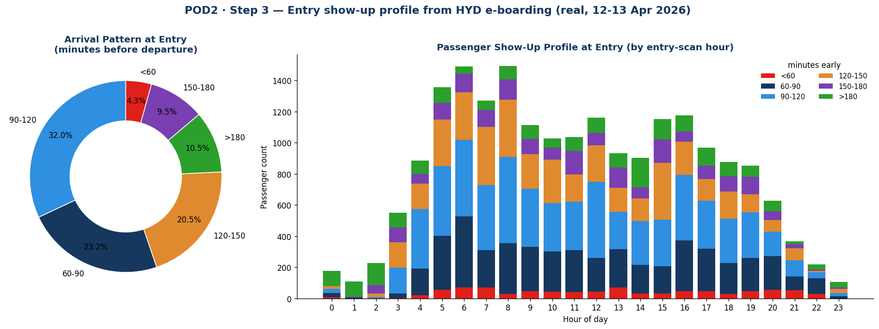
Step 3 — Entry show-up profile from the real HYD e-boarding (12–13 Apr).
Outcome: 20,079 valid entry records. Show-up profile: <60 = 4.3%, 60–90 = 23.2%, 90–120 = 32.0%, 120–150 = 20.5%, 150–180 = 9.5%, >180 = 10.5%. Peak entry hour 08:00. Data caveat: the file holds only 2 days, enough for a stable overall profile but not day-of-week splits.

6. Step 4 — Entry show-up profile from the digital twin
File / method: step4_twin_entry/analyze_twin_entry.py reconstructs the twin’s Entry minutes-early distribution from its show-up window (DEP_ENTER = (-150, -40, -85)), bucketed the same way as Step 3 so the two are directly comparable. Departures only, matching Step 3’s "minutes before departure".
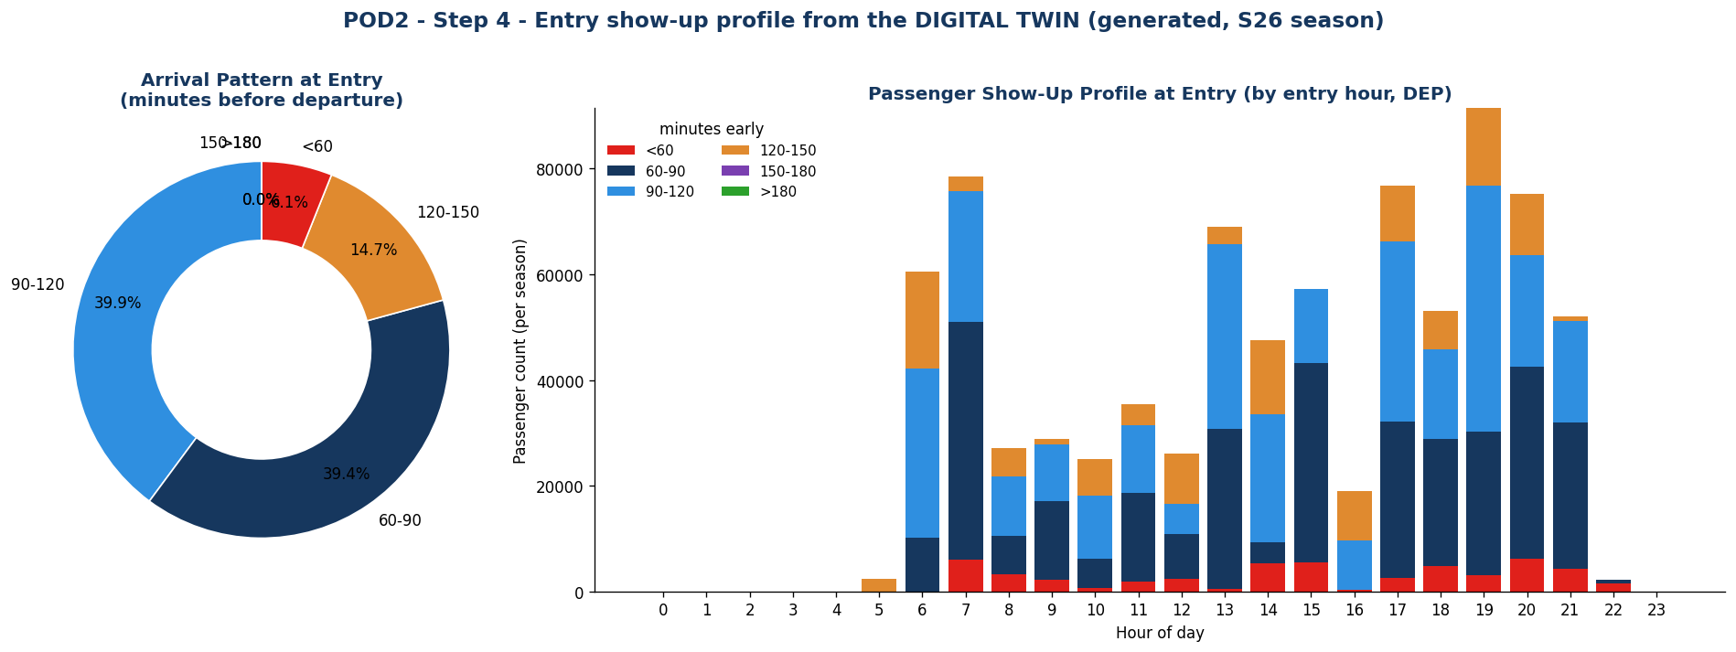
Step 4 — Entry show-up profile from the digital twin (generated).
Outcome: the twin puts 0% of passengers in the 150–180 and >180 buckets because its window caps at 150 minutes, and over-concentrates in 60–120 (79% vs the real 55%). This is the first sign of mis-calibration, confirmed in Step 5.

7. Step 5 — Cross-dataset comparison
File / method: step5_comparison/compare_datasets.py lines up the three POD datasets on like-for-like dimensions. The comparison is strictly June loads ↔ HYD e-boarding ↔ digital twin (Avra’s dashboard is a style template only and is not a series).
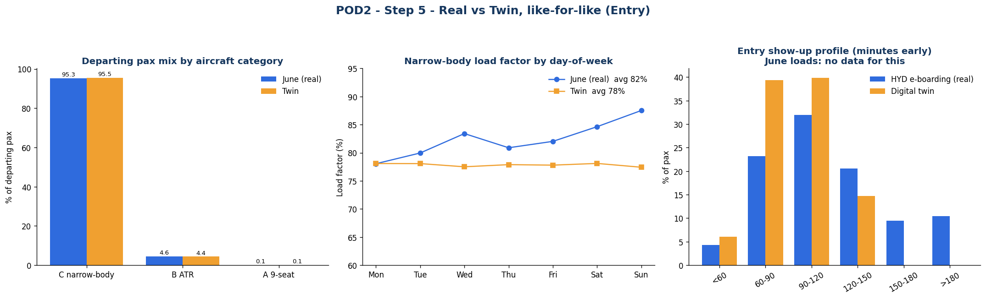
Step 5 — Real vs Twin, like-for-like. Show-up panel is two-way (June has no data for it).

What matches, what doesn’t
Dimension | Compared | Result | Verdict
Aircraft mix | June ↔ Twin | C 95.3 vs 95.5, B 4.6 vs 4.4, A 0.1 vs 0.1 | Matches
Load factor (level) | June ↔ Twin | 82.1% vs 77.8% | Twin ~4 pt low
Load factor (day-of-week) | June ↔ Twin | Mon 78→Sun 88% vs flat ~78% | Misses weekly shape
Show-up profile | HYD ↔ Twin (June: none) | 20% >150 min vs 0% past 150 | Mis-calibrated

8. The two recalibrations
Step 5 identified two behavioural layers to correct before the Entry dataset is trustworthy. Both are folded into the finalised dataset (Step 6).
- Show-up window. Drive terminal entry from the measured e-boarding show-up buckets (Step 3) instead of the twin’s triangular DEP_ENTER window. This is exactly how Avra does it — measured percentages, not an assumed curve — and it restores the >150-minute tail automatically.
- Load factor. Use the real June load factor by category and day-of-week (narrow-body ~82%, rising into the weekend) instead of a flat ~78% draw.

9. Step 6 — The finalised Entry dataset
File / method: step6_finalise/build_entry_pod.py materialises Avra’s Entry construct on the VTZ S26 schedule, with both recalibrations applied. It is a pure calculation — no ML. Outputs: finalised_entry_daily_summary.csv (per-day peak demand and lanes) and finalised_entry_sample_day.csv (the busiest day’s 5-minute profile).

The formula-derived columns (Avra’s construct)
Column | Formula | Source
passengers | seat_capacity × LF[category, day_of_week] | June LF + VTZ schedule
minutes_early | departure_time − entry_scan_time | e-boarding (real) / show-up curve
showup_bucket | bucket(minutes_early), <60 … >180 | Step 3 thresholds
entry_demand_5min | Σ passengers × showup_weight(offset) | passengers × measured profile
entry_demand_30min | rolling 30-min sum of entry_demand | Avra’s 30-min projection
lanes_required | ceil(entry_demand_30min / 60) | ATRS 120 pax/hr/lane = 60/30min

Result
- 5,820 departures across the S26 season (210 days).
- 873,509 season entry passengers — higher than the twin’s 827k because the real ~82% load factor replaced the flat ~78%.
- Peak requirement: 4 entry lanes; busiest day 30-minute demand 229 passengers.

10. Data caveats — to confirm with Avra
- The e-boarding file is only 2 days (12–13 Apr) — good for the overall show-up profile, but a full month is needed for day-of-week show-up splits.
- The June workbook’s second sheet is a July-labelled calculated copy; we used the clean June sheet only. Confirm this is correct.
- Confirm the throughput assumption: ATRS 180 trays/hr and 1.5 trays/passenger, giving 120 passengers/hour/lane (60 per 30 minutes).

11. Next steps
The Entry touchpoint is fully built and internally consistent. The immediate next step is Avra’s confirmation of the Entry approach and the finalised dataset. Once confirmed:
- Replicate the same six-step build for the remaining touchpoints (Security, Boarding, Belt).
- Only then move to modelling, which becomes meaningful once real touchpoint scan data accumulates after go-live.
All code and outputs live in the POD2/ folder of the repository, one sub-folder per step.

