**SUPPLIERS Table:**

**SUPPLIERS Table Values:**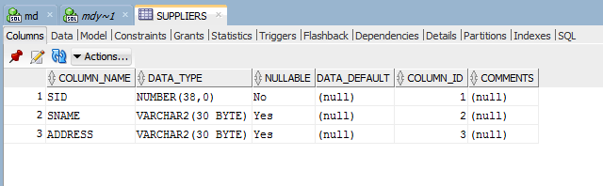

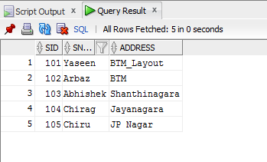

**PARTS Table:**

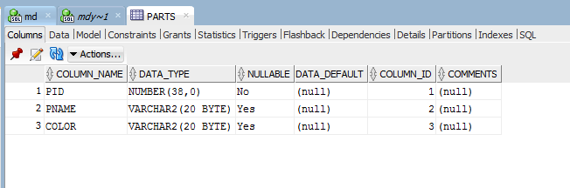

**PARTS Table Values:**

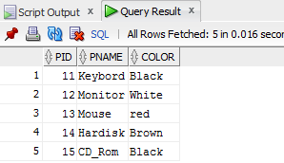

**CATALOG Table:**

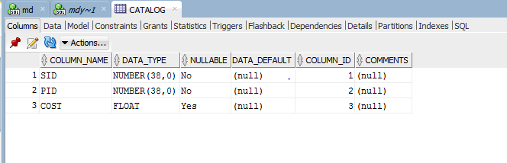**CATALOG Table Values:**

