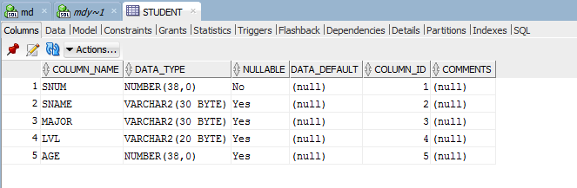**STUDENT Table:**

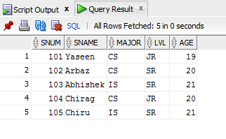**STUDENT Table Values:**

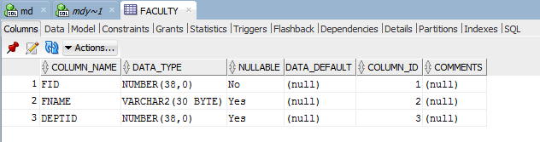**FACULTY Table:**

**FACULTY Table Values:**

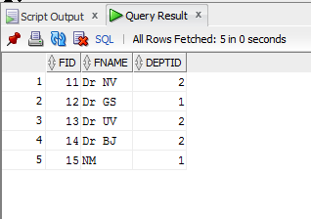

**CLASS Table:**

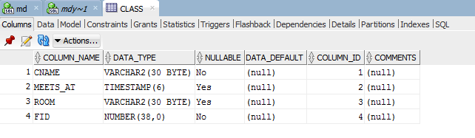**CLASS Table Values:**

**ENROLLED Table:**

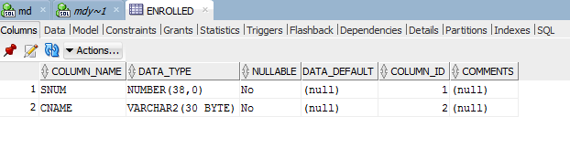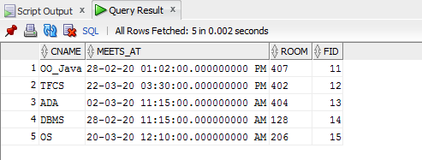**ENROLLED Table Values:**

