Goal: The purpose of this individual assignment is to learn how to use the Amazon AWS cloud platform and how to develop an AWS application that uses existing cloud services. Specifically, you will learn: (1) how to create VMs (EC2 instances) in the cloud; (2) how to use cloud storage (S3) in your applications; (3) how to communicate between VMs using a queue service (SQS); (4) how to program distributed applications in Java on Linux VMs in the cloud; and (5) how to use a machine learning service (AWS Rekognition) in the cloud.

Description: You have to build an image recognition pipeline in AWS, using two EC2 instances, S3, SQS, and Rekognition. The assignment can be done in your preferred language on Amazon Linux VMs. For the rest of the description, you should refer to the figure below:

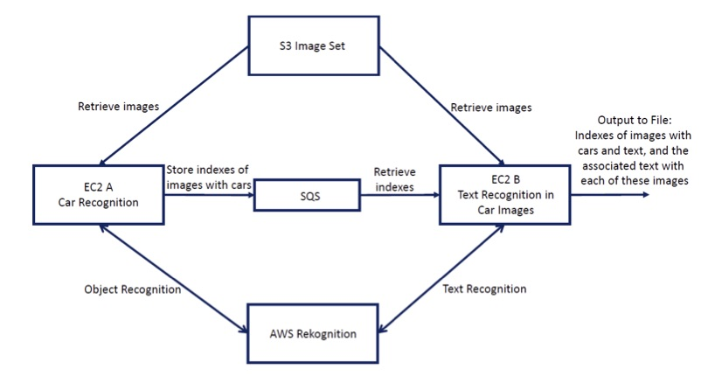

Your have to create 2 EC2 instances (EC2 A and B in the figure), with Amazon Linux AMI, that will work in parallel. Each instance will run a Java application. Instance A will read 10 images from an S3 bucket that we created (https://njit-cs-643.s3.us-east-1.amazonaws.com) and perform object detection in the images. When a car is detected using Rekognition, with confidence higher than 90%, the index of that image (e.g., 2.jpg) is stored in SQS. Instance B reads indexes of images from SQS as soon as these indexes become available in the queue, and performs text recognition on these images (i.e., downloads them from S3 one by one and uses Rekognition for text recognition). Note that the two instances work in parallel: for example, instance A is processing image 3, while instance B is processing image 1 that was recognized as a car by instance A. When instance A terminates its image processing, it adds index -1 to the queue to signal to instance B that no more indexes will come. When instance B finishes, it prints to a file, in its associated EBS, the indexes of the images that have both cars and text, and also prints the actual text in each image next to its index.

Additional Information:

1. EC2 Management
   * You should use the same .pem key for both instances.
   * You must configure the Security Group well to prevent any attacks. In the Security Group  
     tab, there is a column called “Source” which tells from which IP address this instance can be accessed: you should select “MYIP” from the drop box. You should open just three ports: SSH, HTTP, HTTPS.
   * For this assignment, the free tier instances are more than enough (this will incur no cost).
   * If you don’t use free-tier instances, be sure to terminate your instances after finishing your  
     jobs. Otherwise, you will be charged for every hour of running your instances.
2. Programmer’s keys  
   To code with AWS SDKs, you need a pair of keys (access-id, secret-key) which is provided by AWS and will be created uniquely for your account. For Standard Account and Educate Account, you will have two different sets of keys.
   * Standard Account (for which you will be charged): https://docs.aws.amazon.com/rekognition/latest/dg/setup-awscli-sdk.html
   * Educate account: Login to your Educate account and go to “Vocareum”, using the same procedure for entering to your Educate AWS account. In the Vocareum page, click on Account details to open a pop up. Then click “access your credentials”: access-key, secret-key and session-token. You need to copy/paste all of them into your credential file on the system your app is running (EC2 instances). The information about the credential file can be found in link above. When you want to create a client in your programs to access different AWS services (e.g., SQS, Rekognition), you need to retrieve your credentials from the file. The Educate session expires every 3 hours, and a new session starts when you refresh your Vocareum web page. Therefore, you will need to re-copy the credentials in your EC2 instances in such a case.

These credentials work for all AWS programming services which you intend to connect through AWS SDKs. Therefore, the same credentials can be used for Rekognition, SQS, and S3.

**ECLIPSE JAVA FILES COMPILATION**

EXPORT RUNNABLE JAR FILES

**EC2 INSTANCES**

**EC2-A**

**EC2-B**

**AWS CONFIGURATION**

**TRANSFERRED JARFILES TO EC2 INSTANCES**

pscp -i "C:\Users\Hrithikka\OneDrive\Desktop\CS643-AWS\mykey.ppk" "C:\Users\Hrithikka\OneDrive\Desktop\CS643-AWS\CarDetection\AWSDetectionFinal.jar" ec2-user@ 3.88.224.244:/home/ec2-user/

pscp -i "C:\Users\Hrithikka\OneDrive\Desktop\CS643-AWS\mykey.ppk" "C:\Users\Hrithikka\OneDrive\Desktop\CS643-AWS\CarRekogition\AWSRekognitionfinal.jar" ec2-user@ 3.92.135.152:/home/ec2-user/

java -jar your-jar-file.jar main.java.org.example.AWSDetection

java -jar your-jar-file.jar main.java.org.example.AWSDetection

java -jar AWSObjectDetection.jar