Community Development Project
on
ARPANDEEP SEVA SANSTHAN

Submitted by
Hrithik kumar
Registration Number :12306372

In partial fulfillment for the requirements of the award of the degree of
BTech.CSE

LOVELY PROFESSIONAL UNIVERSITY, PHAGWARA , PUNJAB



From 15/June/2024 to 15/JULY/2024

Student Declaration

To whom so ever it may concern
I, Hrithik kumar, 12306372, hereby declare that the work done by me.

On “Content Formulation, Video Making, Data and Report Making Of Social Event”

From 15/June/2024 to 15/July/2024, is record of original work for the partial fulfillment of the requirements for the awards of degree.

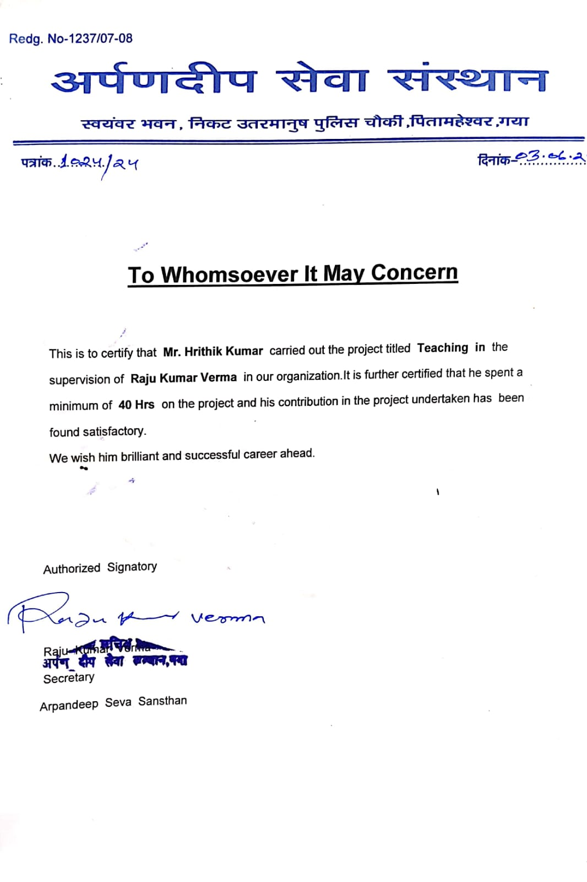

ACKNOWLEDGEMENT

I cannot express enough thanks to my committee for their continued support and encouragement. I offer my sincere appreciation for the learning opportunities provided by my committee.
My completion of this certification course could not have been accomplished without the support of my friend and senior.
Thank you for allowing me to take part to experience something from you to research and write. You deserve a trip to destination visit plan! Thanks to my parent and all my close friends who I did it complete by all the precious means. The timeless count that you gave to do it possible will not be forgotten. Ultimately, to my loving, caring and all the supportive friends and classmates who resourcefully supported me.
My Deepest gratitude and love to all the ones who gave the countless time with the kind attention. It was a great comfort

and relief to know that what you were willing to provide while I completed my work. My warm-hearted thanks to all the ones.

Introduction of our NGO’s:

1st ARPANDEEP SEVA SANSTHAN

A non-governmental organization (NGO) is a non-profit group that functions independently of any government NGOs, sometimes called civil societies, are organized on community, national and international levels to serve a social or political goal such as humanitarian causes or the environment.
Arpandeep seva sansthan is a committee of men and young children and students who come from all walks of life with the motto of being the change they want to see in the society in terms of education and all. The biggest problem our country faces is the presence of too many people discussing issues but few trying to find solutions. Where we understand that finding loopholes are important, we believe every small action gets counted and it is important that we give away the complaints and try to do things for a brighter tomorrow.
If we want our democracy to work, it becomes extremely important that civil society is responsible and actively involved because when we get to choose the government, we become a part of it and as has been rightly said, with great power comes great responsibilities.
Our committee has motto to help every person and society. Work for only society development. Like provide education to poor children, food distribution, copies pencil pen or study material distribution for children, or many more things help for society development and encouragement of youth to do something for their nation.

Non-Governmental Organizations (NGOs) participate in many activities, including environmental protection, social services, advocacy, and human rights work. They
strive to create social or political changes, whether on a large scale or within local communities. NGOs play a crucial role in societal development, community
improvement, and encouraging citizen involvement.

Arpandeep seva sansthan is a group of men, women, young children, and students and is a nongovernmental organization but funded by various government resources.
Most of its members are politically connected and it is under leadership of MR. Raju kumar verma sir who has the main motto of making Tibet independent from the Chinese control.
They organized various camps in northern part of India and hundreds of events in a year. They have also operating various healthcare operation in northern part of India where they are treating the patient free of cost with the natural and non herbs collected from Tibet and various bud ministries.
They currently have their head office in Bihar Gaya and in every state they have a team of local leaders and other member who are working to achieve aim one day.

DEFINITION:
A Non-Governmental Organization (NGO) is a non-profit, voluntary group that is independent of any government.
NGOs are organized on local, national, or international levels to address various issues, such as social, environmental, advocacy, and human rights. They aim to effect positive change, provide services, and support communities through various initiatives and programs.

AIM AND OBJECTIVES:
Aims and Objectives of our Society are:
- To provide Social, Educational and Economic Empowerment to Women and Children.
- To safeguard the rights of the Child and provide for the well-being of Children in need, more particularly,
- Children should know the Right to equality under Article 14
- Children exposed to any form of abuse,
- Children deprived of education
- Children suffering from ill health, physical and mental.
- To identify the beggars and impress upon them the significance of dignified living and persuade them to take up an alternative livelihood and to take such measures so as to equip them in attaining such means of living.
- To provide medical and legal aid and assistance to the old aged and to take such other Measure to ensure their social wellbeing.
• To help each and every needy at time of covid-19 and to discuss facts among them.

OBJECTIVE OF OUR NGO :-

The objective of the true NGO, the non-governmental Organisations should be the social as well as economic welfare. The objective of the NGO should be to provide education to the children so that their society should develop with modern thinking and also help the economy of the country with good GDP. Trust is the great NGO of India who objects at providing educational facilities to all. They mainly work to bring the rural and the urban people together for a better society. The helps the rural people.NGO which is providing free education to them. The Joint trust for child sponsoring organisation who have helped many poor and unprivileged children to come ahead. They donate for the provision of education to all and also to provide facilities to them. The teachers gave value-based education to the students which makes them more capable in society with a good name. They are taught all the spiritual values which are needed to be a respected person. Knowing the importance of values, they always maintained the balance between the modern scientific education and the spiritual values. When the person gets proper education, awareness is created among them, they started thinking and also the sense of questioning arose in them. This had led to the development of the economy as well. With education, employment increased in the society with which the income of the society also showed remarkable changes. With the improvement in the income, people started spending more on them, they started spending on their lifestyle, particularly on their health.

Scope of the our ARPANDEEP SEVA SANSTHAN

The scope of is to develop the society, to help every people more and more and more. for poor people distribute food .and children are also developed in every society. All children are educated. On-Government Organizations are the non-profit voluntary groups established at local, national or international level. They perform different tasks for solving problems and development of society. NGOs are connected with government or private sector firms. They deal with some social issues like women empowerment, girl child, gender issues, education, pollution, street children, slum dwellers, health, urban development, human rights, concerns of less privileged etc. NGOs bring up people's concerns and issues to the government and policy makers non-profit making, voluntary, service oriented/development oriented organization, either for the benefit of members or of other members of the population. It is an organization of private individuals who believe in definite basic social principles and who structure their activities to bring about development to communities that they are servicing. An independent, democratic, non-sectarian people’s organizations working for the empowerment of. As a result, development of courses in the nonprofit stream had also taken a back seat. However, now the scene is entirely different. Government policies, work of the existing NGOs and the media have a lot to do with bringing Nonprofit management . a normal career option. 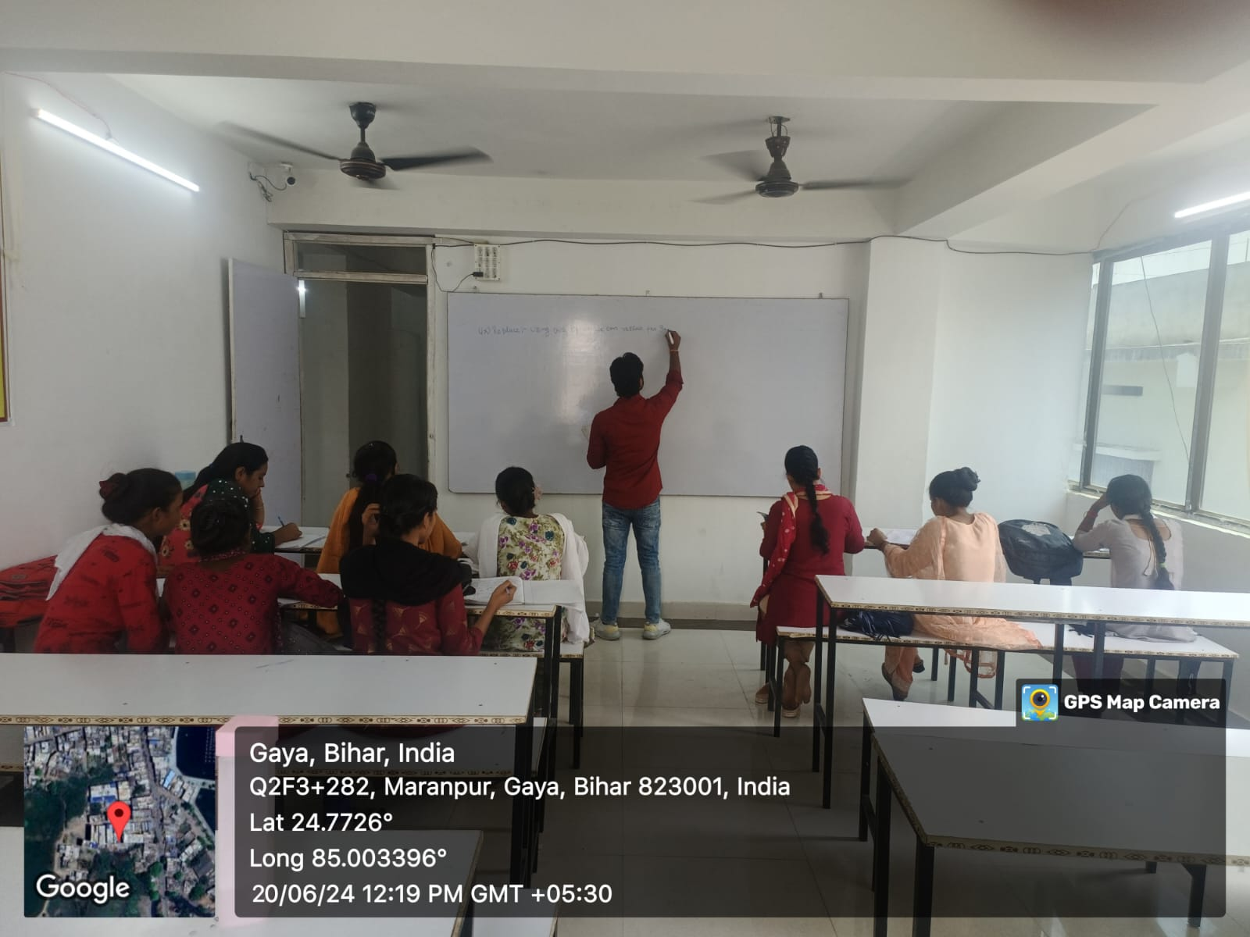

Arpandeep classes for poor class people.

MISSION STATEMENT:
  - Education, research and training

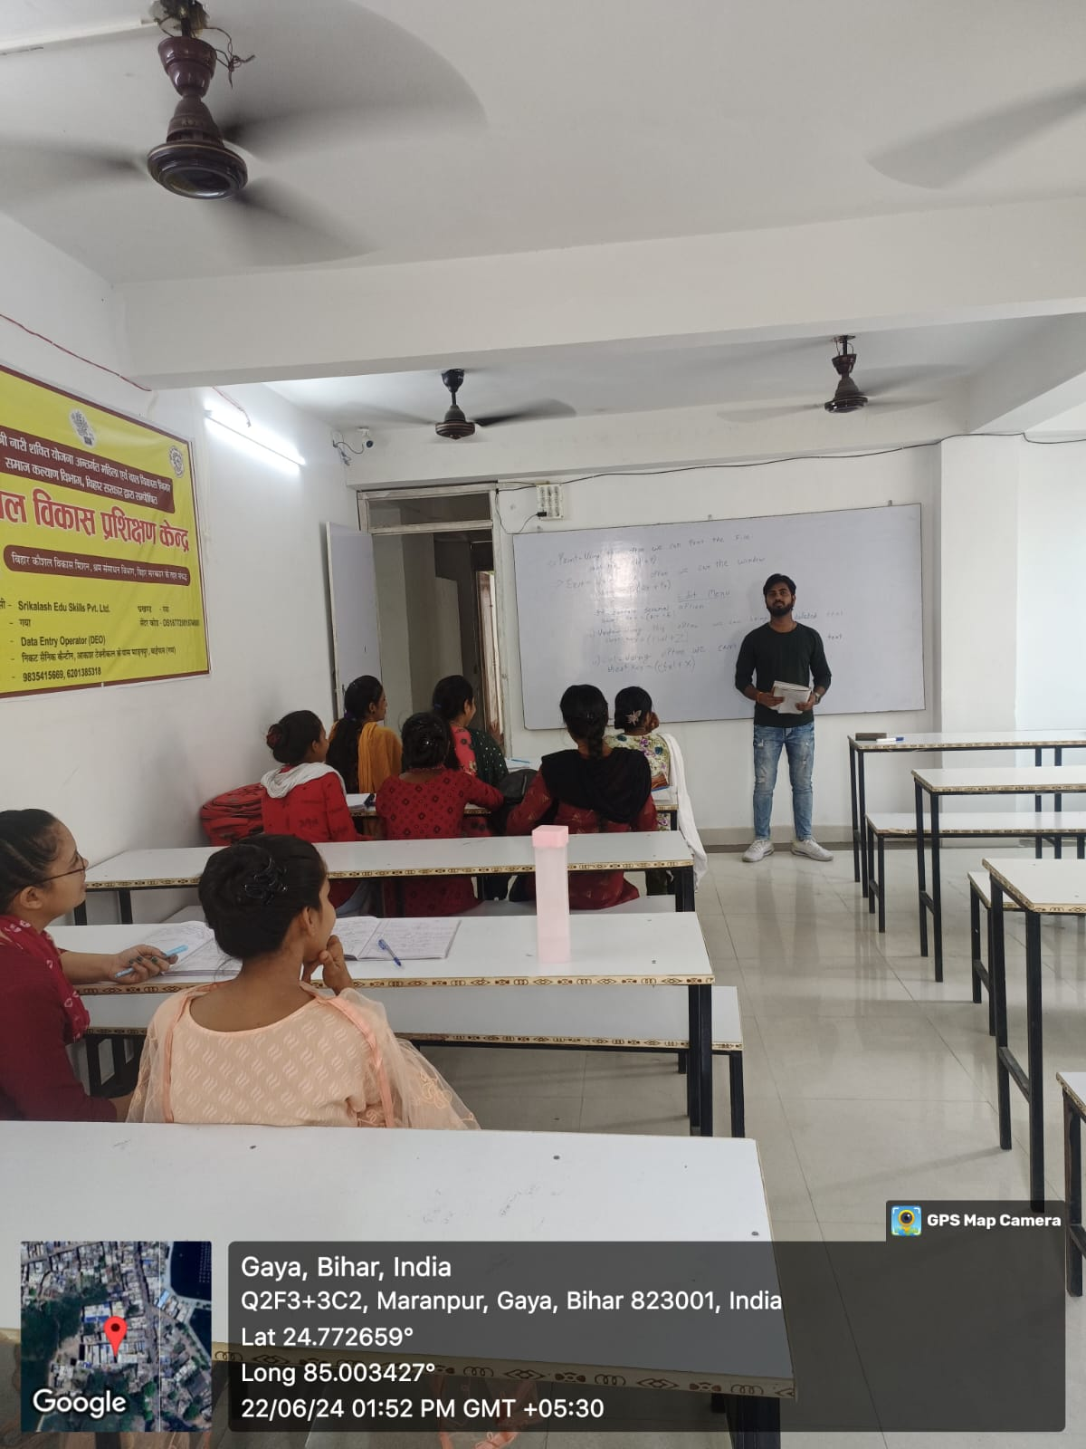

- To promote education, especially education for girl child and women.
- To conduct educational, environmental and sociological studies
• To promote use of Information & Communication Technology (ICT) for
Social economic development of the community.

- To organize training and refresher programs for the volunteers and officials of different Non-government Organizations to strengthen the development skills of trainees through IEC (information, education and communication) which they can use in the development sector.
- To disseminate information and knowledge, to edit, publish, and print literature and documents and to organize seminars/ conference/meetings etc.

2. spreading awareness regarding throwing garbage on near home place. And how to avoid them.
•To promote social welfare activities with special emphasis on cleaning city.
- To work for the betterment of Colony, road and citizens.
- To organize clean up campaigns. to collaborates with local residents, business ,schools, and Community organization to organize regular clean up events to remove litter and debrits from Road and public place.

•To encourage people for proper waste disposal by providing clearly marked trash Bins in public areas.
- Environment: •To work for environmental awareness, sustainable development and
participative management of local natural resources for village level development.
- To spreading awareness in people regarding recycling programs in the city to reduce
The amount of waste sent to landfills. Increase access to recycling facilities and educate residents on what can be recycled.

Current Problem in Society:

  - Lacking complete knowledge among people regarding the disease
  - People of lower class being panicked and lots of anxiety is there
  - Increase Unemployment among youth and less availability of food for poor people
  - People being unaware about the risk and importance of mask
  - People unable to find beds and other resources to help others and themselves get helped.
  - Black hording in Indian markets

Now, there two situation arises one of thinking what to do and other is to find the solution of these problem and we and our organization start following second step
And start identifying the problem and working in the positive approach.

Main Target—Objective to be achieved:
We have categorized our objective in that way so that our goals can be achieve in easy way.
We start with spreading awareness among all class of people so that they at least know about the situation and prevent themselves from taking any step that can be hazardous to their life.
Secondly to fulfill the needs of needy we start donating foods on daily basis with all precaution and safety measure door to door so that everyone can be safe.
We will start a campaign of distributing masks among people and all so that they should understand the need for the mask and talk to local authority to make use of masks compulsory

At last we will try to encourage the people to planting more trees near the Road side and bridge to overcome the pollution and improve the quality of air in cities.

Steps taken to achieve target:
Our first objective is to spread knowledge in order to do so we used all possible technique as:

As we know that now a day people are more adhered to social media, so we try to spread awareness with the means of the website names:
1.facebook
2.instagram
3.twitter

Which provide various features other than spreading awareness
We provide information about human right

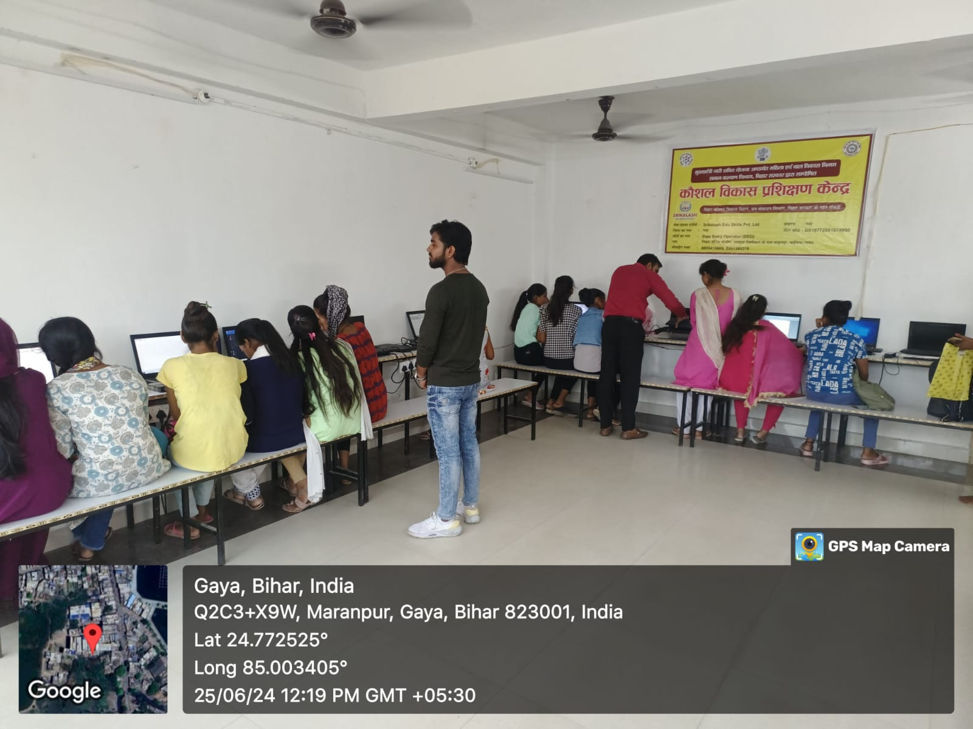

ACTIVITIESDONE
Day1: Introduction of gyanodaya foundation and discuss on work

Day 2: Understanding the work. Making report of second day.

Day 3: Started teaching student about computer.

Day 4: Continued the teaching about computer.

Day 5: Give parcticle class to student what I teach to them.

Day 6: Continued the teaching.

Day 7: Making video to encourage the people about social awareness.
Day 8: Telling student about human right.

Day 9: Go some places to encourage the student about value of study.

Day 10: Attended Meeting for new tasks.

Day 11: Provide classes with other teammates.

Day 12: Making report.

Day 13: making report.
Day 14: Attended principal and teachers meeting.

Day 15: making report on women empowerment and food distribution.

Day 16: purchasing copy pencil and stationary objects of poor children.

Day 17: Convocation for good performing students Day 18: Making report

Day 19: giving lots of reviews and quizzes and they give form of volunteer of NGO and all reports submitted and certificate distributed.

Photo
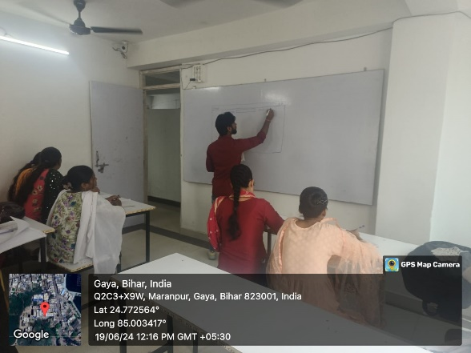

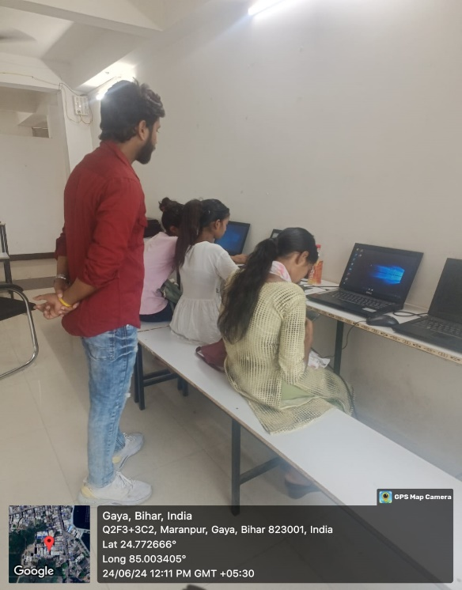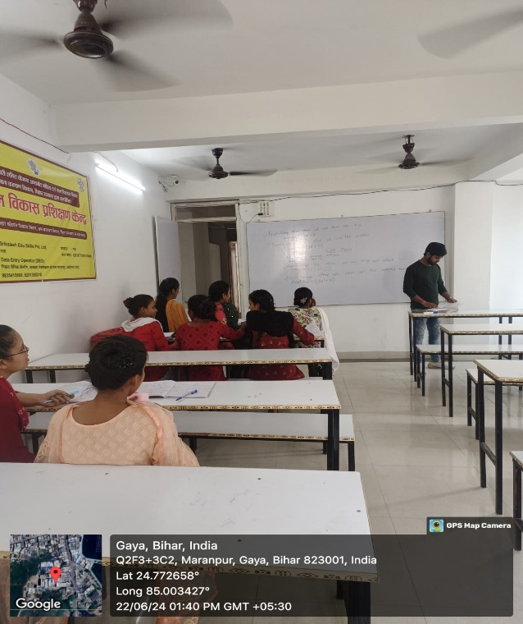

CONCLUSION

Although this section on gender and NGOs in the management and sustainable use of the environment has been only exploratory, it is hoped that it will serve as a basis for further research into the gender and NGO issue, with special reference to women's access to critical resources such as training in farming systems, extension services, land, technology, credit, farming inputs and strategies for wood-fuel management to stem the environmental degradation NGOs and people's organizations, unburdened with large bureaucracies and noted for their flexibility and innovativeness, are often able to implement programs and activities more effectively.

NGOs are able to respond more quickly to grassroots needs, implement projects at a faster pace and gather feedback sooner than other types of development agencies. In most cases, NGOs are able to muster the necessary skills and expertise needed to carry out pilot programs and projects and to implement government programs for social service delivery.

In certain cases, such as in Bangladesh, the scale of operations of some NGOs has gone beyond pilot projects. With small or even non-existent bureaucratic structures, NGOs typically have far lower operating costs than government service delivery mechanisms. The GYANODAYA FOUNDATION must be at the forefront of responding to the rapidly escalating humanitarian needs around the Jharkhand – saving lives and so much more, through this pandemic and beyond. And, as with any crisis, there’s opportunity.

Opportunity here to design and develop new financing solutions, which could help to find new and better ways to tackle global challenges together.

This has never been more needed than now
The effectiveness of NGO interventions in the development process hinges, to a large extent, on whether or not the policy environment is conducive. Governments which actively welcome NGO involvement and participation in the development process provide a policy environment where NGOs are viewed as partners and not as competitors. NGO activities include, but are not limited to, environmental, social, advocacy and human rights work. They can work to promote social or political change on a broad scale or very locally. NGOs play a critical part in developing society, improving communities, and promoting citizen participation.

