Can Mathematics Recognise Musical Notes?
The mathematics behind a Fourier-based note detector
The program is a chain of seven mathematical steps, each turning the output of the previous one into something closer to a note name: from the physics of a vibrating string, through sampling and the Fourier transform, to a note name and a tuning error in cents.
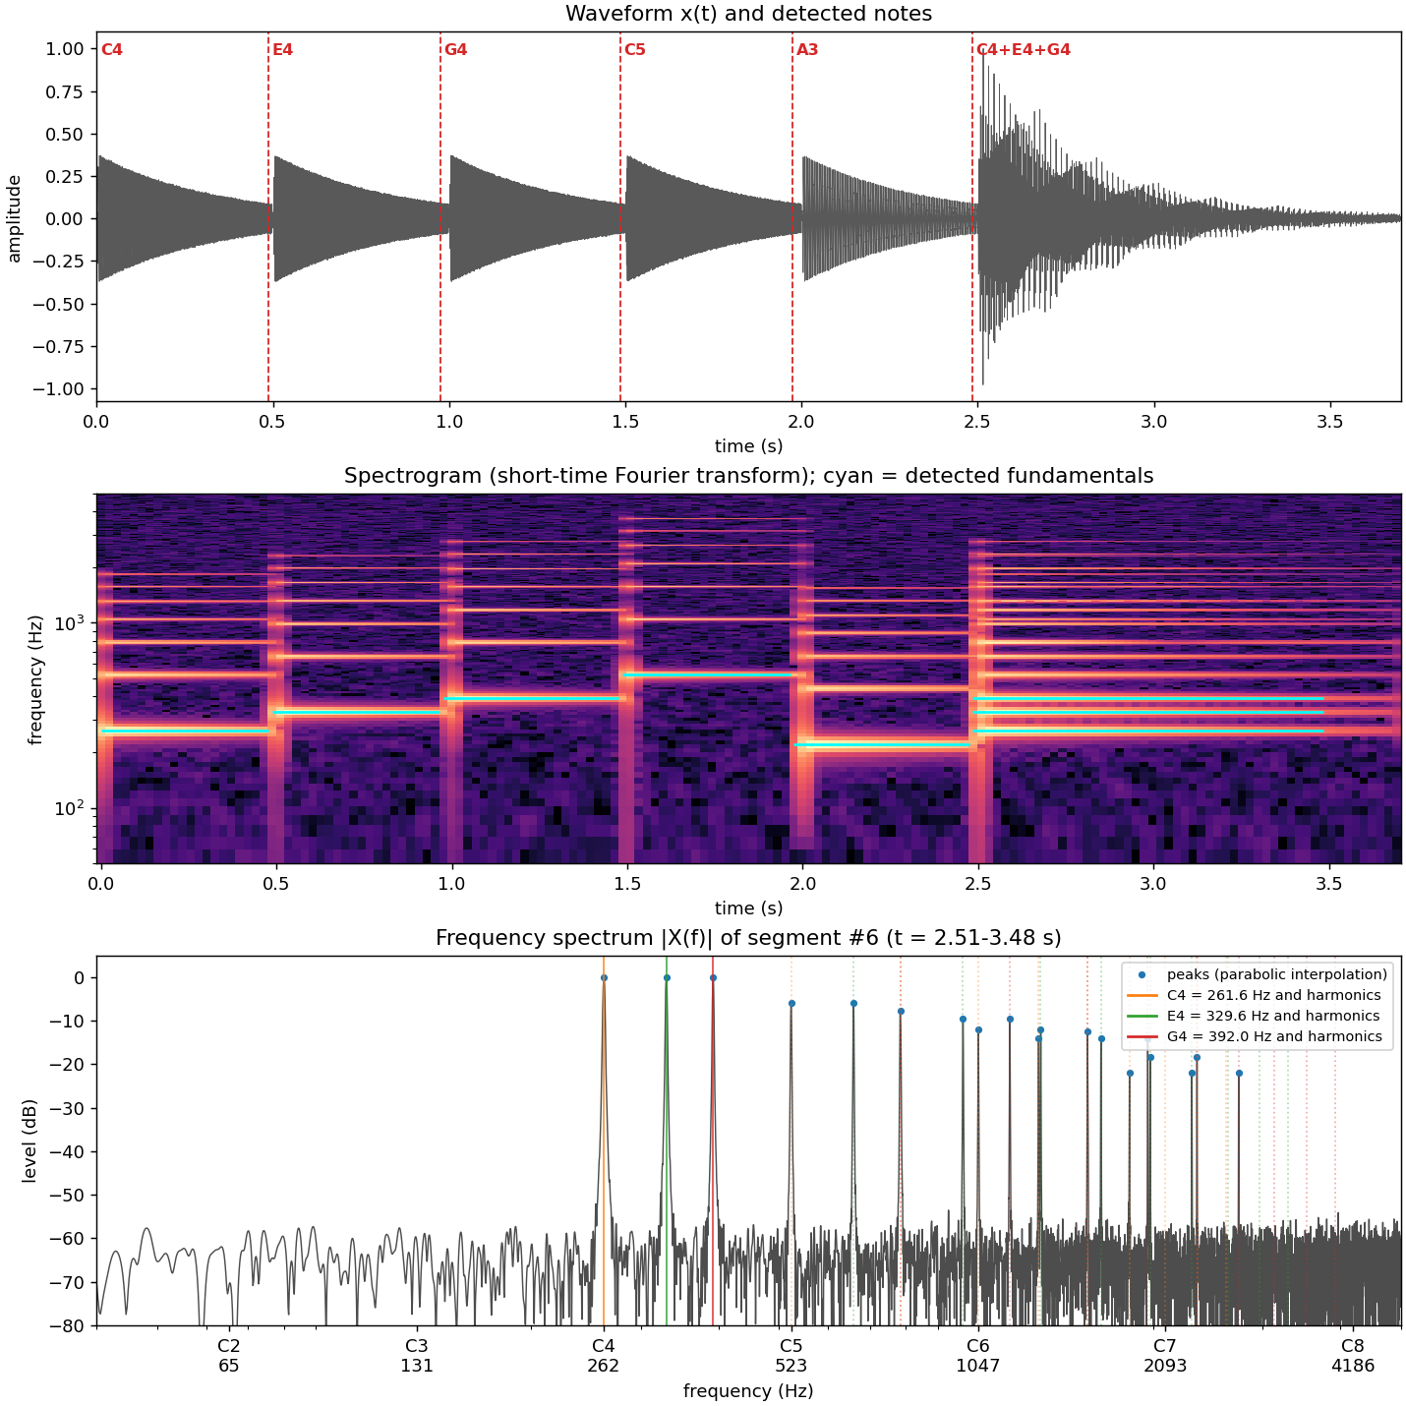
Output of the program on a test melody: waveform with detected notes (top), spectrogram (middle) and the frequency spectrum of a C major chord with its harmonic series marked (bottom).

1. Why a note is a sum of sines
A string of length L fixed at both ends obeys the wave equation
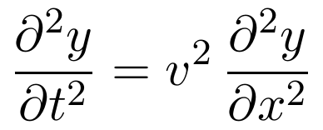
Because the ends cannot move, only whole numbers of half-wavelengths fit on the string, so the allowed frequencies are
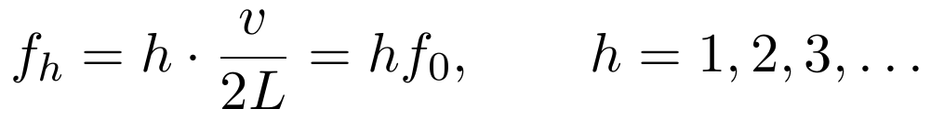
The sound is therefore a Fourier series:
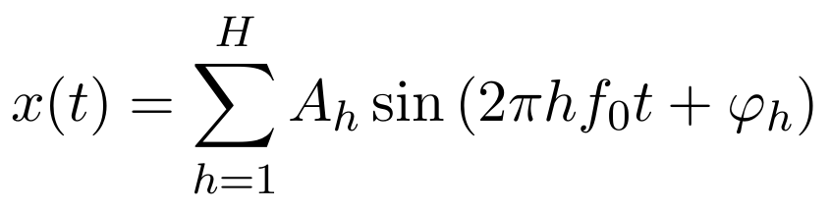
We hear the pitch as f₀. The amplitudes A_{h} are the timbre, which is why a guitar and a piano playing the same note sound different.

2. Sampling
The microphone stores the values x[n] = x(n/f_{s}), with f_{s} = 44 100 samples per second. By the Nyquist theorem, only frequencies below f_{s}/2 = 22 050 Hz can be represented, which is enough for every note on a piano.

3. The Fourier transform: how you measure a frequency
The discrete Fourier transform (DFT) of N samples is
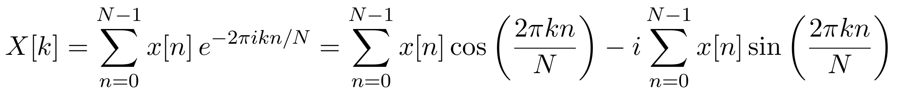
Each X[k] multiplies the signal by a test cosine and a test sine at frequency f_{k} = k f_{s}/N and adds up the result.
This works because of orthogonality:
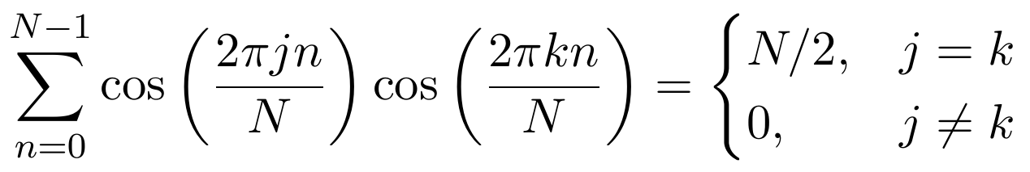
The proof uses the product-to-sum identity cos a cos b = ½[cos(a−b) + cos(a + b)]. A cosine summed over whole periods is zero, so only the j = k term survives.
So if x[n] = A cos(2πf₀n/f_{s}), then |X[k]| is about AN/2 at the bin where f_{k} = f₀ and near zero everywhere else. A peak in |X| means a sine wave at that frequency, and its height gives the amplitude A.
Worked example. With a chunk of T = 0.5 s, N = 22 050 samples, the bin spacing is Δf = f_{s}/N = 1/T = 2 Hz. A4 at 440 Hz lands on bin k = 220.

4. The FFT: making it fast
Computing the formula directly costs N² multiplications, about 486 million for this chunk. The Fast Fourier Transform splits the sum into even- and odd-numbered samples:
where E and O are DFTs of half the size. Applying this split recursively needs only N log₂ N operations. That is why the program’s --verify-dft option shows roughly a 900-fold speed-up while giving the same answer to about 10⁻¹³.

5. Windowing and resolution
Cutting out a chunk of the signal is the same as multiplying it by a rectangle. By the convolution theorem, multiplying in time means convolving in frequency. The rectangle’s transform is a sinc function, whose sidelobes (only 13 dB down) smear energy into neighbouring bins. This is called spectral leakage.
The fix is the Hann window, which fades the chunk in and out:
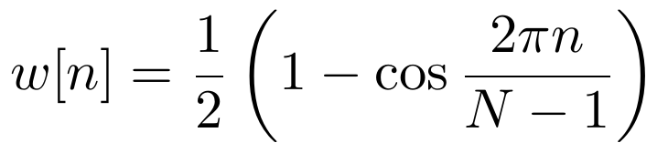
Its sidelobes are 31 dB down and fall off quickly. The program divides the spectrum by ½∑_{n}w[n] so that a sine of amplitude A still shows a peak of height A.
The trade-off is resolution: two frequencies can only be separated if they differ by more than about 2/T. The two lowest guitar notes, E2 (82.4 Hz) and F2 (87.3 Hz), differ by 4.9 Hz, so the chunk needs
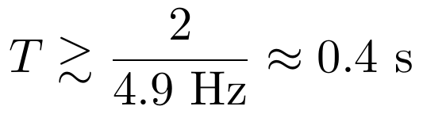
Sharp time precision and sharp frequency precision cannot be had at the same time; this is the same mathematics as the uncertainty principle.

6. Finding the peak between bins
A true frequency usually falls between two bins. The program fits a parabola y = a(x−p)² + b through three points: the peak bin (in dB) and its two neighbours, placed at x = −1, 0, 1. Solving for the vertex gives
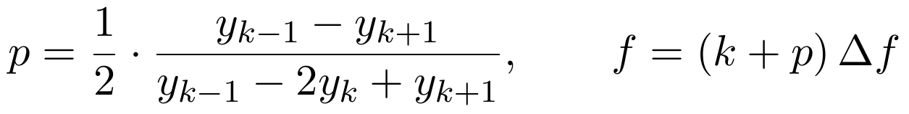
The Hann peak shape in dB is close to a parabola, so this locates the frequency to within less than 0.1 of a bin, which the program’s tests check.

7. Where does each note start?
The program takes FFTs of overlapping frames (the spectrogram S_{t}[k]) and computes the spectral flux:
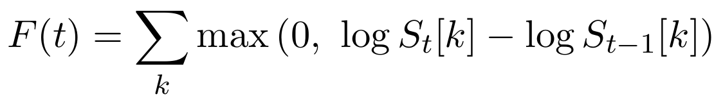
A new note suddenly adds energy, so F spikes. A spike counts as an onset if it exceeds the local median plus a constant.

8. From peaks to the note: the harmonic sum
The loudest peak is not always the note that was played. So for each candidate fundamental f₀, the program scores how well that note’s harmonic series explains the peaks:
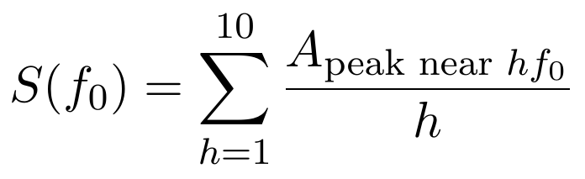
where a peak counts as “near” hf₀ if it lies within 40 cents:
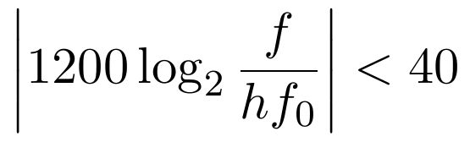
Why this avoids octave errors. Take harmonic amplitudes 1, 0.5, 0.33, 0.25, …
The true f₀ scores 1 + 0.5/2 + 0.33/3 + … ≈ 1.47. The octave above, 2f₀, only matches every other peak and scores about 0.66. The octave below, f₀/2, matches every peak, but they all sit at even h where the weight 1/h is smaller, so it also scores lower.
The winning frequency is then refined by a weighted least-squares average:
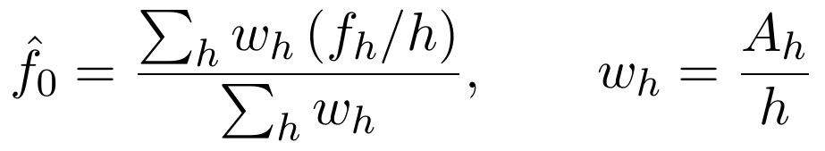
Chords. The program keeps the best note, deletes the peaks it explains, and repeats. It stops when the next candidate scores below 35% of the first note’s score.

9. Frequency to note name
Equal temperament divides each octave (a doubling of frequency) into 12 equal ratios of 2^{1/12}. Anchoring A4 = 440 Hz = MIDI note 69:
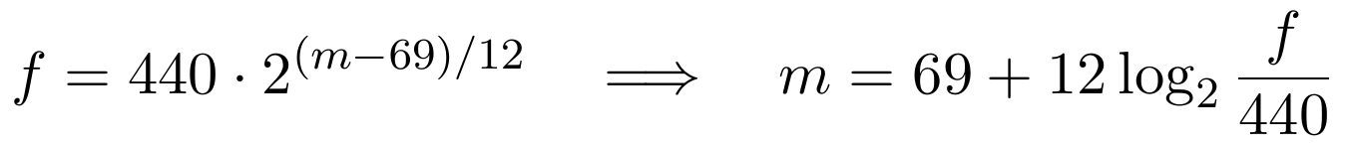
Example. For f = 261.6 Hz:
which is C4.
The part left over after rounding, multiplied by 100, is the tuning error in cents. For instance, m = 69.20 means A4, 20 cents sharp.

10. Case study: analysing a full song (“Before the Siege”)
This section explains exactly what was done with the uploaded MP3, step by step, with the numbers from this recording.
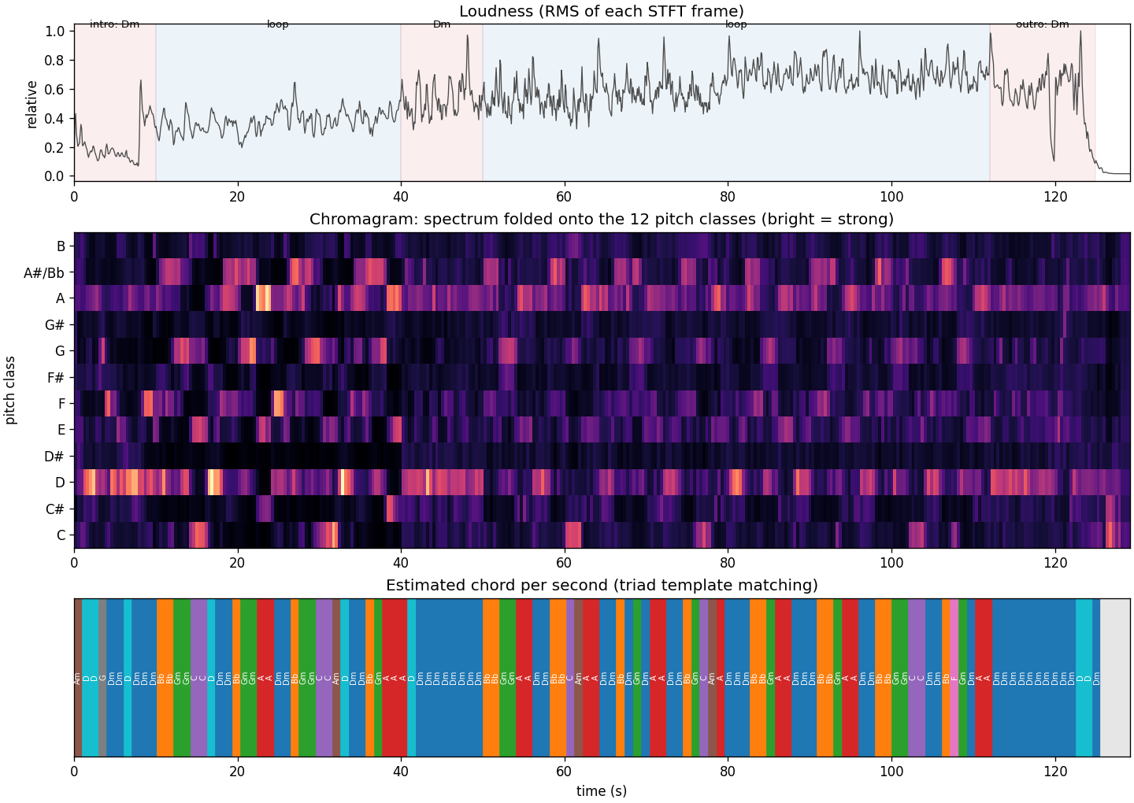
Loudness (top), chromagram (middle) and estimated chord per second (bottom) for “Before the Siege”.

10.1 Turning the MP3 into numbers
An MP3 does not store the waveform directly. It stores frequency coefficients from a cousin of the Fourier transform, the modified discrete cosine transform (MDCT). Decoding reverses that and gives back samples. The original file is stereo, sampled at f_{s} = 44 100 Hz, and 129.2 seconds long. It was prepared in three steps.
Mono. The two channels were averaged:
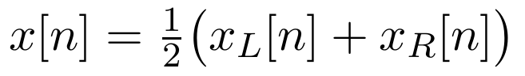
Downsampling to f_{s} = 22 050 Hz. The Nyquist limit becomes f_{s}/2 = 11 025 Hz, far above anything the chord analysis needs.
Normalising. The average (DC offset) was subtracted, then everything was divided by the largest absolute value, so that x[n] ∈ [−1, 1].
That leaves about 2.85 million numbers.

10.2 First attempt: the note detector
The note detector was run unchanged. It found about 250 onsets, and in each one the strongest harmonic series was the bass: D2, B♭1, G1, A1, repeating. The harmonic-sum method works well for one instrument, but in a full mix the bass has the most energy, so it wins. For a whole band, different questions are needed: which pitch classes are present, and how they change over time.

10.3 The spectrogram (short-time Fourier transform)
The signal was cut into overlapping frames of N = 8192 samples, stepping forward H = 2048 samples each time. Each frame was multiplied by a Hann window and transformed with the FFT:
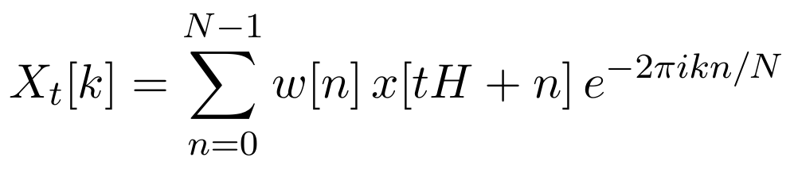
The frequency resolution is Δf = f_{s}/N = 22050/8192 ≈ 2.69 Hz, fine enough to separate low bass notes, which is why such a long frame was chosen. Each frame lasts N/f_{s} = 0.37 s and the step between frames is H/f_{s} = 0.093 s. The result is about 1390 frames × 4097 frequency bins.

10.4 The chromagram: folding octaves together
Every frequency bin is given a pitch class:
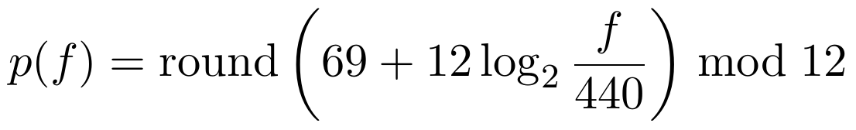
For example, D2 = 73.4 Hz gives m = 69 + 12 log₂(0.1668) = 38 and 38 mod 12 = 2, which is D. A3 = 220 Hz gives m = 57 and 57 mod 12 = 9, which is A.
Every octave of a note lands in the same class, because doubling f adds exactly 12 to m. The energy in each class is then added up, using only bins from 55 to 2000 Hz to skip rumble and cymbals:
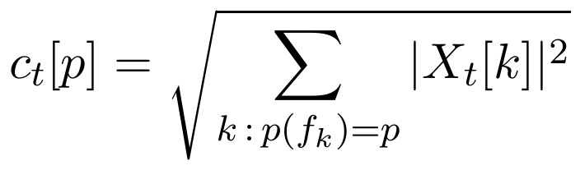
and each frame is normalised so that ∑_{p}c_{t}[p] = 1. This gives 12 numbers per frame: the middle panel of the figure.

10.5 Key: correlation with key profiles
Averaging c_{t} over the loud frames gives the song’s pitch-class profile:
C | C♯ | D | D♯ | E | F | F♯ | G | G♯ | A | B♭ | B
.072 | .061 | .156 | .041 | .089 | .090 | .053 | .087 | .047 | .145 | .099 | .061
The Krumhansl–Schmuckler profiles come from experiments in which listeners rated how well each note “fits” a key. Shifting a profile by k positions gives the profile for any of the 12 keys, making 24 candidates (12 major, 12 minor). Each was compared with the song’s profile using the Pearson correlation
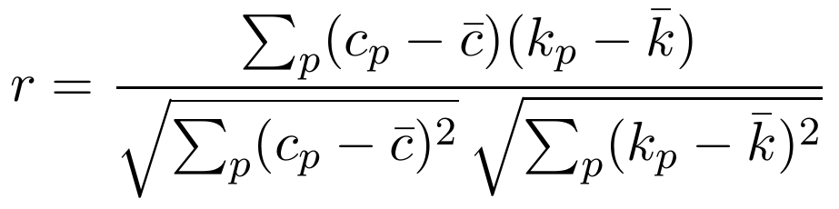
The results were D minor r = 0.88, D major 0.71, A minor 0.52 and F major 0.47.

10.6 Chords: cosine similarity with triad templates
Each of the 24 major and minor triads is a template vector t with 1s on its three notes; for example, Dm has 1s at D, F and A. For each one-second block (11 frames), the best chord is the one with the highest cosine similarity
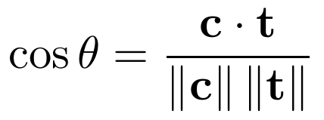
As an example using the whole-song profile, where ‖c‖ = 0.313 and ‖t‖ = √3:
Chord | Notes | Sum of those notes | cos θ
Dm | D F A | 0.156 + 0.090 + 0.145 = 0.391 | 0.72
D | D F♯ A | 0.354 | 0.65
B♭ | B♭ D F | 0.345 | 0.64
F | F A C | 0.307 | 0.57
On individual seconds, the winners change in the pattern Dm → B♭ → Gm → A, each held for about 2 s. Some passes end on C instead of A.
For the bass line, the same folding was done using only 38–160 Hz, taking the strongest class. The bass followed the chord roots, D → B♭ → G → A, which confirmed the chords. Blocks quieter than 8% of the loudest block were marked “no chord”; that is how the silence at the end was found.

10.7 Tempo: autocorrelation
The spectral-flux onset curve F(t) from the note detector has 43.07 values per second and spikes on every drum hit and note start. Comparing it with a copy of itself shifted by a lag τ gives
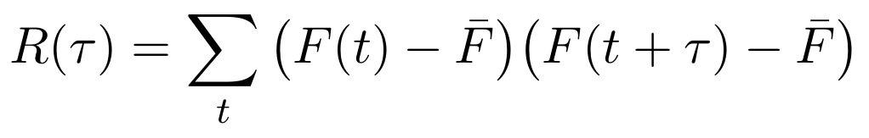
This is large when τ equals the beat period, because the spikes line up again. Searching between 60 and 180 BPM, the peak is at a lag of 22 frames:
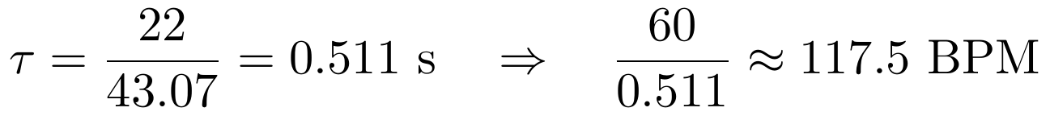
The neighbouring lags, 21 and 23 frames, would give 123 and 112 BPM, so the measurement is only precise to about ±5 BPM and the true tempo could well be 120. Parabolic interpolation on R(τ), the same trick used for spectral peaks in Section 6, would sharpen this.
As a check, 4 × 0.511 ≈ 2.0 s, which matches how long each chord lasts. So each chord is one bar of 4/4, and the four-chord loop takes about 8 s.

10.8 Loudness and structure
The loudness curve is the root-mean-square of each spectrogram frame:
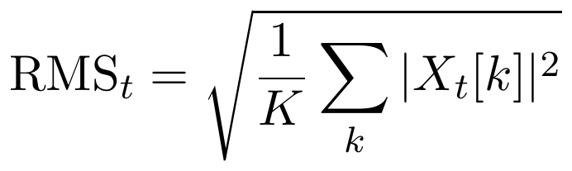
The song was divided into sections by looking at this curve together with the chord timeline, not by an algorithm. The quiet start (0:00–0:10) is where only Dm is detected. The loop starts where B♭ first appears (0:10) and runs to 0:40. A held Dm follows (0:40–0:50), then the loop returns, getting louder, until 1:52. The piece ends on Dm (1:52–2:05), followed by silence.

10.9 Why the A chord is interesting
The whole-song profile has only 0.061 on C♯. Yet the A major chord keeps winning just before each return to Dm, because its C♯ appears briefly there, as the chromagram shows. C♯ is not in D natural minor; it belongs to D harmonic minor. C♯ is one semitone below D, so the pitch rises by a ratio of only
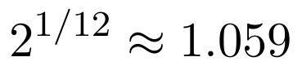
and that tiny step is what makes the loop feel like it resolves back to D.

10.10 Limitations
The chords were estimated in one-second windows, so chords changing right at bar boundaries are sometimes mislabelled. The templates only contain major and minor triads, so seventh and suspended chords appear as the nearest triad. The section boundaries were chosen by inspection rather than computed.

