Software Requirements Specification

For

Organic Dairy Farming- ERP System
Version 1.0 approved
Prepared by Hrithik Puri
NIIT University
Date : 12/09/2016

Revision History
Name | Date | Reason For Changes | Version

1. Introduction

1.1 Purpose
Purpose of this document is to collect and analyze the ERP system of the Organic Dairy Farming and the ideas that have come up to define the system. It will explain the purpose of the system , the detailed overview of ths system, how the product will be used. It helps both developers and stakeholders of the system for better understanding of the system.

1.2 Document Conventions
This doc. is written in Times New Roman Font, and used font-size is 14 for main Headings, and 12 for sub-headings and 12 for all the paragraphs.

1.3 Intended Audience and Reading Suggestions
This document is intended for the farm owner, for the developers, marketing staff and users. This SRS explains the detailed overview of the system.

1.4 Product Scope
Our Product is to reduce admin work, making the managment efficient and easier for him. Our ERP system provides various functions that will make Product owner free of updating all his day to day data on paper and he could keep check on everything from any where he want to.

1.5 References

********************

2. Overall Description

2.1 Product Perspective
ERP database is a product made to ease the tasks of the
Product Owner.

2.2 Product Functions
Functions of the system is to upload day to day information about Cattle,its fodder and to check customers data when required. We can take a look on the current status of the cattle, daily sale and will get alert for emergency if there is any.

2.3 User Classes and Characteristics
Product will be used mainly by the Admin himself, Employees for day to day updation and obciously the Customers who will place their order.

2.4 Operating Environment
HTTP supporting browsers (Google Chrome, Safari, Mozilla Firefox, IE, Netscape, etc). It is compatible with PC and Tablets. There is no such Operating system compatible issues, as of now.

2.5 Design and Implementation Constraints
We are using Django Framework to develop the ERP. Language: HTML, CSS, Bootstrap for Front end while Python and Django for Back end and Mysql for database,

2.6 User Documentation
A user manual will be created that will help the first timers to use this product though the software will be very user friendly that customer will not have any difficulty using it.

2.7 Assumptions and Dependencies
One of the assumed factors is that the users of this software have internet access. It has been assumed that the users will access the portal using a PC or tablet with HTTP supporting browsers.

3. External Interface Requirements

  - User Interfaces
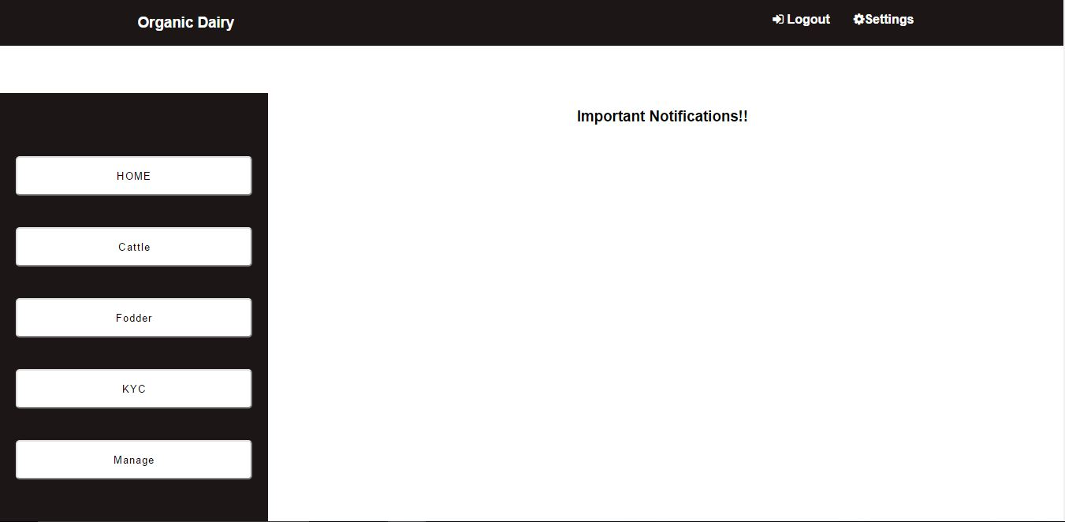

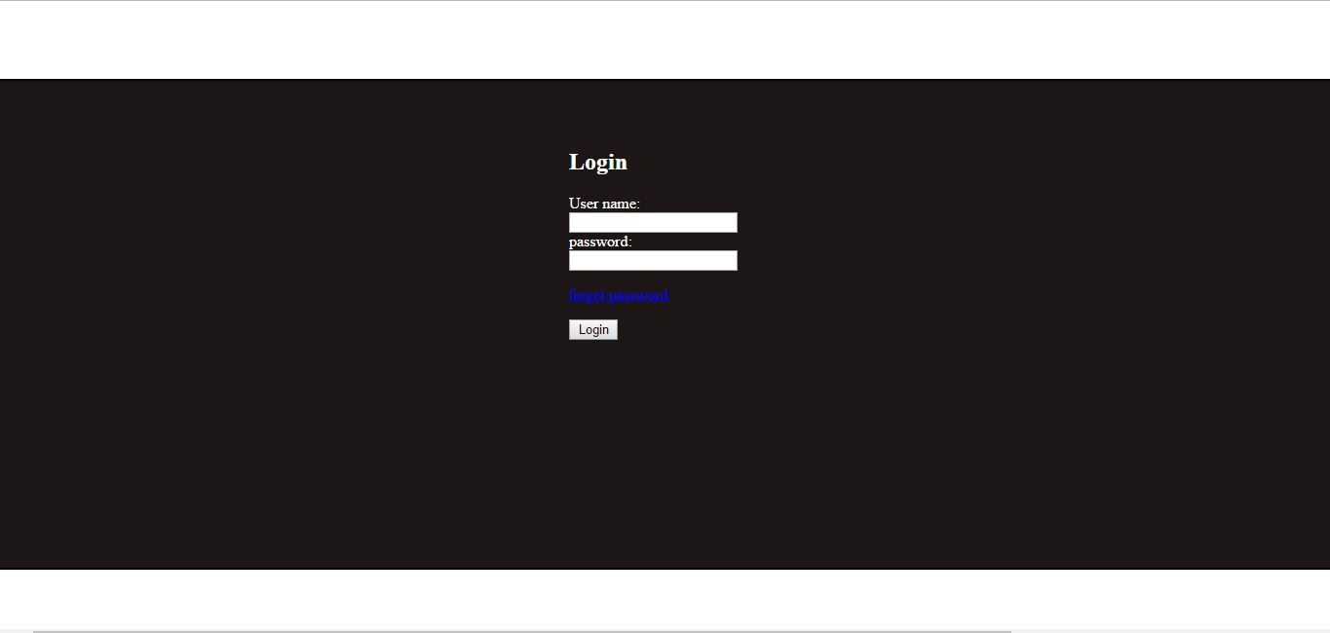

- Index page of system is login page, for login different username password will be provided to admin, customers and employees. If username password entered are not correct an error will be shown.
- Home page will consist a navigation bar with settings and logout option.
- There will a vertical panel with certain options which are
: Database, which when chosen, will direct to another page.
: Create more users, where the accessibility rights will be given to the employees.
- On the right side there will be a section for daily updates and emergency alerts, reminder system will be there that will automatically add certain required updates here.
- Inside database page there will be a panel on the left side of the page that will contain all the required database that are:-
:Cattle database –> It will contain cattle id, name of the cattle , cattle's breed, age, sex, etc.
: Fodder database –> It will have the information about the fodder produced for the cattle. Information like type of seeds, fertilizers used ,irrigation, harvest etc.
: Customer database –> Customer data will be stored here. Customer information like its customer id, name, contact etc.
- Each and every field could be updated(only by admin). Admin decides the options available for other users and what facility will they have.
-The main web page made for users will have a list of available products.
-An add to cart option will also be given and a view cart option will be there through which customer can see the item and move forward for checkout(options will be available for registered users only)which will redirect them further to the payment gateway.
-An invoice will be sent to the customer via email at every successful transaction.

3.2 Hardware Interfaces
The software Product will work on PCs, laptops and tablets, with HTTP supported browsers.

3.3 Software Interfaces
A Database is required to store the cattle, fodder, customer and others details. We will use django frame work and mysql for the same. Data will be inserted by the employees which could be viewed and changed by admin and day to day record will be kept.

3.4 Communications Interfaces
The communication standards used by us is HTTP.

4. System Features

REQUIRMENT IDENTIFIER | REQUIRMENT NAME | DESCRIPTION
SI | sign in | Each user is provided with unique password and can only move to main page if password is entered correctly.
FP | Forgot password | If user forgot its password can reset it at anytime by confirmation mail sent on his/her email address.
ADD_CD | Add Cattle data | Only authorized employees and admin is allowed to add cattle info to the database.
ADD_FD | Add Fodder data | Only authorized employees and admin is allowed to add fodder info to the database.
ADD_CuD | Add Customer data | Only authorized employees and admin is allowed to add customer info to the database.
View_CD | View Cattle data | Allows logged in users to view cattle info through the portal.
View_FD | View fodder data | Allows logged in users to view fodder info through the portal.
View_CuD | View customer data | Allows logged in users to view customer info through the portal.
Manage_acct | Managing account | It gives admin right to manage employees account that is what authority should be given to what employee.
Alert | Alerts | Important notifications will be alerted on the main page.
Update_CD | Update cattle data | Allows Admin and authorized  employees to update the existing  cattle data.
Update_FD | Update fodder data | Allows Admin and authorized  employees to update the existing  fodder data.
Notify | Event notifications | Implement a color based notification through calendars, by marking important dates.
Update_prod | Update products in store | Only authorized employees can update production.
View_prod | View products | Customers can view the products  on the store page without sign in.
ATC | Add to cart | Customers can add products from the main page to cart.
DEL_Cart | Delete from cart | If customer don't want to buy the product can cancel it at any point of time.
SU | Sign up | New customer can sign up to avail the services provided by our software.
Update_CuD | Update customer profile | Customer can update their profile by signing in to the account
Chkout_Cart | Checkout cart | Here, the customer can make their purchases after being  signed in.
Pay | Payment of the product | After clicking the checkout option customer will be redirected to the payment gateway for payment.
History | View purchase history | Customer can see their purchase history.
Invoice | Send Invoice | An invoice will be sent to the buyer to his/her email address.
Quant_reqd | Selecting quantity required | Customer can select the item and its quantity he/she needs.
LI | Log in | Admin and employees must use the given username password to access database.

USE CASE DIAGRAM:-

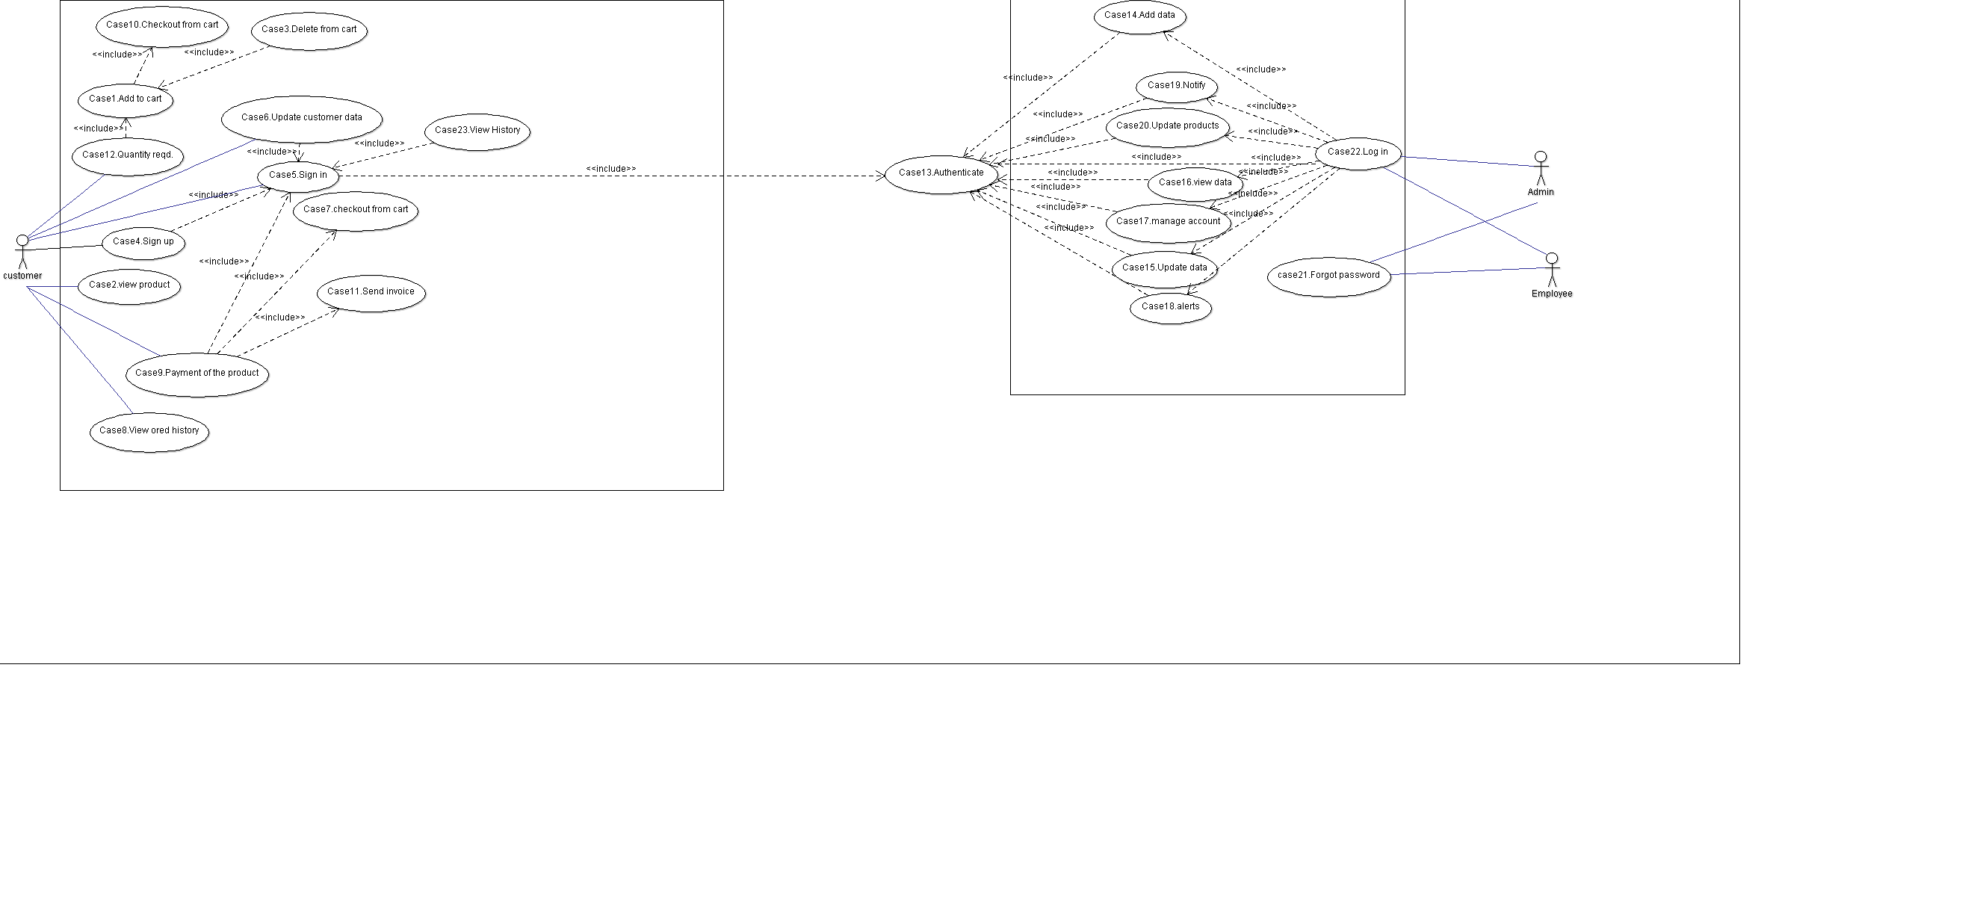

- Other Nonfunctional Requirements

REQUIRMENT ID | Name | Description
NR1 | Performance requirement | Our software will work in any situation even in poor connectivity of internet.
NR2 | Safety Requirements | Our software is secured from any sort of malware attacks so data is secured and unwanted crashes of server.
NR3 | Security Requirements | Each user will be provided with unique password and various security measures will be taken that will secure database from hackers.
NR4 | Quality attributes- Adaptable | It will adapt in any surroundings .
NR5 | Quality attributes-Correctness | Correct results will be generated every time.
NR6 | Quality attributes-Availability | User can access software from any where in the world without any problem.
NR7 | Quality attributes- Flexibility | Software is very flexible with surroundings.
NR8 | Quality attributes-Maintainability | Software is easy to maintain as coding is very efficient and can be updated by any coder.
NR9 | Quality attributes- Testability | Could be tested easily by developers.
NR10 | Quality attributes- Usability | Software is very easy to use so no user manual will be required though user manual will be provided .

