**Project Report**

**Hrithik Saini**

**2013339**

**B (22)**

**V semester**

**Problem Statement:** Creating a PDF viewer and creator with offline dictionary.

Language Used: Python

Libraries Used:

* Os (to open the already present files)-

The OS module in python provides functions for interacting with the operating system. OS, comes under Python’s standard utility modules. This module provides a portable way of using operating system dependent functionality. The *os* and *os.path* modules include many functions to interact with the file system[. (source)](https://www.geeksforgeeks.org/os-module-python-examples/#:~:text=The%20OS%20module%20in%20python,using%20operating%20system%20dependent%20functionality.&text=path*%20modules%20include%20many%20functions%20to%20interact%20with%20the%20file%20system.)

* Tkinter (to make the GUI for the app)-

The [tkinter](https://docs.python.org/3/library/tkinter.html" \l "module-tkinter" \o "tkinter: Interface to Tcl/Tk for graphical user interfaces) package (“Tk interface”) is the standard Python interface to the Tk GUI toolkit. Both Tk and [tkinter](https://docs.python.org/3/library/tkinter.html" \l "module-tkinter" \o "tkinter: Interface to Tcl/Tk for graphical user interfaces) are available on most Unix platforms, as well as on Windows systems. (Tk itself is not part of Python; it is maintained at ActiveState.) [(source)](https://docs.python.org/3/library/tkinter.html#:~:text=The%20tkinter%20package%20(%E2%80%9CTk%20interface,it%20is%20maintained%20at%20ActiveState.))

* PyDictionary (to search for meanings of words)-

PyDictionary is a Dictionary Module for Python 2/3 to get meanings, translations, synonyms and Antonyms of words. [(source)](https://pypi.org/project/PyDictionary/)

* Fpdf ( to create a new pdf)-

PyFPDF is a library for PDF document generation under Python, ported from PHP (see [FPDF](http://www.fpdf.org/) “Free”-PDF, a well-known PDFlib-extension replacement with many examples, scripts and derivatives).Compared with other PDF libraries, PyFPDF is simple, small and versatile, with advanced capabilities and easy to learn, extend and maintain[. (source)](https://pypi.org/project/fpdf/)

* Easygui (to take user inputs easily)-

EasyGui provides an easy-to-use interface for simple GUI interaction with a user. It does not require the programmer to know anything about tkinter, frames, widgets, callbacks or lambda. All GUI interactions are invoked by simple function calls that return results. [(source)](https://pypi.org/project/easygui/)

**Motivation:** The motivation of this project comes from my reading habit. Whenever I’m reading something, I often get stuck in a situation where I’m not able to comprehend the meaning of the written sentence. Then I have to refer to the internet for the meaning of the specific word. So if I open the internet , the internet addiction takes over and I get distracted every time and open youtube or instagram and my time gets wasted. In order to overcome this situation , I thought to add a dictionary directly to the pdf reader itself. And to make the work of taking notes easier , we can create a new pdf by pressing the create button. So overall to make the document reading easy , I was motivated to make this app.

Methodology:

* We create two files namely main.py and test.py
* In main.py we will create our pdf reader app and in test.py we will have the program to create a new pdf from scratch
* Test.py will be accessed from main.py by pressing create button.
* First we make the Gui window for our app using tkinter library in python
* Then we add the components like the buttons and their functionalities
* Then we add the areas where the pdf is going to show
* And then we add the entry box where the user will input the word to find its meaning using PyDictionary module
* Then we make the file test.py to enter the text in a blank canvas of tkinter
* When the user will click save button a new pdf file will be saved in the working directory after asking the user about its name.

Code: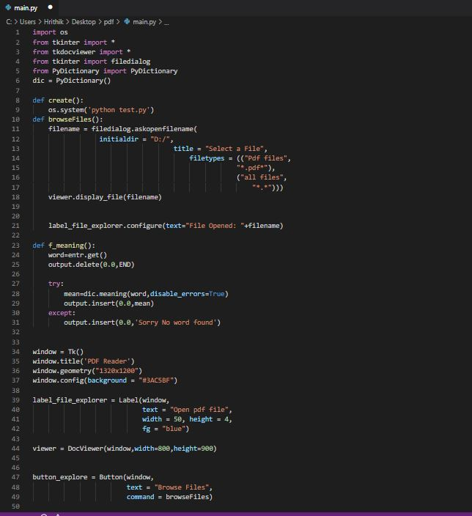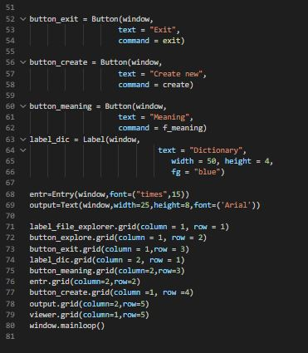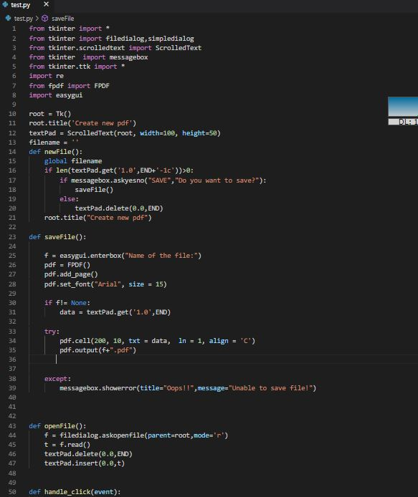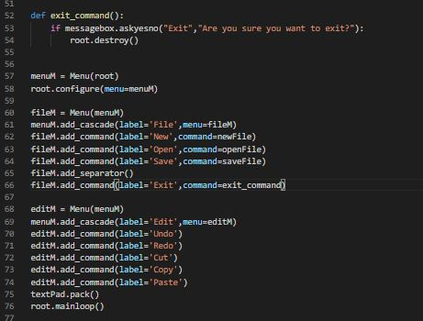

Some Screenshots:

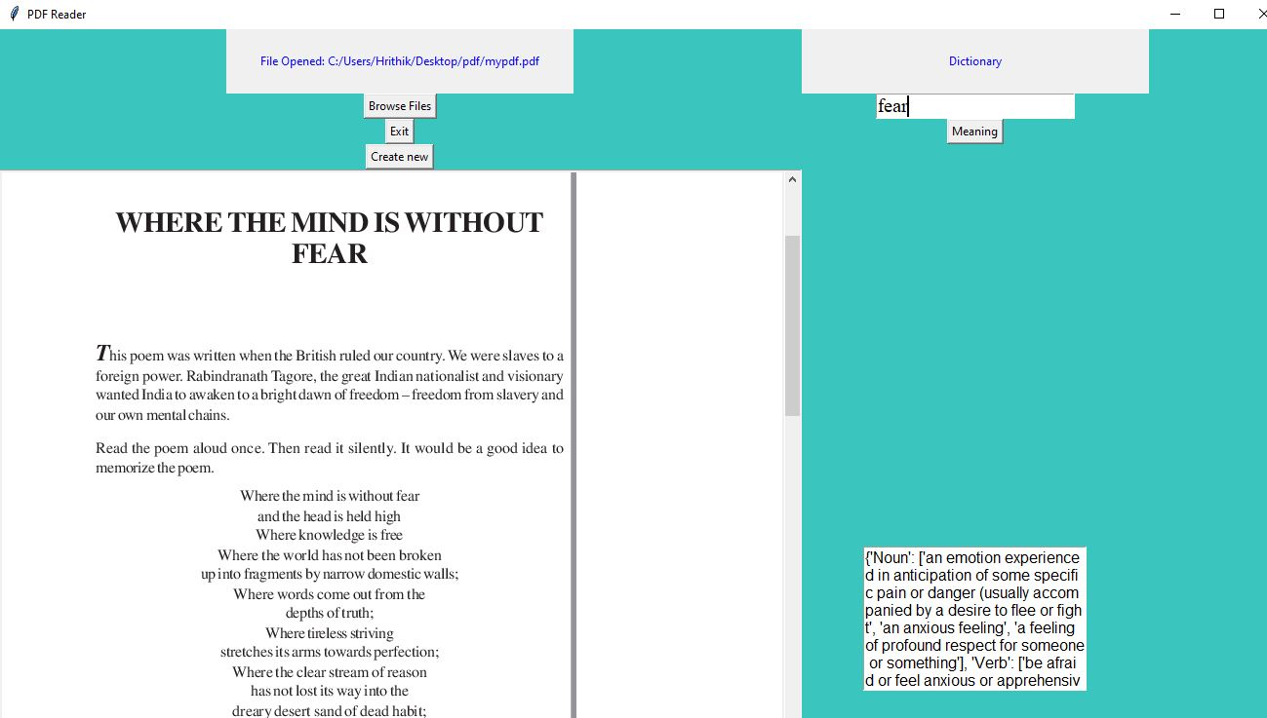

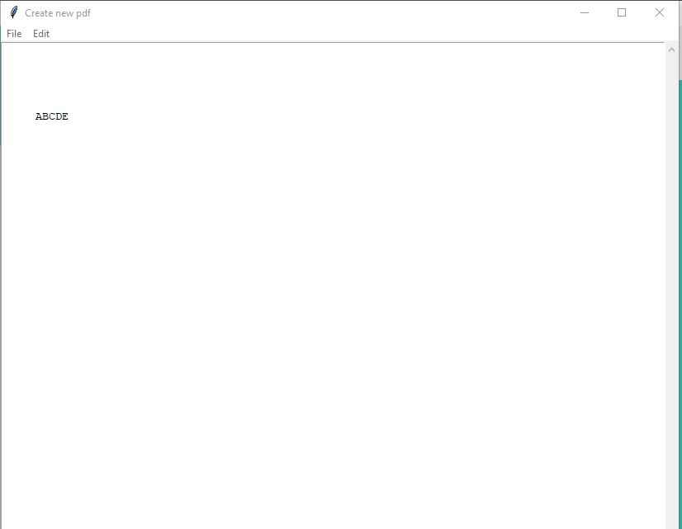

**Thank You.**