**DAD => Drag And Drop**

**Category 1**

**Message Box Bot**

* DAD message box
* Create a variable e.g Roll No

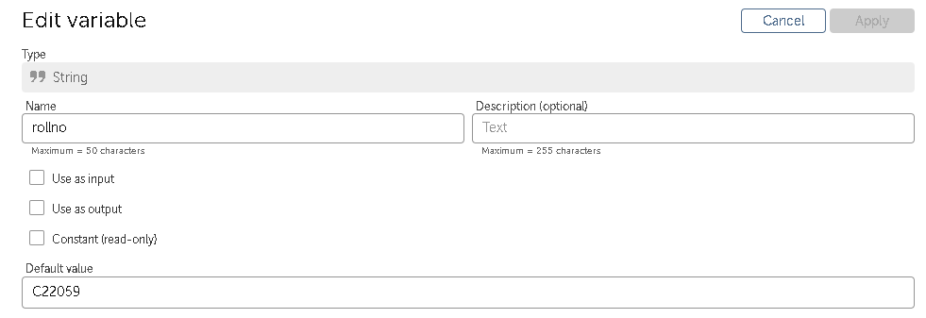

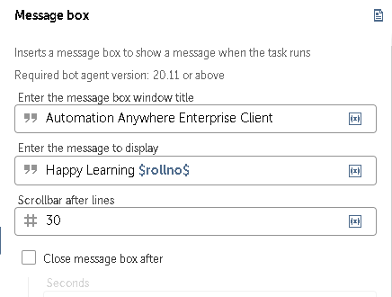

* Run the bot

**Bot to demonstrate prompt**

* DAD Prompt For File
* Create a variable of type list e.g filename

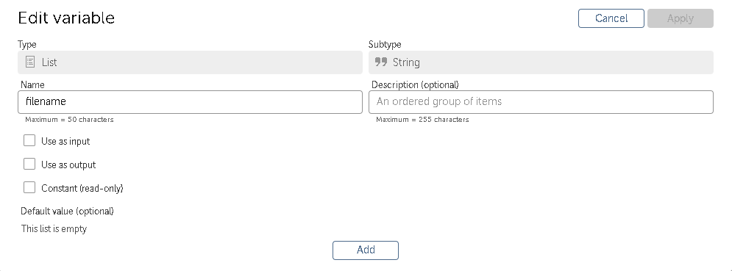

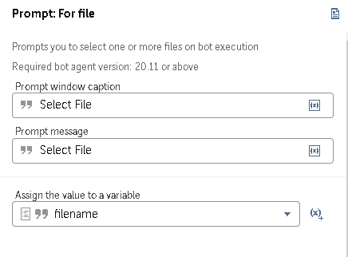

* DAD File Open
* Use the filename variable

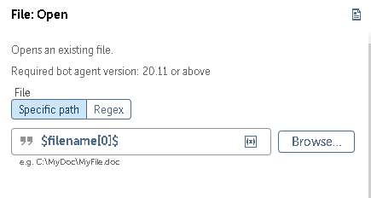

* DAD Prompt For Yes and No
* Create variable of type string e.g answer

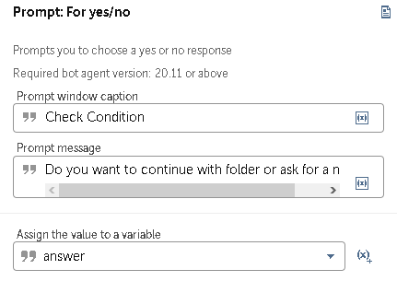

* DAD If condition
* Use the same answer variable here

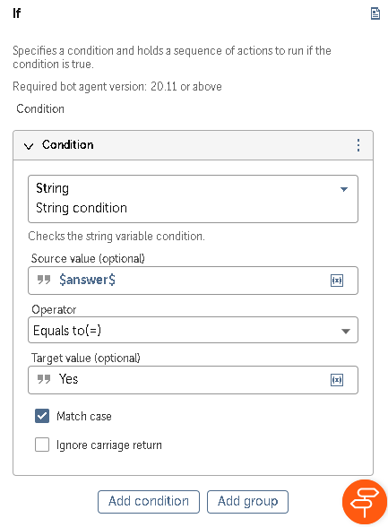

* DAD Prompt for folder inside If condition
* Create variable of type string e.g. foldername1

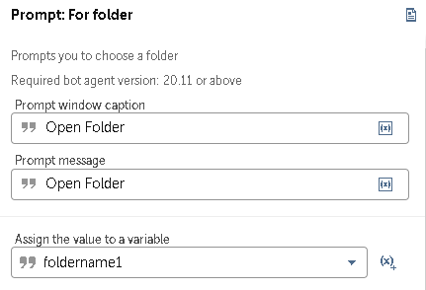

* DAD Folder Open below Prompt for folder inside If condition
* Use the variable we created i.e foldername1

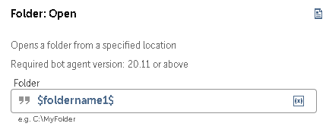

* DAD If: Else If condition beside If condition
* Use the answer variable we created earlier for source value

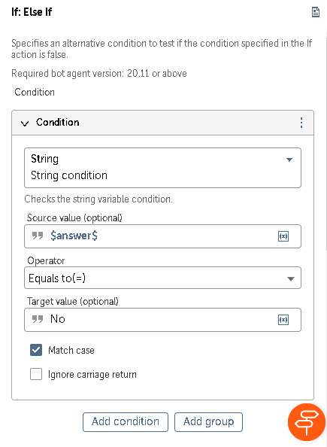

* DAD Prompt for value inside If: Else If condition
* Create a variable of type String e.g. num

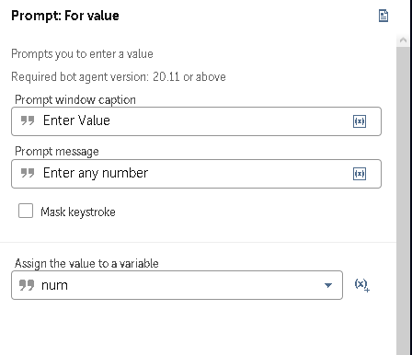

* DAD message box below Prompt for value inside If: Else If condition
* Use the same varible we created earlier i.e. num

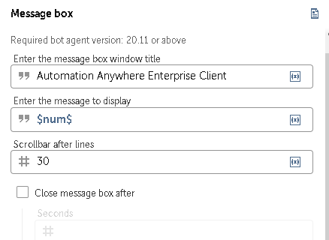

* Run Bot

**List Variable**

* DAD Loop
* In Iterator select For each item in list
* In list create a variable of type List and subtype String e.g ListItem
* In Assign the current value to variable create a variable of any type e.g. ListItem1

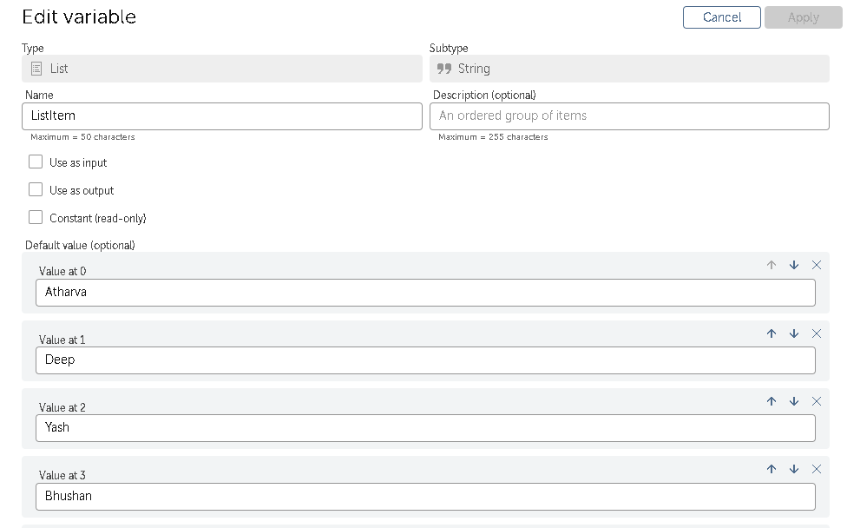

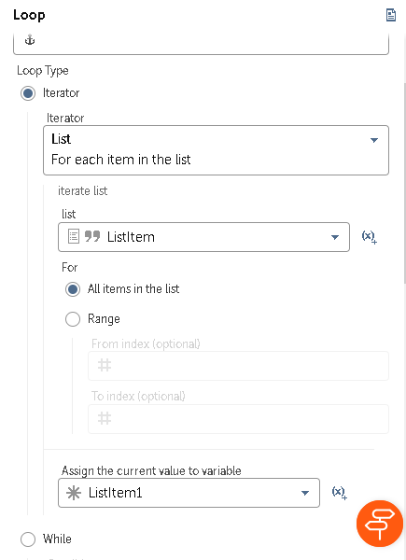

* DAD message box inside Loop
* Display the message using the variable created earlier i.e. ListItem1

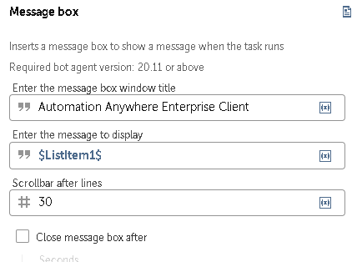

**Log to File**

* DAD loop
* In Iterator select For each item in list
* In list create a variable of type List and subtype String e.g ListItem
* In Assign the current value to variable create a variable of any type e.g. ListItem1

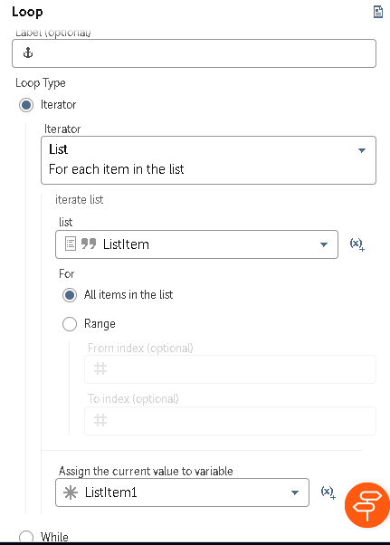

* DAD Log to File
* Create a empty txt file and copy the location of the file in File Path and in Enter text to log enter the variable we created earlier i.e. ListItem1

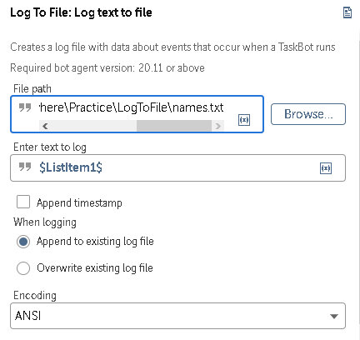

* Run Bot

**Keystroke**

* DAD CSV/TXT: Open
* Create a comma seprated text file and copy the path and enter the path in File path

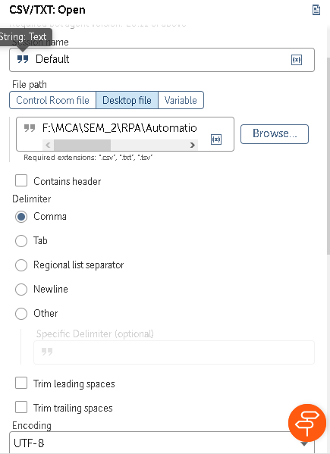

* DAD Loop
* In Iterator select For each item in list
* In list create a variable of type List e.g. ListItem and add some String values in it
* In Assign the current value to variable create a variable of any type e.g. ListItem1

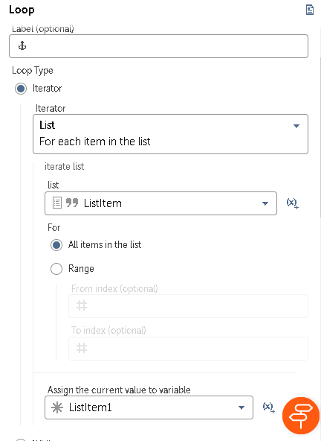

* DAD Simulate Keystroke inside loop
* Create a empty text file
* Select window -> Application -> Refresh -> From the drop down list Select the empty text file that we created earlier

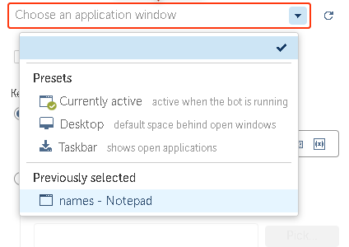

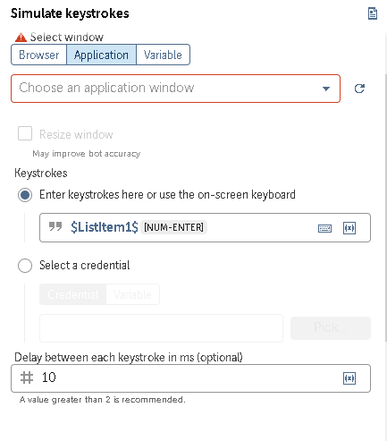

* Run the bot

**Cateogory 2**

**Demonstrate String Function**

* DAD String: Compare
* Create 2 variables of type string e.g. str1 and str2 and in default value type a string

**Note: The default value in both the string must be same so that the string compare output will be Yes and if both values are different then the output will be no inshort string compare will compare both the default values and if both matches then yes or else no.**

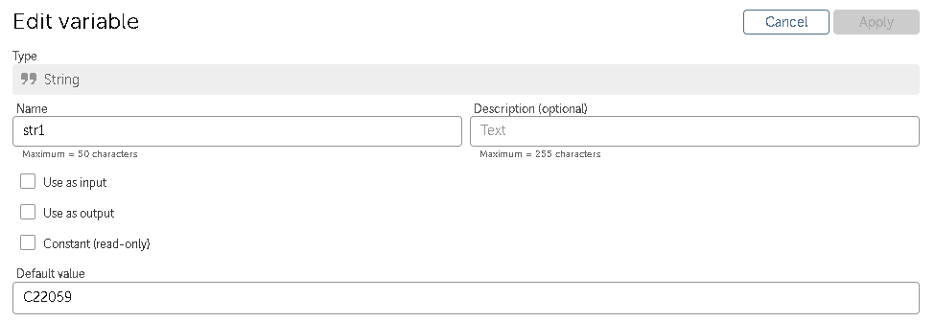

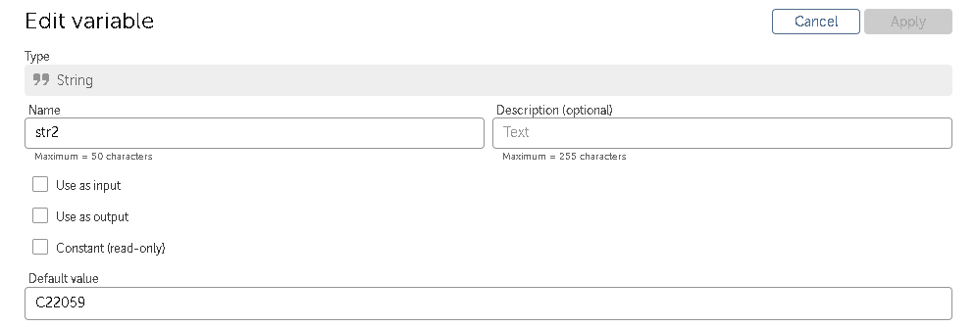

* Create new variable of type Boolean for Assign the output to variable

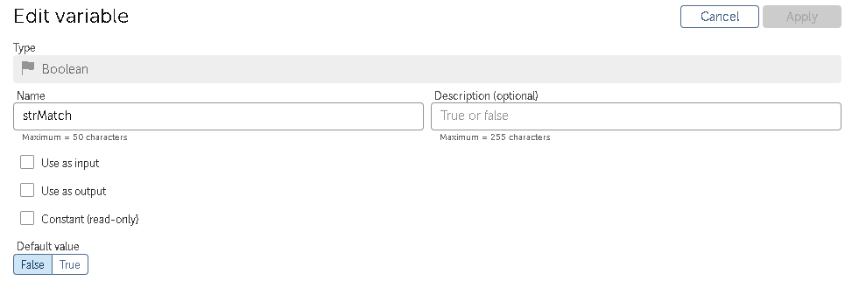

* Use both the varibles in Source string and compare string respectively

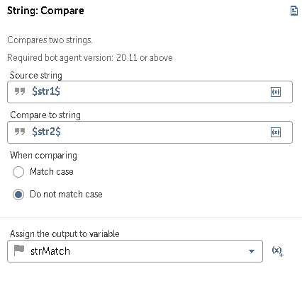

* DAD Boolean: To String
* In Select boolean variable use the strMatch variable created earlier
* Create a new variable of type string e.g. strMatch1
* In Select the string variable to store the result use the strMatch1 variable we created earlier

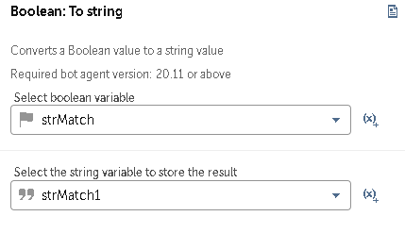

* DAD Message Box
* In Enter the message to display type the following text

**Syntax: Variable1** matches **Variable2:Variable3**

**Actual text: $str1$** matches **$str2$**:**$strMatch1$**

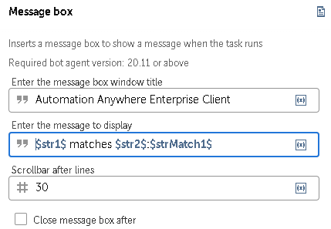

* DAD String: Lowercase
* In source string enter the variable1 i.e. str1
* Create a new variable of string e.g. strLower
* In Assign the output to variable enter the variable created earlier i.e strLower

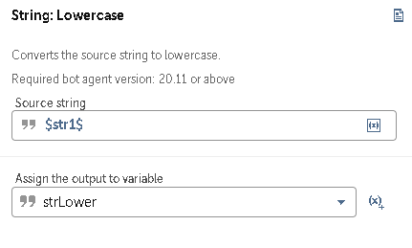

* DAD Message Box
* In Enter message type the following text

**Syntax:** Some text: Variable we used in Assign the output to variable i.e. strLower

**Actual text:** The String in LowerCase:**$strLower$**

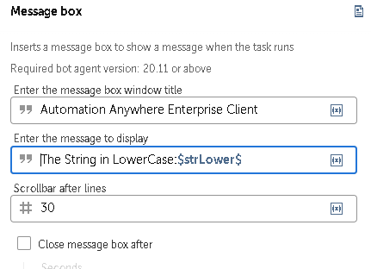

* DAD string reverse
* In Source string enter the variable1 i.e. str1
* Create a new variable of type string e.g. strReverse
* In Assign output to reverse use the variable we created earlier i.e. strReverse

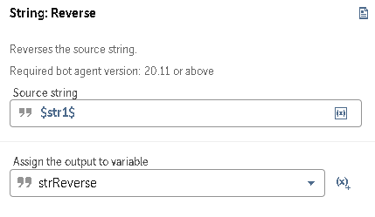

* DAD Message box
* In the Enter message to display type the following text

**Syntax:** Some text : variable we used in Assign the output to variable i.e. strReverse

**Actual Text:** The String in Reverse:**$strReverse$**

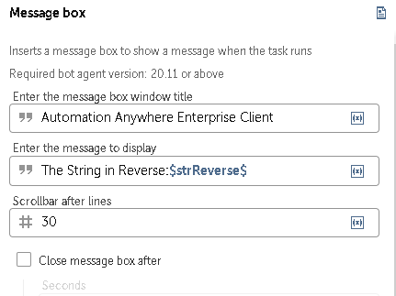

* DAD String: Generate random string
* Create a new variable of type string e.g. strRandomStr
* In Enter the destination value to assign the random string use the variable we created earlier i.e. strRandomStr

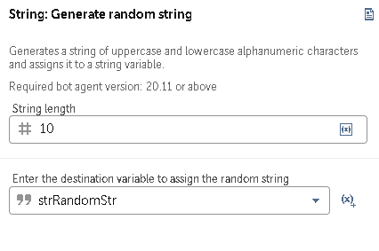

* DAD Message Box
* In the Enter the message to display type the following text

**Syntax:** Some text : variable we used in Enter the destination value to assign the random string i.e. strRandomStr

**Actual text:** Random String:**$strRandomStr$**

* Run the bot

**String operations: Split, extract and replace**

**Split**

* DAD String: Split
* Create a variable of type dictionary Enter key 1 and value your name
* Use that dictionary variable by clicking on the (x) symbol from the drop down select the dictionary variable we created earlier and enter the key you want
* Delimiter –
* Create a new variable of type list e.g. ListData and use it in Assign the output to list variable

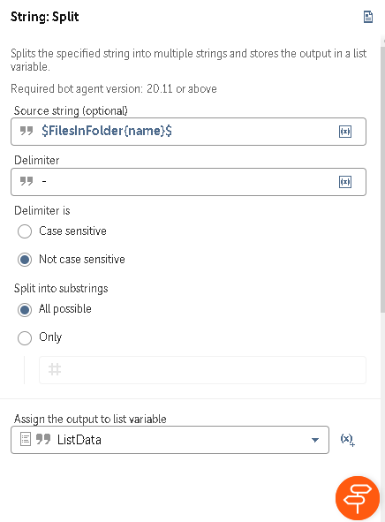

* DAD Loop
* In Iterator select For each item in the list
* In list enter the variable we created earlier for Assign the output to list variable i.e. ListData
* Creata a new variable of type string and use it in the Assign the current value to variable
* DAD Message Box inside Loop
* Use the variable we created earlier in the Assign the current value to variable
* Run the bot

**Replace**

* DAD String: Replace
* In source string type any string you want e.g. your name
* In Find String type the particular string you want to find e.g. I entered my full name Siddharth Jambhavdekar so now in Find string I will either type Siddharth or else Jambhavdekar
* Scroll down you will find Replace with here you have to enter a string that will be replace with the original string
* Create a new variable of type string and use it in Assign the output to variable
* DAD Message Box and enter the variable we used in Assign the output to variable
* Run the bot

**Reverse**

* DAD String: Reverse
* In source string type any string you want
* Create a new variable of type string and use it in Assign the output to variable
* DAD Message Box and use the variable we used in Assign the output to variable
* Run the bot

**Demonstrate loop using number package**

* DAD Loop
* In Iterator select For n times
* In times #3
* DAD Number: Increment
* Create a new variable of type number and use it in Enter Number e.g. num
* In Enter increment value enter #5
* In the Assign the output to variable use the same variable i.e. #num
* DAD Number: To String below Number: Increment
* In enter the number use the same variable i.e num
* Create a new variable of type string and use it in Assign output to variable e.g numStr
* DAD Message Box below Number: To String
* Use the numStr variable we created earlier to display message
* DAD List: Add Item
* Create a new variable of type list and use it in List variable e.g. listDemo
* In Items to be added use the numStr variable we created earlier
* In Add item Select To end of list
* DAD List: size outside loop
* Use the list variable we created earlier i.e. listDemo
* Create a new variable of type number and use it in the Assign the number of items to variable e.g. listSize
* DAD Number: To String below List: Size
* Create a new variable of type number and use it in Enter a number e.g. listSize
* Create a new variable of type string and use it in Assign the output to variable e.g. listSizeStr
* DAD message box and use the listSizeStr variable to display the message
* DAD loop
* In list select the For each item in list
* In list enter the list variable that we created at the beginning i.e. listDemo
* In the Assign the current value to variable use the numStr variable
* DAD Message box inside loop and use the numStr variable to display message
* Run the bot

**Bot to demonstrate increment and decrement actions on number and datetime variable**

* DAD Number: Increment
* Create a new variable of type number and Default value as 10 e.g num
* Enter increment value as 5
* Use the same num variable in the Assign the output variable i.e. num
* DAD Number: To String
* Use the same variable num in Enter the number
* Create a new variable of type string and use it in the Assign the output to variable e.g. numStr
* DAD Message Box and use the same numStr variable to display the message
* DAD Number: Decrement
* Use the same num variable in Enter the number
* Enter the decrement value as 5
* Use the same num variable in the Assign the output variable i.e. num
* DAD Message box
* In the display message type the following text:

Decremented Value:**$num.Number:toString$**

* DAD Datetime: Add
* Create a new variable of type string e.g. tempDate
* Go to Variable beside Datetime and use the tempDate variable
* Time value to add 12
* Time unit to add minutes
* Use the same tempDate in the Asssign the output to variable
* DAD Datetime: To String
* Go to Variable beside Datetime and use the tempDate variable
* Create a new string variable of type string and use it in Assign the output to a variable e.g. dateStr
* DAD Message Box and use the same dateStr variable to display message

**Bot to demonstrate loop for reading file names in a folder and writing those into notepad file**

* DAD Loop
* Iterator For each file in folder
* Folder Path enter the path of the folder that consists multiple files (.pdf, .csv, .txt)
* Create a new variable of type dictionary and use it in Assign the name and extension to this variable
* DAD Simulate keystroke inside loop
* Create a empty text file
* Go to Application -> Refresh and from drop down select the empty text file
* In Enter Keystrokes type the following text

**$FilesInFolder{name}$**.**$FilesInFolder{extension}$**[NUM-ENTER]

**Demonstrate list variable using List package**

* DAD List: Add Item
* Create a variable of type list and add some values in it and use it in List variable e.g. names
* Create a variable of type string and use it in Items to be added e.g. SampleString
* Select Add item to the end of list
* DAD loop
* In Iterator select For each item in list
* In list us the names variable created earlier
* For All items in the list
* Create a new string variable and use it in Assign the current value to variable e.g. currentStr
* DAD Message box and use the currentStr variable to display message
* DAD List: Join Items
* In List variable use the names variable created earlier
* Delimiter ,
* Create a new variable of type string and use it in assign the output to variable e.g. joinStr
* DAD Message Box and use the joinStr variable to display message
* DAD List: Remove Item
* In List Variable use the names variable created earlier
* Index number 2
* Create a new variable of any type and use it in Assign the output to variable e.g. removeStr
* DAD Message box and use the removeStr message to display message

**Bot to demonstrate Excel operations: Compare and Update excel sheet**

* DAD Step and give some heading
* DAD Excel Advance: Open inside Step
* Go to Desktop File -> Browse -> Select the excel file
* DAD Excel Advace: get multiple cells
* Select the range of cells to be returned All rows
* Create a new variable of type Table and use it in Assign value to variable e.g Table1
* DAD Excel Advance: Close
* DAD another step and give some heading
* Follow the above steps to open another excel file

**Data table operations**

* Then again add new step and give heading data table operations
* DAD Data Table: Remove Duplicate
* In data table name enter Table1 we created earlier
* DAD Datab Table: get Number of rows
* In data table name enter Table1
* Create a new variable of type number and use it in Assign result to variable e.g. noOfRows
* DAD Number: To String
* Use the noOFRows variable in Enter the number of rows
* Create a new variable of type string and use it in Assign the output to variable to strNoOfRows
* DAD Message Box and type following text

No of Rows in Students1 After removing duplicating rows:**$strNoOfRows$**

* Repeat the same steps for second excel file

**Joining new data tables**

* Add new step and give heading as Joining new data tables
* DAD Data Table: Join
* Use Table1 variable in Enter first data table name
* Enter column name for first table here enter any column name in your excel sheet e.g. Roll No
* Use Table2 variable in Enter second data table name
* Enter column name for first table here enter any column name in your excel sheet e.g. Roll No
* Select the type of join you want (provided in question)
* Create a new variable of type table and use it in Enter name of the data table in which to join e.g. Table3
* DAD Data table : Write to file
* Use the Table3 variable in Data Table name
* Create a empty csv file and in Enter file name browse that empty file location
* Append to existing file

**Merge and sort data table**

* DAD Excel advance: Open
* Go to Desktop file and Browse and excel file location
* DAD Excel Advance: get multiple cells
* Select range of cells to be returned All rows
* Create a new variable of type table and use it in Assign value to the variable e.g. Table Add
* DAD Excel advance: Close
* DAD Data table: Merge
* Use Table1 variable in Enter first data table name
* Use Table2 variable in Enter Second data table name
* Use TableAdd variable in Enter name of the data table in which to merge
* DAD Data table: Sort
* Use the TableAdd variable in Enter datatable name
* Sort by column -> name -> name of column in your excel file e.g. Roll No
* Select the order in which to sort -> ascending order
* DAD Data table: Write to file
* Use TableAdd variable Data Table name
* Create a empty csv file and Browse the file location in Enter file name
* Run the bot

**Bot to copy data from text file and write to excel**

* DAD CSV/TXT: Open
* Create a comma separated text file
* Go to Desktop File -> Browse the text file you created earlier
* Delimiter Comma
* DAD CSV/TXT: Read
* Create a new variable of type Table and use it in Assign value to variable e.g. TableFromTXT
* DAD Excel Advace: Open
* Create an empty excel file
* Go to Desktop file -> Browse the excel file you created earlier
* DAD Excel Advance: Write from data table
* Use the TableFormTXT variable in Enter data table variable
* Specify the first cell -> A1
* Excel Advace: Close
* Run bot

**Bot to copy files from one folder to another**

* DAD Folder: create
* Folder -> Browse the folder you want to create the folder
* DAD File: Copy Desktop File
* Source file -> Browse the folder location and at the end add “\*.*”

e.g. F:\MCA\SEM_2\RPA\RPA study material\Theory\*.*

* Destination file -> Browse the folder location and at the end mention the folder name that the bot must create

e.g. F:\MCA\SEM_2\RPA\Automation_Anywhere\File_Operations_06_06_23\Folder_created_by_bot

The end “\Folder_created_by_bot” is the folder created by bot

* DAD Folder: Zip
* Specify the file(s)/folder(s) to compress enter the path of folder

e.g. F:\MCA\SEM_2\RPA\Automation_Anywhere\File_Operations_06_06_23\Folder_created_by_bot

* Specify the type to compress -> *.pdf
* Specify Destination filename and location -> Browse the file location where you want to store the compressed file

e.g. F:\MCA\SEM_2\RPA\Automation_Anywhere\File_Operations_06_06_23\folder.zip

* Run bot

**Category 5**

**Bot to demonstrate PDF actions: merge doc and split doc**

**Merge doc**

* DAD PDF: Merge documents
* Go to Add Pdf document -> browse any pdf file present and add the location
* Similarly add one more pdf location
* In Output file path -> Browse the folder path where you want to save the merge pdf doc and at the end of the location mention the merged pdf doc file name

e.g. F:\MCA\SEM_2\RPA\Automation_Anywhere\PDF_Merge_Split\PDF_Merge\Merged.pdf

Here the “Merged.pdf” is our output

* Run bot

**Split Doc**

* DAD PDF: Split document
* Go to desktop file -> browse for such a pdf doc which we can split in 2 pdf doc. Let’s use the same “Merged.pdf” here

e.g. F:\MCA\SEM_2\RPA\Automation_Anywhere\PDF_Merge_Split\PDF_Merge\Merged.pdf

* Scroll Down in Folder Path enter the path where you will save the final output pdf docs
* Run bot

**Demonstrate screen scraping using extract field- bot shall paste extracted strings into excel sheet**

* DAD Loop
* In iterator select For each file in folder
* In Folder path -> Browse the path you want to select the files

e.g. F:\MCA\SEM_2\RPA\Automation_Anywhere\PDF_Extract_Field_TXT_to_Excel\Source

* Create a variable of dictionary type and use it in Assign file name and extension to this variable e.g FilesInFolder
* DAD PDF: Extract Field
* Add Variable Mapping -> Key-name and title, Map to variable-name and title
* DAD Log to File: Log to text to file
* Create an empty text file
* File path -> Browse the path of the text file you created
* Enter text to log -> Author:**$name$**, Research Paper Title:**$title$ (**Depends on your file data)
* When Logging -> Append to existing log file
* DAD CSV/TXT: Open
* Go to Desktop File -> Browse the text file path mentioned earlier
* Delimiter -> Comma
* DAD CSV/TXT: Read
* Create a variable of type table and use it in Assign the value to variable e.g. TableFromCSV
* DAD CSV/TX: Close
* DAD Advace Excel: Open
* Create a empty excel file and browse the path in Desktop File
* DAD Excel Advance: Write from data table
* Enter data table variable -> TableFromCSV(we created earlier)
* Active Worksheet
* Specify the first cell -> A1
* Advance Excel -> Close
* Run Bot

**Bot to demonstrate screen scraping using extract text**

* DAD PDF: Extract text
* Go to Desktop file -> Browse the location of any pdf

e.g. F:\MCA\SEM_2\RPA\Automation_Anywhere\PDF_Extract_Text\ATAL Certificate 2020-21.pdf

* Text Type -> plain text
* Page range -> All pages
* Create an empty text file and enter the file location in Export data to text file
* Run Bot

**Bot to demonstrate screen scraping using extract text**

* DAD PDF: Extract Image
* Go to Desktop file -> Browse the location of any pdf
* e.g. F:\MCA\SEM_2\RPA\Automation_Anywhere\PDF_Extract_Text\ATAL Certificate 2020-21.pdf
* Page range -> All pages
* Type of image to be converted -> JPEG
* JPEG Quality -> 100
* Folder path -> Browse the path where you want to save the image
* File prefix -> Img
* Run Bot

**Bot to demonstrate screen scraping using extract text – bot shall paste extracted strings into TXT file**

* DAD Loop
* Iterator -> For each file in folder
* Folder path -> Browse path of folder for source

e.g. F:\MCA\SEM_2\RPA\Automation_Anywhere\Screen_Scraping_Bot_28_06_23\Source

* Create a dictionary variable and use it in Assign file name and extension to variable e.g. FilesInFolder
* DAD PDF: Extract Field
* Go to desktop File -> Browse the above path along with it add the pdf name at end using dictionary variable

e.g. F:\MCA\SEM_2\RPA\Automation_Anywhere\Screen_Scraping_Bot_28_06_23\Source\**$FilesInFolder{name}$**.pdf

* Open PDF viewer -> Enter the details present in pdf to be viewed

e.g name and author title in pdf (depends on what content is present in your pdf)

* DAD Simulate Keystroke
* Create an empty text file
* Go to Application -> Browse the empty text file location
* Create 2 variables. In my case I have created Author and R_Title both of string type
* Enter keystrokes here or use the on-screen keyboard mention the variables created earlier

e.g. **$Author$** and **$R_Title$**

* Run bot

**Bot to demonstrate screen scrapping using OCR – capture image by path**

* DAD Loop
* Iterator -> For each file in folder
* Folder path -> Browse the path of the folder

e.g. F:\MCA\SEM_2\RPA\Automation_Anywhere\Screen_Scraping_Bot_using_OCR_28_06_2023\1

* Create a dictionary variable and use it in Assign file name and extension to this variable
* DAD OCR: Capture image by Path
* Go to Desktop file -> Browse the folder path and at the end mention the file name and extension using dictionary variable created earlier

e.g. F:\MCA\SEM_2\RPA\Automation_Anywhere\Screen_Scraping_Bot_using_OCR_28_06_2023\1\**$FilesInFolder{name}$**.**$FilesInFolder{extension}$**

* Filter the captured text
* Before (optional) -> In Recognition of
* Select locale -> Based on Locale
* Create a name variable of type string and use it in Assign value in variable e.g. name
* DAD Message Box -> Use the name variable here to display message
* DAD Log to File: Log text to file
* Create an empty text file and copy the location in File Path
* Enter text to log -> use name variable
* Run bot

**Bot to demonstrate screen scrapping using OCR – capture window with filter and without filter**

* DAD Loop
* Iterator -> For Each file in folder
* Folder path -> browse folder which contains the pdf files

e.g. F:\MCA\SEM_2\RPA\Automation_Anywhere\Screen_Scraping_Bot_using_OCR_28_06_2023\OCRCErtificates

* Create a dictionary variable and use it in Assign file name and extension to variable e.g. FilesInFolder
* DAD File: Open
* File Path -> Same path as mentioned above only add name of pdf using dictionary variable

e.g. F:\MCA\SEM_2\RPA\Automation_Anywhere\Screen_Scraping_Bot_using_OCR_28_06_2023\OCRCErtificates\**$FilesInFolder{name}$**.pdf

* DAD OCR: Capture Window
* Go to Application -> Browse the pdf file name and select it
* Create a variable of type string and use it in Assign value to variable e.g. data
* DAD Message Box and use the data variable to display message
* DAD Log to File: Log text to file
* Create an empty text file and copy the loaction in File path

e.g. F:\MCA\SEM_2\RPA\Automation_Anywhere\Screen_Scraping_Bot_using_OCR_28_06_2023\pdf_to_txt_using_ocr.txt

* Enter text to log -> use the data variable created earlier
* Run bot

**Bot to demonstrate screen scrapping using OCR – capture area**

* DAD Step and give heading
* DAD OCR: Capture area
* Go to Application -> Browse the image location
* Create a variable of type string and use it in Assign value to variable e.g name1
* DAD Message box and use the name1 variable to dislay message
* Run bot

**UI Path Practical Zip file**

https://drive.google.com/drive/folders/1sAwsvBLV7dn2zpN5Sz_BUAHhe6pRoHsD