1. List down some limitations of RPA.

* RPA cannot be used for the processes that require judgment.
* RPA cannot learn from experiences.
* It cannot understand the unstructured inputs that are non-electronic.
* RPA enhances the efficiency of workflows by replacing human tasks with automated tasks. However, there are some limitations to the types of tasks on which it can be implemented.

### 2.What do you understand by a thin client and thick client in RPA? Explain with examples.

**Thin Client**

The thin client can be referred to as applications that never acquire the quality properties while spying using any RPA tool. It does not run on a local machine. It runs only on virtual client/server architecture.

**Example:** VMware, VirtualBox, or any other virtual environment.

**Thick Client**

The thick client can be defined as the applications which provide handful attribute features using RPA tools.

**Example:** Apps like notepad, browser, etc.

### 3.What do you understand by the term 'Process Studio' in Robotic Process Automation?

A process studio is a feature of the RPA tool that is used to develop the actual flow of the business you want to automate. It includes variables, control loops, and several other business logic that can be sequenced and tested in a visible business flow. The Process Manager is mainly used to implement the rules and logic for the software robots. The processes that are sequenced in the process studio are almost similar to a flowchart.

### 4.What do you understand by the term 'Workflow Design' in Robotic Process Automation?

The term 'Workflow Design' represents a graphical structure of coding. It includes condition and decision-based tasks which are required to automate the processes.

5.What are the main components of RPA architecture?

The core components of Robotic Process Automation are listed below:

* Recorder
* Development Studio
* Plugin / Extension
* Bot Runner
* Control Center

**List the different types of tools in RPA.**

* Blue Prism
* UiPath
* Automation Anywhere
* WorkFusion
* OpenSpan

### ****How do you perform Screen Scraping in RPA?****

Screen scraping is an essential component of the RPA toolkit. It is used to capture bitmap data from the screen and cross-check it with the stored information to decipher it.

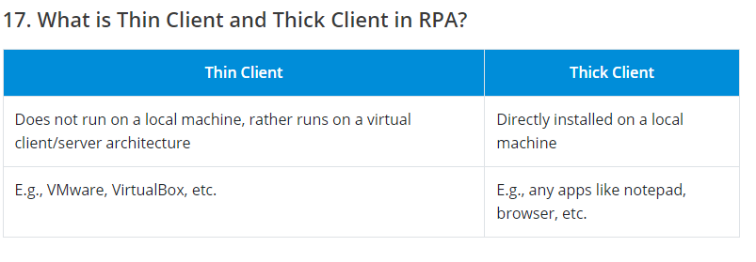

**What are the different activities performed by UiPath?**

* **Core activities**: For the automation process
* **Cognitive activities**: For language translations
* **Credential activities**: For enabling the addition and deletion of credentials
* **Database activities**: For executing queries, transactions, etc.
* **Excel activities**: For automating MS Excel tasks
* **FTP activities**: For performing functions in the FTP server
* **Intelligent OCR activities**: For digitization and scraping
* **Mail activities**: For working with IMAP, POP3, SMTP, Outlook, etc.
* **PDF activities**: For data extraction from PDF
* **Python activities**: For invoking Python scripts and methods
* **Terminal activities**: For retrieving data from the terminal
* **Web activities**: For performing SOAP and HTTP requests to any web APIs
* **Word activities**: For automating activities in MS Word

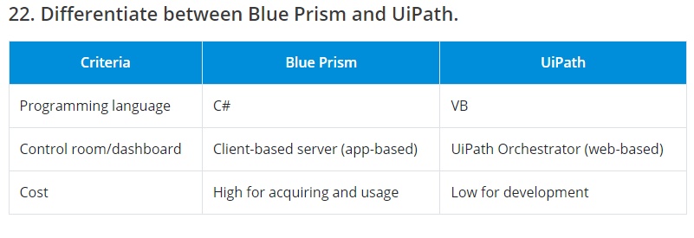

**How do you use Assign Activity and Delay Activity in UiPath?**

* **Assign activity** is generally used to assign a value or output to a variable. It can be used inside loops, arrays, etc.
* **Delay activity** is used to delay or pause the automation for a particular duration.

**Question: How does exception handling work in RPA?**

Answer: Exception handling involves defining how bots respond when they encounter unexpected situations during automation. Bots can be programmed to take specific actions, notify humans, or follow predefined error-handling protocols.

**Explain the features of UiPath?**

The UiPath features are:

* Sets of activities that are pre-defined
* Drag and drop the workflow
* Playback and recording
* Automation that is both attended and unattended
* Reusability and workflow templates
* Multi-tenancy is a term that refers to a situation
* C# and.NET functions can be inherited.
* No programming skills are required to use RPA technologies.
* Process automation scheduling that is intelligent

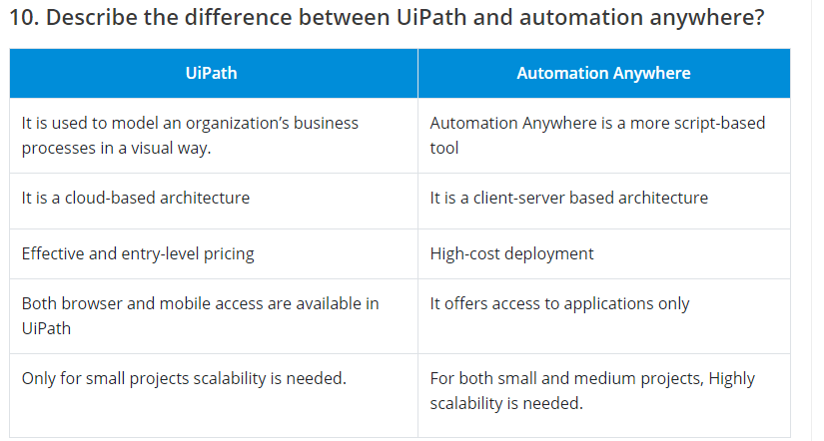

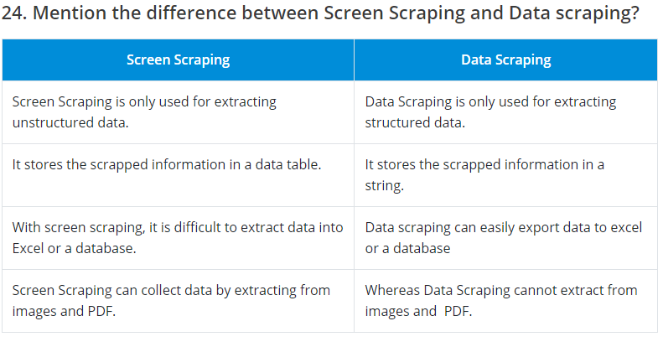

**How can I connect the database to UiPath and read data from it?**

To connect the database to UiPath, follow the instructions below.

* You must first install the Database activities package. The Package Manager can be used to install this package.
* You may now utilize the “Connect” activity to establish a link between UiPath studio and the database.
* Then, to configure the connection, click the “Configure Connection” button.
* Select the necessary connection settings and perform a connection test. When the test connection is successful, click OK.
* Use the “Execute Query” activity to write your required SQL query to read data once the connection has been created.

### ****In UiPath, explain the terms read range, read cell, read csv, write range, write cell, and write csv.****

Read range – It is used to read data from an excel spreadsheet.

Read cell — This command is used to read all of the data from the specified cell.

Write range – It can be used to write data on an excel sheet. Read csv – It can be used to read all csv data.

Write cell – We may use write cell to write data into a certain column.

Write csv — This command is used to save data in a csv format.

 In AA, What option is used to read the entire cell in Excel?

A. Get multiple cells.

B. Get Cell

C. Go to Cell

**D. Get all cells – right**

Which of the following reads the content of the specified cell on the active spreadsheet?

A. Go to cell

B. Set cell

C. Open spreadsheet

**D. Get cell – right**

Automation Anywhere supports what kind of browser, by default?

A. Internet explorer

B. Google Chrome

C. Mozilla Firefox

**D. Both A and B**

* + <https://coderdestination.blogspot.com/2019/01/automation-anywhere-multiple-choice.html>

for the multiple types questions of AA visit the above link