**K. J. SOMAIYA COLLEGE OF ENGINEERING**

**SOMAIYA VIDYAVIHAR**



**Source Adaptive Disinformation Detection**

Software Project Management Plan

**PROJECT ID :**

**Project By:**

**Hritik Jaiswal (1714086)**

**Vedang Parasnis (1714100)**

**Heet Sakaria (1714110)**

*Under the guidance of*

**Dr Irfan Siddavatam**

**DEPARTMENT OF INFORMATION TECHNOLOGY A. Y. 2020-2021**

**Contents**

1. Introduction 3
   1. Project Overview 3
   2. Project Deliverables 3
2. Project Organization 4
   1. Software Process Model 4
   2. Roles and Responsibilities 5
   3. Tools and Techniques 6
3. Project Management Plan 6
   1. Tasks 6
      1. Requirement Gathering and Analysis 6
      2. Design 7
      3. Implementation 8
      4. Testing 8
      5. Deployment 9
   2. Assignments 10
   3. Time Table : Gantt Chart 10

# Introduction

## Project Overview

Disinformation detection system is a system for detecting disinformation in fake news. It is s a web based application that enables the users from field of information security, information law and also normal users to determine the disinformation in the news articles and provides awareness so as to prevent getting fallacious information about the given topic Disinformation identification System mainly works to identify the fabricated content in the news and provide adaptive based approach to adapt itself and thereby enabling itself to a state as to determine with confidence that the given information generated from this source is of high chance being fake using machine learning .We are following an hybrid based approach which is and ensemble and feedback based approach by analyzing transitive relations and two level ensemble approach so as the domain in determining fake news can work on variety of news as an input .We focus on providing accurate results as of proving scrapping data from various sources so as to provide wider category for classification.

The purpose of this document is to present a detailed description of the Application. It will explain the purpose and features of the system along with its interfaces, the constraints under which it must operate and how the system will react to external stimuli. This document is intended for both the users and the developers of the system. The main purpose of the application is to gather all information from various news websites or from various social media platforms needed, in background so as to generate reports from our strong and robust machine learning models so as to provide diminutive overhead to the end users by providing the result what they need. The system also provides an NoSQL Database to store the information and add the news sources or articles which are detected fake inside the database so as the user can be presented with an graphical analytical user interface about fake sources or articles detected by the application. This is a single all in one application to the end user, which prevents the user to surf over the internet to guess whether a information is true or false, so that the end user can come to single platform to identify whether a given information is fake or correct by providing most accurate and relevant results .The Application is on web based platform on various OS support and utilize the power of AWS cloud for faster processing using EC2 instances and AWS Sagemaker for faster training of our machine learning models. It can be used by a broad spectrum of people in field of Information Security, Information Law, Normal Users, Business Stakeholders to manage for personal use or even for their organization. SPMP document is created to list the intended audience and provides suggestions for the same. This document is mainly for both developers and project manager to determine the procedure in the creation of further phases of the application and determine a road map or work flow for the same.

## Project Deliverables

Projects create deliverables, which are simply the results of the project or the processes in the project. That means a deliverable can be something as big as the objective of the project itself or the reporting that is part of the larger project.

* + - Requirement gathering & Analysis: Preliminary Project Plan, Software Requirement Specifications (SRS), Technical Requirement Specifications documents are created which serves as the input for next phase. **Expected Date:**
    - Design: UML Diagrams, System Architecture, Detailed Design Specifications (DDS) are created which serves as the input for next phase. **Expected Date:**
    - Implementation and Coding: Working software which serves as the input for the next phase. **Expected Date:**
    - Testing: Test Summary Report, Test results, QA plan, Revised bugs list, User Ac- acceptance test are submitted which serves as the input for the next phase. **Expected Date:**
    - Deployment: Deployed software, reviews and Data which serves as the input for the next phase. **Expected Date:**
    - Documentation: An user guide and manual with the working procedure of the application along with supporting documents. **Expected Date:**

# Project Organization

## Software Process Model

Source adaptive disinformation detection is a project that demonstrates its need in the current scenario and also provides features which are more streamlined and efficient approach than before. In order to achieve this the application needs to approved by the new kinds of trends in sources and strategies for fake news generation. For the same, their inputs are taken at the highest level of seriousness. We use the Spiral Software Process Model in order to keep a constant sync in process of development along scalability and software maintenance.

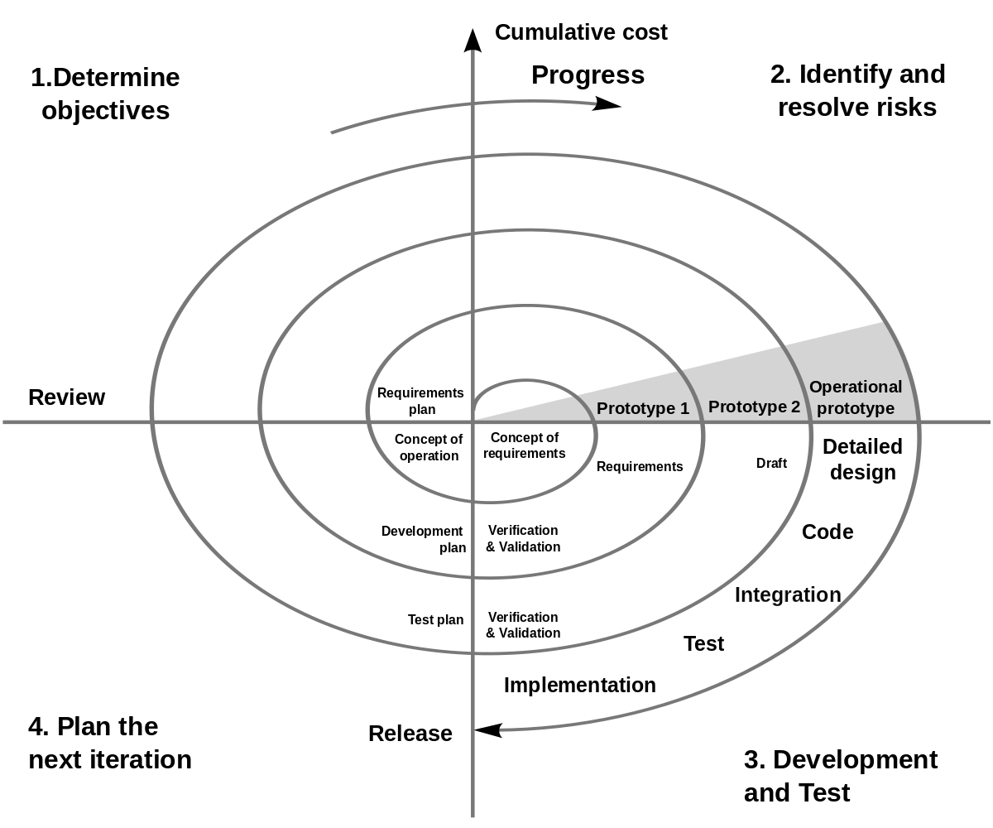

The SPIRAL process model used for Disinformation in fake news will consist of mainly 2 to 3 iterations. Each iteration will consist of Research, Planning, Development, Review and Deployment phases. The Research phase will consist of the Literature Review and Requirement survey and analysis. Followed by the Planning phase which will include the designing of System Architecture and Documentation. Then comes the Development phase which include some research on development tools and the actual development of the software. The penultimate phase is the review phase where testing of software is done, and based on the issues the system architecture is re planned or the implementation of the software is improved. After this the cycle is repeated and the Deployment stage is reached when the software is working as expected and there are no issues generated during the testing phase.

## Roles and Responsibilities

* + - Project Manager – Vedang Parasnis
      * Description - Project Manager is responsible for the timely execution and completion of the project. She will work with all the group members and will see that every group member is performing his/her task. She will communicate with the Faculty and inform him/her about the development of the project. She can schedule group meetings to look over the development of the project.
    - Developer – Hritik Jaiswal, Heet Sakaria, Vedang Parasnis
      * Description - Developer will code for applications and programs for backend processing systems to build a working project as proposed by the manager and team. Once the core of the software is developed, the software is passed on to the next Team member that is to the Tester.
    - Designer – Hritik Jaiswal
      * Description - Designer deals with the look and feel of the software. Designer’s task will be to work hand-in-hand with the developer and help him with creative styling ideas, improving frameworks to make the project more user-friendly.
    - Tester – Vedang Parasnis, Heet Sakaria
      * Description - Tester’s role will be to perform checks on the services provided by

the software, to see if they are functioning properly or are bugged for a given

condition.

* + - Analyst – Heet Sakaria, Hritik Jaiswal
      * Description - Project analyst is responsible for managing the development of project through special research, data analysis, and data collection to facilitate strategic decision-making.

## Tools and Techniques

For the development of the product following tools will be used.

* + - The front-end of the web application is developed using HTML / Bootstrap CSS framework.
    - TypeScript for front-end development
    - Express Js using NodeJS runtime and Flask will be used for back-end development and serve as an application server
    - Python Scrapy and Beautifulsoup is used for web scrapping, News Api is used for information gathering
    - Firebase cloud Storage will be used as the database for storage of application data.
    - Visual Studio IDE / Sublime Text, Jupyter Notebook, Google Colab will be used for developing the application and testing of machine learning models.
    - Aws EC2 Instances will be used for faster computation of application server request
    - AWS Sagemaker will be used for faster training of Machine Learning models on the cloud
    - StarUML will be used for creating UML diagrams.

# Project Management Plan

## Tasks

### Requirement Gathering and Analysis

**Description** Requirement Analysis would be done to know the exact expectations of the client from the product. The functionalities and working of the product would also be clear by doing sufficient and effective requirement analysis.

**Deliverable and Milestones** Final Version of SRS and SPMP

**Resources Needed** For effective requirements analysis, multiple meetings would have to be conducted with the stakeholders. Brainstorming sessions of Joint discussions must be organized for effective communication and information gathering.

### Design

**Description** In this task, we focus on developing the UI Designing which plays an important part in how the user will be interacting with the product software and also designing the UML diagrams which defines how the product will be created to capture the system’s functionality and requirements along with its dynamic behavior.

**Deliverable and Milestones**

* + - * User Interface Designs
      * UML Diagrams
      * Final Version of SDD

**Resources Needed** Star UML is required for designing the UML Diagrams and Boot- strap / HTML is required for designing the UI.

**Dependencies and Constraints**

* + - * Clear, complete, unambiguous understanding of requirement.
      * Complete UML structure.

**Risks and Contingencies**

* + - * Unclear Requirements - Leads to erroneous codes.
      * Gold Plating - Adding extra functionalities to the system which is not originally defined in the project scope.

### Implementation

**Description** Coding is the third phase of software development. Detailed design specification are used as the input by developers to build the software product. The main focus of this phase is development. Entire design will be broken into modules and developers will work on individual modules, then they will integrate the separate modules into one system finally. The software is classified into 3 modules: End-user, Cloud Instances, Machine Learning Models

**Deliverable and Milestones** Final prototype of the working modules.

**Resources Needed:** Visual Studio Code IDE / Sublime Text, Jupyter Notebook / Google Colab and Aws account,

**Dependencies and Constraints**

* + - * Proper Choice of Programming Language
      * Feasible Project Scope

**Risks and Contingencies**

* + - * Insufficient resources
      * Unclear Project Scope
      * Complicated Design

### Testing

**Description** Once the design and final software is developed, the application goes for testing. Testing is based on different criteria related to efficiency, bugs, performance, response time, correct functionality, etc.

**Deliverable and Milestones:** Final Version of STD

**Resources Needed** Web Testing Framework and Tools, Aws software test automation tools

**Dependencies and Constraints**

* + - * Proper knowledge of using the testing tool.

**Risks and Contingencies**

* + - * Unavailability of test environment.
      * Delay in fixing defects by development team.
      * Major changes in the SRS which invalidates the test cases and requires changes in the test case.

### Deployment

**Description** The deployment phase is the final phase of the software development life cycle (SDLC). After the project team tests the product and the product passes each testing phase, the product is ready to be deployed.

**Deliverable and Milestones:** Ready and tested Modules

**Resources Needed:** Free/Shared hosting service

**Dependencies and Constraints**

* + - * Nominal cost of hosting service.
      * All the requirements are user friendly.

**Risks and Contingencies**

* + - * Procedures to deploy the project fails.
      * The changes need to be backed out

## Assignments

Task 1 - Requirement Analysis – Heet

Task 2 - Software Requirement Specification Vedang, Hritik Jaiswal Task 3 - Software Project Management Plan - Vedang

Task 4 - Designing Hritik

Task 5 - Coding – Vedang, Heet, Hritik

Task 6 - Testing - Hritik, Heet

Task 7 - Analysis – Vedang, Heet

## Time Table: Gantt Chart

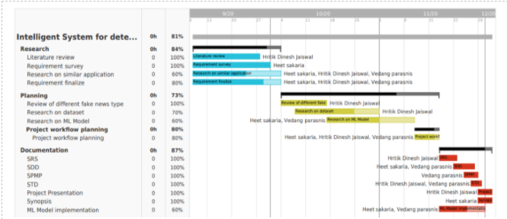

**Figure 2: Timeline Creation**

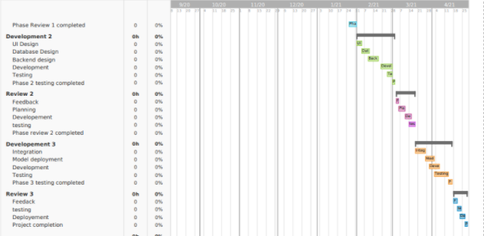

**Figure 3: Gantt Chart**