**Experiment No.: 4**

**Title:** Preparing Software Project Management Plan (SPMP)

**Batch:B2 Roll No.:1714097 Experiment No.: 4**

**Aim: To Prepare Software Project Management Plan (SPMP)**

**___________________________________________________________________________**

**Resources needed:** Internet Explorer, GanttProject, LaTex Editor **___________________________________________________________________________**

**Procedure:**

**Database Model:**

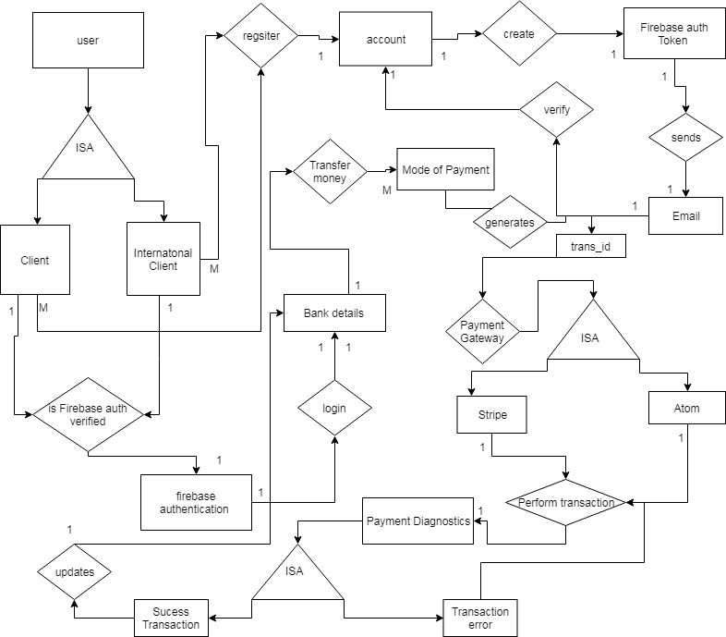

**Relational Model**

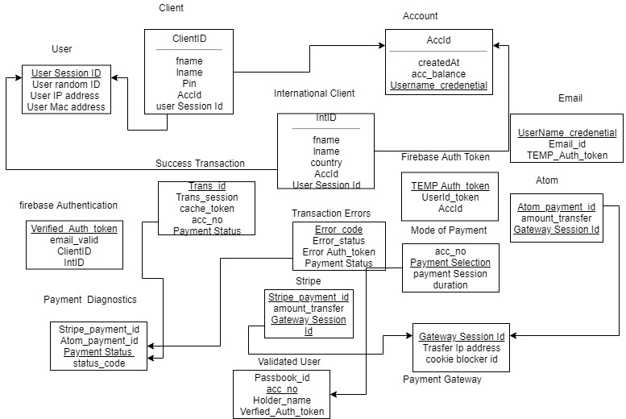

1. Prepare Gantt chart using Gantt Project.

Incremental Process Model

|  |  |  |  |  |  |  |  |  |  |  |  |  |
| --- | --- | --- | --- | --- | --- | --- | --- | --- | --- | --- | --- | --- |
| Months | 1 | 2 | 3 | 4 | 5 | 6 | 7 | 8 | 9 | 10 | 11 | 12 |
| Inception |  |  |  |  |  |  |  |  |  |  |  |  |
| Feasibility  Report |  |  |  |  |  |  |  |  |  |  |  |  |
| Brainstorming |  |  |  |  |  |  |  |  |  |  |  |  |
| Requirement  Analysis  Finalizing  (SRS) |  |  |  |  |  |  |  |  |  |  |  |  |
| Modeling-  (SDD) |  |  |  |  |  |  |  |  |  |  |  |  |
| Implementation-  Coding  &  Unit testing |  |  |  |  |  |  |  |  |  |  |  |  |
| Integration-  System Testing |  |  |  |  |  |  |  |  |  |  |  |  |
| Deployment-  Customer feedback  (In releases) |  |  |  |  |  |  |  |  |  |  |  |  |

1. Prepare SPMP document for chosen problem definition in LaTeX.

Ans : uploaded separately

**_______________________________________________________________________**

**Results:** SPMP Document in given format

**_______________________________________________________________________**

**Questions:**

**1. Can a project be undertaken without a plan? What are the possible consequences?**

Planning is the foundation on which you base the project execution. Without a strong and stable foundation, the project is more than likely to collapse around your ears.  
Good planning will ensure that the resources are ideally utilized. You should not waste resources when planning a project as this will result in the decrease of the overall profits from the project.  
  
The whole team should work as a unit to complete the tasks. Improper planning will result in the assignment of redundant tasks, thus increasing the cost and time taken to complete a project.

Five badly affected areas due to poor planning :  
  
a) Over budgeted  
b) Poor quality - Customer dissatisfaction  
c) Schedule failure  
d) Lost business  
e) Low team morale

**________________________________________________________________________**

**Outcomes:**

Comprehend design pattern, architectural style usage and software planning paradigm

**__________________________________________________________________________**

**Conclusion:**

Successfully prepared the gantt chart and SPMP doc on latex.

**Grade: AA / AB / BB / BC / CC / CD /DD**

**Signature of faculty in-charge with date**

**___________________________________________________________________________**

**References:**

**Books:**

1. Roger S. Pressman, Software Engineering: A practitioners Approach, 7th Edition, McGraw Hill, 2010.
2. Ian Somerville, Software Engineering, 9th edition, Addison Wesley, 2011.
3. John M. Nicholas, “Project Management for Business and Technology”, 2nd edition, Pearson Education