**Group 2**

**1714086- Hritik Jaiswal**

**1714096-Niket Mehta**

**1714097- Riddhisha Nirmal**

**1714100- Vedang Paranis**

**Modelling Behaviour - Activity and State Chart Diagram using UML** _____________________________________________________________________

**Results :**

**E-Banking System portal**

**Activity Diagram:**

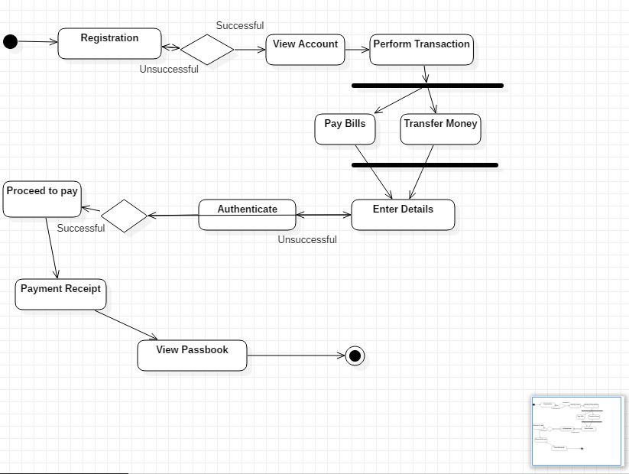

**State Chart Diagram:**

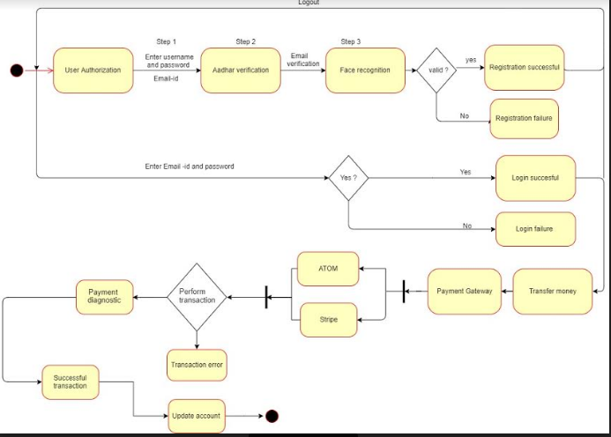

_____________________________________________________________________

**Questions :**

1. Explain the difference between activity diagram and state chart diagram.

Activity diagram is used to document the logic of a single operation/method, a single use case or the flow of logic of a business process. It is equivalent to flowchart and data flow diagram from structured development.

The state diagram depict (show)the state of objects as their attributes change from state to the other state. State chart modeling is used to show the sequence of states that an object goes through, the cause the transition from one state to other and the action that result from a state change.

But the difference is, **activity diagrams** describe activities and **state charts** describe states. So those models are orthogonal - you might imagine there is an activity between two states (somethign that occours during the transition) and you might say there is a state between two activities

_____________________________________________________________________

**Outcomes :**

Model the requirements using UML.

_____________________________________________________________________

**Conclusion :**

The concept of UML was learned via Activity diagrams and State Chart diagrams.

Activity diagrams and State Chart diagrams were learned in depth to understand the concept and importance of it.

Also Graphical presentation of Activity diagrams and State Chart diagrams was done to get a general idea of how the UML structure should be.

_____________________________________________________________________