## *Modelling Structural Diagram Using UML*

1714097

Riddhisha Nirmal

IT B2

**Aim :** To model the Structural Diagram for the OOSE Mini-Project 2019.

**Tools :** draw.io a Open Source Software for making flowcharts, process diagrams, org charts, UML, ER and network diagrams.

**Result : Class Diagram for the ‘E-Banking System Software’:**

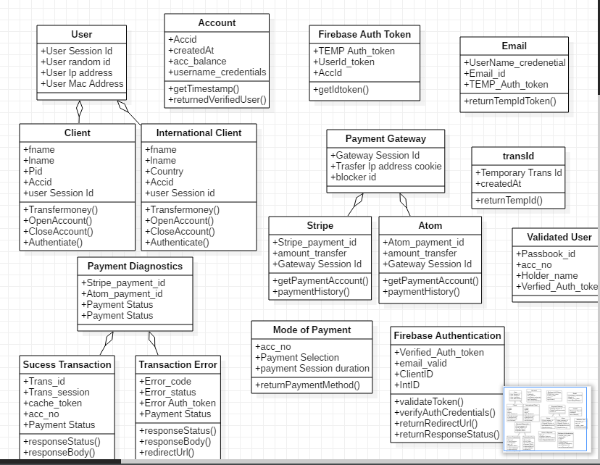

**Package Diagram for the ‘E-Banking System Software’:**

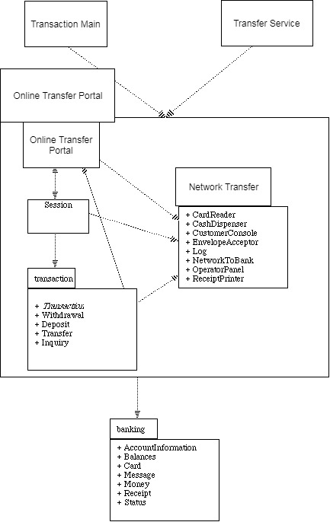

**Component Diagram for the ‘E-Banking System Software’:**

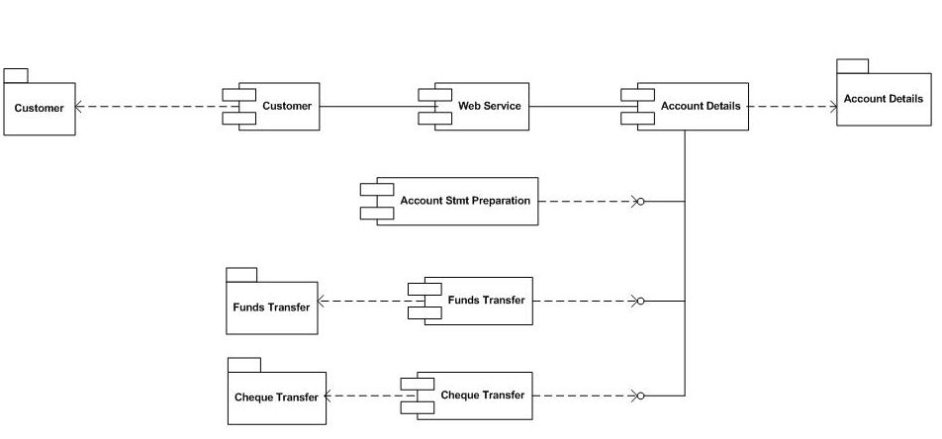

**Deployment Diagram for the ‘E-Banking System Software’:**

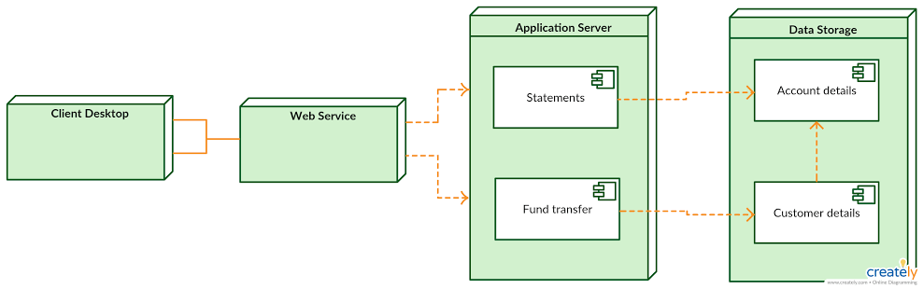

**Post Lab Question :**

Q. Give example of Deployment Diagrams for modelling a Fully Distributed System.

**Ans.**

**“A deployment diagram is a diagram that shows the configuration of run time processing nodes and the components that live on them. ”**

* Deployment diagrams are one of the two kinds of diagrams used in modeling the physical aspects of an object-oriented system.
* used to model the static deployment view of a system (topology of the hardware)
* A deployment diagram is just a special kind of class diagram, which focuses on a system’s nodes.
* Graphically, a deployment diagram is a collection of vertices and arcs.
* Deployment diagrams commonly contain Nodes and Dependency & association relationships. It may also contain notes and constraints.
* Deployment diagrams are important for visualizing, specifying, and documenting embedded, client/server, and distributed systems and also for managing executable systems through forward and reverse engineering.

**Common Uses:**  
Deployment diagrams are used in one of three ways,

* To model embedded systems
* To model client/server systems
* To model fully distributed systems

**Example** Deployment Diagram forModeling an Embedded System of a Simple Autonomous Robot

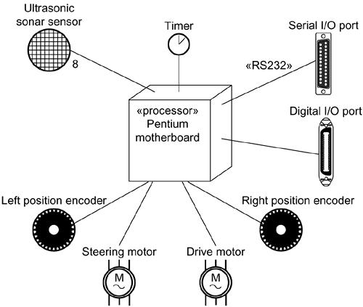

**Outcomes** **:** Model the requirements using UML

**Conclusion** **:** Modelling of Class Diagrams, using UML was studied and implemented successfully.