Name- Hritik Anand

Student ID- 104185477

Data Flow Diagrams

Context Diagram

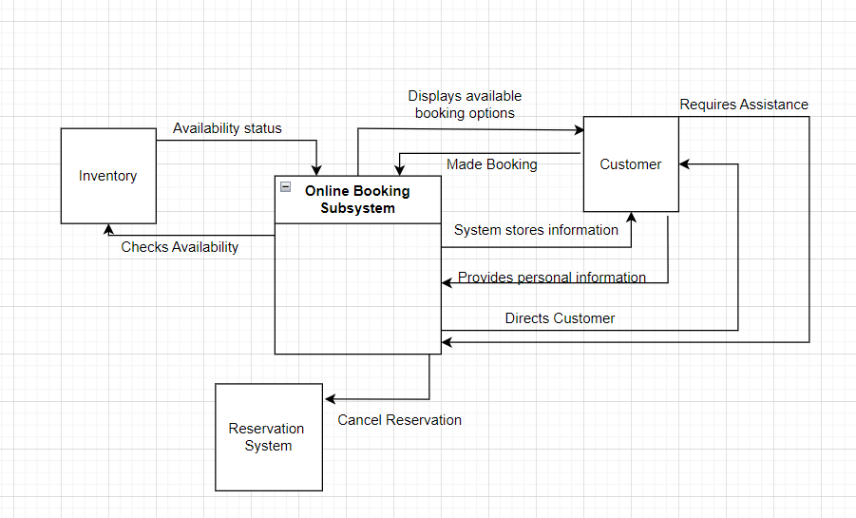

Diagram 0

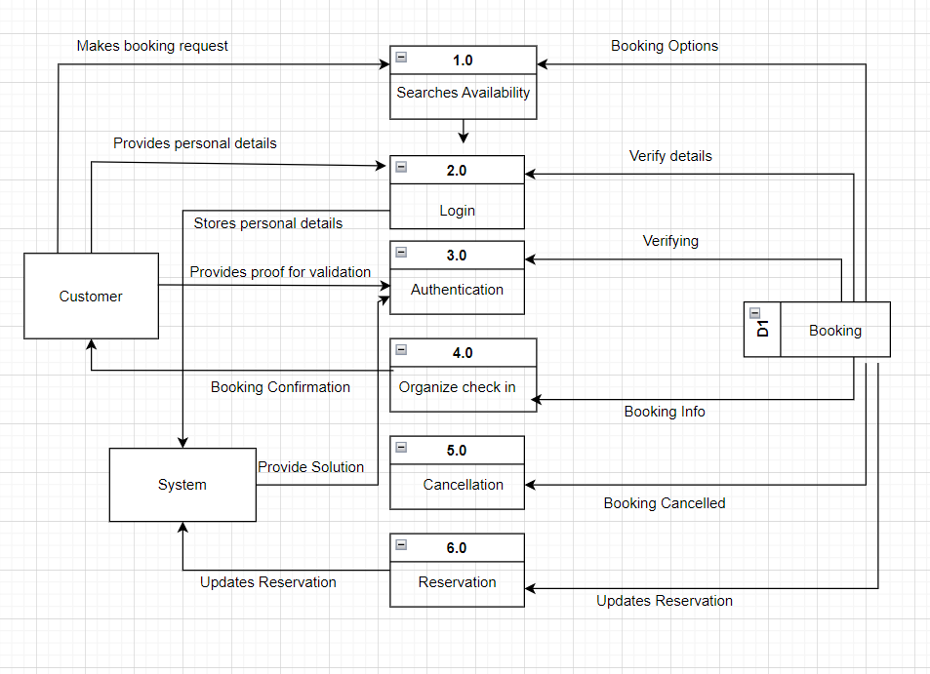

Diagram 1

