**MINI PROJECT – I**

(2018-19)

**Sentimental Analysis of YouTube Videos**

**SRS**



**Institute of Engineering & Technology**

**Members**

Arya Gupta (161500131)

Hritik Goyal (161500244)

Kajal Gupta (161500252)

Kamal Varshney (161500253)

Sahil Vashishtha (161500474)

Supervised By:

Mr. Vaibhav Diwan

(Technical Trainer)

Table of Contents

Revision History I

Document Approval II

1. Introduction 1

1.1 Purpose 1

1.2 Scope 1

1.3 Definitions, Acronyms, and Abbreviations 2

1.4 Tools used 2

1.5 References 3

1.6 Overview 3

2. Specific Requirements 4

2.1 External Interface Requirements 4

2.1.1 Hardware Interfaces 4

2.1.2 Software Interfaces 4

2.2 Non-Functional Requirements 4

2.2.1 Performance 4

2.2.2 Scalability 4

2.2.3 Capability 4

2.2.5 Availability 4

2.2.6 Maintainability 4

2.2.6 Portability 4

3. Analysis Models 5

3.1 Sequence Diagram 5

3.2 Data Flow Diagram 6

**1. Introduction**

## 1.1 Purpose

Sentimental Analysis of YouTube is defined as the task to analyze and extract the sentiment of the YouTube videos. Social networking applications such as Twitter, Facebook, YouTube, Instagram, etc. are popularly used to express one’s sentiment and opinion on a variety of topics. A large number of these applications rely on text as the main medium of communication. Websites such as YouTube use video as the primary source of the communicating information. For example, “Unboxing” is a popular theme on YouTube where users express their opinion and sentiment about products while unpacking and experiencing the product for the first time. Sentiment systems that can crawl and mine these information resources can assist in establishing

the popular sentiment or the “word of mouth” on a large range of topics. Such information can be useful to business and consumers alike.

**1.2 Scope**

* help YouTube to promote right Videos.
* Subtitle Generation.

**1.3 Definitions, acronyms and abbreviations**

**SAYV-** Sentimental Analysis of YouTube Videos is a software that allows the user to analyses the content of videos.

**User-** It is the person who will give video as an input and polarity analysis as an output.

**UML-**Unified Modeling Language is a standard language for writing software blueprints. The UML may be used to visualize, specify, construct and document.

**1.4 Tools Used**

**Python IDLE -** is an [integrated development environment](https://en.wikipedia.org/wiki/Integrated_development_environment) for [Python](https://en.wikipedia.org/wiki/Python_(programming_language)), which has been bundled with the default implementation of the language. IDLE is intended to be a simple [IDE](https://en.wikipedia.org/wiki/Integrated_development_environment) and suitable for beginners, especially in an educational environment. To that end, it is cross-platform, and avoids feature clutter.

**Natural Language Toolkit -** NLTK is a leading platform for building Python programs to work with human language data. It provides easy-to-use interfaces such as WordNet, along with a suite of text processing libraries for classification, tokenization, stemming, tagging, parsing, and semantic reasoning, wrappers for industrial-strength NLP libraries.

NLTK has been called “a wonderful tool for teaching, and working in, computational linguistics using Python,” and “an amazing library to play with natural language.”

[Natural Language Processing with Python](http://nltk.org/book) provides a practical introduction to programming for language processing. Written by the creators of NLTK, it guides the reader through the fundamentals of writing Python programs, working with corpora, categorizing text, analyzing linguistic structure, and more. The online version of the book has been updated for Python 3 and NLTK 3.

* 1. **References**
* https://www.researchgate.net/publication/276886742_Sentimental_Extraction
* <https://www.github.com>
* Software Engineering, seventh edition, Roger S. Pressman.
* Software Engineering, Seventh Edition, Ian Somerville.
* Hans van Vliet. Software Engineering: Principles and Practice (Second Edition). Wiley, 1999.
* Encyclopedia of Software Engineering” by LaPlante.
* Wikipedia -www.wikipedia.com
* Object Oriented Modelling and Design with UML-Michael Blaha, James Ram Baugh..

## 1.6 Overview

The rest of the SRS examines the specifications of the Sentimental Analysis in details.

Section 2 outlines the detailed, performance, system, non-functional, inverse and other related requirements along with design constraint of the Sentimental Analysis of videos.

The final section i.e. Section 3 contains Data Flow Diagrams (D.F.D.), Sequence Diagram, Activity Diagram. This section is highly useful in analysis phase of model.

* The user can easily analyze the video content.
* User has to enter the videos.

# 2. Specific Requirements

# External Interface Requirements

# 2.1.1 Hardware Interfaces

1) Minimum 4 GB RAM.

2) Minimum i5 processor.

### 2.1.2 Software Interfaces

1. Any windows based operating system.
2. Python
3. NLTK
4. NLP Libraries

## 2.2 Non-Functional Requirements

Non-functional requirements cover all the remaining requirements.

### Performance: For example, Response Time, Throughput. There is no need for the internet connection and other operations are done on time.

* **Scalability:** There is no limit of data i.e., no constraint related to size of the data.

### Capacity: It can analyse all type of videos

* **Availability:** It is offline software; software does not need any internet connection.
* **Maintainability:** There is no such maintenance needed.
* **Portability:** The application can be run on any operating system.

# 3. Analysis Models

## 3.1 Sequence Diagrams

PolarityAnalysis

AudioToText

User

VideoToAudio

Path

Video

Audio

Text

Positive

Neutral

Negaitive

X X X X

**Fig. 3.1 Sequence Diagram**

## 3.2 Data Flow Diagrams

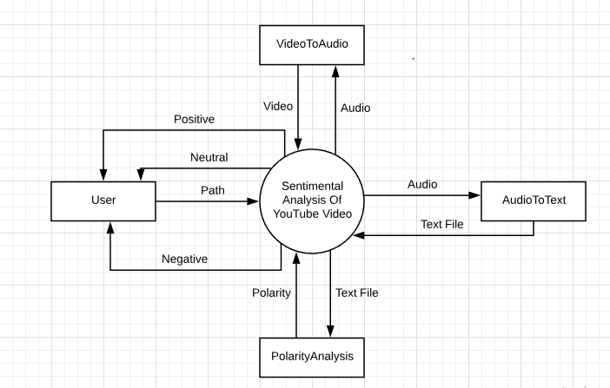

Fig.3.2 : 0-Level DFD