**Meeting setter Web App**

Hritik Handa - [hritikhanda4@gmail.com](mailto:hritikhanda4@gmail.com) Divyanshi Kaushik – [divyanshikaushik88@gmail.com](mailto:divyanshikaushik88@gmail.com)

MEETING SETTER WEB APPLICATION is the video conference chat service in which people can create profiles, add friends in their friend list, manage their schedule by updating the free slots and connect to their friends together for real time interaction.

**Note:** There is no need to download this application as it is in your web browser. It can be particularly beneficial for users who are having problems installing desktop apps or are in a locked-down environment who cannot download software.

**Why use the Web App?**

Setting up a meeting with friend is always an easy task but collaboration with customers, clients or boss is not easy. MEETING SETTER WEB APPLICATION provides the facility to the customer to fix meetings with the members of the friend list in their free slots. Slots will be updated themselves if meeting has been fixed.

**Features:**

* Easy to use
* Setting up meeting according to your and partner mutual free slots
* Easy User Interface
* Adding friends and accepting invites
* High-quality Video Conference Call
* Chat with participants
* Screen Sharing with participants
* Video and audio preview screen
* Setting and Attending Meetings at one place

**Technologies Used:**

1. Front end technologies – HTML CSS, client side Javascript
2. Backend technologies – Java, Servlet, Jsp, JDBC
3. Database- IBM-DB2 and MySQL
4. Other technologies- AJAX

**Core learning:**

1. We can’t process 2 result sets at a same time…First on will be closed if we call 2nd
2. Java is a secured language because of which we can’t access result set from another file.
3. How to send AJAX request and be on same page (with textual and multi type data like images etc.)
4. When we fetch data from db we get spaces with it because if we took varchar (40)  and filled 10 chars only then we get 10 chars and 30 spaces during fetching.
5. In IBM-DB2, before making use of a table we need to give admin access to it to reorganize contents otherwise it will raise -668 exception.
6. We can’t save any variable of object in session with ‘user’ as name, if we do so, there will be session problems.

**Difficulties:**

1. Lack of clear goals and success criteria at beginning : But with time we changed a lot of features and made them better.
2. Budgeting issues: we required an real time online database and an video calling API for our project, But they were very costly, A lot of time was consumed in search of low prize resources RnD. At last we have used
   * + AWS- For hosting purposes
     + Vidyo.io – For real time video calling
     + IBM-DB2- Real time online Database

**How to Use:**

1. Open a Google Chrome browser.
2. Go to http://3.139.39.16:8080/Meeting%20Setter%20Web%20App/
3. Create your Account.

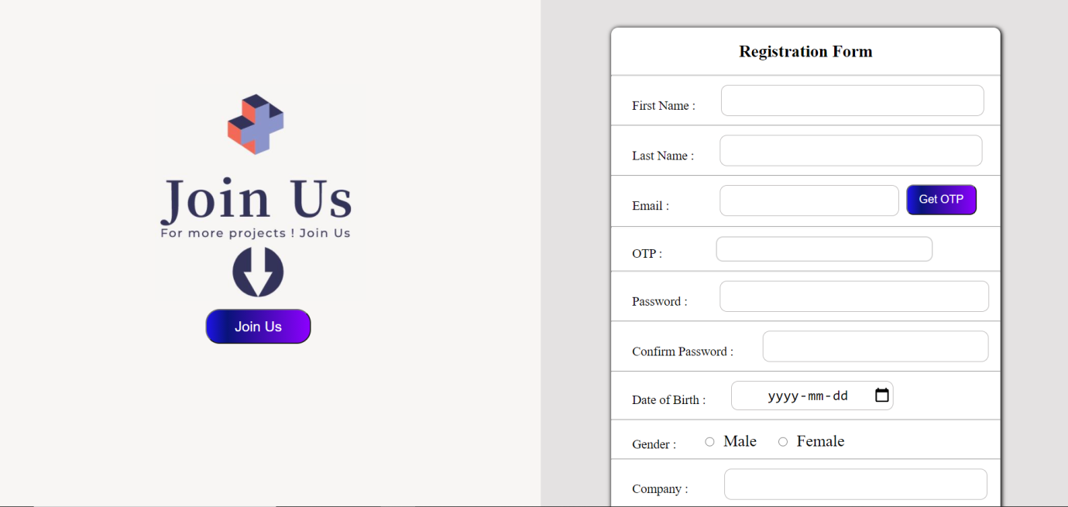

1. Login your Account.

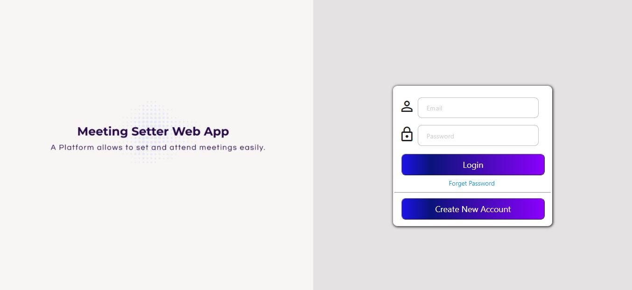

1. Add friends in your friend List

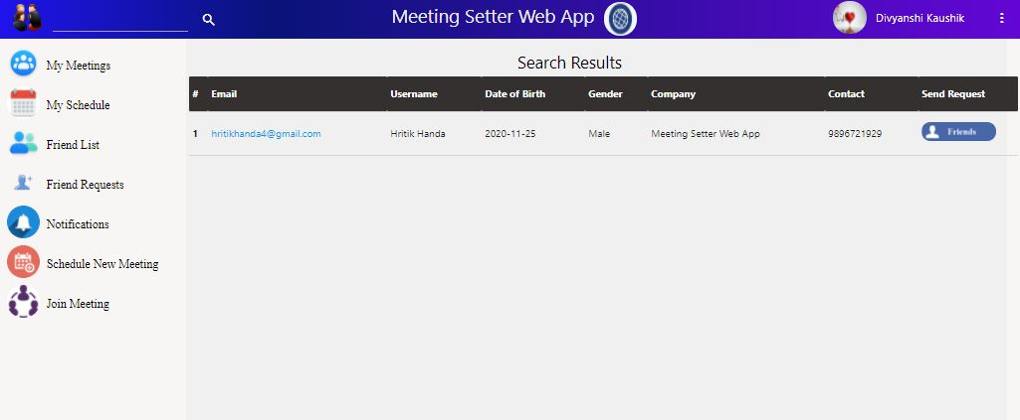

1. Update your schedule by managing free slots.

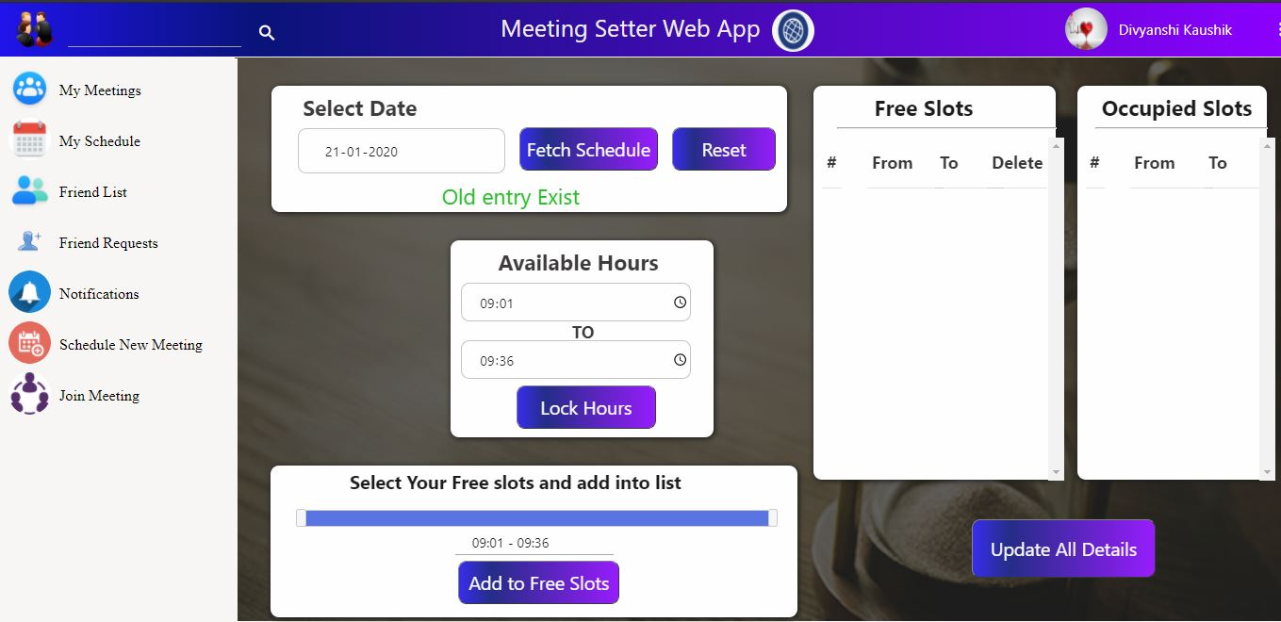

1. Fix your meeting with your friends in their free slot. Room id and password will be generated.

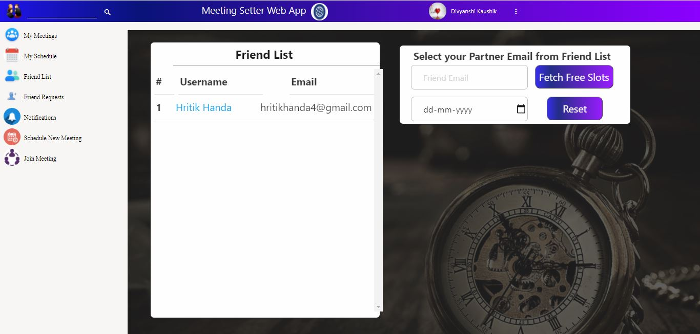

1. Details for joining a meeting are shown in MY MEETING folder.

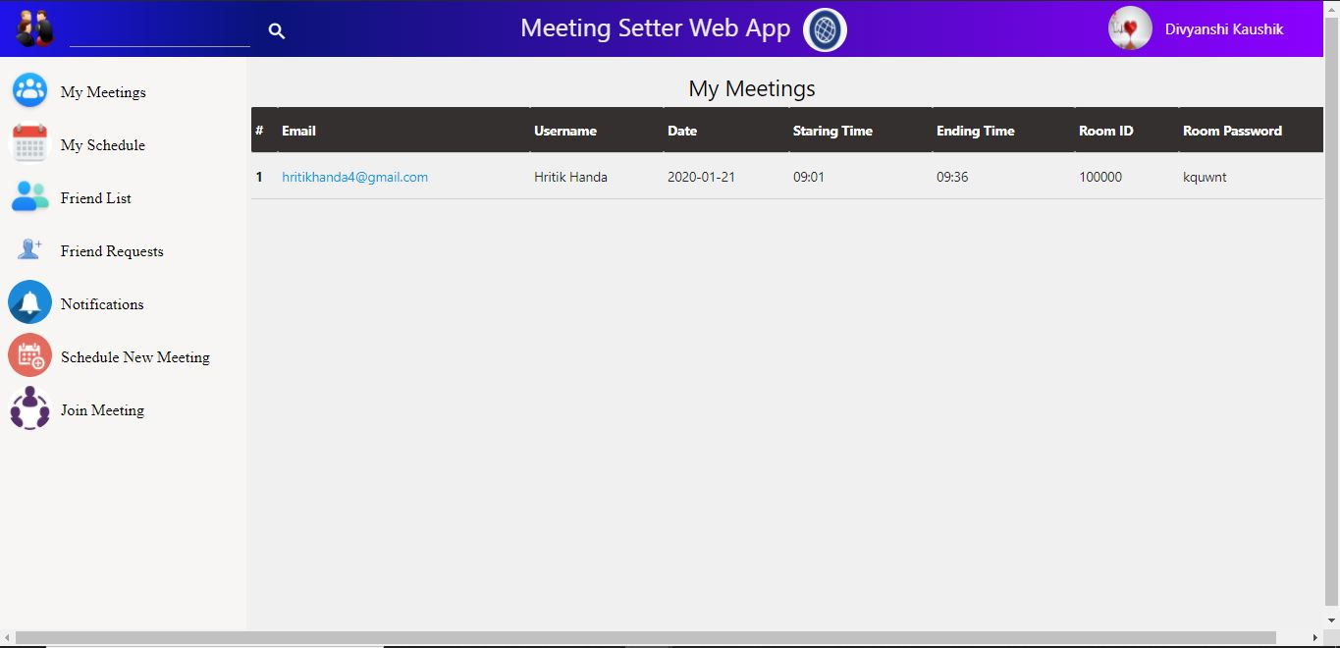

1. Enter room id and password for joining a meeting.

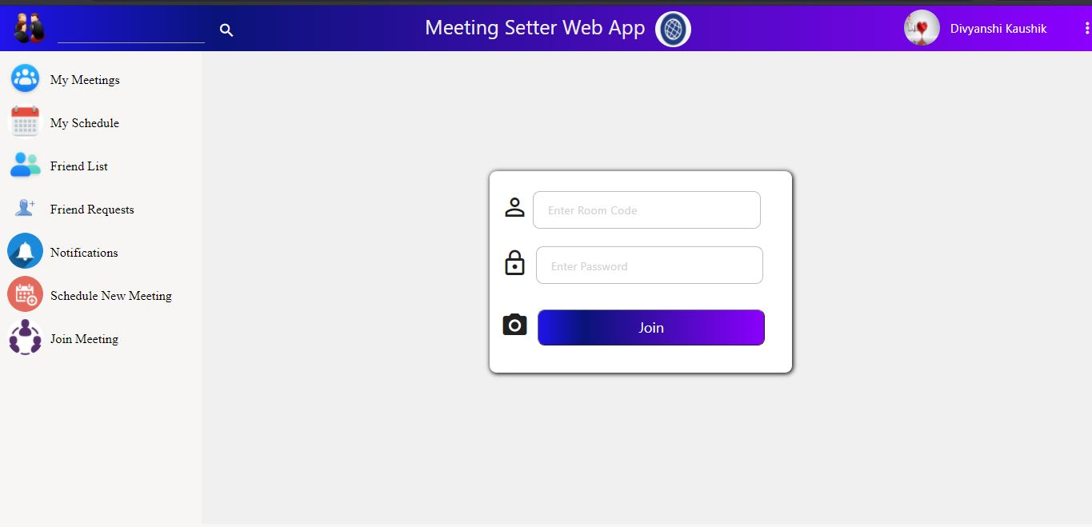

1. Attend your meeting

