**Introduction – Data Structure**

1. **What is Data structure?**

* Organising of data so that we can efficiently perform operations.

1. **What are Data types?**

* **Primitive data types**

**Int , float , double , string**

* **User defined data types**

**Employee{**

**Name Age Empid**

**}**

**Employee : Name , Age , Empid**

* **C++ : Structures and Classes**

1. **What is user defined Data type?**
2. **Different types of Data Structures?**

* **Linear Data structure**

**Arrays**

**Linked List**

**Stack**

**Queue**

* **Non-Linear Data structure**

**Trees**

**Binary Tree**

**Binary Search Tree**

**Heaps**

**Balanced Trees**

**Segment Tree**

**Binary Indexed Tree or Fenwick Tree**

**Graphs**

1. **What is an Array?**

* **Collection of data of same/ homogenous data type**
* **Memory location will be continuous**

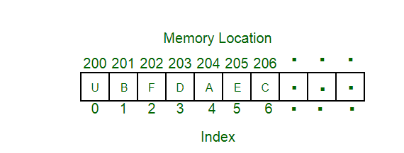

1. **What are we going to study?**

**SHLOK : 1 2 3 4 5 or 1 2 3 4 5**

**Bandari : 1 2 3 4 5 or 100 2 200 4 5**

**Prahant : 1 2 3 4 or 1 3 4**

1. **Basic Introduction to Time Complexity and Space Complexity:**

**O(N) O(logN) O(1)**

**1 2 3 4 5 6 7 8 9 10**

**Ques) Given a number N return sum from 1 to N?**

1. **Pre-Requisites?**

**Recursion**

**Basic Language proficiency**

**Pointers**