DBMS LAB 1 :-

CREATE TABLE PERSON(

driver_id VARCHAR(10),

name VARCHAR(20),

address VARCHAR(50),

PRIMARY KEY(driver_id)

);

CREATE TABLE CAR(

regno VARCHAR(10),

model VARCHAR(20),

year VARCHAR(4),

PRIMARY KEY(regno)

);

CREATE TABLE ACCIDENT(

report_no INT,

date DATE,

location VARCHAR(50),

PRIMARY KEY(report_no)

);

CREATE TABLE OWNS(

driver_id VARCHAR(10),

regno VARCHAR(20),

PRIMARY KEY(driver_id,regno),

FOREIGN KEY(driver_id) REFERENCES PERSON(driver_id)

ON delete CASCADE ON update CASCADE,

FOREIGN KEY(regno) REFERENCES CAR(regno)

ON delete CASCADE ON update CASCADE);

CREATE TABLE PARTICIPATED(

driver_id VARCHAR(10),

regno VARCHAR(20),

report_no INT,

damage_amount INT,

FOREIGN KEY(driver_id,regno) REFERENCES OWNS(driver_id,regno)

ON delete SET NULL ON update CASCADE,

FOREIGN KEY(report_no) REFERENCES ACCIDENT(report_no)

ON delete SET NULL ON update CASCADE

);

INSERT INTO PERSON VALUES('A01','Richard','Srinivas nagar');

INSERT INTO PERSON VALUES('A02','Pradeep','Rajaji nagar');

INSERT INTO PERSON VALUES('A03','Smith','Ashok nagar');

INSERT INTO PERSON VALUES('A04','Venu','N R Colony');

INSERT INTO PERSON VALUES('A05','Jhon','Hanumanth nagar');

INSERT INTO CAR VALUES('KA052250','Indica','1990');

INSERT INTO CAR VALUES('KA031181','Lancer','1957');

INSERT INTO CAR VALUES('KA095477','Toyota','1998');

INSERT INTO CAR VALUES('KA053408','Honda','2008');

INSERT INTO CAR VALUES('KA041702','Audi','2005');

INSERT INTO ACCIDENT VALUES(11,'2003-01-01','Mysore Road');

INSERT INTO ACCIDENT VALUES(12,'2004-02-02','South end Circle');

INSERT INTO ACCIDENT VALUES(13,'2003-01-21','Bull temple Road');

INSERT INTO ACCIDENT VALUES(14,'2008-02-17','Mysore Road');

INSERT INTO ACCIDENT VALUES(15,'2005-03-04','Kanakpura Road');

INSERT INTO OWNS VALUES('A01','KA052250');

INSERT INTO OWNS VALUES('A02','KA053408');

INSERT INTO OWNS VALUES('A03','KA031181');INSERT INTO OWNS VALUES('A04','KA095477');

INSERT INTO OWNS VALUES('A05','KA041702');

INSERT INTO PARTICIPATED VALUES('A01','KA052250',11,10000);

INSERT INTO PARTICIPATED VALUES('A02','KA053408',12,50000);

INSERT INTO PARTICIPATED VALUES('A03','KA095477',13,25000);

INSERT INTO PARTICIPATED VALUES('A04','KA031181',14,3000);

INSERT INTO PARTICIPATED VALUES('A05','KA041702',15,5000);

SELECT * FROM PERSON;

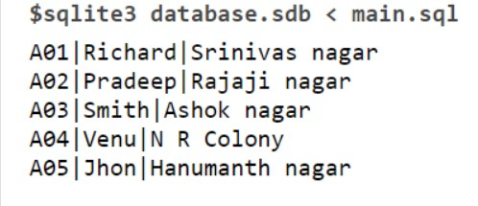

SELECT * FROM CAR;

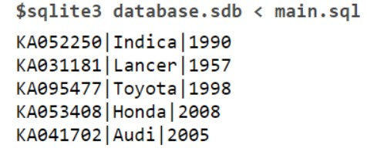

SELECT * FROM ACCIDENT;

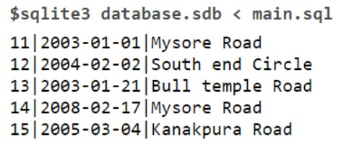

SELECT * FROM OWNS;

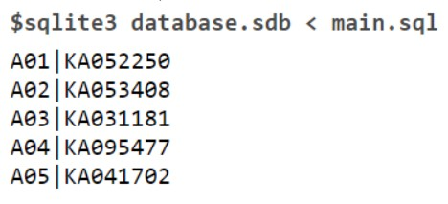

SELECT * FROM PARTICIPATED;

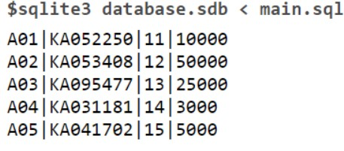

UPDATE PARTICIPATED SET damage_amount=25000 WHERE REPORT_NO =12 AND REGNO='KA053408';

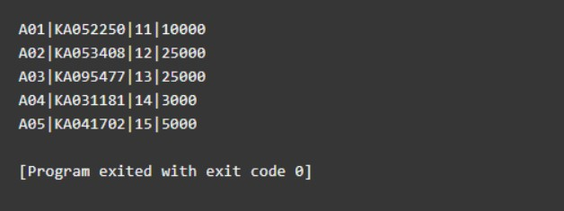

INSERT INTO ACCIDENT VALUES(16,'2018-04-08','MYSORE');

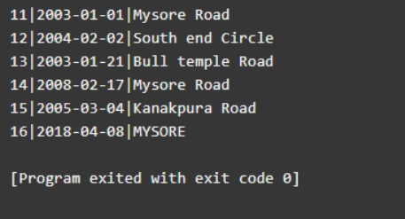

SELECT COUNT(*) FROM ACCIDENT WHERE DATE LIKE '2008-__-__';

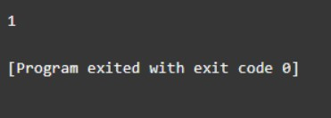

SELECT COUNT(*) FROM CAR WHERE model LIKE 'Indica';

