LOVELY PROFESSIONAL UNIVERSITY, PUNJAB
DEPARTMENT OF COMPUTER SCIENCE AND ENGINEERING

Metro Station Connectivity Analysis Using GraphX and Visualization

Submitted By: ______________________
Registration No.: ___________________
Course: Big Data Analytics / Graph Analytics
Session: 2025-26
Submission Date: ___________________

CERTIFICATE
This is to certify that the project report titled "Metro Station Connectivity Analysis Using GraphX and Visualization" is a bonafide work carried out in partial fulfillment of academic requirements. The work presented in this report is original and has been completed under proper guidance.
Supervisor Signature: ______________________
HOD Signature: _____________________________
Date: _____________________________________

ACKNOWLEDGEMENT
I would like to express my sincere gratitude to the Department of Computer Science and Engineering, Lovely Professional University, for providing me with the opportunity to complete this project. I am especially thankful to my faculty mentor for continuous guidance, valuable suggestions, and motivation throughout this work. I also thank my peers and family for their support in successfully completing this project.

Abstract
Urban metro systems are complex transportation networks with numerous stations, route dependencies, and interchange points. As city populations increase, there is a strong need for data-driven techniques to evaluate station connectivity, identify critical hubs, and support future planning. This project models metro stations as graph nodes and direct station-to-station links as directed edges. Apache Spark GraphX is used for scalable graph computation, while Python-based tooling is used for complementary analysis and visualization.
The analysis includes degree centrality for identifying highly connected stations, isolated/least connected station detection, and PageRank for measuring network-wide station importance. A cleaned geographic visualization highlights route structure and important nodes. In addition, a Random Forest pipeline is demonstrated for passenger traffic prediction using graph-derived features. Because the dataset does not include real passenger labels, a proxy target is used strictly for methodological demonstration.
Results show that interchange stations dominate centrality and PageRank, while terminal stations are generally least connected. The workflow demonstrates that graph-based analysis is effective for understanding metro systems and can be extended to real-time transport analytics with richer datasets.

Table of Contents
I. Introduction
II. Problem Statement
III. About Big Data and Graph Processing
IV. Objectives
V. Dataset Description
VI. Methodology
VI.1 Data Preprocessing
VI.2 Graph Construction
VI.3 Degree Centrality and Connectivity Analysis
VI.4 PageRank-Based Importance Analysis
VI.5 Random Forest Traffic Prediction
VII. Tech Stack Required
VIII. Implementation Details
IX. Results and Analysis
X. Visualization and Interpretation
XI. Advantages of Graph-Based Analysis
XII. Limitations
XIII. Future Enhancements
XIV. Code Repository and Execution Steps
XV. Conclusion
References

I. Introduction
Urban transportation determines the efficiency, inclusiveness, and sustainability of modern cities. As urbanization accelerates, public transit systems must support larger passenger volumes while maintaining reliability, safety, and cost efficiency. Metro systems have emerged as a high-capacity solution that reduces dependence on road transport and improves travel consistency.
Despite their practical benefits, metro networks are structurally complex. They include route branches, interchanges, terminal stations, and dependency chains where local disruption can affect wider areas. Traditional tabular analysis is often insufficient to understand these relational patterns. Graph-theoretic modeling converts this transport complexity into a mathematical structure that can be systematically analyzed.
In this project, stations are represented as nodes and route connections as directed edges. The model enables computation of station-level metrics such as degree and PageRank, revealing which stations are structurally central or peripheral. By combining distributed graph processing (GraphX) with clear visual representation, the project provides an interpretable framework suitable for academic study and practical extension.

II. Problem Statement
Metro systems generate highly connected data with implicit relationships that are difficult to interpret through basic statistics. Authorities and planners require methods that identify critical stations, evaluate resilience, and reveal weakly connected areas.
The core problem is to build a scalable analytical pipeline that can model station connectivity, compute meaningful graph metrics, and present actionable insights through visualization. The solution should also be adaptable for future integration with richer operational data such as passenger demand, delays, and service frequency.

III. About Big Data and Graph Processing
Big Data analytics is characterized by high volume, velocity, and variety. Urban transport analytics naturally evolves into a Big Data problem when multiple lines, historical ridership logs, smart-card transactions, and real-time events are considered.
Apache Spark addresses scalability by distributing processing across partitions and executing transformations in parallel. GraphX, built on top of Spark, provides efficient abstractions for property graphs and iterative graph algorithms. These capabilities are well-suited for centrality and ranking computations that require repeated neighborhood aggregation.
In this assignment, the provided data is static CSV and not streaming. However, the chosen architecture is future-ready and can scale to larger and dynamic datasets with minor pipeline extensions.

IV. Objectives
1) Construct a directed graph of metro stations and route links from the dataset.
2) Compute degree centrality to identify busiest and structurally significant stations.
3) Detect least connected and isolated stations.
4) Compute PageRank scores to estimate global station importance.
5) Visualize network connectivity using spatial coordinates and metric encoding.
6) Demonstrate a Random Forest workflow for traffic prediction using graph-derived features.

V. Dataset Description
The project uses a metro dataset containing station identity, station names, route line information, distance from origin, opening year, station layout, and geographic coordinates. These attributes are sufficient for graph construction and map-based plotting.
Key columns include: ID (Station ID), Station Names, Dist. From First Station(km), Metro Line, Opened(Year), Layout, Latitude, and Longitude. The distance column is particularly useful for ordering stations along each line during edge construction.
A small number of coordinate anomalies are present; therefore, preprocessing applies numeric conversion and geographic filtering to improve visualization quality and prevent distorted layouts.

VI. Methodology
The methodology combines data cleaning, directed graph construction, metric computation, visualization, and ML demonstration. The network is represented as G(V, E), where V is the set of stations and E is the set of directed edges between sequential stations on each metro line. Interchange naming variants are normalized to avoid duplicate semantic nodes.
After graph creation, station connectivity is measured using degree-based metrics, and station influence is evaluated using PageRank. Results are then interpreted through a map-oriented visualization and a ranked importance chart.

VI.1 Data Preprocessing
Data preprocessing converts relevant columns to numeric type, removes incomplete records, and normalizes station names by removing bracketed connection notes when required. This step improves node consistency across lines and avoids artificial fragmentation of interchange stations.
For visualization, latitude and longitude values are filtered within valid regional bounds to remove outliers that can stretch the map and reduce interpretability.

VI.2 Graph Construction
Stations become nodes with attributes (display name, latitude, longitude, and lines served). For each metro line, stations are sorted using distance from the first station, and directed edges are added between consecutive stations.
This design preserves route direction and captures topological continuity. Where the same station appears in multiple lines, normalization allows merging into a unified node that reflects interchange behavior.

VI.3 Degree Centrality and Connectivity Analysis
Degree centrality quantifies direct connectivity. Nodes with high degree typically correspond to interchanges or structurally important transit hubs. Low-degree nodes often represent terminals or edge stations.
The analysis also computes in-degree and out-degree for directional interpretation. Isolated nodes are identified where total degree is zero, signaling disconnected components or data construction issues.

VI.4 PageRank-Based Importance Analysis
PageRank extends beyond local connectivity by weighting links from already important neighbors. In metro networks, this helps highlight stations that sit within influential substructures even if raw degree values are similar across many nodes.
PageRank is computed iteratively until convergence, producing a station ranking used in both tabular output and visualization encoding (node size/color).

VI.5 Random Forest Traffic Prediction
To integrate predictive analytics, a Random Forest regressor is trained with graph-derived features: degree, in-degree, out-degree, PageRank, and number of served lines. Because the dataset lacks real passenger counts, a proxy target is generated for educational demonstration only.
This section validates the pipeline structure (feature engineering, train/test split, model fit, and feature importance) while explicitly noting that results are illustrative rather than production-grade demand forecasting.

VII. Tech Stack Required
Apache Spark and GraphX (Scala) for distributed graph analytics; Python with Pandas and NetworkX for data handling and graph operations; Matplotlib for plotting; Scikit-learn for Random Forest regression. The hybrid stack balances scalability, algorithmic depth, and ease of visualization.

VIII. Implementation Details
The project is implemented through three main scripts. metro_gx.scala performs GraphX-based graph creation and ranking outputs in Spark shell. metro_visual.py provides enhanced route-aware map visualization with decluttered annotations. metro_assignment.py executes end-to-end analysis, exports connectivity visualization, and runs the ML demonstration.
Execution is terminal-friendly and reproducible from the project directory. Relative paths are used to avoid machine-specific configuration issues.

IX. Results and Analysis
Observed outputs indicate that major interchange stations show highest structural significance. For example, Kashmere Gate appears among top-degree stations, with additional high-ranking hubs such as Rajiv Chowk, Hauz Khas, and Kalkaji Mandir.
Least connected stations are primarily line endpoints with degree one, while isolated stations are absent in the constructed graph. PageRank results similarly prioritize interchange-rich and centrally positioned stations.
These findings align with expected transport behavior: transfer points and central connectors naturally attract higher structural importance than peripheral terminals.

X. Visualization and Interpretation
The generated connectivity map encodes node importance using marker size and color. Geographic plotting helps users quickly identify dense corridors, terminal tails, and critical interchange locations. Complementary ranked charts summarize top stations for presentation and reporting.
Visualization quality is improved by coordinate cleaning, reduced annotation overlap, and line-aware edge ordering. These improvements make the figure suitable for academic submission and viva discussion.

XI. Advantages of Graph-Based Analysis
Graph modeling preserves relational structure and supports intuitive interpretation of transit systems. It identifies critical hubs, quantifies network influence, and offers a robust foundation for optimization tasks such as route planning, bottleneck detection, and resilience analysis.
The same framework scales from classroom-sized datasets to enterprise-grade city networks when combined with distributed processing platforms like Spark.

XII. Limitations
The current dataset is static and does not include real-time operational variables (train frequency, service delays, surge events). Passenger counts are unavailable, so ML uses a synthetic proxy target. Consequently, prediction metrics cannot be interpreted as true ridership forecasting accuracy.
Additionally, simplified route assumptions may omit real-world operational nuances such as branch scheduling and temporal variability.

XIII. Future Enhancements
Future work should include real passenger demand labels, smart-card tap-in/out data, and time-aware service logs to enable genuine supervised forecasting and dynamic congestion modeling.
Algorithmic extensions may include shortest-path optimization, community detection, centrality comparison, anomaly detection, and graph neural networks for spatiotemporal prediction.
An interactive dashboard can further improve stakeholder usability through filtering, station drill-down, and scenario analysis.

XIV. Code Repository and Execution Steps
Project directory: /Users/hrituraj/Desktop/clusterproject
Primary files: metro_gx.scala, metro_visual.py, metro_assignment.py, metro.csv, README.md
Python run commands:
1) cd /Users/hrituraj/Desktop/clusterproject
2) python3 -m pip install pandas networkx matplotlib numpy scikit-learn
3) python3 metro_assignment.py
Spark run commands:
1) cd /Users/hrituraj/Desktop/clusterproject
2) spark-shell
3) :load metro_gx.scala

XV. Conclusion
This project demonstrates a practical workflow for metro network analytics by combining graph theory, distributed processing, and visualization. Degree and PageRank metrics effectively identify structurally important stations and connectivity patterns.
The implemented pipeline is academically complete for assignment objectives and forms a strong base for future city-scale extensions. With richer operational and passenger datasets, this framework can evolve into a robust decision-support system for smart urban transportation planning.

Figure 1. Metro Network Connectivity Visualization
Generated from the project workflow and included as evidence of visual analysis output.
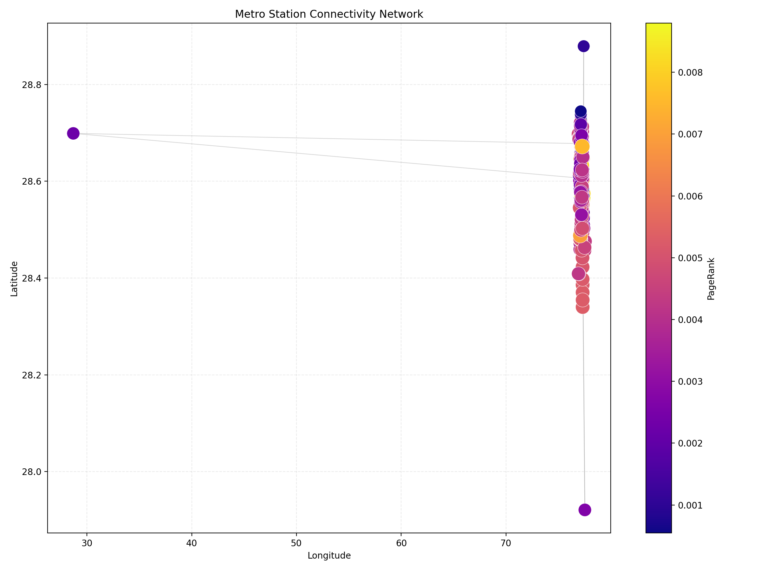

References
Diestel, R. (2000). Graph Theory (2nd ed.). Springer-Verlag.
Zaharia, M., & Chambers, B. (2018). Spark: The Definitive Guide.
Salloum, S., Dautov, R., Chen, X., Peng, P.X., & Huang, J.Z. (2016). Big Data Analytics on Apache Spark. International Journal of Data Science and Analytics.
Ramamonjison, R. (2015). Apache Spark Graph Processing. Packt Publishing.
Platt, E.L. (2019). Network Science with Python and NetworkX Quick Start Guide. Packt Publishing.
Yim, A., Chung, C., & Yu, A. (2018). Matplotlib for Python Developers. Packt Publishing.
Vyakaranam, L., Raman, R., Shah, H., Mishra, N., Meenakshi, R., & Murugan, S. (2024). Simplifying Graph-Parallel Computation in Apache Spark with GraphX. IEEE ICECA.

Appendix A: Key Observations from Output
A1. High-degree stations are largely interchange points that bridge major corridors and increase route flexibility for passengers.
A2. Terminal stations tend to have low degree, reflecting expected endpoint topology in directed line models.
A3. PageRank rankings are less noisy than raw degree in some regions because they incorporate global neighborhood influence.
A4. Coordinate cleaning was essential to avoid axis stretching caused by malformed longitude values.
A5. The Random Forest stage is a methodological extension to demonstrate machine learning integration with graph analytics.

Appendix B: Extended Discussion
Graph-centric transportation analytics is increasingly important for smart-city planning. By combining topological indicators with geospatial context, planners can detect vulnerabilities, prioritize upgrades, and evaluate intervention scenarios with greater confidence. In future versions, scenario-based simulation can be added to test disruptions, maintenance schedules, and demand spikes. Integrating temporal edges and weighted capacities would further improve realism and make recommendations operationally actionable. A consistent data-governance process (schema validation, anomaly checks, and audit trails) is also required for enterprise deployment. These enhancements can transform the present educational prototype into a reliable decision-support pipeline for metropolitan transport authorities.
Graph-centric transportation analytics is increasingly important for smart-city planning. By combining topological indicators with geospatial context, planners can detect vulnerabilities, prioritize upgrades, and evaluate intervention scenarios with greater confidence. In future versions, scenario-based simulation can be added to test disruptions, maintenance schedules, and demand spikes. Integrating temporal edges and weighted capacities would further improve realism and make recommendations operationally actionable. A consistent data-governance process (schema validation, anomaly checks, and audit trails) is also required for enterprise deployment. These enhancements can transform the present educational prototype into a reliable decision-support pipeline for metropolitan transport authorities.
Graph-centric transportation analytics is increasingly important for smart-city planning. By combining topological indicators with geospatial context, planners can detect vulnerabilities, prioritize upgrades, and evaluate intervention scenarios with greater confidence. In future versions, scenario-based simulation can be added to test disruptions, maintenance schedules, and demand spikes. Integrating temporal edges and weighted capacities would further improve realism and make recommendations operationally actionable. A consistent data-governance process (schema validation, anomaly checks, and audit trails) is also required for enterprise deployment. These enhancements can transform the present educational prototype into a reliable decision-support pipeline for metropolitan transport authorities.
Graph-centric transportation analytics is increasingly important for smart-city planning. By combining topological indicators with geospatial context, planners can detect vulnerabilities, prioritize upgrades, and evaluate intervention scenarios with greater confidence. In future versions, scenario-based simulation can be added to test disruptions, maintenance schedules, and demand spikes. Integrating temporal edges and weighted capacities would further improve realism and make recommendations operationally actionable. A consistent data-governance process (schema validation, anomaly checks, and audit trails) is also required for enterprise deployment. These enhancements can transform the present educational prototype into a reliable decision-support pipeline for metropolitan transport authorities.
Graph-centric transportation analytics is increasingly important for smart-city planning. By combining topological indicators with geospatial context, planners can detect vulnerabilities, prioritize upgrades, and evaluate intervention scenarios with greater confidence. In future versions, scenario-based simulation can be added to test disruptions, maintenance schedules, and demand spikes. Integrating temporal edges and weighted capacities would further improve realism and make recommendations operationally actionable. A consistent data-governance process (schema validation, anomaly checks, and audit trails) is also required for enterprise deployment. These enhancements can transform the present educational prototype into a reliable decision-support pipeline for metropolitan transport authorities.
Graph-centric transportation analytics is increasingly important for smart-city planning. By combining topological indicators with geospatial context, planners can detect vulnerabilities, prioritize upgrades, and evaluate intervention scenarios with greater confidence. In future versions, scenario-based simulation can be added to test disruptions, maintenance schedules, and demand spikes. Integrating temporal edges and weighted capacities would further improve realism and make recommendations operationally actionable. A consistent data-governance process (schema validation, anomaly checks, and audit trails) is also required for enterprise deployment. These enhancements can transform the present educational prototype into a reliable decision-support pipeline for metropolitan transport authorities.
Graph-centric transportation analytics is increasingly important for smart-city planning. By combining topological indicators with geospatial context, planners can detect vulnerabilities, prioritize upgrades, and evaluate intervention scenarios with greater confidence. In future versions, scenario-based simulation can be added to test disruptions, maintenance schedules, and demand spikes. Integrating temporal edges and weighted capacities would further improve realism and make recommendations operationally actionable. A consistent data-governance process (schema validation, anomaly checks, and audit trails) is also required for enterprise deployment. These enhancements can transform the present educational prototype into a reliable decision-support pipeline for metropolitan transport authorities.
Graph-centric transportation analytics is increasingly important for smart-city planning. By combining topological indicators with geospatial context, planners can detect vulnerabilities, prioritize upgrades, and evaluate intervention scenarios with greater confidence. In future versions, scenario-based simulation can be added to test disruptions, maintenance schedules, and demand spikes. Integrating temporal edges and weighted capacities would further improve realism and make recommendations operationally actionable. A consistent data-governance process (schema validation, anomaly checks, and audit trails) is also required for enterprise deployment. These enhancements can transform the present educational prototype into a reliable decision-support pipeline for metropolitan transport authorities.

