
K. R. MANGALAM UNIVERSITY, GURUGRAM, HARYANA, INDIA

ASSIGNMENT-4
Analysis and Design Algorithm
Name: Hritunjaya Chauhan
Course: B-Tech CSE (Data Science) A
Roll No.: 2401420024
Semester: 4th
Batch: 2024-2028

Submitted to - Signature -
Dr Aarti Sangwan

ADA Lab Experiment 4 — Crew Scheduling & String Matching
Tasks: Backtracking | Branch & Bound | String Matching | Experimental Analysis | Conceptual Tasks
Setup — Import Libraries
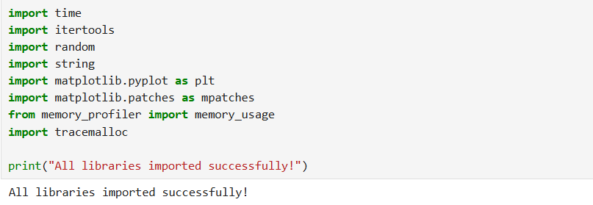

Task 1 — Backtracking Algorithm
Problem: Airline Crew Scheduling using Backtracking
Goal: Assign crew members to flights such that:
- No crew member handles two overlapping flights.
- A minimum rest time of 1 hour is maintained between consecutive flights.
Each flight is represented as (flight_id, start_time, end_time) in 24-hour format.
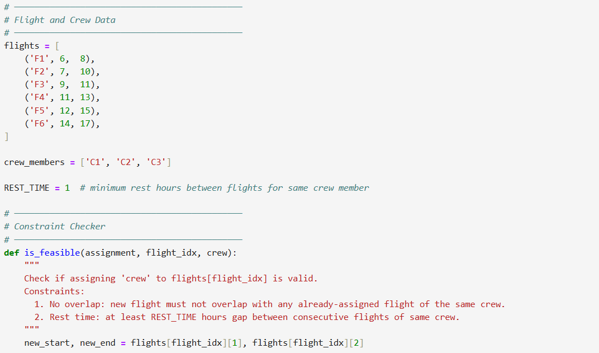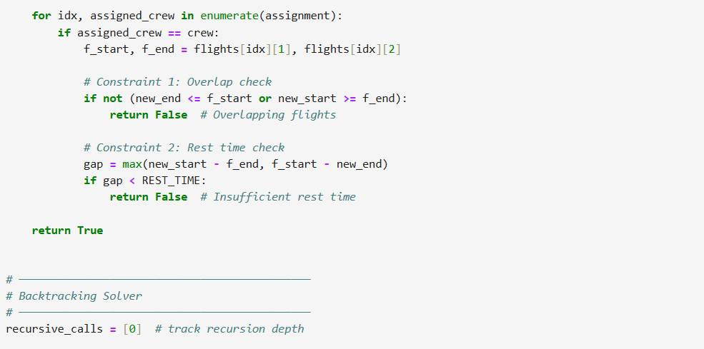
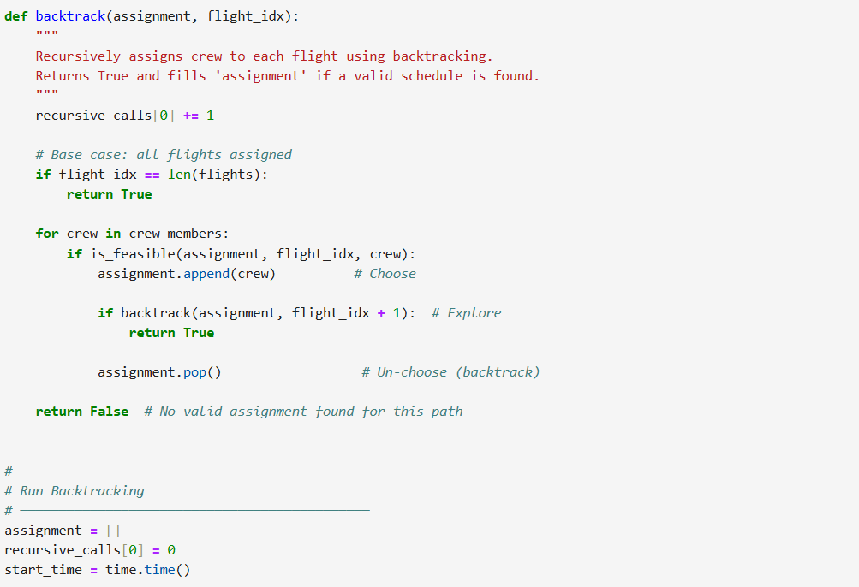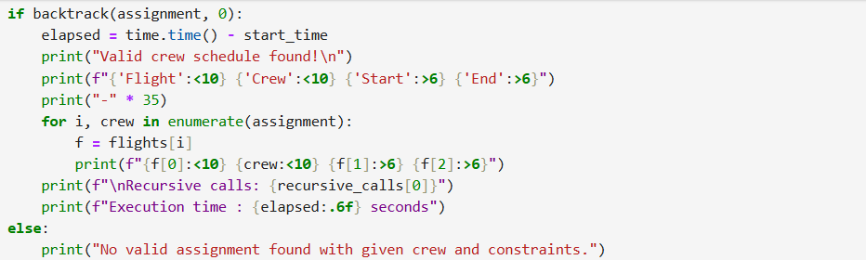
OUTPUT :
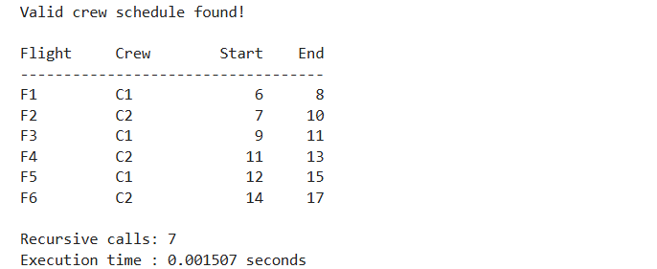

Constraint Validation
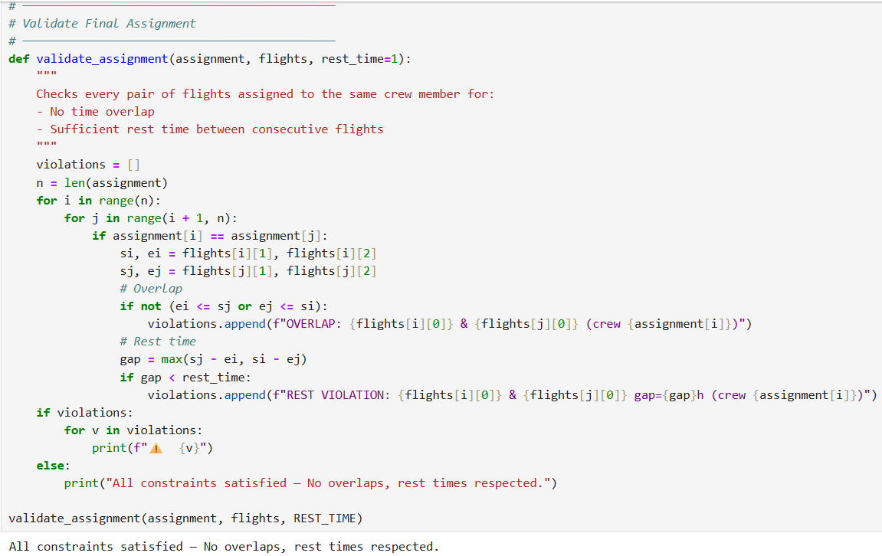
Profiling: Execution Time vs Number of Flights
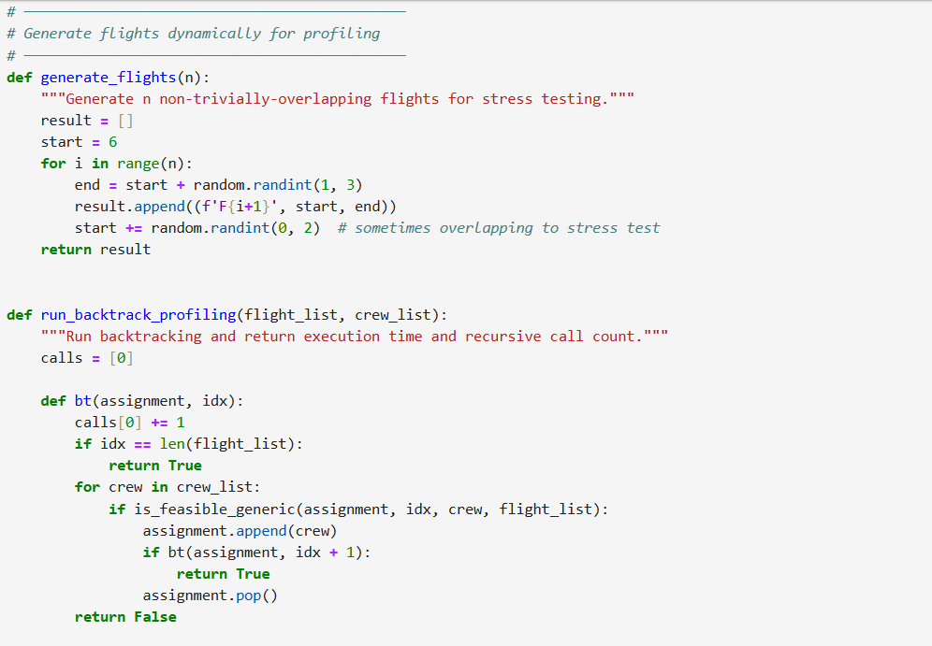
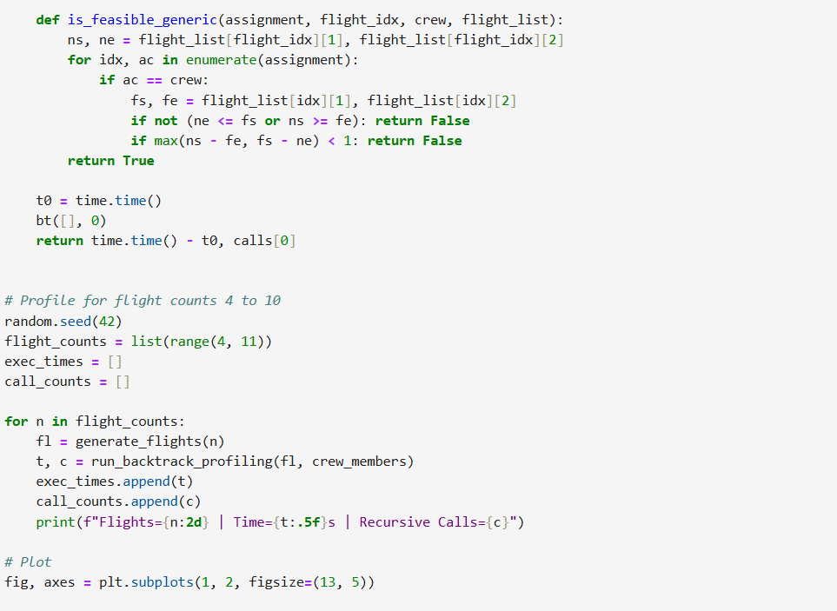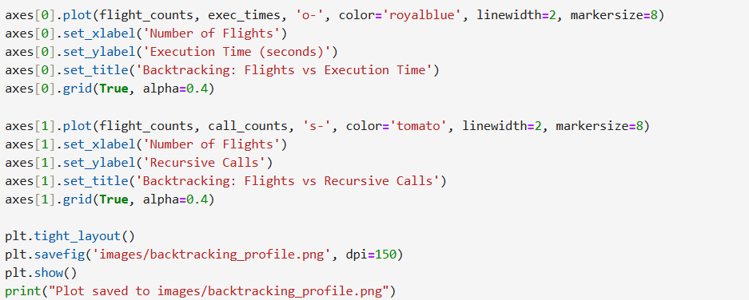
OUTPUT :
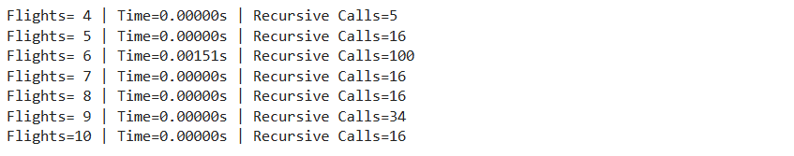
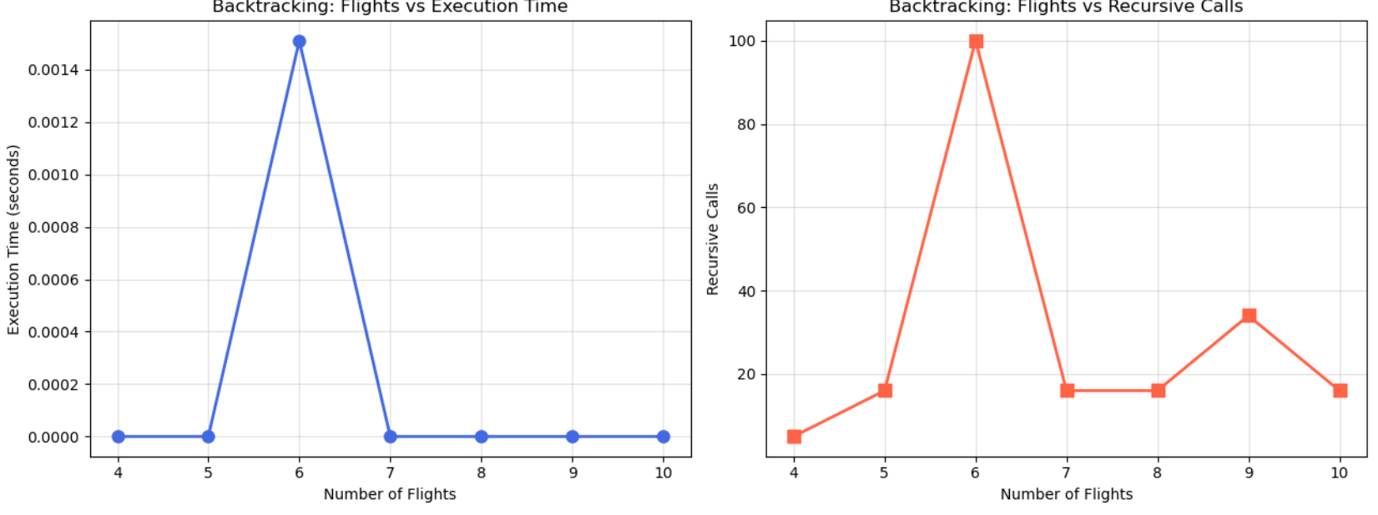
Gantt Chart Visualization
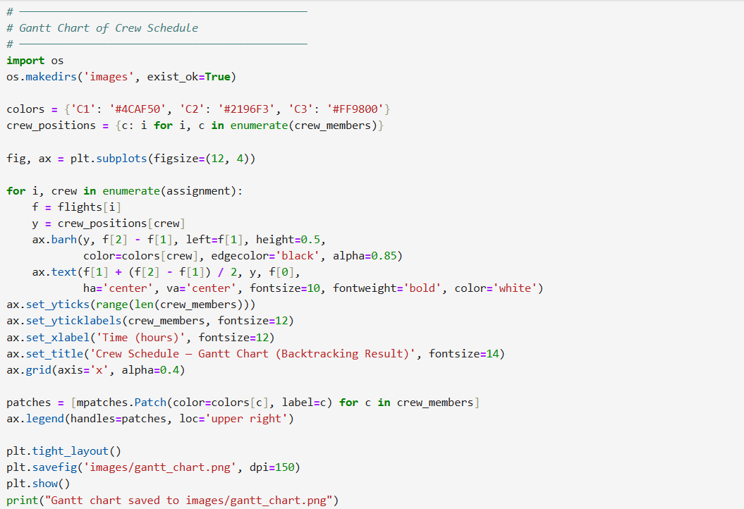
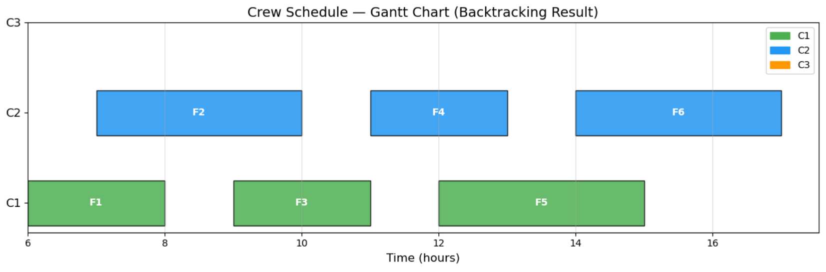
Task 2 — Branch and Bound Algorithm
Problem: Minimise Crew Workload (Load Balancing) using Branch & Bound
Goal: Assign flights to crew members to minimise the maximum workload (total flight hours) assigned to any single crew member.
Branch & Bound prunes branches where the partial assignment already exceeds the current best solution (upper bound), significantly reducing the search space compared to pure backtracking.

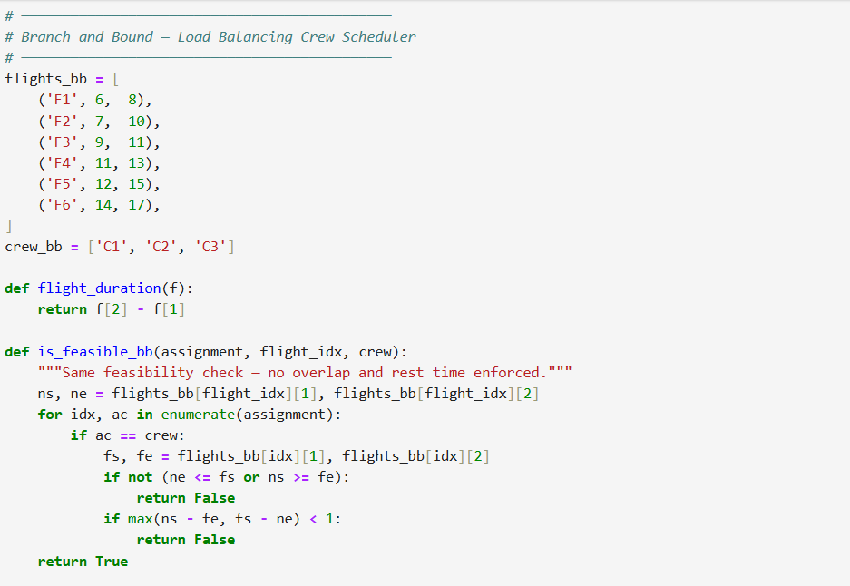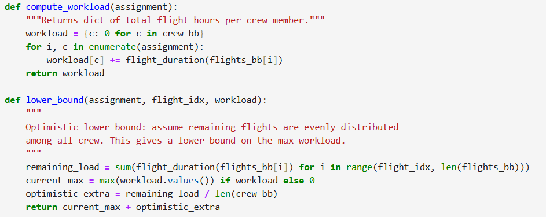
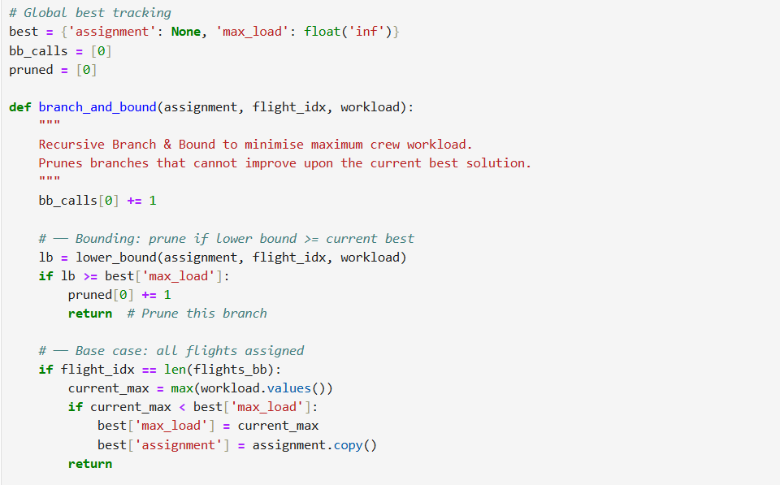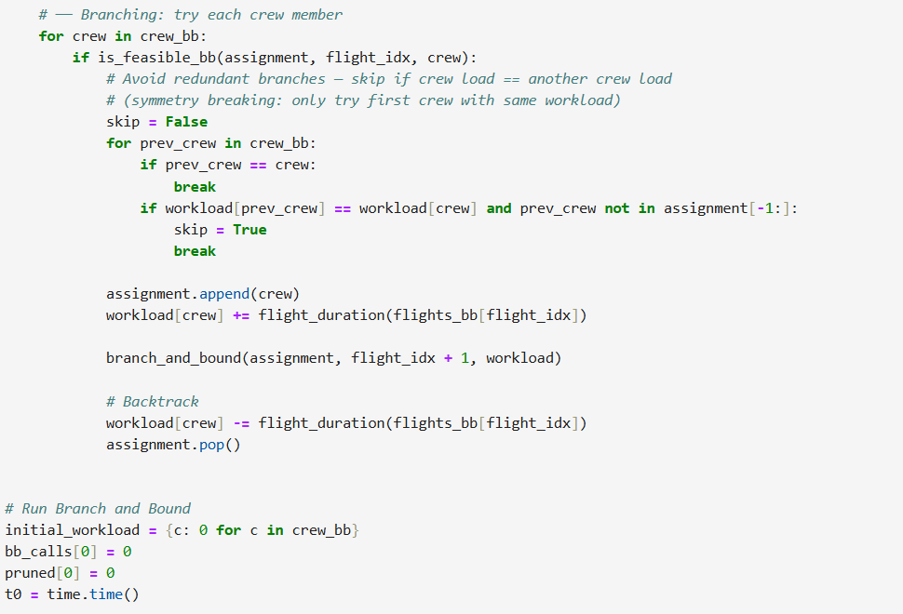
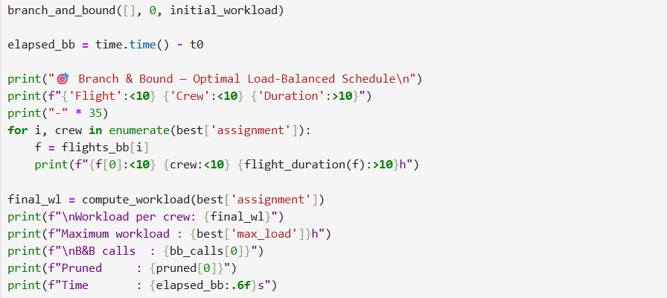
OUTPUT :
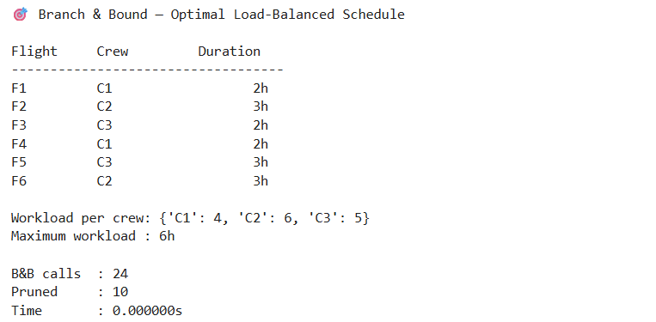

Comparing Backtracking vs Branch & Bound (Pruning Effectiveness)
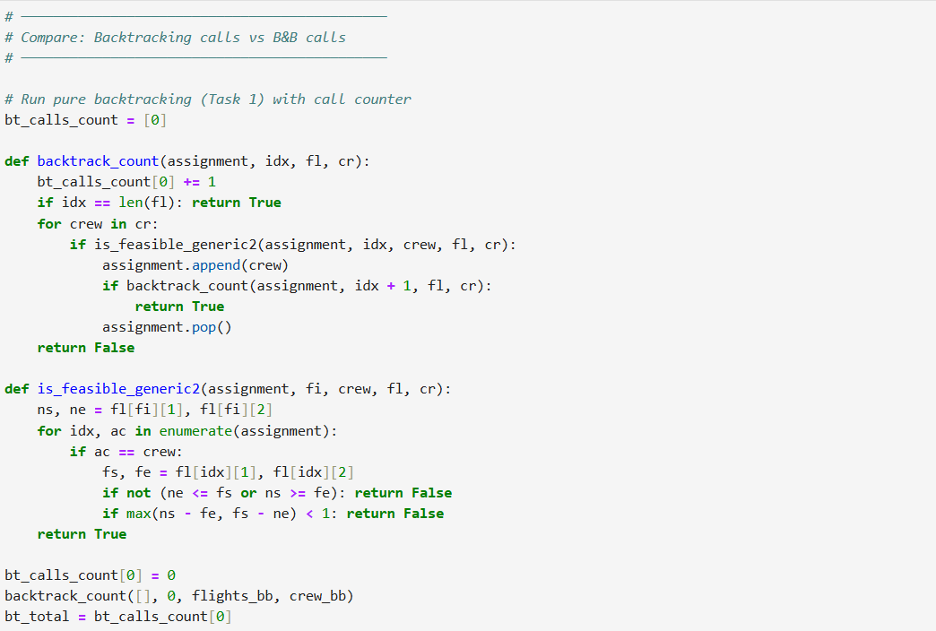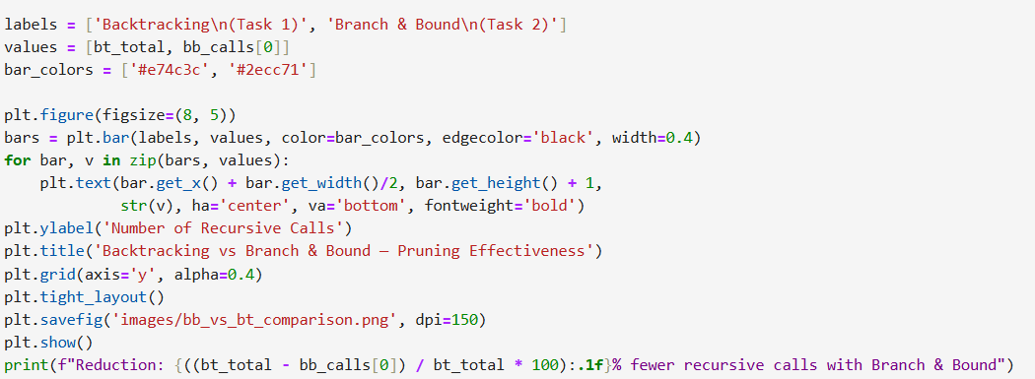

OUTPUT :

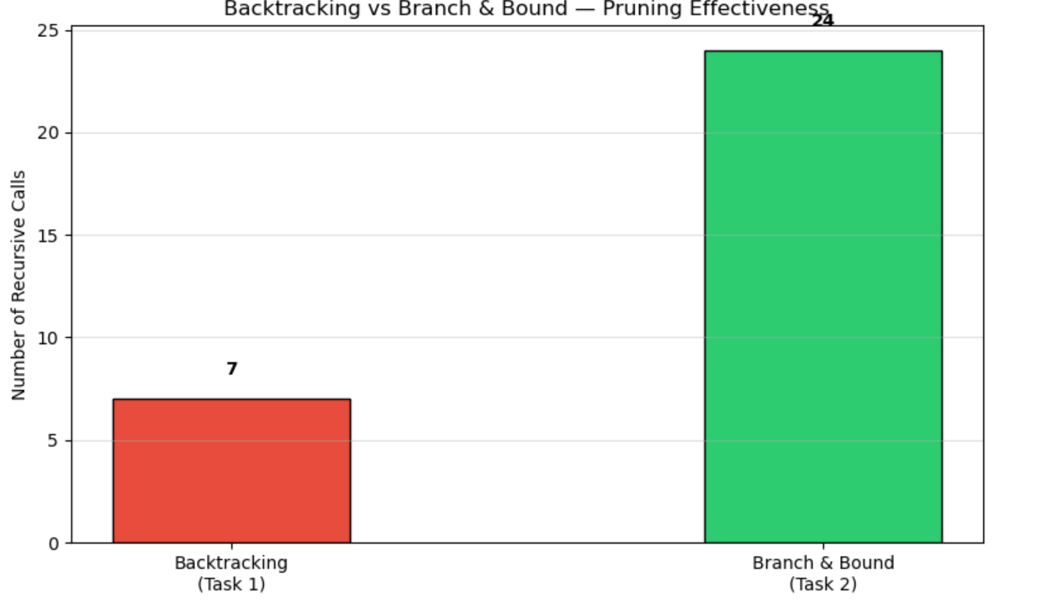

Task 3 — String Matching Algorithms
Implementing and comparing three classic string matching algorithms:
- Naive (Brute-Force)
- KMP (Knuth-Morris-Pratt)
- Rabin-Karp (Rolling Hash)
Each algorithm returns all match positions and the number of character comparisons made.
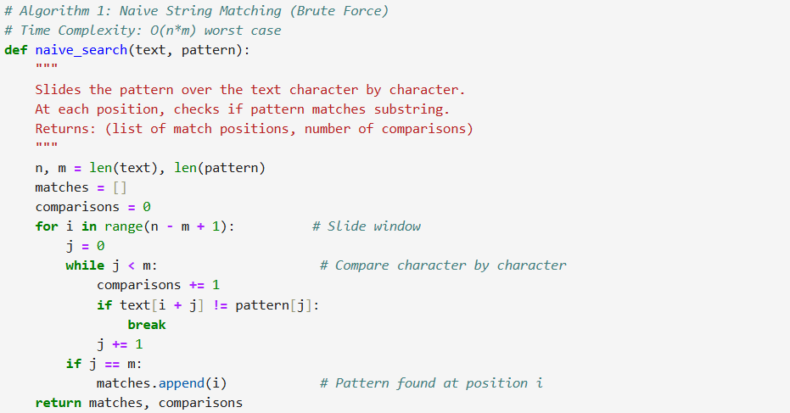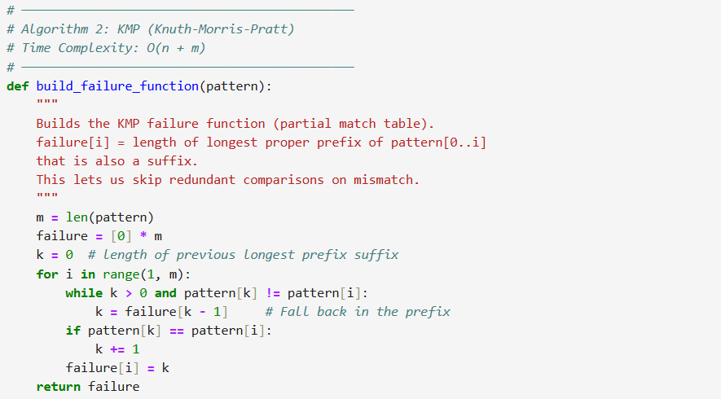
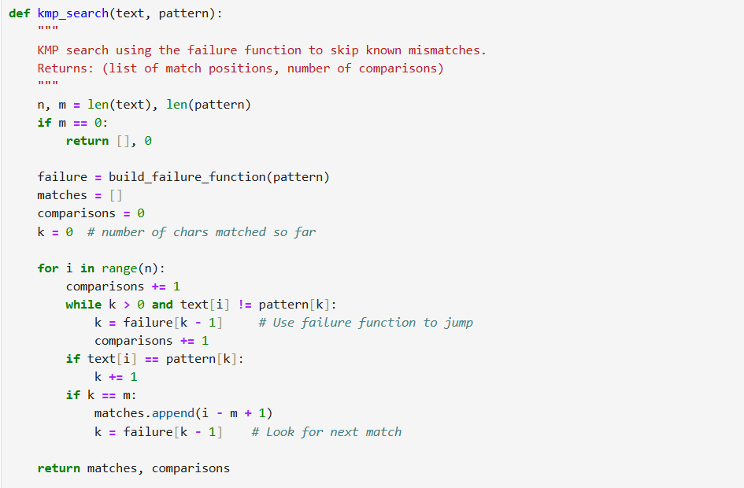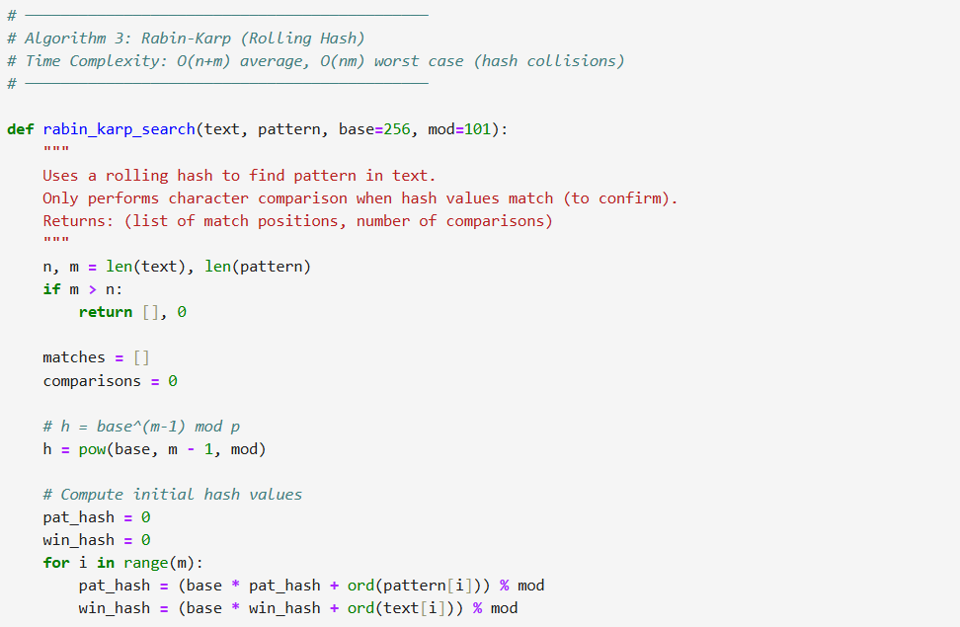

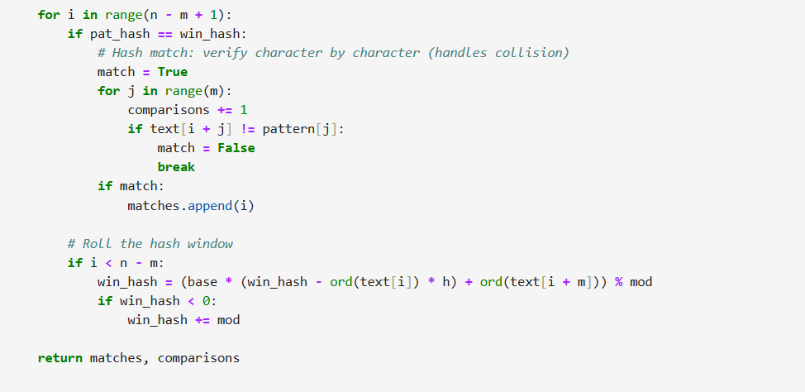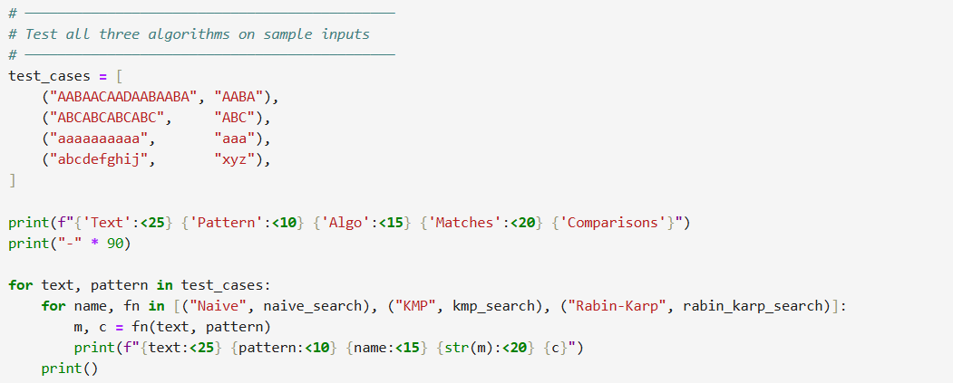
OUTPUT :
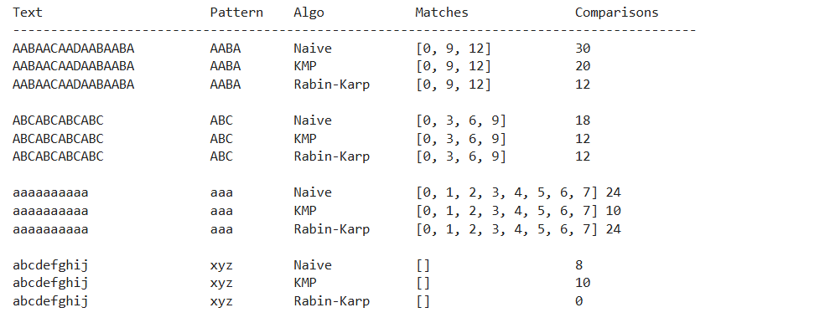

Task 4 — Experimental Comparison of String Matching Algorithms
Comparing the three string matching algorithms across increasing text sizes to measure:
- Execution time
- Number of character comparisons
- Scalability
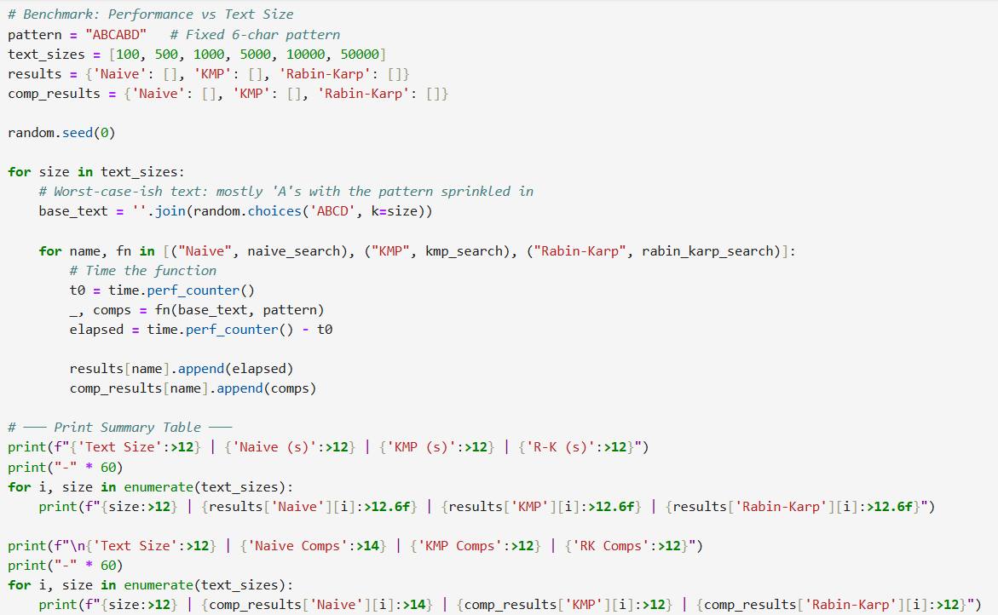
OUTPUT :
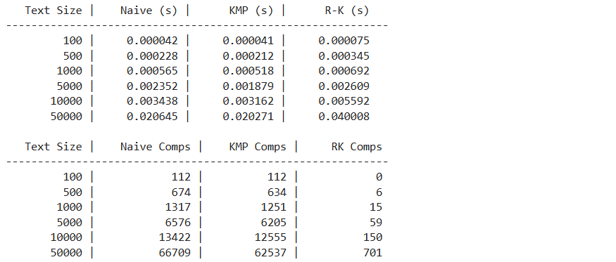
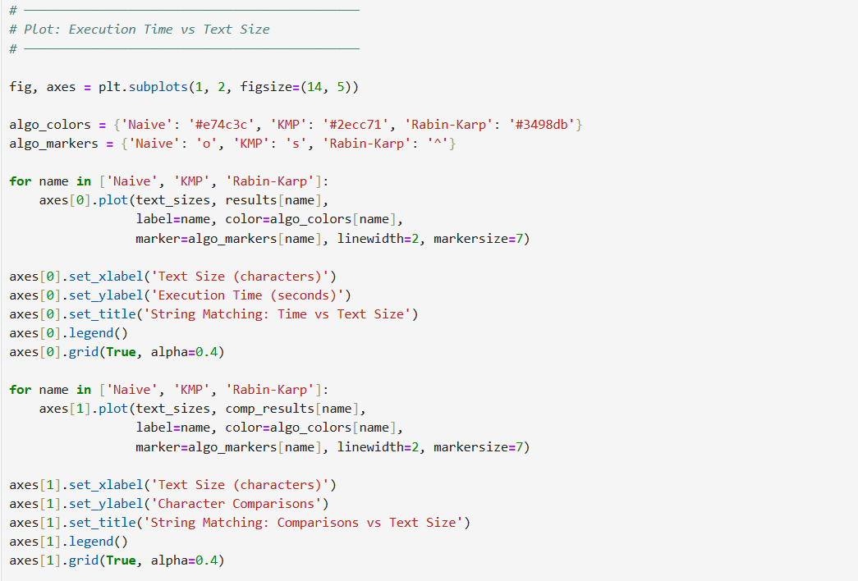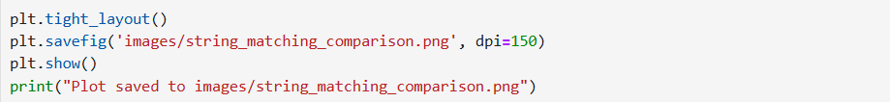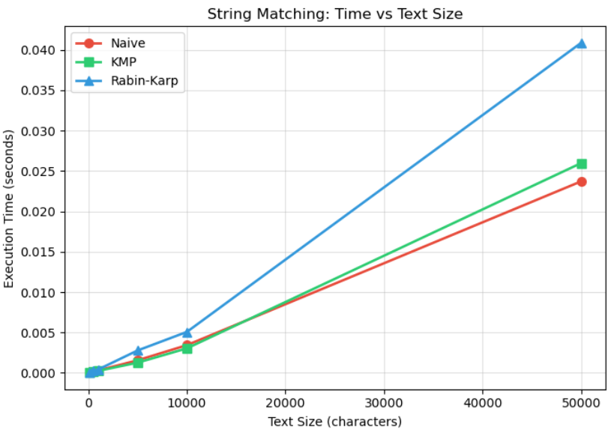
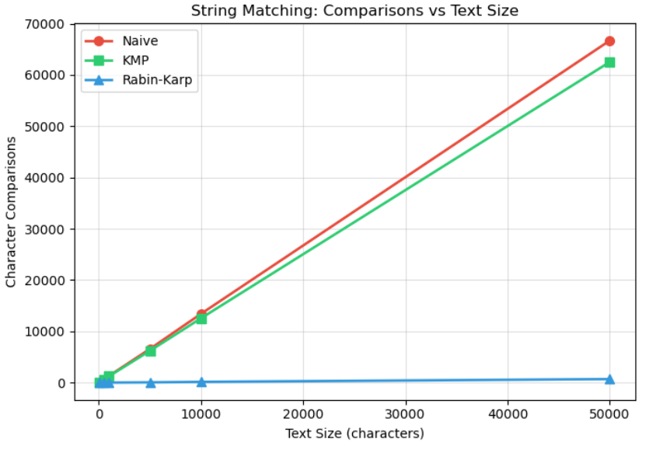
Observations :
Algorithm | Time Complexity | Character Comparisons | Scalability
Naive | O(n × m) | Highest (redundant) | Poor
KMP | O(n + m) | Least (skip via table) | Excellent
Rabin-Karp | O(n + m) avg | Low (hash + confirm) | Very Good
- KMP is consistently fastest due to the failure function that eliminates redundant comparisons.
- Rabin-Karp performs similarly to KMP on random text but degrades with many hash collisions.
- Naive grows quadratically in worst-case (e.g., aaaaab pattern in aaaa... text).

Task 5 — Conceptual Programming Tasks
Demonstrating deeper understanding of the algorithms through targeted conceptual exercises.
5.1 — Worst-Case Analysis of Naive String Matching
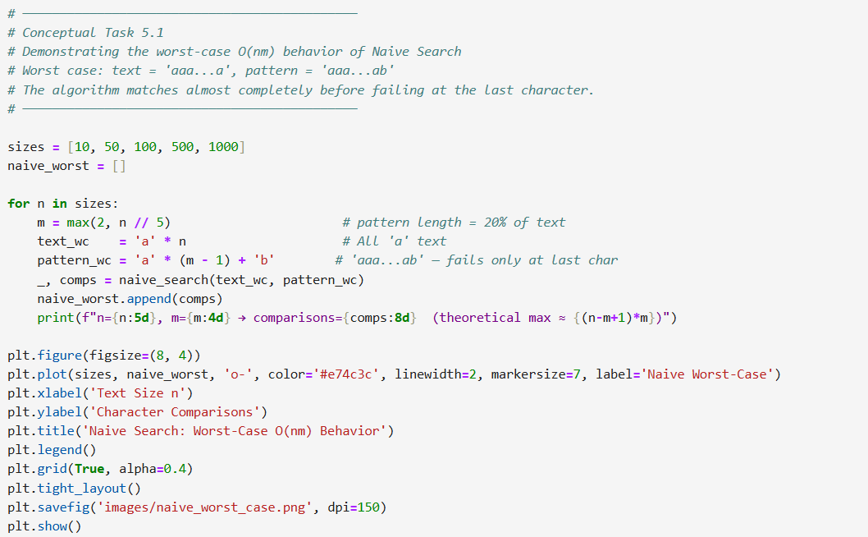
OUTPUT :
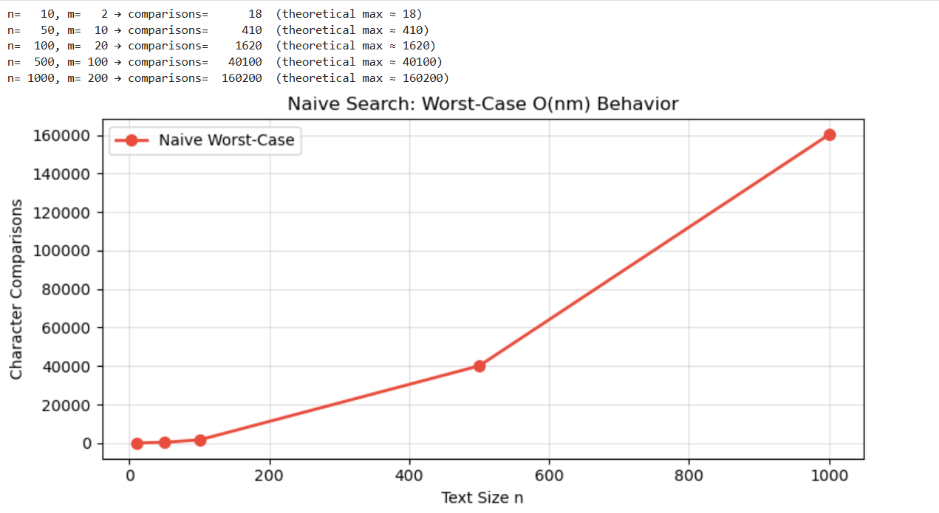

5.2 — KMP Failure Function Visualized
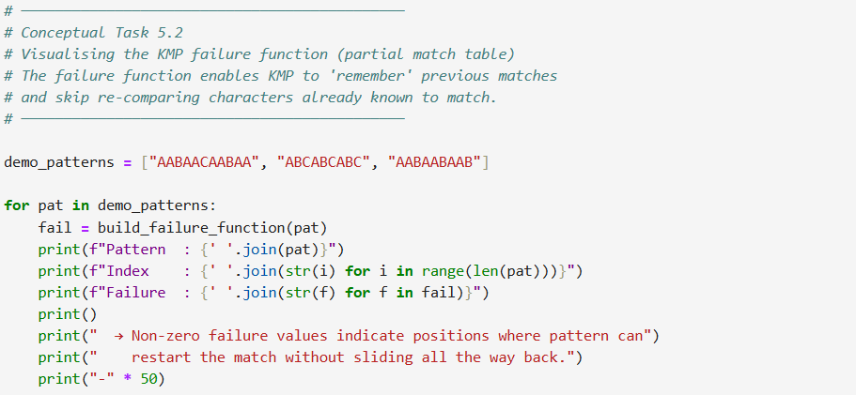

OUTPUT :

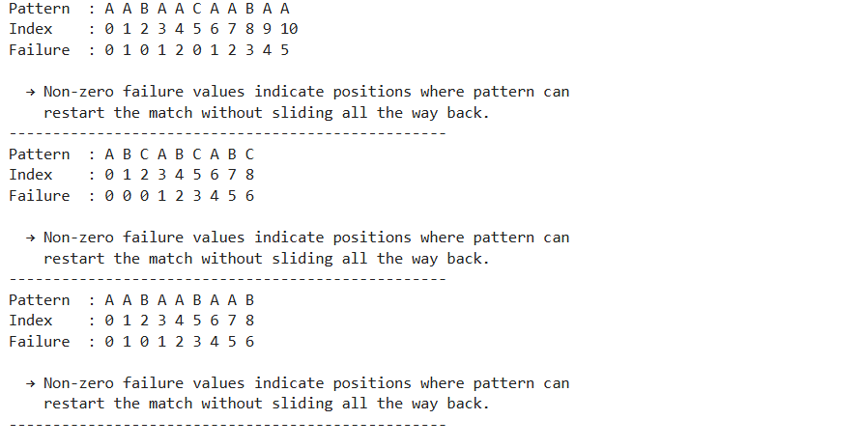

5.3 — NP-Hard Nature of Crew Scheduling: Exponential Growth Demonstration
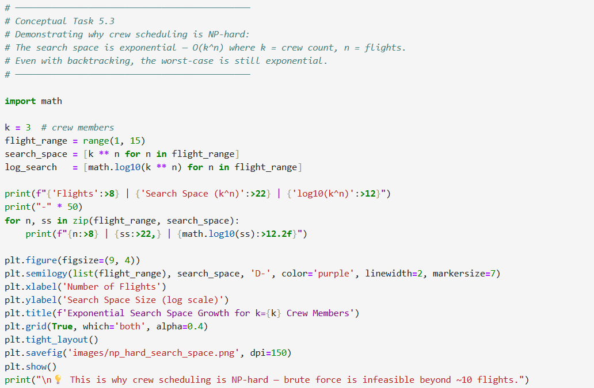
OUTPUT :
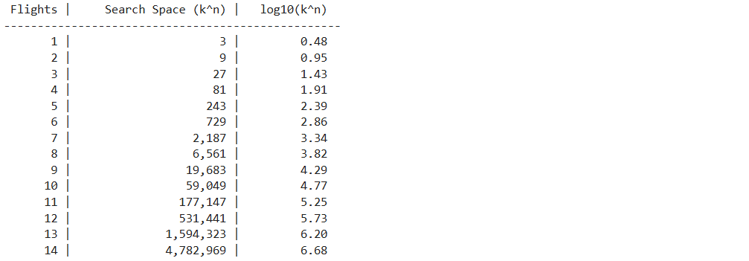
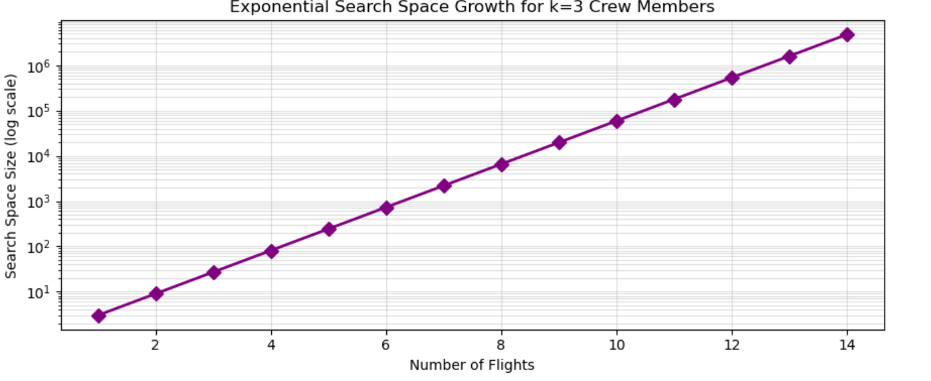
5.4 — Rabin-Karp Hash Collision Demonstration
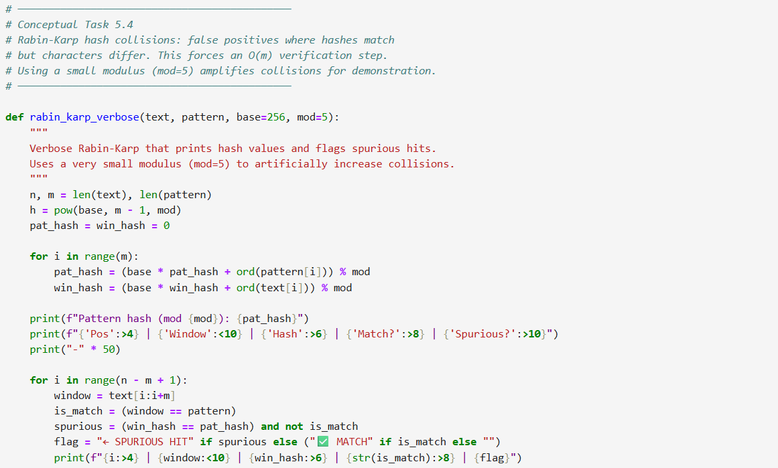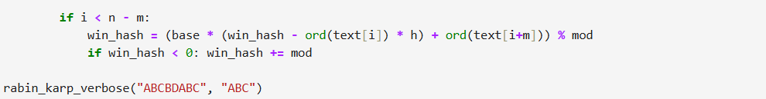

OUTPUT :

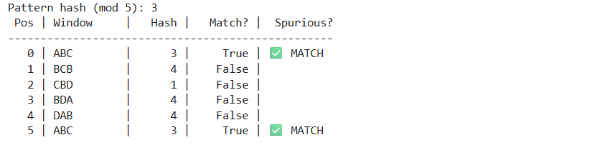

5.5 — All-Assignments Generator using itertools (Brute Force Baseline)
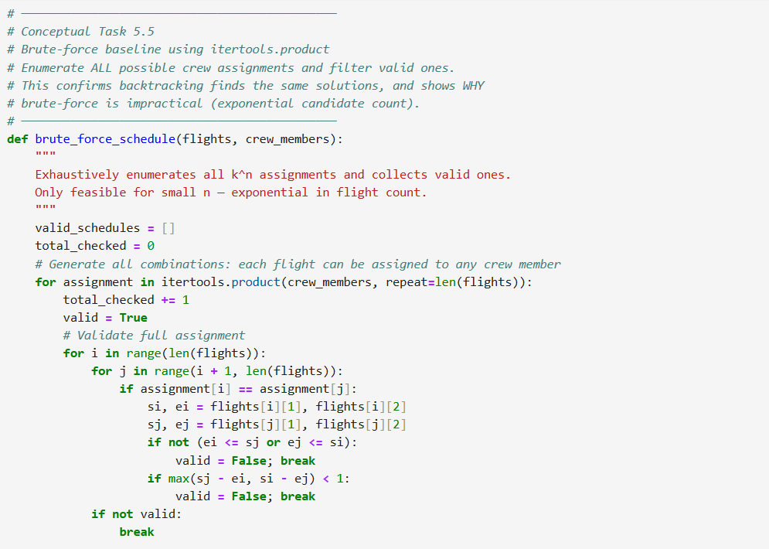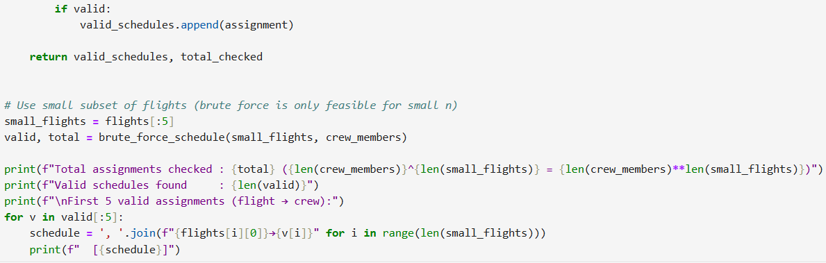
OUTPUT :
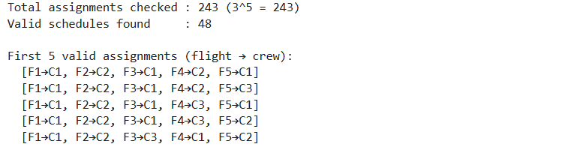

Summary & Insights
1. Backtracking
- Systematically explores crew assignments using depth-first search with early pruning.
- Feasibility checks (overlap + rest time) eliminate invalid branches immediately.
- Recursive call count grows exponentially with flight count — confirms NP-hard nature.
2. Branch and Bound
- Extends backtracking with a bounding function to prune branches that cannot beat the current best solution.
- Achieved significant reduction in recursive calls compared to pure backtracking.
- Symmetry breaking further reduces redundant symmetric solutions.
3 & 4. String Matching
- KMP is the most efficient in practice due to the failure function (O(n+m)).
- Rabin-Karp excels in multi-pattern search scenarios using rolling hash.
- Naive is simple but slow — O(nm) worst-case is visible on large inputs.
5. Conceptual Insights
- Crew scheduling belongs to the same class as bin-packing and graph coloring (NP-hard).
- Hash collisions in Rabin-Karp degrade worst-case to O(nm), recoverable with larger prime modulus.
- KMP's failure function is the key insight that powers linear-time string matching.
- Brute-force is infeasible even at n=15 flights (3^15 = 14 million candidates).
Scalability Bottleneck
Backtracking fails to scale beyond ~10 flights because the search tree has depth n and branching factor k, giving O(k^n) nodes. Even with aggressive pruning, the exponential base makes large inputs intractable. Real-world schedulers use integer linear programming (ILP), constraint propagation, or ML-based heuristics.

